Photoelectric effect
1. (a) Define the following:
(i) Photoelectric effect
(ii) threshold wavelength
(b) The variation of frequency f with the maximum kinetic energy E_{k} of the emitted
electrons is shown on the graph below:
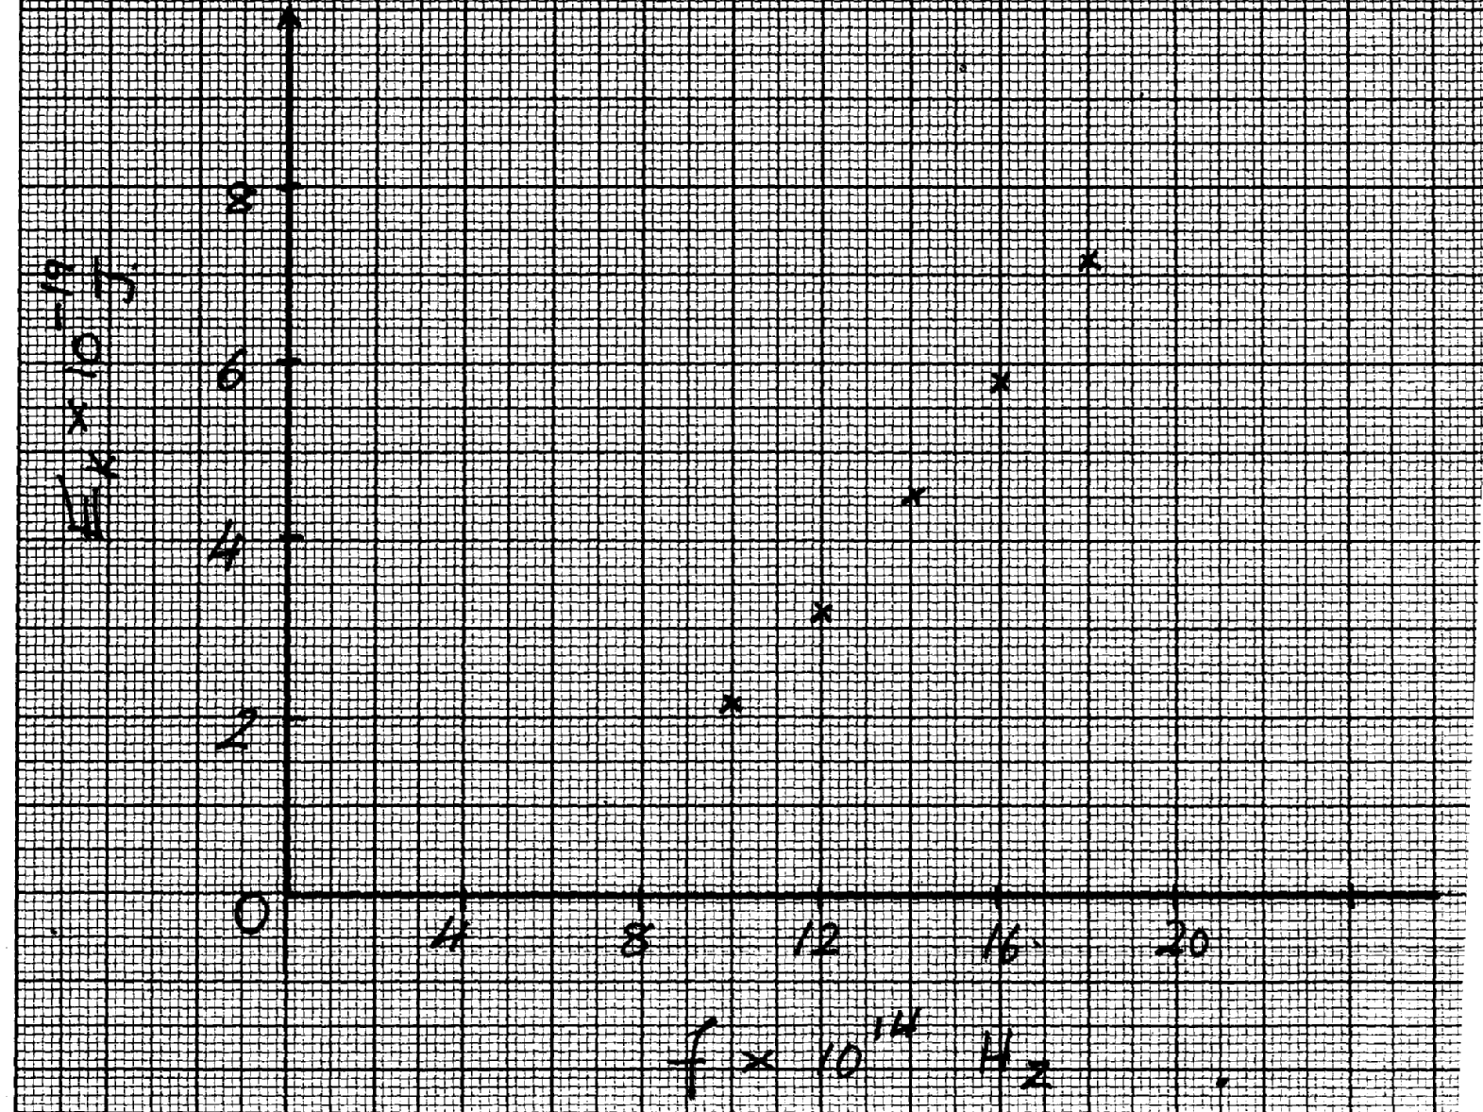

Using the graph above, determine
(i) the threshold frequency f_{o} of the radiation *RCH*

(ii) the value of the Planck’s constant h
(iii) the work function, W_{o}
(c) On the same graph in (b) above, draw a line to show the variation of frequency, f, with the
maximum kinetic energy, E_{k}, of the emitted electrons from a second metal which has a lower
work function that used in (b)
2. Figure 8 below shows a mercury vapour lamp, which emits ultraviolet light held over a
negatively charged electroscope:
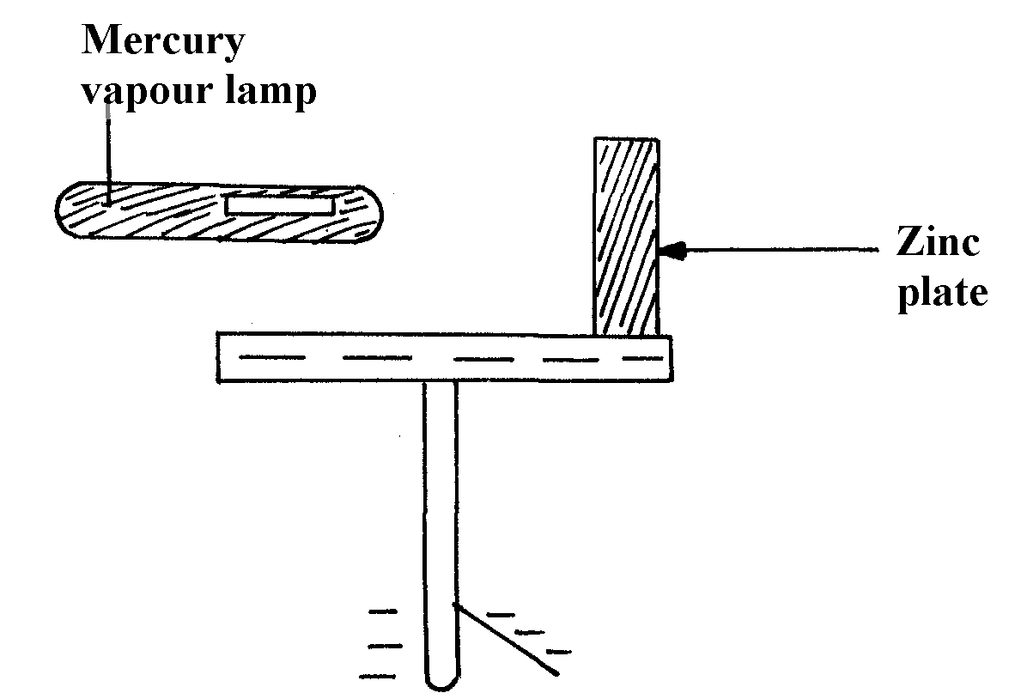

figure 8

(i) What happens to the leaf after the lamp is switched on?
(ii) Explain why it happens
(iii) If the experiment is repeated with equally bright red light held the same distance from the
plate in place of the mercury vapour lamp, what effect would this have on the leaf?
Give a reason
(iv) What does photoelectric effect suggest about the nature of light?

3. Calculate the wavelength of Green light whose energy is 3.37 x 10⁻¹⁹ J .
(h = 6.63 x 10⁻³⁴JS, C = 3.0 x 10⁸m/s)

4. a) Define the term work function
b) Name one factor that determines the velocity of photoelectrons produced on a metal surface
when light shine on it
c) In a photoelectric effect experiment, a certain surface was illuminated with radiations of
different wavelengths and stopping potential determined for each wavelength. The table
below shows the results obtained.

Stopping potential , Vs | 1.35 | 1.15 | 0.93 | 0.62 | 0.36
Wave length, (x10⁻⁷m) | 3.77 | 4.04 | 4.36 | 4.92 | 5.46

i) On the grid provided plot a graph of stopping potential (Y –axis) against frequency
ii) From your graph determine:
a) The threshold frequency
b) The plank’s constant, h
(e = 1.6 x 10⁻¹⁹ Coulomb, C = 3.0 x 10⁸ m/s)
5. a) State the role of the Grid in a cathode ray tube
b) Explain why a magnetic field is used in the TV deflection system instead of an electric field
c) The time base of a CRO is 25ms/div while its gain is 2.5V/div. Use this information to
answer the questions that follow:
i) Calculate the frequency of the signal
ii) What is the peak voltage of the signal

6. The graph below shows the relation between the stopping potential, Vs and the frequency
of radiation when a certain surface is illuminated with light of different frequencies
Stopping potential V_{s}(ev)
Frequency x 10Hz
0
2
6
8
10
12
0.5
1.0
1.5
2.0

From the graph determine:-
(i) The threshold frequency
(ii) The value of plank’s constant (e = 1.6 x 10⁻¹⁹C)
(III) The work function of the material

7 a) State one reason why a C.R.O is a more accurate voltmeter than a moving coil voltmeter
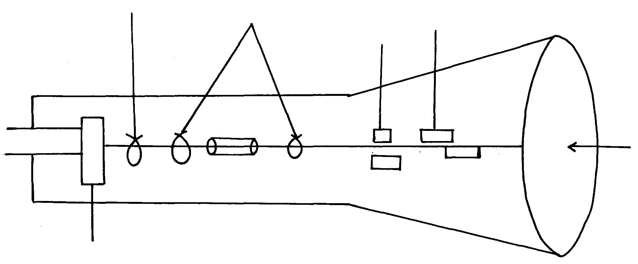
(b)The diagram below represents a cathode ray oscilloscope (CRO)
A
B
C
D
Screen

;

i) Name the parts labeled A and B
ii) What are the functions of C and D?
iii) State how electrons are produced

8. a) What is meant by the term photo electric effect b) In an experiment using a photo cell, ultra violet light of varying frequency strikes a metal
surface. The maximum Kinetic energy (KE max) of the frequency F is measured. The graph
below shows how the maximum kinetic energy varies with frequency F
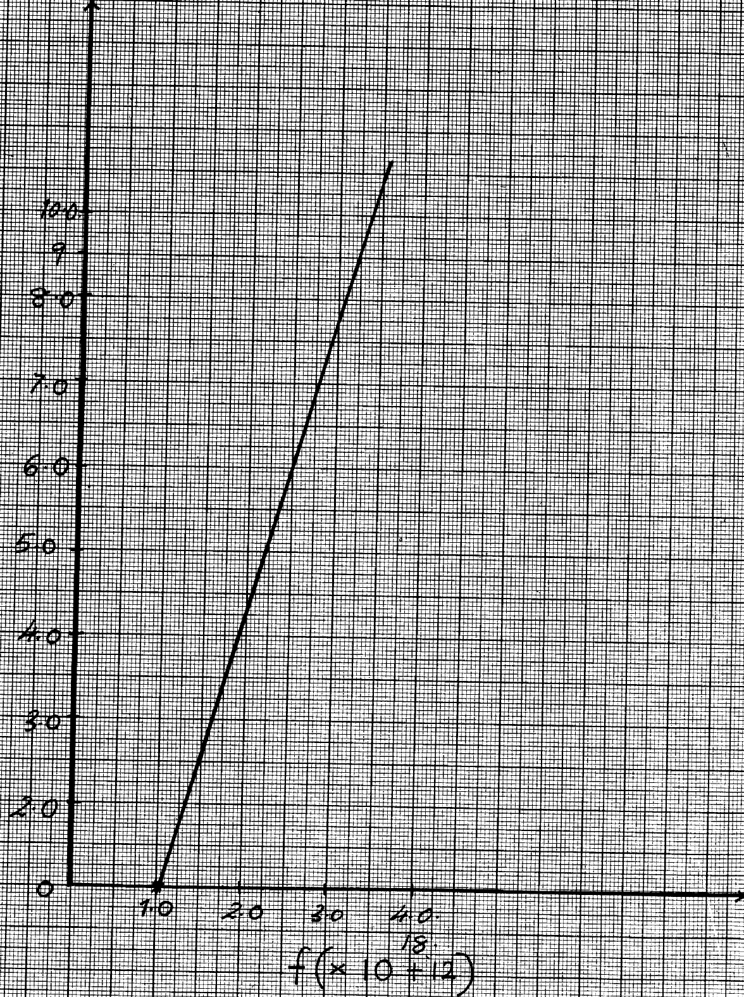

K.E max ( X 10⁻¹⁹kJ)

Use the graph to determine:-
i) Threshold frequency F
ii) The plank’s constant, h
iii) Work function of the metal

9. (a) The diagram fig 9 below shows a photo cell; connected in a circuit:-
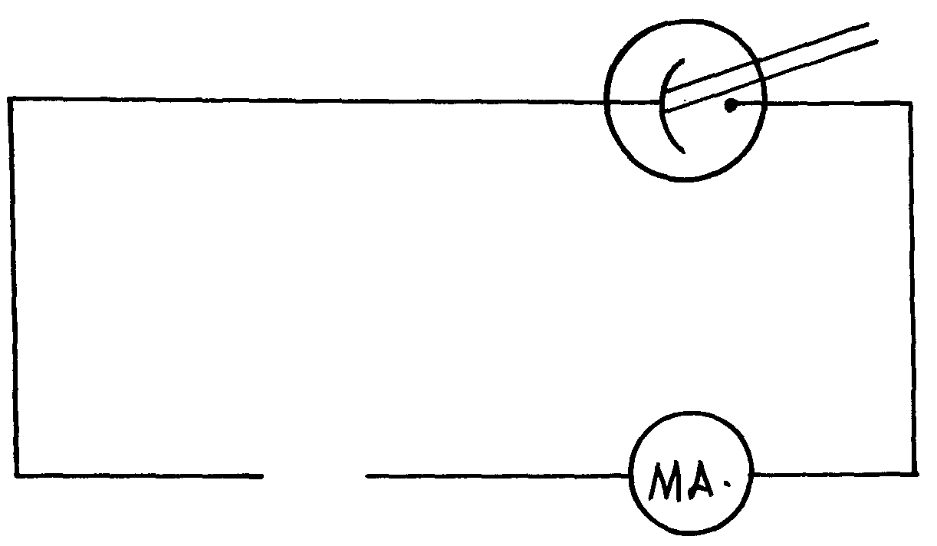
fig. 9

(i) Complete the diagram by indicating the correct polarities in the gap for current to flow in
the circuit
(ii) State and explain the effect of using light of different wave lengths on the amount of
current flowing in the circuit given that the distance of the source of light remains the same

(b) Two fixed resistors one of 100Ω and the other of unknown resistance are connected in parallel.
The combination is placed in a circuit and current passing through the combination was
measured for various p.d. The graph in figure 10 below drawn to scale shows the results:-
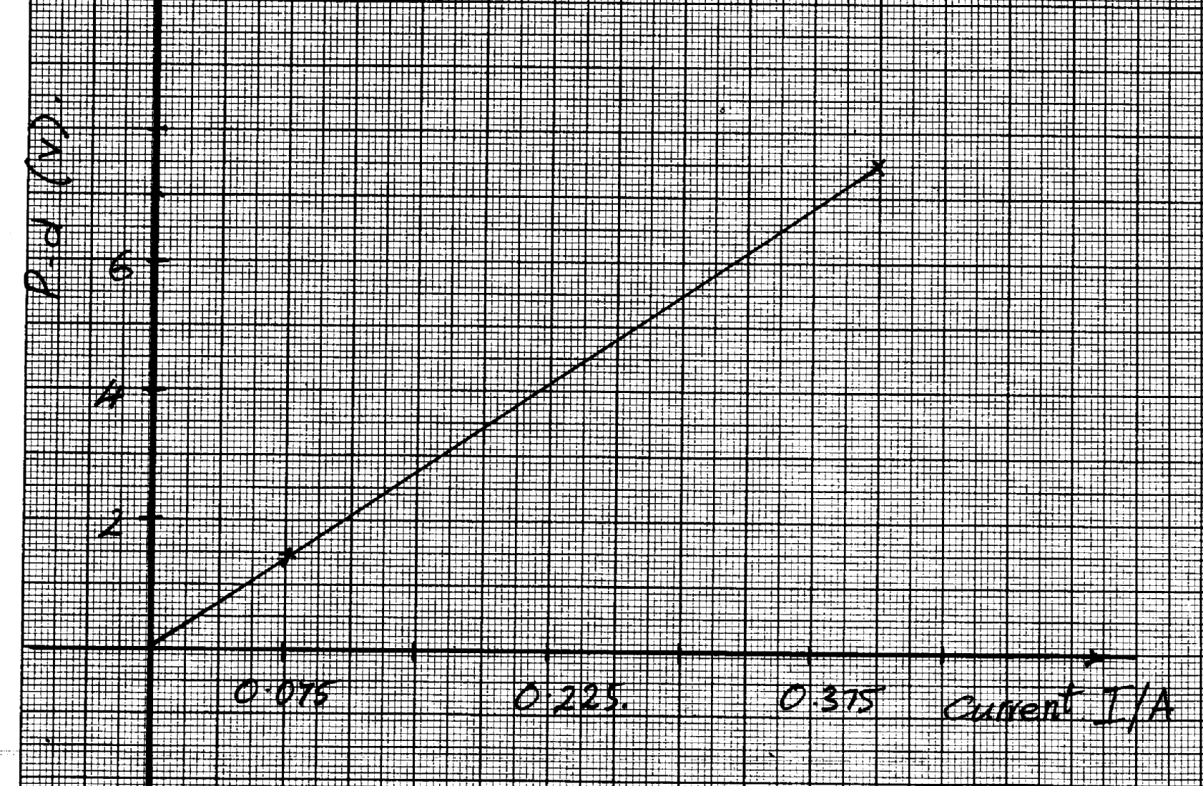

(i) From the graph, calculate the total resistance of the combination
(ii) Determine the value of the unknown resistance
(c) (i) Explain the cause of eddy currents and how they are minimized in a transformer
(ii) A transformer with 4200 turns in the primary coil operates a 240V mains supply and gives an output of 8.0V. Determine the number of turns in the secondary coil (assuming it is 10% efficient)

10. State one factor that affects photoelectric effect


11. a) i) What is photoelectric effect?
ii) You are provided with the following; a photo cell; a source of UV light, a rheostat,
a source of e.m.f, a millimeter, a voltmeter and connecting wires. Draw a circuit
diagram to show how photoelectric effect may be demonstrated in the laboratory
b) In a photoelectric effect experiment, a certain surface was illuminated with radiation of
different frequencies and stopping potential determined for each frequency. The following
results were obtained:
Frequency (f) (x 10¹⁴ H_{z}) | 7.95 | 7.41 | 6.88 | 6.10 | 5.49
Stopping potential, (V_{s}), (V) | 1.35 | 1.15 | 0.93 | 0.62 | 0.36

i) Plot a graph of stopping potential (Y-axis) against frequency
ii) Determine plank’s constant, h and the work function of the surface given that
EV_{s} = hf – hf_{o}, where hf_{o} = Q_{e} = 1.6 x10-¹⁹ C
c) A surface whose work function Q = 6.4 x 10⁻¹⁹ J is illuminated with light of frequency
3.0 x10¹⁵ H_{z}. Find the minimum K.E of the emitted photo electrons
(use value of h obtained in b(ii) above)

Photoelectric effect
1. a) i) – The emission of electrons from metal surface when radiation of unstable wave
length falls on it √
ii) The maximum wavelength beyond which no photoelectric effect occurs √
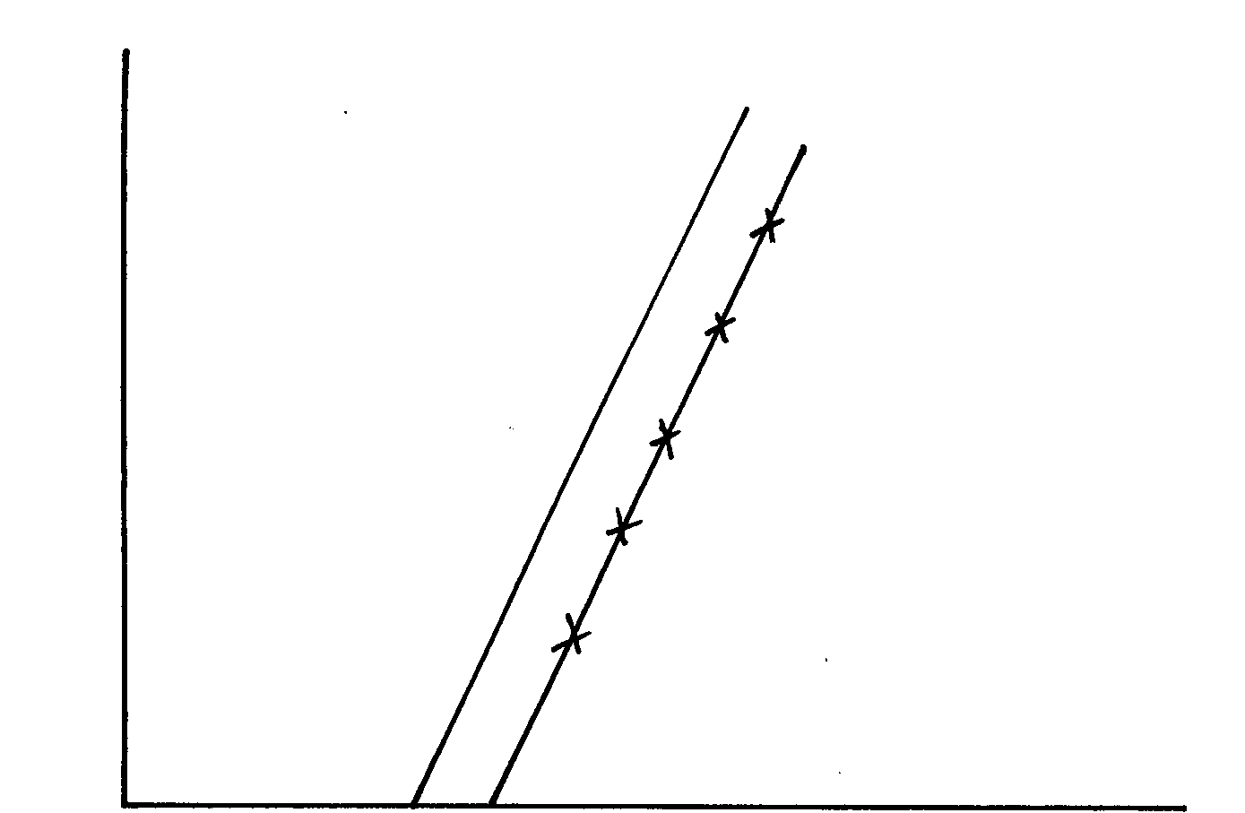
b)

i) f = 6.4 x 10¹⁴H √
ii) EK = hf –W
h = gradient√
= (6.2 – 22) x 10⁻¹⁹√
(16 – 10) x 10¹⁴
= 6.667 x 10⁻³⁴Js√
iii) W_{o}= hf_{o}
= 6.667 x 6.4 x 10¹⁴ x 10⁻³⁴√
= 4.267 x 10⁻¹⁹J√
2. (a) (i) X – Intercept = 4.5 x 10¹⁴Hz
1
(ii) Slope = h – h = e x slope
e
1
= e x 6.6 – 0)V
(6-4.5) x 10¹⁴ ^{s-1}
= 1.610⁻¹⁹ x 4 x 10-15
1
= 6.4 x 10⁻³⁴Js
(iii) W₀ =hf₀
1
1
= 6.4 x 10-34 Js x 4.5 x 1014s-1
= 2.88 x 10-¹⁹J
1
1
1
(b) (i) The leaf falls Collapses
(ii) The electrons are repelled causing the leaf potential to decrease
1
(iii) NO effect on the leaf. Light emitted by red light doesn’t have enough energy to cause

photoelectric effect.
1
1
(iv) Light is a wave, it carries energy in small packets (protons).

3. Calculate the wavelength of Green light whose energy is 3.37 x 10-19 J .
(h = 6.63 x 10-34JS, C = 3.0 x 108m/s)

λ = ν ƒ = 3.37 X 10-19j λ = 3.0 X10 8m/s
ƒ 6.63 X 10 -34 5.083X1014HZ

= 5.08 3X10 14HZ = 5.902 X 10 -7m
ƒ =E
h
4. a) This is the least radiation energy required to just dislodge an electron from a metal surface.
b)The energy of the radiation. The higher the energy the higher the velocity of photo electrons
Frequency X 1014 Hz 7.959 7.43 6.88 6.10 5.49
i) On the grid provided plot a graph of stopping potential (Y –axis) against frequency
Graph (diagram)
ii) From your graph determine:
The threshold frequency
ƒo = 4.5 X 10 ¹⁴ HZ

b) The plank’s constant, h
(e = 1.6 x 10-19 Coulomb, C = 3.0 x 108 m/s)
eVs =hf –hfo gradient = 1.15 – 0.93
Vs = h f – h fo (7.43 -6.98) X 10 ¹⁴
= 0.22 X 10 ⁻¹⁴
gradient = h 0.55
e = 0.4 X10⁻¹⁴
= 0.4 X 10⁻¹⁴ X 1.602 X 10 ⁻¹⁹ h = 6.408 X 10 -34js

5. a) It controls the intensity of electron leaving the electron gun controlling the brightness
of the spot on the screen.
b) The magnetic field deflection system make electrons span the whole screen unlike
the electric field deflection system.
c) i) Calculate the frequency of the signal
T = 25ms/div X 2 div f = 1
= 50 ms 50/1000
F = I
T = 20HZ

ii) What is the peak voltage of the signal
  - peak voltage = 21X 2.5v|d.v
=5 Volts

6. (i) Graph is extrapolated to meet x-axis
 1
f₀ = 7 x 1014Hz
 1

(ii) Gradient = ΔVs
Δf
= 1.75 – 0
 1
12 – 7
= 1.75 = 0.35 x 10⁻¹⁴
 1
5 x 10¹⁴ = 3.5 x 10⁻¹⁵

h = Gradient x e
= 3.5 x 10-15 x 1.6 x 10-19
= 5.6 x 10-34Js
 1
 1

(iii) W = hf_{o}
 1
= 5.6 x 10⁻³⁴ x 7 x 10¹⁴
= 3.92 x 10⁻¹⁹ J
 1

7. a) – Has infinite resistance/ does not take up any current
- Sensitive/ does not require heating time
b) i) A – Grid
B- Electron gun
ii) C – Vertical deflection of the beam
D- Horizontal deflection of the beam
iii) – By thermionic emission as heating the filament

8. a) Electrons being ejected from metal surfaces by use of electromagnetic waves
b) i) X – intercept = 1.0 x 10¹⁵
ii) From K.E = hf
Planks constant (h) = gradient of graph
= (8.2 – 0) x 10⁻¹⁹
(2.5 – 1.0) x 10¹⁵
= 8.2 x 10⁻¹⁹
1.5 x 10¹⁵
H = 5.5 x 10⁻³⁴ JS

iii) Work function, W₀ = 5.5 x 10⁻³⁴ x 1.0 x 10
= 5.5 x 10⁻¹⁹ J
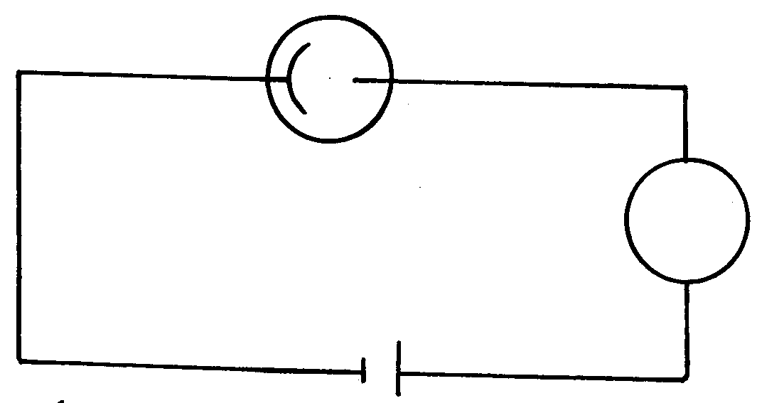
9. (a) (i)



mA



Correct polarity
(ii) No change in the amount of photo current. Change in wavelength/frequency of the

radiation does not affect the amount of photo electrons produced. It is the number of photo electrons that determines the photocurrent.


(b) (i) Total resistance = gradient


= 7.5 – 0 = 20Ω
0.375 – 0

(ii) Combine d resistance = 100R
100 + R
100R = 20

100 + R
100R = 20R + 2000
80R = 2000 R = 25Ω

(c) (i) Alternating magnetic flux in the coil induces current in the core of the same coil
causing eddy currents.


- Eddy currents are minimized by lamination of the core

(ii) Vs = Ns = 8 = Ns Ns = 4200 x 8
Xp Np 240 4200 240
10 - Intensity of the radiation
- Energy of the radiation
- Type of the metal
Ns = 140turns
11. a)i) Emission of electrons from metal surface by electromagnetic radiation falling on
the surface
b) ii) M= u = 0.56 – 0 = 0.56 = 40 X 10 ⁻¹⁵
e (6-4.6) x10¹⁴ 1.4 X 10¹⁴

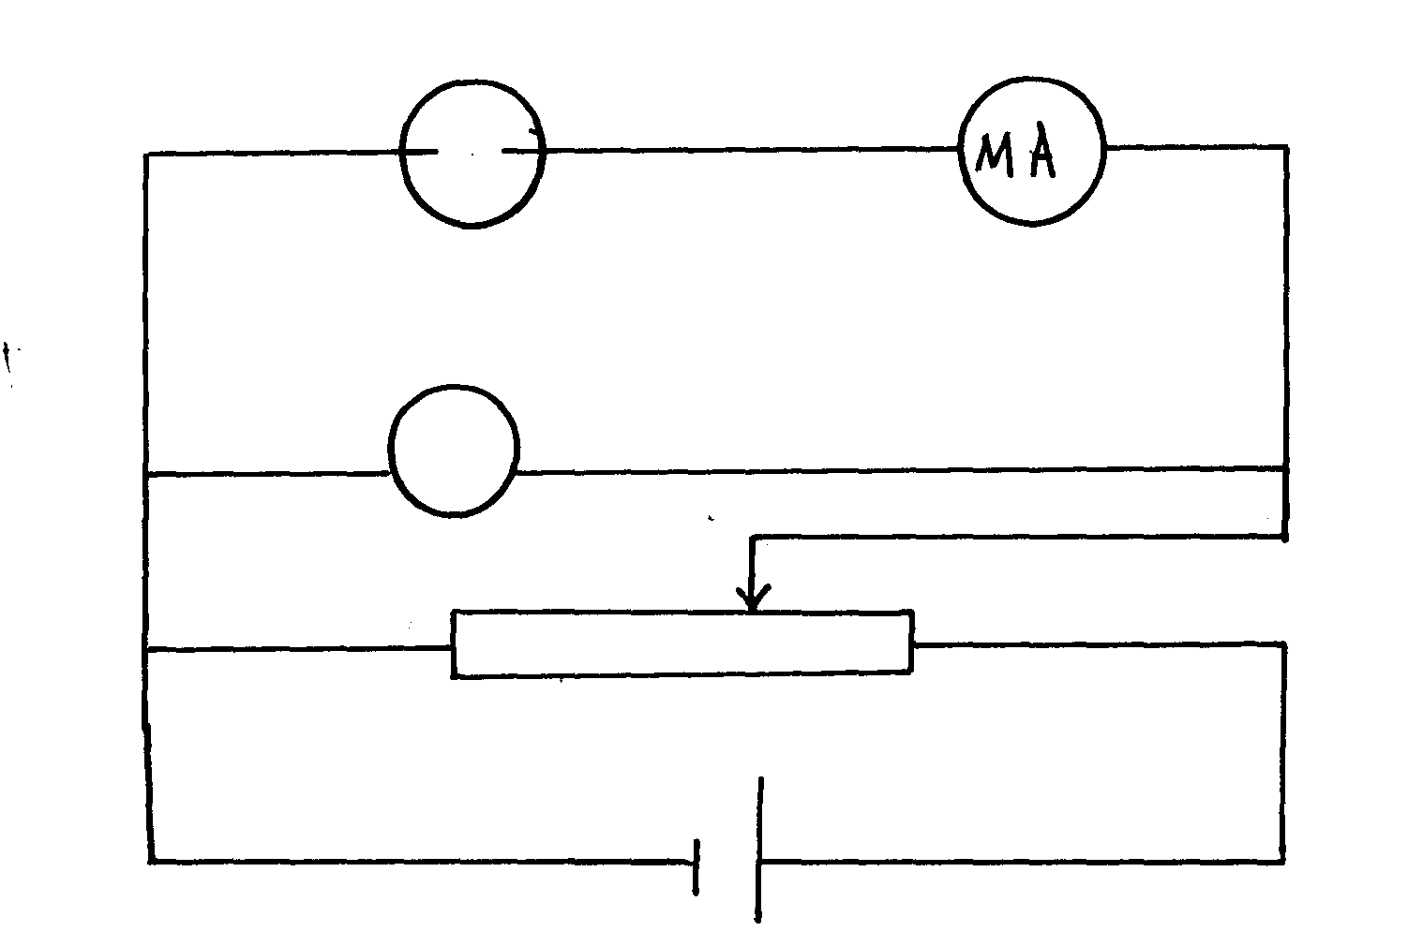
h = 4.0 X 10⁻¹⁵ X 1.6 X 10 ⁻¹⁹ = 6.4 X 10⁻³⁴ Jl

c) hf = Q + K.E
6.4 X 10⁻³⁴ X 3.0 X 10¹⁵ = 6.4 X 10 ⁻¹⁹ + K.E
K.E = 19.2 X 10⁻¹⁹ – 6.4 X 10⁻¹⁹
= (19.2 – 6.4) X 10⁻¹⁹
= 12.8 X 10⁻¹⁹
= 1.28 X 10⁻¹⁸ J

