**Name ………………………..…………………………Index No.. ..………………..……….**

**School……………………………………………….Adm No………………Stream………..**

232/2

**PHYSICS**

Paper 2

July, 2024

**Time: 2 Hours**

**CHAMPIONS JET EXAMINATIONS - 2024**

***Kenya Certificate of Secondary Education (K.C.S.E)***

**INSTRUCTIONS TO CANDIDATES**

* Write your name,school and index number in the space provided above.
* Answer ALL questions in the spaces provided in the question paper.
* Mathematical tables and electronic calculators may be used.

**FOR EXAMINER’S USE ONLY**

|  |  |  |  |
| --- | --- | --- | --- |
| **Section** | **Questions** | **Maximum Score** | **Candidate’s Score** |
| **A** | **1 – 12** | **25** |  |
| **B** | **13** | **11** |  |
| **14** | **13** |  |
| **15** | **11** |  |
| **16** | **10** |  |
|  | **17** | **10** |  |
| **TOTAL SCORE** | | **80** |  |

*This paper consists of* ***14 printed pages****.*

**SECTION A ( 25 MARKS)**

1. (a) In a certain pin-hole camera, the screen is 10cm from the pinhole. When the camera is placed 6m away from a tree, a sharp image of the tree 16cm high is formed on the screen. Determine the height of the tree. (2 marks)

…………………………………………………………………………………...................................…………………………………………………………………………………................................................................…………………………………………………………………………………........................................……………………………………………………………………………...............

( b ) State one main advantage of taking photographs with a pinhole camera. (1 mark)

………………………………………………………………………………….....................................

………………………………………………………………………………….....................................

2. **Figure 1**(a) shows a positively charged electroscope. A negatively charged conductor and an uncharged conductor is brought close to the cap in turns as in (b) and (c). It is observed that the divergence of the leaf falls in both cases. 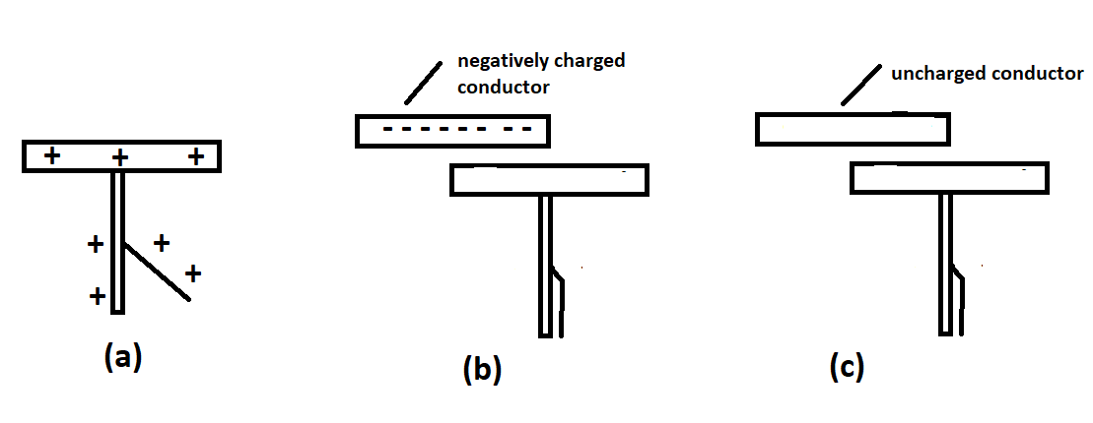

Explain the two observations (2 marks)

…………………………………………………………………………………...............................

…………………………………………………………………………………...............................

………………………………………………………………………………..................................

…………………………………………………………………………………...............................

…………………………………………………………………………………...............................

1. State the condition that can cause an electric current to accidentally flow through a path of

extremely low resistance and avoid the path of the load. (1 mark)

…………………………………………………………………………………...............................

…………………………………………………………………………………...............................

1. **Figure 2** shows an incomplete circuit that can be used to produce consequent poles for a U shaped magnet. Complete the diagram so that sides A and B are both north poles.

( 2 marks)

A

B

Figure 2

1. An incomplete ray from an object is reflected as shown in **Figure 3. Complete the ray and using one other ray, locate the position of the object. ( 3 marks)**

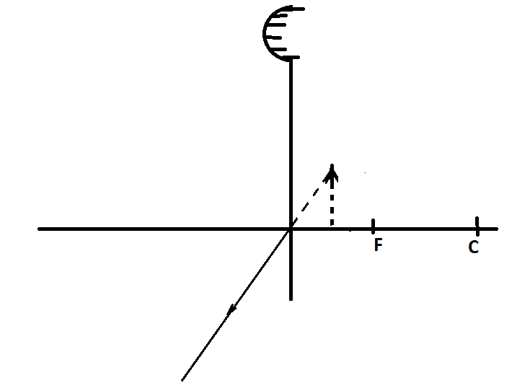

**Figure 3**

1. State the right hand grip rule for a straight conductor. ( 1mark)

…………………………………………………………………………………...................................…………………………………………………………………………………................................................................……………………………………………………………………………

1. A girl shouts and hears an echo after 0.6 seconds later from a cliff. If velocity of sound is 330m/s, calculate the distance between her and the cliff. ( 3 marks)

…………………………………………………………………………………...................................…………………………………………………………………………………................................................................……………………………………………………………………………..

1. Thediagram in **Figure 4** shows a wavemoving in a medium with a velocity of 3000m/s. Determine the wavelength of the wave. (3marks)

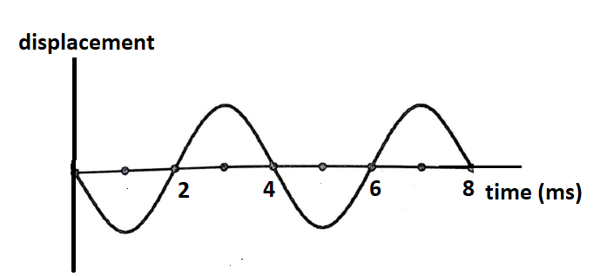

**Figure 4**

…………………………………………………………………………………...................................…………………………………………………………………………………................................................................…………………………………………………………………………………........................................……………………………………………………………………………...............

1. Figure 5 shows a potential barrier formed in a p-n junction of a semionductor.

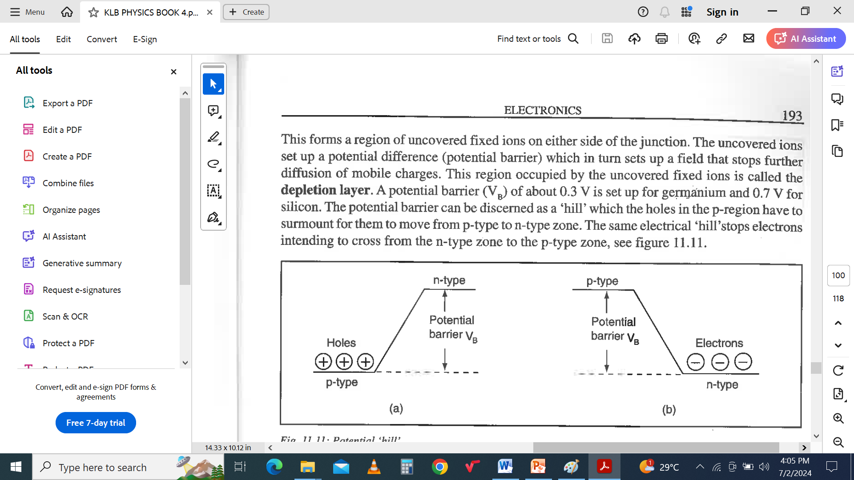

**Figure 5**

Explain how this barrier is formed. (2 narks)

……………………………………………………………………………................................................................…………………………………………………………………………………......

..........…………………………………………………………………………….............................

..........…………………………………………………………………………….............................

1. State one use of **UV** rays in hospitals. (1 mark)

……………………………………………………………………………................................................................…………………………………………………………………………………......

1. The graph in **Figure 6** shows a photocellwith the pointer of the milliametershowing a deflection..Withoutchanging the size of the aperture or source of light, state one otherway in which the deflection on the milliametercanbeincreasedfurther.

(1 mark)

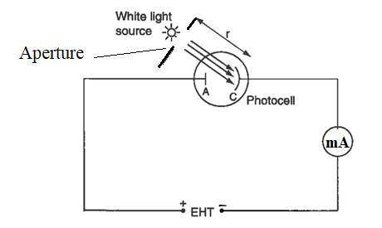

**Figure 6**

……………………………………………………………………………................................................................…………………………………………………………………………………......

1. The earth pin in a three pin plug shown in **figure 7**is usually longer so as to open the shutter for the neutral and live pins.

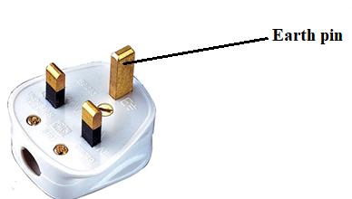

**Figure 7**

1. State one otherreasonwhy the earth pin ismade longer. (1 mark)

……………………………………………………………………………................................................................…………………………………………………………………………………......

1. An immersion heater rated 2000W is used for 10 minutes 8 times per day. What is the cost of running this heater for 30 days. The cost of electricity is kShs 22.22 per kWh.

(2 marks)

..........…………………………………………………………………………….............................

..........…………………………………………………………………………….............................

..........…………………………………………………………………………….............................

**SECTION B ( 55 MARKS)**

1. (a) State Faraday’s Law. (1 mark)

..........…………………………………………………………………………….............................

..........…………………………………………………………………………….............................

..........…………………………………………………………………………….............................

1. When the switch in **Figure 8**is closed, the galvanometer shows a reading and then returns to zero. When the switch is then opened, the galvanometer shows a reading in the opposite direction and then returns to zero.



Figure 8

1. Explain these observations. (3mks)

……………………………………………………………………………................................................................…………………………………………………………………………………..............................……………………………………………………………………………................................................................…………………………………………………………………………………..............................……………………………………………………………………………................................................................…………………………………………………

1. State why the deflection is higher when the switch is opened. ( 1 marks)

……………………………………………………………………………................................................................………………………………………………………………………………………………………………………………………………………………………………………….

1. State one other way in which the deflection in the secondary coil can be made higher.

( 1mark)

……………………………………………………………………………................................................................………………………………………………………………………………………………………………………………………………………………………………

1. A transformer has 10,000 turns on its secondary coil and 100 turns on its primary coil. An alternating current 5.0A flows in the primary circuit when it is connected to a 12V a.c supply.
2. Determine the current in the secondary if the transformer is 90% efficient.

( 4marks)

……………………………………………………………………………................................................................…………………………………………………………………………………..............................……………………………………………………………………………................................................................………………………………………

………………………………………………………………………………………………………………………………………………………………………………………………

1. State how hysteresis loss can be minimised in transformers. (1 mark)

……………………………………………………………………………................................................................…………………………………………………………………………………..............................………………………………………………………………

1. (a) Describe how the set up in Figure 9 can be used to verify Ohm’s law. (4 marks)

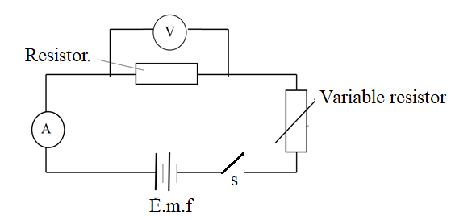

**Figure 9**

……………………………………………………………………………………………………..

......................................................................................................................................................................................................................................................................................................................

......................................................................................................................................................................................................................................................................................................................

……………………………………………………………………………………………………..

1. A cell drives a current of 1.2A through a 2.8 Ω resistor. When it is connected to 1.6Ω

resistor, the current that flows is 2.4 A. Find the E.m.f (E) for the cell and Internal resistance (r) for the cell. (3 marks)

......................................................................................................................................................................................................................................................................................................................

......................................................................................................................................................................................................................................................................................................................

.....................................................................................................................................................................................................................................................................................................................

1. The graph below shows the relationship between the reciprocal of current against resistance in a circuit containing one cell. The relationship between E.M.F, internal resistance, external resistance and current is given as**E = Ir + IR**

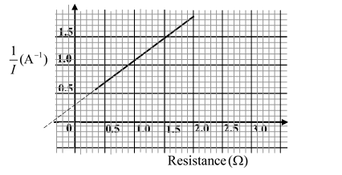

(i) Write the equation in the form of **Y = mx + C** (2mks)

.....................................................................................................................................................................................................................................................................................................................

......................................................................................................................................................................................................................................................................................................................

......................................................................................................................................................................................................................................................................................................................

(ii) Determine the E.M.F and internal resistance of the cell (4 marks)

.....................................................................................................................................................................................................................................................................................................................

...........................................................................................................................................................................................................................................................................................................................................................................................................................................................................................................................................................................................................................................

1. (a) The diagram in figure 10 shows a cathode ray oscilloscope.

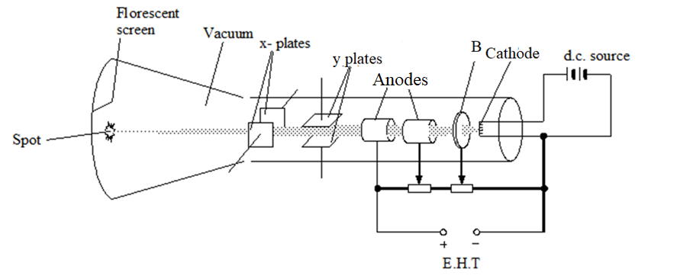

(i) Identify the part labelled B and state its function. (2 mks)

.....................................................................................................................................................................................................................................................................................................................

......................................................................................................................................................................................................................................................................................................................

(ii) Explain why the Anodes are at different potentials. (2 mks)

.....................................................................................................................................................................................................................................................................................................................

......................................................................................................................................................................................................................................................................................................................

.....................................................................................................................................................................................................................................................................................................................

…………………………………………………………………………………………………………………………………………………………………………………………………………………………………………………………………………………………………………………………………………………………………………………………………………………….

(b) A voltage varying signal applied to the X – plates of a C.R.O produces a saw tooth voltage shown in Figure 11.

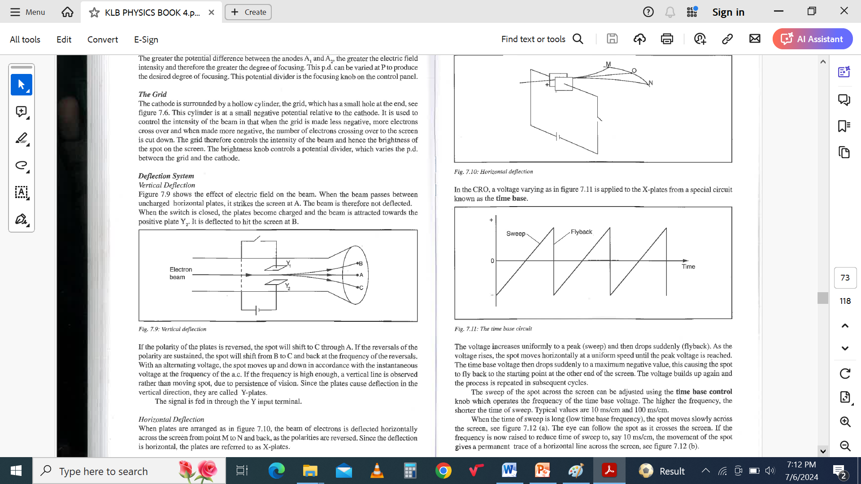

**Figure 11.**

(i) State the name of the special circuit used to produce the varying signal. (1 mark)

...........................................................................................................................................................

(ii) Explain what is observed on the screen if the time of sweep is reduced to say 10ms/cm (2mks)

.....................................................................................................................................................................................................................................................................................................................

......................................................................................................................................................................................................................................................................................................................

(c) The diagram in **figure 12** shows a simplified structure of an X-ray tube.

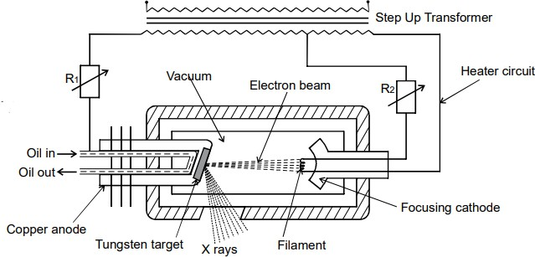

**Figure 12**

(i) State the functions of the resistors **R1** and **R2** (2 mks)

.....................................................................................................................................................................................................................................................................................................................

...........................................................................................................................................................

1. Explain why the target is made of tungsten. ( 1 mk)

..............................................................................................................................................................................................................................................................................................................

1. State the wave property of X – rays used in crystallography. (1 mark)

....................................................................................................................................................................................................................................................................................................................

1. (a) i. Define Critical angle. (1mk)

.................................................................................................................................................................................................................................................................................................................................................................................................................................................................................

1. State the two conditions necessary for total internal reflection to occur. (2 marks

.................................................................................................................................................................................................................................................................................................................................................................................................................................................................................

b) **Figure 13** shows a ray of light passing through a glass prism of refractive index 1.5. Complete the path for the ray of light. (3 marks)

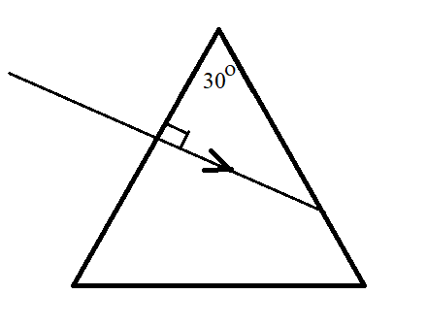

**Figure 13**

c)The diagram in **figure 14** shows a virtual image formed by a diverging lens.

(i) Using ray diagrams. Locate the position of the object. ( 3 marks)

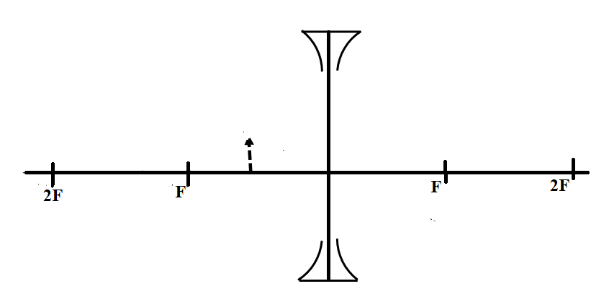

**Figure 14**

1. An object is placed 5 cm infront of a diverging lens focal length 20 cm. Calculate the

distance of the image from the lens and the magnification ( 4 marks)

...........................................................................................................................................................................................................................................................................................................................................................................................................................................................................................................................................................................................................................................

...........................................................................................................................................................................................................................................................................................................................................................................................................................................................................................................................................................................................................................................

1. a)Radium  disintegrates into a new stable element lead  as shown in the equation below.



(i) Determine the number of alpha and beta particles released. ( 3 marks)

...........................................................................................................................................................................................................................................................................................................................................................................................................................................................................................................................................................................................................................................

…………………………………………………………………………………………………….

1. The set up in **figure 15** shows an expansion cloud chamber used to detect radiation.

Explain how it works. ( 3 marks)



**Figure 15**

………………………………………………………………………………………………………………………………………………………………………………………………………….………………………………………………………………………………………………………………………………………………………………………………………………………………………………………………………………………………………………………………

………………………………………………………………………………………………………………………………………………………………………………………………………….………………………………………………………………………………………………………………………………………………………………………………………………………………………………………………………………………………………………………………

**THIS IS THE LAST PRINTED PAGE**