Name: …………………………………………………………Class .………………………….
ADM No.…………………………
Date………………………
232/2 Index number………………………………
PHYSICS
Paper 2
September 2021
Time: 2 hours

KASSU JET EXAMINATIONS – 2021
Kenya Certificate of Secondary Education
PHYSICS
Paper 2
2 hours
Instructions to Candidates

- Write your name and index number in the spaces provided above.
- Sign and write the date of examination in the spaces provided above.
- This paper consists of two sections: A and B.
- Answer ALL the questions in sections A and B in the spaces provided.
- ALL working MUST be shown clearly
- Mathematical tables and silent electronic calculators may be used.
(g) This paper consists of 11 printed pages.
(h) Candidates should check the question paper to ascertain that all the pages are printed as indicated and that no questions are missing.

For Examiner’s Use Only

SECTION | QUESTION | MAXIMUM  SCORE | CANDIDATE’S  SCORE
A | 1 – 10 | 25
B | 11 | 13
B | 12 | 12
B | 13 | 10
B | 14 | 11
B | 15 | 09
TOTAL SCORE |  | 80

SECTION A (25 MARKS)

Answer ALL the questions in this section in the spaces provided

- Distinguish between real and virtual Image (1mk)

- A pinhole camera forms an image of size 10cm. The object is 5m tall and 20m away from the pinhole. Find the length of the pinhole camera. (2mks)

- a) The figure 1 below shows a soft iron bar that’s placed in a coil near a free suspended magnet.

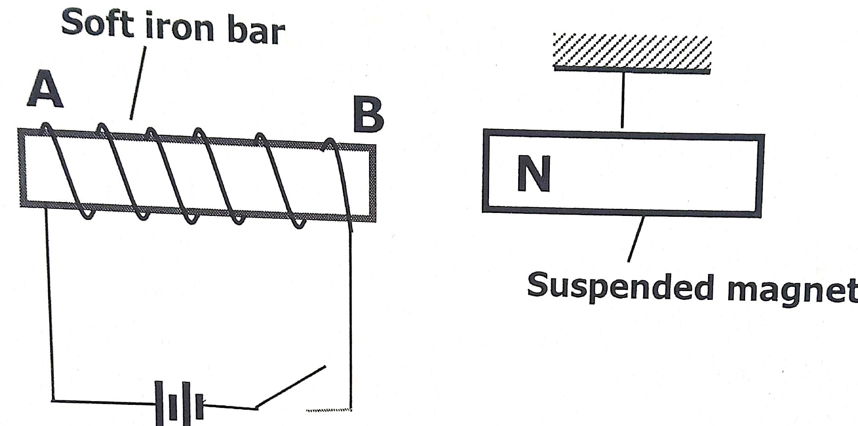

State and explain the observation made when the switch is closed. (2mks)

b.) Give a reason why attraction in magnetism is not regarded as a reliable method of testing for polarity. (1mk)

- The figure 2 below shows an isolated negative charge placed closer to a negatively charged plate. Draw the electric field patterns. (1mk)

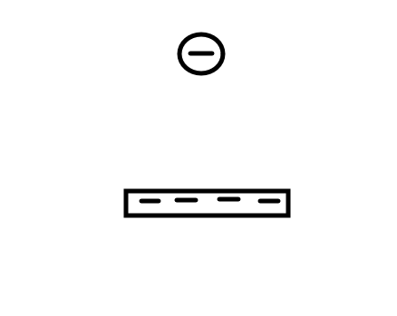

- (a)Define the term principal focus for a diverging lens. (1mk)

(b) The figure 3 below illustrates an eye defect;
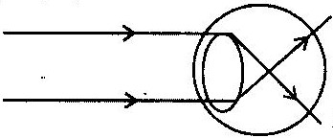

- Identify the defect. (1mk)

- On the same diagram, sketch the appropriate lens to correct the defect and sketch rays to show the effect of the lens. (2mks)
5. (a) State the effect of pressure on the speed of sound in air. (1mk)

(b) A boy stands 190m from a high wall and claps his hands. If he hears an echo1.3 Seconds later, calculate the speed of sound in air. (2mks)

6. State any two factors that determine the heating effect by an electric current. (2mks)

7. Figure 4 below shows an object, O placed 10 cm in front of a concave mirror whose radius of curvature, C is 40 cm.
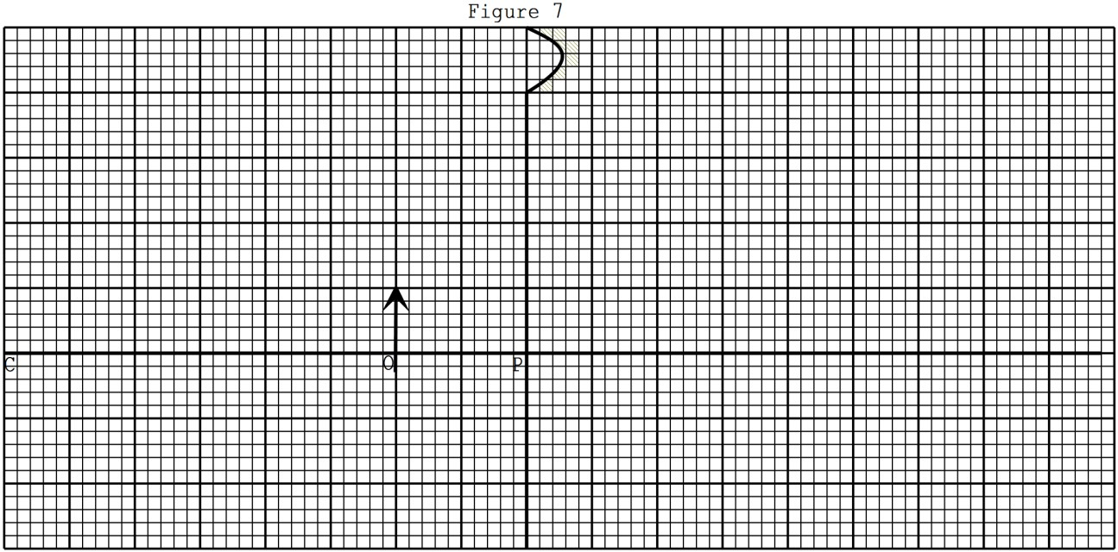
On the same figure, draw a ray diagram to show the position of the image formed. (3 mks)
8. Figure 5 shows the table of electromagnetic. Spectrum in the increasing order of wavelengths.
P | x-rays |  | Q | Infra-red
Identify the radiation marked (2mks)
P.
Q.
9. State two reasons why the earth pin is normally longer than the other two pins in a three pin plug. (2mks)

10. The figure 6 below shows a cross section of a dry cell.
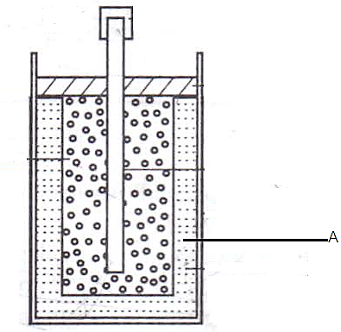Figure 6
- Name the part labeled A (1 mark)

- State the use of manganese (iv) oxide in the cell (1 mark)

SECTION II (55 marks)

11. i) In large currents, large resistors in parallel are preferred to low resistors in series. Explain (1mk)

- State one condition under which ohm’s law is obeyed in a metal conductor. (1mk)

- A circuit constituting a battery, a metal wire, an ammeter and a switch connected in a series. The switch is closed and the ammeter reading noted. The metal wire is now heated. State observation on the ammeter reading and give a reason for your answer. (2mks)

b.) In the figure 7 below, the voltmeter reads 2.4V when the switch is open. When the switch is closed, the voltmeter reads 2.1V and the ammeter reads 0.15A.
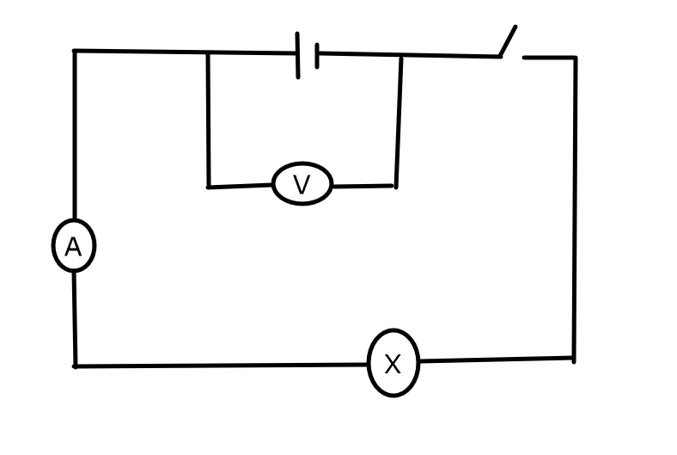
Determine the
- E.m.f of the cell (1mk)

- Internal resistance of the cell (3mks)

- Resistance of the bulb (2mks)

d.) Explain why a voltmeter of high resistance is more accurate in measuring potential difference that one of low resistance (1mk)

d.) Distinguish between electrical resistance and a resistor (1mk)

12. a) I. Define the term wavelength of a longitudinal wave (1mk)

II. The figure 8 below shows a displacement distance for a certain wave motion.

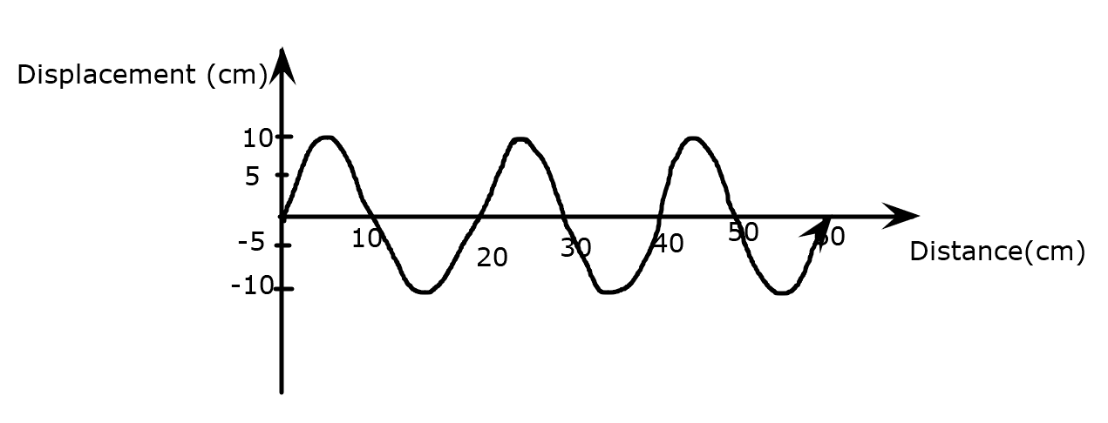

Determine
- The amplitude of the wave (1mk)

- The wavelength of the wave (1mk)

- Given that the frequency of the wave is 40Hz, determine the:
- Periodic time (T) (1mk)

- Speed of the wave (3mks)

b.) Figure 9 below shows light rays from two coherent sources S₁ and S₂ falling on screen. Dark and bright fringes are observed between A and B

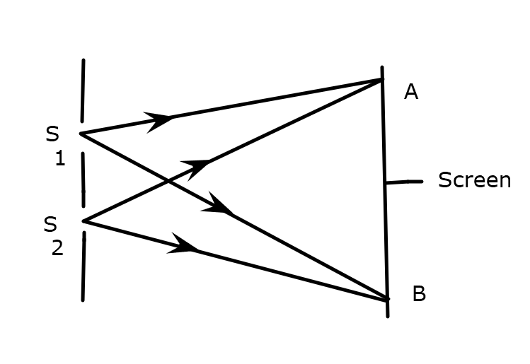

- State the function of S₁ and S₂ (1mk)

- State how
- Bright fringes are formed (1mk)

- Dark fringes are formed (1mk)

c). Figure10 below shows plane water waves incident on a plane reflector placed at an angle to the path of the waves.
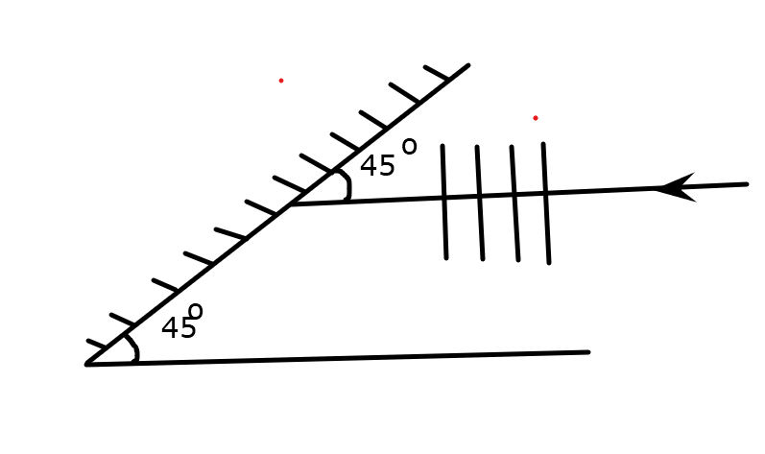

Complete the diagram to show the reflected waves (2mks)

13. State Snell’s law (1mk)

- The Figure 11 below shows a ray of light travelling incident on air-kerosene interface.
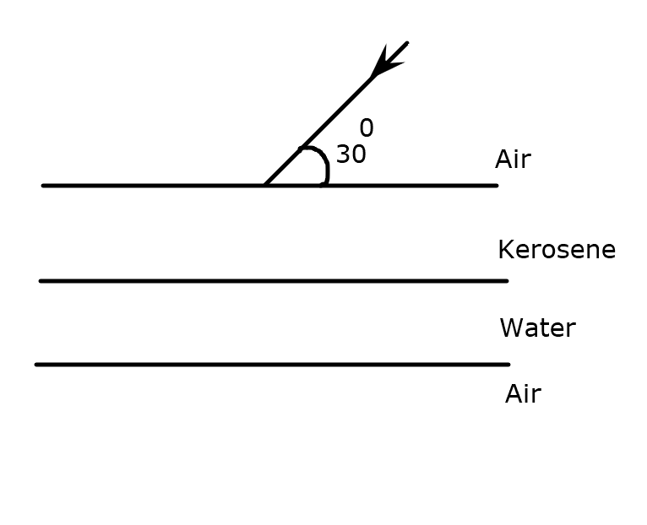
On the same diagram sketch the path of light as it traverses through the media showing the angle of refraction in air (3mks)
- If the speed of light in kerosene is 2.08 x10⁸ m/s, find the refractive of kerosene. (speed of light in air=3.0 x10⁸) (2mks)

iii.) Determine the angle of refraction in water (_{a}n_{w} =4/3) (4mks)

- The Figure 12 below shows a circuit with a battery, two switches, two capacitors and a volt meter

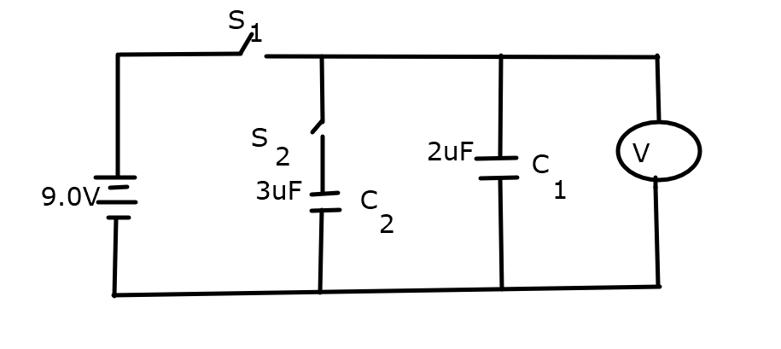

Determine
- The charge on C₁ when switch S₁ is closed S₂ open. (2mks)

ii.) The effective capacitance; C_{T} when both switches S₁ and S₂ are closed. (3mks)

(b)State and explain the expected final reading on the voltmeter when switch S₁ is closed while S₂ is open. (2mks)

(c)Determine the expected reading on the voltmeter when switch S₁ is closed for a while and opened and switch S₂ is then closed. (2mks)

(d)The Figure 13 below shows a polythene ball A and an aluminum coated polystyrene ball B.

x

x
A B

Negative charges were introduced in each of the balls at the point marked x.
Draw similar balls and for each, indicate the final distribution of the charges .
(Use 6 dots to represent the charges in each case.) (2mks)

15.(a) The figure 14 below shows parts of a simple electric motor.

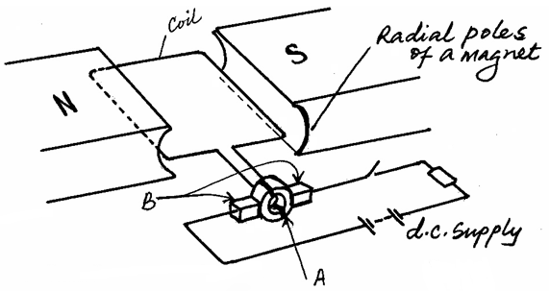
Q

P

R
S

(a)Show the direction of the forces F acting on sides QR and PS of the coil. (1mk)
(b)State the function of the devices; (2mks)
(i) A

(ii) B
(c) State two ways of increasing the rotation of the coil. (2mks)

(d) (i) State one source of energy loss in a transformer (1mk)

(ii) How can the above energy loss be minimized. (1mk)

- A transformer is used on the 240V A.C supply to deliver 9.0A at 80V to a heating coil. If 10% of the energy taken from the supply is dissipated in the transformer itself, what is the current in the primary winding? (3mks)

THIS IS THE LAST PRINTED PAGE

