Name: _________________________________________ Index No.: _____________________
Candidate’s Signature: __________
Date: __________________________
232/2
PHYSICS
Paper 1
Sep 2021
Time: 2 hours

KASSU JET EXAMINATIONS – 2021
Kenya Certificate of Secondary Education
PHYSICS
Paper 1
2 hours
Instructions to Candidates

- Write your name and index number in the spaces provided above.
- Sign and write the date of examination in the spaces provided above.
- This paper consists of two sections: A and B.
- Answer ALL the questions in sections A and B in the spaces provided.
- ALL working MUST be shown clearly
- Mathematical tables and silent electronic calculators may be used.
(g) This paper consists of 11 printed pages.
(h) Candidates should check the question paper to ascertain that all the pages are printed as indicated and that no questions are missing.

For Examiner’s Use Only

SECTION | QUESTION | MAXIMUM  SCORE | CANDIDATE’S  SCORE
A | 1 – 12 | 25
B | 13 | 10
B | 14 | 12
B | 15 | 13
B | 16 | 9
B | 17 | 11
TOTAL SCORE |  | 80 | © 2021 KASSU JET EXAMS  PHYSICS (Paper 1)

Answer ALL the questions in this section in the spaces provided

SECTION A (25 MARKS)

1.Thermodynamics is one of the branches of physics. What does it entail? (1mk)

2.(a) What is the reading in the following; (1mk)

0 45

40

(b) If the reading above was the diameter of a spherical ball; find it’s volume. (2mks)

3.State two factors which affect the spring constant. (2mks)

4.State the relationship between mass and weight. (1mk)

5.(a)State how the pressure in a moving fluid varies with speed of the fluid. (1 mk)

(b)Water flows along a horizontal pipe of cross sectional area 60 cm² which has a constriction of cross sectional area 24 cm² at one place. If the speed of water at the constriction is 5 m/s, calculate the speed in the wider section. (2 mks)

6.Explain why brakes fail in a hydraulic braking system when air gets into the system. (2mks)
7.(i) State the principle of moments ( 1mk)

(ii)The figure below shows a non-uniform log of mass 1000g balanced on the pivot by a 20N weight as shown.
20N
35cm

pivot

Determine the position of the centre of gravity from the pivot ( 2mks).

8.It is observed that a drop of milk carefully put into a cup of water turns the water white after sometime. Explain this observation (1mk)

9.A bullet hits a stationary block at the edge of a cliff 100m high and moves with a common velocity of 200 m/s. Determine the maximum horizontal distance covered. (take g=10 m/s²) (3 marks)

10. The figure below shows a beam balance made out of concrete and reinforced with steel
Concrete
Steel

Use a diagram to explain the behaviour of the shape of the beam when heated up (2mks)

11. When a Bunsen burner is lit below a wire gauze, it is observed that the flame initially burns below the gauze shown in figure (i). After sometime, the flame burns below as well as above the gauze as shown in figure (ii).
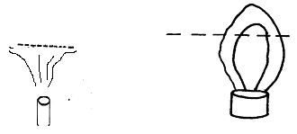
Gauze
(i)
(ii)

State the reason for this observation. (1 mk)

12. a) State Newton’s 2nd Law of Motion (1mk)

b) A car of mass 1200kg moving at 90km/h is brought to rest over a distance of 20m. Calculate the braking force . (3mks)

SECTION II( 55mks)
Attempt ALL the questions in this section in the spaces provided.
13. (a) State Archimedes Principle. (1mk)

(b)The figure below shows a rectangular block of height 10cm floating vertically in a beaker containing two immiscible liquids A and B. The densities of the liquids are 0.8g/cm³ and 1.2g/cm³ respectively. The block is of dimensions 2cm by 3cm 10cm.
Liquid A Block

4cm

5cm
3cm
2cm
2cm
3cm

Liquid B
Determine;
(i)the weight of liquid A displaced by the block. (2mks)

(ii)weight of liquid B displaced by the block. (2mks)

(iii)mass of the block. (2mks)

(c) A hydrometer is one of the applications of Archimedes Principle and relative density. State the functions of the following parts of a hydrometer;
(i) wide bulb (1mk)

(ii) lead shots (1mk)

(d) Sketch a graph of depth of immersion of a hydrometer against the density of a fluid. (1mk)

Height (cm)

Density (g/cm³)

14. (a)Explain what you understand by each of the following;
(i)Angular velocity (1mk)

(ii) Centripetal force. (1mk)

(b) A car is moving in an unbanked circular path. State what provides the centripetal force. (1mk)

(c) A bicycle wheel with radius 0.30m moves with a linear velocity of 9m/s. Determine;
(i) the angular velocity of the wheel. (3mks)

(ii) the centripetal acceleration at a point on the rim of the wheel. (3mks)

(d) A marble of mass 50g attached to a light string of length 0.8m is rotated in a
vertical plane.The string cannot bear a load more than 2.5 Determine the velocity at
which the string would break. (3mks)

15 (a)The Figure below shows a set up that can be used in an experiment to determine the speciﬁc heat capacity of a solid of mass m by electrical method.
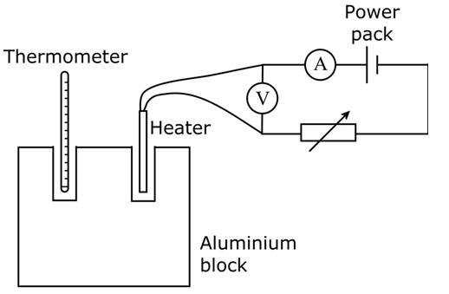
(i)Why are the two holes for the heater and thermometer filled with light oil? (1mk)

(ii)State the measurements that should be taken from the above setup. (2 mks)

(iii)If the change in temperature of the block was recorded as 𝜭. Write an expression that can be used to determine the speciﬁc heat capacity of the solid. (1 mk)

(iv) From the above expression, state the assumption made. (1mk)

(b) The graph below shows a cooling curve for 50g of Naphthalene which was heated until it melted into a liquid then allowed to cool.
Temperature (⁰C)
6

40

60

100

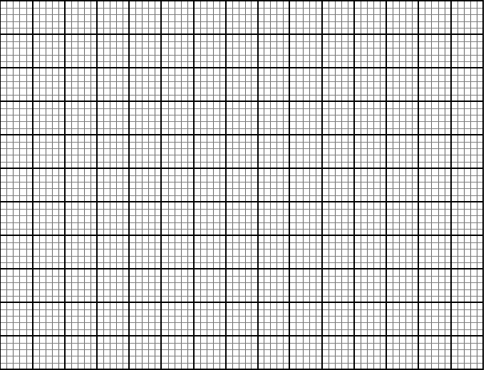

Time (minutes)
C

B

A

D

E

2

4

8

10

12

0

20

80

Explain the shape of the graph between the points:
(i)AB. (1mk)

(ii)BC. (1mk)
(iii)Given that the specific latent heat of fusion for Naphthalene is 19097.3J/kg. Calculate the heat evolved between the region BC of the 50g of Naphthalene. (3mks).

(iv) How much heat energy would be released by the 50g.of Naphthalene in
region CD, if the specific heat capacity of Naphthalene is 1720J/kgK. (2mks)

16.(a)A gas has a volume of 20cm³ at 27⁰C and normal atmospheric pressure. Calculate the new volume of the gas if it is heated to 54⁰C at the same pressure. (3mks)

(b)The figure below shows a set up that may be used to verify one of the gas laws.

(i) State the law being investigated (1 mark)

(ii) State the measurements that may be taken in the experiment. (2 marks)

(iii) Explain how the measurement in (i) above may be used to verify the above law (4 marks)

17. the figure below shows a windlass. An effort is applied on the handle which is turned on a radius of 60 cm. As the handle turns, a rope is wound around the drum of diameter 24 cm, thus raising a bucket of water out of the well
Handle
24cm
60cm

a) If an effort of 20N is needed to lift a bucket full of water of mass 8kg, Calculate:
(i) the energy gained by the mass when the drum turns through one revolution (3mks)

(ii) The work done by the effort during this revolution. (3mks)

b) Suggest a reason why the two quantities in a(i) and (ii) are not equal (1mk)

c) Calculate:
(i) the velocity ratio of the machine (2mks)

(ii) the efficiency of the windlass (2mks)

THIS IS THE LAST PRINTED PAGE

