232/1 - | PHYSICS | - Paper 1
 | MARKING SCHEME

CONFIDENTIAL

SECTION A (25 MARKS)

1. The figure below shows a micrometer screw gauge used by a student to measure the thickness of a wire. If it has a zero error of -0.08mm, determine the actual thickness of the wire. (2 marks)
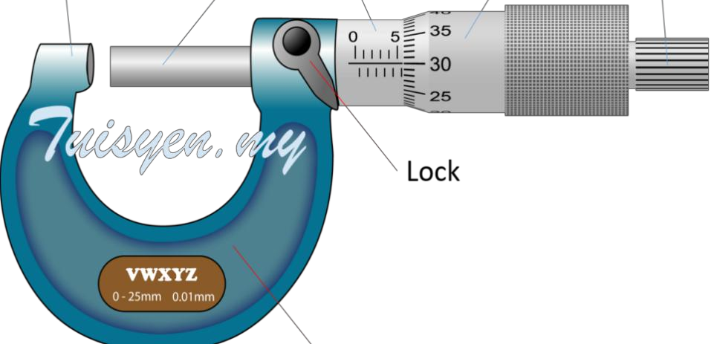

Sleeve scale reading = 5.50mm

30 x 0.01mm = 0.30mm
Thimble | scale | reading | =

Micrometer screw gauge reading = 5.50mm + 0.30mm = 5.80mm √1

Actual thickness of the wire = 5.80mm + 0.08mm = 5.88mm√1

2. In an experiment to demonstrate Brownian motion, smoke was placed in a smoke cell and observed under a microscope. State and explain the observation. (2marks) Bright specks are seen to be moving in random motion√1.Thebrightspecksaresmokeparticles

whicharebombardedbytheinvisibleairmoleculeswhichareincontinuousstateofrandommotion.

√1

3. The diagrams below show two glass tubes of different diameters dipped in water.

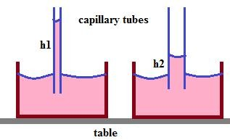
Explain why h2 is less than h1. (1mark)

Since tube 2 is wider, the adhesive force between water molecules and the glass tube 2 is weaker/lower compared to the adhesive force between water molecules and glass tube 1 hence h2 is less than h1. √1

4. State a reason why a burn from steam at 1000C is more severe than a burn from boiling water at the same temperature (1 mark)
Steam at 1000C has more energy because it has latent heat of vaporization as opposed to water at 1000C

which does not poses latent heat of vaporization√1

5. The figure below shows the instrument used to measure pressure

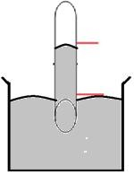
X

Mercury

a) Name the instrument (1 mark)
Mercury barometer √1

b) What would be observed if the test tube is tilted assuming the instrument is functioning normally? (1 mark)

fill the tube √1
X | will | increase/ | Mercury | will

6. The rate of heat flow in thermal conductivity increases with increase in cross-section area.
Explain this observation. (1mark)
…..… The conducting number of electrons or atoms per unit length of the thicker conductor is more

than | thinner | conductor. | √1

7. A mass of 100g is hung at the 10cm mark and a 50g mass at the 70cm mark of a uniform metre rule balanced at the 40cm marks. Determine the weight of the rule. (3 marks)

Sum of clockwise moments = Sum of anticlockwise moments √1
0.3m x 1N = 0.1m x W + 0.3m x 0.5N √1
0.3Nm = 0.15Nm + 0.1W
0.15Nm = 0.1W
W = 1.5N √1

8. An object dropped from a height h attains a velocity of 6m/s just before hitting the ground, find the value of h. (2 marks)
mgh = ½ mv2 √1
gh = ½ v2
10 x h = ½ x 6 x 6 h = 1.8m. √1
Alternative
u = 0m/s, a = g = 10m/s2, v2 = u2 + 2as √1
v | = | 6m/s, | S | = | h

62 = 02 + 2 x10 x h
36 = 0 + 20h
36 = 20h
h = 1.8m √1

9. The springs shown in the arrangement in figure 4 below are identical.

180N
90N

Given that the 180N weight causes a total extension of 30cm, determine the spring constant of each
spring. (The weight of each spring is negligible.) (3 marks)

F=Ke √1
eT = e1+e2

0.30 = 180/3k + 180/2k√1

K = 500N/m√1

10. The radius of the effort piston of a hydraulic lift is 1.4cm while that of the load piston is 7.0cm.
This machine is used to raise a load of 120kg at a constant velocity through a height of 2.5m given that the machine is 80% efficient, calculate the effort needed. (3 marks)
V.R = R2/r2
= 7.02/1.42 √1
= 25
Ƞ = M.A/V.R x 100
80 = M.A/25 X 100
M.A = 20 √1
M.A = Load/Effort
20 = 1200N/Effort
Effort = 60N √1
11. State the branch of physics that deal with kinetic energy of matter. (1 mark)

Thermodynamics. √1

12. The water in a burette is 30.6cm3, 50 drops of water each of volume V are added to the water in the burette. The final reading of the burette was 20.6cm3. Calculate the radius of the drop of water. (2 marks)
30.6 – 20.6 = 10cm3 √1
Volume of drop of water = 10/ 50 = 0.2cm2 √1
Volume of sphere = 4/3 πr3
0.2 cm3 = 4/3 πr3
r= 0.3627cm √1

13. State two factors that affect the stability of an object (2 marks)
• Position of centre of gravity of the object

• Area of the base of the object

SECTION B: (55 MARKS)

14. a) State Newton’s second law of motion. (1 mark)
The rate of change of momentum of a body is directly proportional to the resultant external force producing the change and takes place in the direction of the force. √1

b) Use the law above to derive the relation F = Ma. (3 marks)
From Newton’s second law of motion,
F α m(v-u)/t √1
But (v-u)/t = a
F α ma
F = kma √1
From definition, k = 1
Therefore, F = ma √1
c) Distinguish between elastic and inelastic collisions. (1 mark)
Elastic collision is a collision where both kinetic energy and linear momentum are conserved while inelastic collision is a collision where only linear momentum is conserved but kinetic energy is not √1
d) A car of mass 1500kg is brought to rest from a velocity of 40ms-1 by a constant force of
2400N.Determine the change in momentum produced by the force and the time it takes the car to come to rest. (3 marks)
Change in momentum, Δρ = mv – mu
= 1500kg x 0m/s – 1500kg x 40m/s √1
= 0 – 60,000kgm/s
= - 60,000kgm/s √1
Ft = mv – mu
-2400N x t = - 60,000
t = 25 seconds. √1

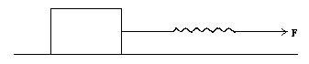
e) The diagram below shows a rectangular block of wood resting on a horizontal flat surface. It is pulled by force, F as shown in the diagram.

The spring reading are plotted against time and represented in the graph below.

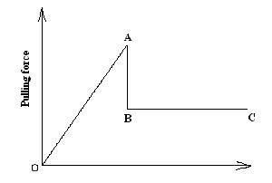
Explain what is happening in the sections.

i) OA (1 mark)
The block is stationary/ at rest √1
ii) AB (1 mark)
The block begins to move/ slide √1
iii) BC (1 mark)
The block moves/ slides at constant velocity √1

15. a) An astronaut in orbit round the earth may feel weightless even when the earth’s gravitational field still acts on him. Explain (2 marks)
Gravitational force of attraction between the Astronaut and earth provides centripetal force. √1 For the astronaut to move round orbit then gravitational force must be equal to centripetal force. √1

b) Distinguish between angular velocity and linear velocity (1 mark)

Angular velocity is the rate of change of angular displacement while linear velocity is the rate of displacement. √1

c) a stone is whirled with uniform speed in a horizontal circle of radius 15 cm. it takes the stone 10 seconds to describe an arc of length 4cm. calculate
i) Angular velocity (3 marks)
ώ = Δϴ/ Δt √1
= (4cm/15cm)/ 10s = 0.2667/10 √1
= 0.02667rad/s √1

ii) Linear velocity of the stone (2 marks)

v =r ώ√1
= 0.15 X 0.02667
= 0.004 m/s√1
Alternative working

Δv = ΔS/Δt√1

= 4cm/10s = 0.04m/10s

= 0.004m/s√1

iii) Periodic time (2 marks)

T = 2π/ ώ √1
= 2π/0.02667
= 235.59 s √1

16. a) State the Bernoulli’s principle of fluids. (1 mark)
In a streamline flow of a non- viscous and incompressible fluid, the sum of its static pressure, kinetic energy per unit volume and potential energy per unit volume is constant. √1

b) In derivation of equation of continuity in fluids, state three assumptions to be made. (3marks)

i. the fluid flows steadily√1
ii. incompressible√1
iii. Non- viscous √1

c) The figure below shows cross-section of two submerged bodies P and Q in an ocean. The
bodies were then pulled by a ship in the direction shown.


P Q

i) State with a reason, which body is easier to pull if they have equal volume and density
(2 marks)
P –√1

It is more streamlined/ Requires less effort √1

ii) On the same diagram, show the path followed by each body and their streamlines
(2 marks)
c) Water flows steadily in a pipe as shown in the figure below. The diameter of A and B are 3cm and 5cm. If the volume flux at A is 45cm3/s. find the speed of water at B. (3 marks)

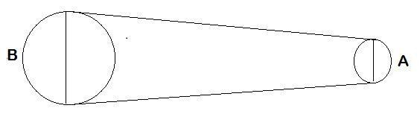

A1V1= A2V2 √1

) = (52
Velocity | at | B | (V2

X45)/32 √1

= 125cm3/s √1

17. a) State the law of floatation (1 mark)
A floating body displaces its own weight on the fluid in which it floats√1

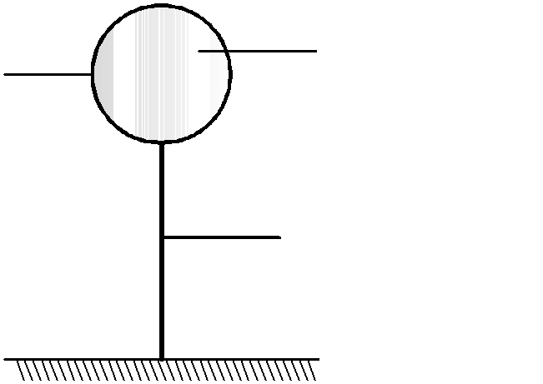
b) The diagram below shows a hot air balloon tethered to the ground on a calm day. The balloon contains 1300m3 of hot air of density 0.82 kg/m3. The mass of the material making the balloon without hot air is 420kg. The density of the surrounding air is 1.35 kg/m3. Determine

Balloon

Hot air
Hydrogen gas

String

i) The total weight of hot air balloon (3 marks)
W= 1300 X 0.82 X 10 + 420 X 10 √1

= 10660 + 4200 √1
= 14860N √1

ii) The weight of air displaced by the balloon (2 marks)
W = pVg √1
= 1.35 X1300 X10
= 17550N √1

iii) Upthrust force on the balloon (1 mark)
Upthrust = weight of air displaced
= 17550N √1

iv) the tension in the rope holding the balloon in the ground. (2 marks)
T = U – W √1
= 17550 – 14860
= 2690N √1

v) the acceleration with which the balloon begins to raise when released. (3 marks)

F = Ma √1
2690 = 1486 kg X a √1 a = 1.8102 m/s2√1

18. a) Define the term specific latent heat of fusion of a substance. (1 mark)
This is the amount of heat required to change a unit mass of a substance from solid to liquid without change in temperature √1

b) In an experiment to determine the specific latent of heat of vaporization of water, the following results were obtained.
- Mass of calorimeter = 250g

- Mass of calorimeter + water = 750g

- Mass of ice at 00C in the calorimeter = 20g

- Final temperature when dry steam is passed over the calorimeter = 250C

- Mass of condensed steam = 25g

Given that the latent heat of fusion of water is 3.36x105 JKg-1, the specific heat capacity of copper is 400Jkg -1 k-1 and specific heat capacity of water is 4200JKg-1K-1. Determine the heat gained by;
i) Ice (2 marks)

heat gained by ice = mLf

= 0.02 x 3.36 x 105 √1

= 6720J √1

ii) Water (2 marks)

heat gained by water = mcΔѲ

= 0.52 x 4200 x 25 √1

= 54,600J √1

iii) Calorimeter (2 marks)

heat | gained | by | calorimeter | = | mcΔѲ

= 0.25 x 400 x 25 √1

= 2500J √1

c) If LV is the specific latent heat of vaporization of water, use an appropriate equation to find

LV. (4mks)
Heat lost = Heat gained √1

mLf + mcΔѲ = 6720 + 54600 + 2500 √1

0.025Lf + 0.025 x 4200 x 75 = 63820 √1

0.025Lf = 63820 – 7875

0.025Lf = 55945

Lf | = | 2237800J/kg | √1

