NAME: ………………………………………………………. INDEX NO: …...…………………………….
CANDIDATE’S SIGNATURE: ……………………
DATE: ……………………………..
232/3
PHYSICS
PAPER 3
(PRACTICAL)
2 ½ HOURS

CHUGU BOYS SECONDARY SCHOOL
Kenya certificate of secondary education (K.C.S.E)
INSTRUCTIONS TO CANDIDATES
- Write your name and index number in the spaces provided above.
- Answer ALL the questions in the spaces provided in the question paper.
- You are supposed to spend the first 15 minutes of the 2 ½ hours allowed for this paper reading the whole paper carefully before commencing your work.
- Marks are given for a clear record of the observations actually made, for their suitability and accuracy and the use made of them.
- Candidates are advised to record their observations as soon as they are made.
- Mathematical table and electronic calculators may be used.

For Examiners Use Only

Question 1 | b | f | g(i) | g(ii) | h | Part B
 |  |  |  |  |  | I - IV
Maximum Score | 1 | 5 | 5 | 3 | 2 | 4
Candidate’s Score

Question 2 | a(i) | (ii) | (iii) | (iv) | (v)
Maximum Score | 1 | 8 | 5 | 3 | 3
Candidate’s Score

Total

This paper consists of 7 printed pages. Candidates should check the question paper to ensure that all pages are printed as indicated and no questions are missing.

- You are provided with the following:
- A lens and a lens holder labelled L₁.
- A candle.
- A graph paper 1mm mounted on a screen.
- A metre rule.
- Object consisting of a circular hole and parallel wires in a stiff card.
Proceed as follows.
- Arrange the object, lens and screen in line as shown in figure 1 below
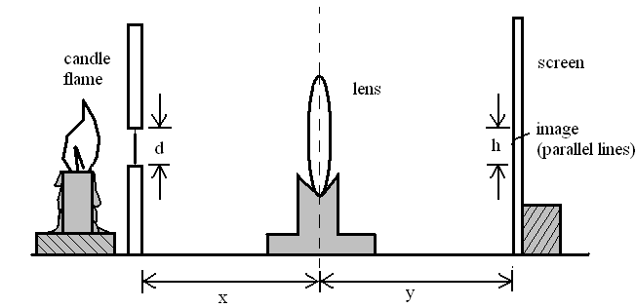
Object illuminated parallel wires
Figure 1
- Measure the distance, d, between the two parallel wires that acts as the object.
d = ………………………………… (1 Mark)
- Adjust the lens, u to 50cm.
- Move the screen until a clear image is formed on it.
- Measure the distance, h, of the image, making sure that what you measure is an image corresponding to the previous reading, d. Record this value in the table below.
- Repeat (iii) above for values of x = 25, 35, 40 and 50cm. and tabulate your result.
Table 2
$$x(\text{cm})$$ | 50 | 40 | 35 | 30 | 25 | 20
y(cm)
h(cm)
M =$hd$
- Marks)

- (i) On the grid provided plot a graph of M (y – axis) against y. (5 Marks)
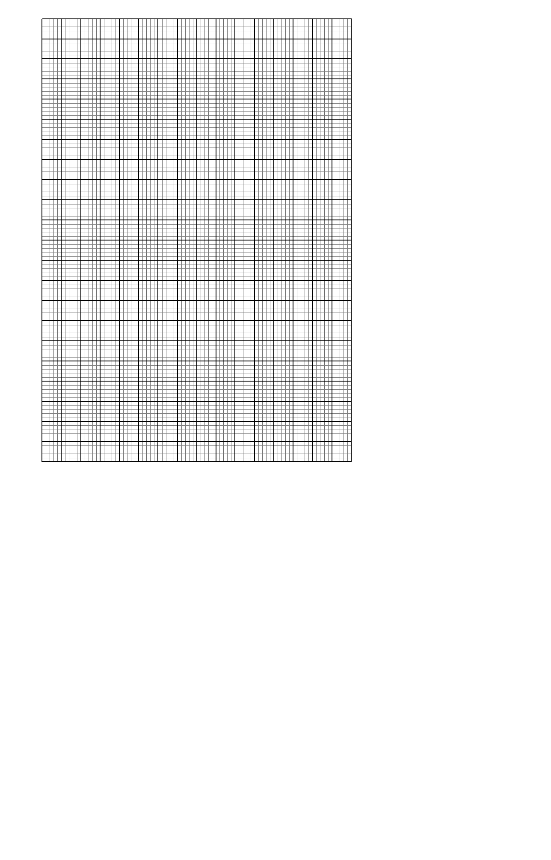
(ii) Determine the slope, s, of the graph. (3 Marks)
………………………………………………………………………………………………………………………………………………………………………………………………………………………………………………………………………………………………………………………………………………………………………………………………………………………………………..

- The equation of the graph is given as $M = \frac{v}{p} − 1$where p is a constant use the slope s of the graph to determine p. (2 Marks)
………………………………………………………………………………………………………………………………………………………………………………………………………………………………………………………………………………………………………………………………
PART B
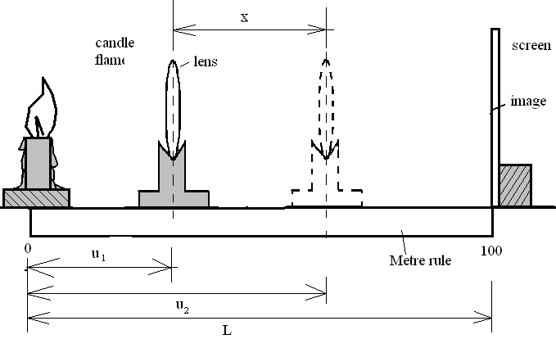
Figure 2
Proceed as follows:
- Set up the apparatus as shown in figure 2 above. (Ensure that the candle and the lens are in the line).
- With the candle placed a distance $L=\text{100}\text{cm}$ from the screen, determine the position of a sharply focused magnified image of the candle on the screen by moving the lens.
- Determine the distance of the lens to the candle u₁ =…………………….. cm (1 Mark)

- Now move the lens towards the screen until you get a sharply focused diminished image. Determine the new distance of the lens from the candle, u₂.
u₂ = ………………………………..cm (1 Mark)

- Calculate the displacement of the lens $x = u_{2} − u_{1} = \text{.}\text{.}\text{.}\text{.}\text{.}\text{.}\text{.}\text{.}\text{.}\text{.}\text{.}\text{.}\text{.}\text{.}\text{.}\text{.}\text{.}\text{.}\text{.}\text{.}\text{.}\text{cm}$ (1 Mark)

- Given that$f = \frac{L^{2} − x^{2}}{4L}$, Calculate the value of, f. (1 Mark)
- You are provided with the following apparatus.
- 2 new dry cells size D.
- A cell holder.
- 8 connecting wire at least two with crocodile clips.
- A resistance wire PR 1m long mounted on a metre rule.
- An ammeter (0-1A).
- A voltmeter (0 -3v).
- Lamp R.
- Switch S.
- A micrometer screw gauge (to be shared).
Proceed as follow:-
Connect the circuit as in figure 2 below;
PR is the resistance wire.
S
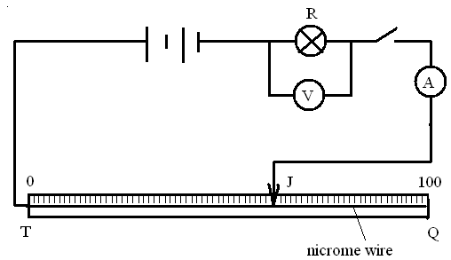
Fig. 3
- With the jockey J at Q (Y= 100 cm from T) record the ammeter and voltmeter readings.
V =……………………… I =…………………… (1 Mark)
- Repeat (a) (i) for other values of l and records the ammeter and voltmeter readings in the table below.
Table 2
Y(cm) | 80 | 60 | 40 | 20 | 0
Ammeter reading I (A)
Voltmeter reading V (v)
$R = \frac{V}{I}$$\left(Ω\right)$
(8 Marks)
- Plot a graph of R against Y. (5Marks)
- From your graph, find the slope s at Y = 40 cm. (3 Marks)

(v) Using a micrometer screw gauge, measure the diameter D of the wire. (1 Mark)
D = …………………………………m
Calculate the quantity,
p = 0.5 $\left(\frac{D^{2}}{s}\right)$ at Y=40cm. (2 Marks)

