Term 2 - 2022
PHYSICS (232/1)
FORM FOUR (4)
Time: 2 Hours
Name: …………………………………………………………. Adm No: ………………. School: ……………………………………………………….. Class: ………………….. Signature: …………………………………………………….. Date: …………………...
Instructions to candidates
- This paper consists of two sections A and B.
- Answer all the questions in the two sections in the spaces provided after each question
- All working must be clearly shown.
- Electronic calculators, mathematical tables may be used.
- All numerical answers should be expressed in the decimal notations.
- You may use ‘g’ as 10m/s²
For Examiner use only
SECTION | QUESTION | MAX MARKS | CANDIDATE’S SCORE
A | 1 – 13 | 25
B | 14 | 13
B | 15 | 13
B | 16 | 14
B | 17 | 07
B | 18 | 08
 | TOTAL | 80
This paper consists of 10 printed pages. Candidates should check to ascertain that all pages are printed as indicated and that no questions are missing.
SECTION A (25 MARKS)
1. Figure 1, shows a Vernier caliper of zero error 0.02 cm being used for measuring the diameter of a cylindrical container of height 10 cm. The scale reading of the Vernier is as shown alongside.
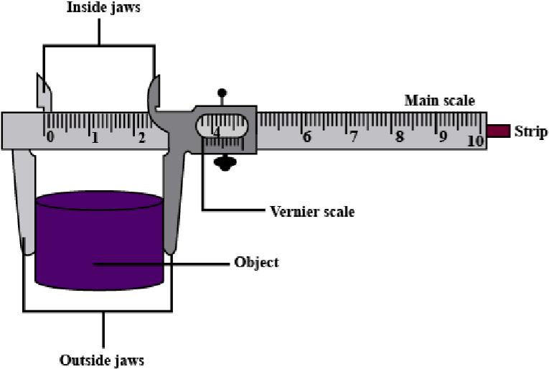
Figure
1

0

5
10

4

cm
 | a. Determine the diameter of the container | (2 marks)
 | b. Estimate the volume of a liquid which can completely fill the container | (2 marks)
2. | State one factor that affects the turning effect of a force on a body. | (1 mark)
- Figure 2 shows some air trapped by mercury in a glass tube. The tube is inverted in a dish containing mercury.
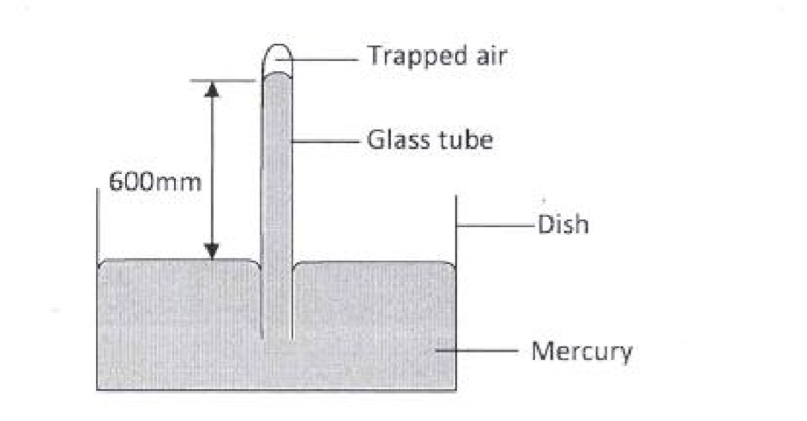
Figure 2
Given that the atmospheric pressure is 760 mmHg and the height of mercury column in the tube is 600 mm, determine the pressure of the air trapped in the tube in mmHg. (2 marks)
- Figure 3 shows drops of mercury and water on a glass surface, Explain the difference in the shapes of the drops. (2 marks )

Mercury

water

Glass surface

Figure 3
- A ball is thrown from the top of a cliff 20m high with a horizontal velocity of 10ms⁻¹. Calculate the distance from the foot of the cliff to where the ball strikes the ground. (3 marks )
- Explain one advantage of mercury over alcohol as a thermometric liquid. (1mark)
- A body of mass M is allowed to slide down an inclined plane. State two factors that affect its final velocity at the bottom of the inclined plane. (2 marks )
- A stopwatch reads 08:10:84 and 09:10: 90 before and after an experiment respectively. Determine the duration of the event in SI units. (2 marks )
9. Explain the meaning of thermodynamics as a branch of physics.  10. | (1 mark)
a. State the Hooke’s Law. | (1mark)
b. Figure 4 shows identical spiral springs supporting a load of 90N. Each spring has a spring constant
k = 200N/m
90
N
springs
Figure
4

Determine the total extension of the system (take the weight of the cross bars and springs to be negligible) (2 marks)




- Figure 5 shows a rectangular loop with a thin thread loosely tied and dipped into a soap solution.
A

B

thread

Figure
5

Draw on the space provided what is obse rved when point A is
punctured. (1mark)
- Two horizontal strings are attached to a block, resting on a frictionless surface, as shown in figure 6.

F

100
N

support

Figure 6
A force of 100N pulls on one string. The block does not move. Find the value of the force, F on the
other string. (1 mark)
- A wooden bench feels neither warm nor cold when touched by your bare hands. Explain this
observation. (2 marks)

SECTION B (55 MARKS)
14.
  - Explain why bodies in circular motion undergo acceleration even when their speed is constant. (1mark)
  - A particle moving along a circular path of radius 5cm describes an arc of length 2cm every second. Determine:
  - Its angular velocity. (1mark)
  - Its periodic time. (2marks)
  - A stone of mass 150g is tied to the end of a string 80cm long and whirled in a vertical circle at
2rev/s. Determine the maximum tension in the string. (3 marks )
d) | State one factor affecting centripetal force | (1mark)
e) | State the principle of conservation of linear momentum | (1 mark)
f) A bullet of mass 60g is fired horizontally with a velocity of 200 m/s into a suspended stationary wooden block of mass 2940g. Determine:
i. Common velocity of both the bullet and the block, if the bullet embedded into the block.
(2 marks)
ii.  15. | Height to which the block rises. | (2 marks)
a) State two factors that affect the boiling point of a liquid |  | (2 marks)
b) 100g of a liquid at a temperature of 10⁰ C is poured into a well lagged calorimeter. An electric heater rated 50W is used to heat the liquid. The graph in figure 7 shows the variation of the temperature of the liquid with time.
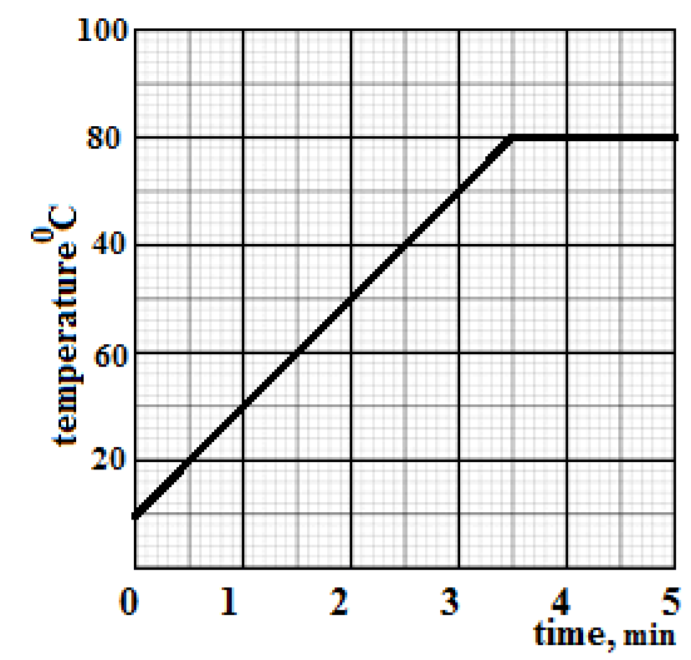
Figure 7
  - From the graph, determine the boiling point of the liquid (1 mark)
  - Determine the heat given out the by the heater between the times t = 0.5 minutes and t = 5.0 minutes (3 marks)
  - From the graph determine the temperature change between the times t = 0.5 minutes and t = 5.0 minutes, hence determine the specific heat capacity of the liquid (3 marks )
  - 1.8 g of vapor was collected from above the liquid between the times t= 3.5 minutes and t= 4.5 minutes. Determine the specific latent heat of vaporization of the liquid (4 marks )
16.
  - State the law of floatation (1 mark)
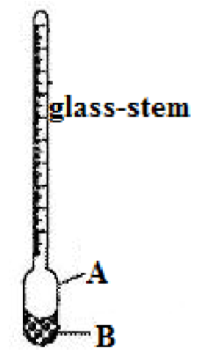
  - Figure 8 below shows a simple hydrometer
    - ……………………………………………….....
    - ……………………………………………………
Figure 8
 | i. Identify the parts labelled A and B | (2 marks)
 | ii. State the purpose of the part labelled B | (1 mark)
c) | How would the hydrometer be made more sensitive? | (1 mark)
d) | Describe how the hydrometer is calibrated to measure relative density | (3 marks)
e) Figure 9 shows a cork floating on water and held to the bottom of the beaker by a thin thread.
  - Name the forces acting on the cork (3 marks)
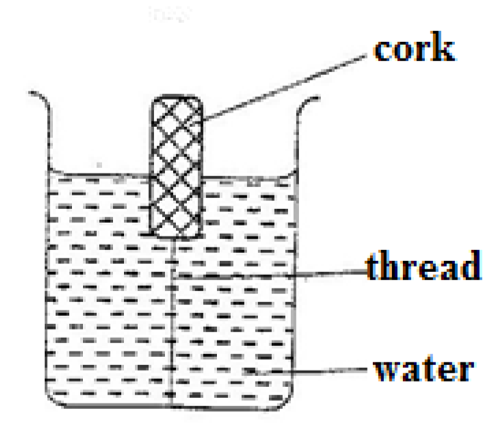
Figure 9
  - Describe how each of the forces mentioned in (i) above changes when water is added until the container is completely filled (3 marks )
17.
- Figure 10 shows a graph of pressure against volume for a fixed mass of a gas at constant

temperature.
Figure
10

P
ressure
, p

V
olume
, v

In the space provided, sketch a graph of pressure, p against (1 mark)
- Explain the pressure law using the kinetic theory of matter (3 marks)
- 20cm³ of a gas exerts a pressure of 760mmHg at 25⁰C. Determine the temperature of the gas when the pressure increases to 900mmHg and the volume decreases to 15 cm³. (3 marks )
18.
- Define the term velocity ratio of a machine (1 mark)
- The figure 11, below shows part of the hydraulic lift system. State any one property of the liquid under which the hydraulic system works (1 mark)
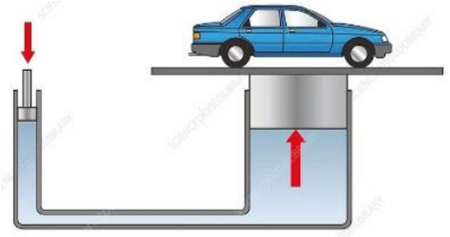
Figure 11
- The hydraulic lift machine above has velocity ratio 45 and it overcomes a load of 4500 N when an effort of 135 N is applied. Determine:
i. | The mechanical advantage of the machine | (2 marks)
ii. | Efficiency of the machine | (3 marks)
iii. | The percentage of work that goes to waste | (1 mark)
This is the last printed page

