**MARKING SCHEME**

**232**

**PHYSICS(THEORY)**

**END TERM 1 2025**

**PHYSICS FORM 2**

**SECTION A (40 MARKS)**

1. A mass of 7.5 kg has weight of 30N on a certain planet. Calculate the acceleration due to gravity on this planet. (3mks)

*Weight of objects on planet = mass of object X planets gravitational strength*

$\frac{30}{ 7.5}=\frac{7.5}{7.5}$

*x = 4N/kg*

1. The diagram below shows the scale of the vernier callipers. If the vernier calliper has a zero error of + 0.03 cm. Determine the correct reading. (2mks)

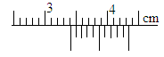

*3.40 3.41*

*+ 0.01 - 0.03*

*3.41 cm 3.38cm*

1. Explain the cause of random motion of smoke particles as observed in Brownian motion experiment using a smoke cell. (2 mks)

*Smoke particles are being hit by unseen air molecules moving in a random motion*

1. When a Bunsen burner is lit below a wire gauze, it is noted that the flame initially burns below the gauze as shown in the figure below. After sometime the flame burns below as well as above the gauze.

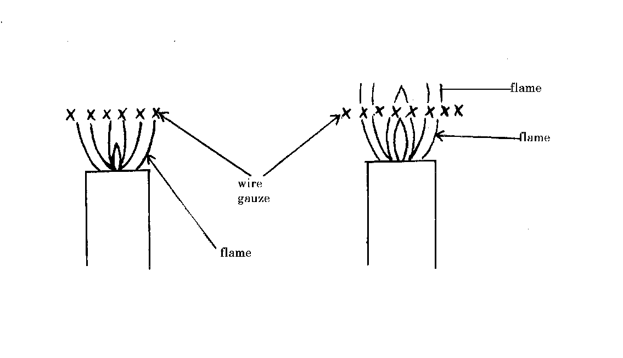

Explain this observation (2 mks)

*Wire gauze is a good conductor of heat and hence conduct heat away from the upper region of the wire gauze. when the gas reaches its ignition temperature later the flame starts showing on the upper region.*

1. A small chain is often seen hanging at the back of a petrol carrying lorry. State and explain its significance. (2mks)

*Friction generates charges on the lorry the chain discharges the lorry to prevent sparks which may lead to explosion.*

1. (a) State the right hand grip rule. (1mk)

*The right hand grip rule states that if a coil carrying a current is grasped in the right hand such that the fingers point in the direction of current in the coil, then the thumb points in the direction of North Pole.*

(b) What is an electromagnet? (1 mk)

*it is a temporary magnet formed when current passes through a solenoid in a core*

1. The diagram below shows a flask fitted with a glass tube dipped into a beaker containing water at room temperature. The cork fixing the glass tube is tight.

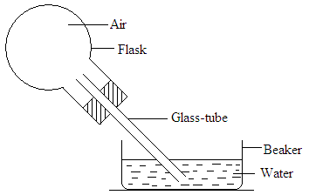

State with reason what would be observed if cold water is poured on to the flask. (2mks)

*Water is sucked in to the glass tube*

*Air in the flask contracts when cooled.*

1. State t**wo** conditions under which a pinhole camera may form an image on its screen which has the same size as the object. (2mks)

*When the object distance from the pinhole is equal to the image distance.*

*When the screen is as large as the object.*

1. The figure below shows two identical thermometers. Thermometer A has a blackened bulb while thermometer R has a silvery bulb. A candle is placed equidistant between the two thermometers

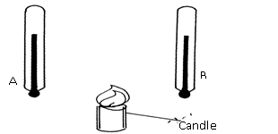

* 1. State the thermometer which records a higher temperature after sometime (1 mk)

A

* 1. Give reason for (a) above (1mk)

*Dull surfaces are good absorbers of heat energy than shiny surfaces.*

1. Name two factors that affect stability of a body. (2mks)

*The area of the base*

*The position of the centre of gravity*

1. Explain how an increase in temperature affect surface tension of a liquid. (2 mks)

*with rise in temperature the kinetic energy of the molecules of a liquid is increased, the intermolecular distance increases and the force of cohesion is decreased therefore surface tension is lowered.*

1. The figure below shows a u-tube manometer containing oil of density 0.9g/cm3. One end is connected to a gas tap.

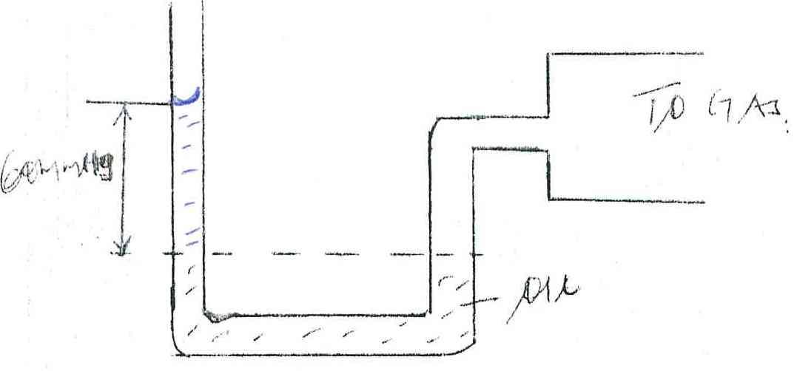

Gas

60mmHg

Oil

If atmospheric pressure is 1.0 x105 pa, find the pressure of the gas. (3 mks)

*Pg = Pa + hpg*

*= 1.0 x 105 + 0.06 x 900 x 10*

*= 1.0054 x 105 Pa*

1. (a) A form one student has the following apparatus two cells, a switch, connecting wires and two bulbs. Draw a possible circuit diagram that will show parallel arrangement of the bulbs.. (2mks)

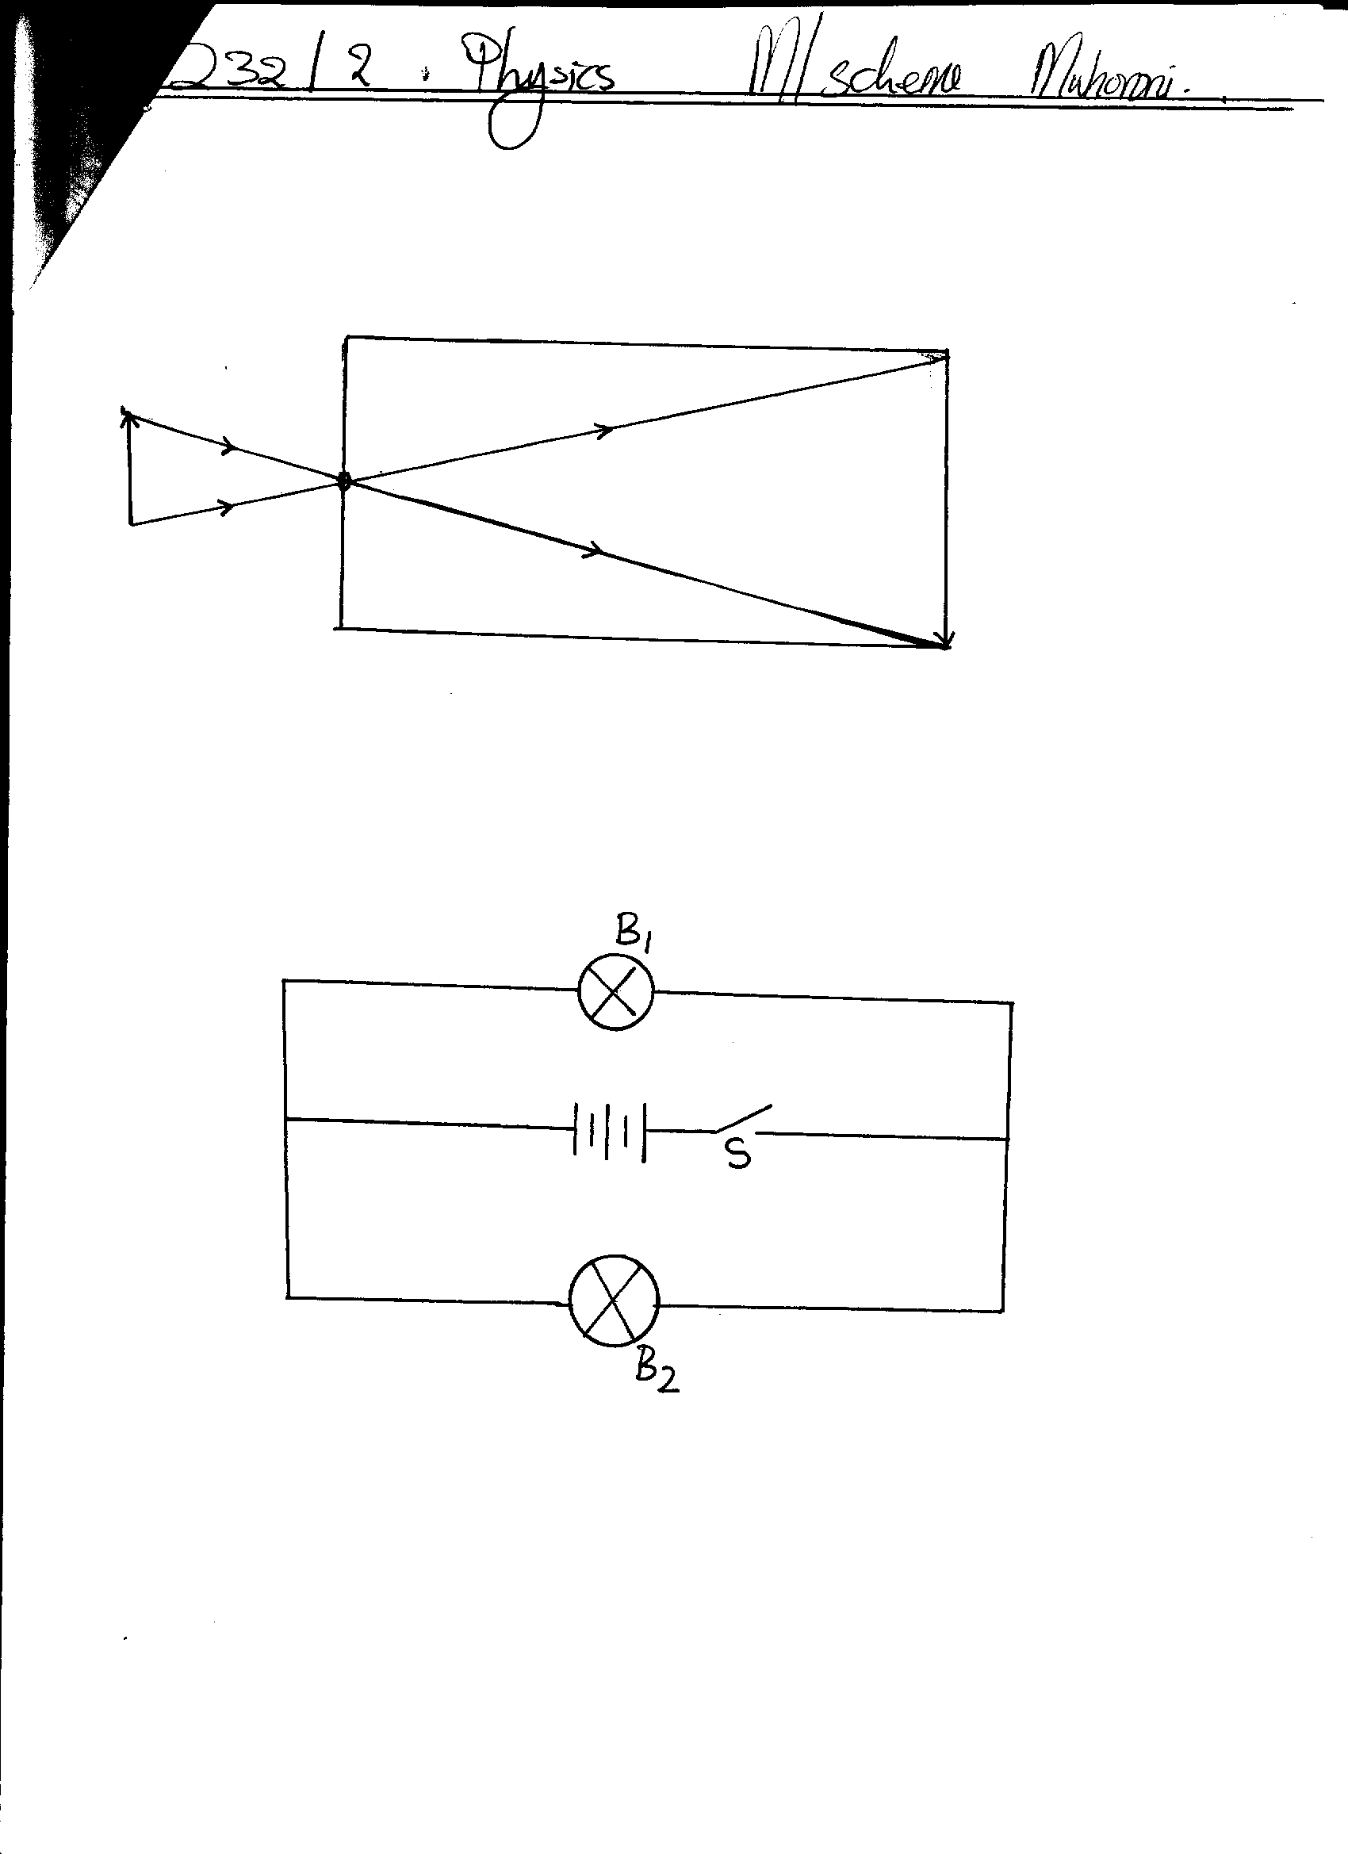

(b) State the two defects of a simple cell. (2mks)

*polarisation*

*local action*

1. You are provided with a boiling tube, a string and a ruler. Describe using a diagram how you would estimate the circumference of the boiling tube. (4mks)

*Wind the thread round the curved surface and note the number of complete turns.*

*Mark the beginning and end of the turns*

*Measure the length between the two marks of the thread*

*Divide the length with the number of turns to get the circumference.*

1. (a) Convert each of the following from 35 Kelvin into degree Celsius. (1mk)

*35 – 273 = -238oc*

(b) Name two parts of a clinical thermometer that make it special compared to the other thermometers. (2mks)

*constriction*

*short scale*

1. The diagram below shows three identical springs which obey Hooke’s law.

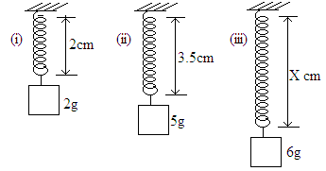

Determine the length X. (3 marks)

 

**SECTION B (60 MARKS)**

1. The mass of a density bottle of 50cm3 is 7.5g when empty. Aluminium turning are poured into the bottle and the total mass is 57.5g. Water is then added into the turnings till the bottle is full. If the total mass of the bottle and its contents is 87.5g.

(density of water = 1g/cm3)

calculate; (i) the mass of aluminium turning. (1mk)

*57.5g – 7.5g = 50g*

(ii) the volume of the water added. (2mks)

*mass of water = 87.5 -57.5 = 30g*

*volume of water =30g*

*1 g/cm3*

*= 30cm3*

(iii) the volume of aluminium (1mk)

*volume of aluminium = 50 -30 cm3*

*= 20 cm3*

(iv) the density of Aluminium. (2mks)

$density=\frac{m}{v}=\frac{50}{20}=2.5g/{cm}^{3}$

1. (a) Define the term pressure and state its SI unit. (2mks)

*this is the force acting normally or perpendicularly per unit area. SI unit newton per square metre.*

(b) Explain why a camel is able to walk on deserts and cannot sink in sand. (2mks)

*Camels have broad feet which are in contact with the ground which reduces the pressure exerted on the ground by the camel.*

(c) A brick 30cm long 20cm and 5cm thick has a mass of 500g. Determine the;

1. Greatest pressure that can be exerted by the brick on the flat surface. (3mks)

*Min area = $\frac{20}{100}×\frac{5}{100}=0.01m$*

*Weight = $\frac{500}{1000}×10$*

*= 5N*

$P=F/A=5/{0.01}=500N/m^{2}$

1. Least pressure exerted by the brick. (3mks)

*Max area = $\frac{20}{100}×\frac{30}{100}=0.06m$*

$P=F/A=5/{0.06}=83.33N/m^{2}$

(d) State the three properties of hydraulic brake fluid (3mks)

*It should not corrode parts of the system*

*It should be highly incompressible*

*It should have a low freezing point and high boiling point*

1. (a) The oil level in a burette is 10.0cm3. 50 drops of the oil are run off the burette. If the radius of 1 drop is 0.35cm.
2. Calculate the volume of one drop. (3 mks)

*V = $\frac{4}{3}πr^{3}$*

*= $\frac{4}{3}×\frac{22}{7}×0.35 ×0.35×0.35$*

*= 0.1796cm3*

1. What is the final reading of the burette. (3 mks)

*Total vol. of drops = 0.1796x 50*

*= 8.98cm3*

*Final level = 10.00*

*+8.98*

*18.98 cm3*

(b) The 50 drops oil was made to spread on a surface of water forming a circular patch of radius 21cm.

1. Calculate the area of the oil patch. (2 mks)

*A = $πr^{2}$*

*= $\frac{22}{7}×21×21$*

*= 1386cm2*

1. Calculate the thickness of the oil molecule. (3 mks)

***t = V/A***

***= $\frac{8.98}{1386}$ =0.006479 cm***

1. a) What is rectilinear propagation of light (1mk)

*It is a property of light stating that light travels in a straight line.*

b) Find the number of images formed when mirrors are inclined at 40o (3mks)

*𝒏 = 𝟑𝟔𝟎 - 1*

*𝜽*

*𝟑𝟔𝟎 - 1*

*4𝟎 = 8 𝒊𝒎𝒂𝒈𝒆𝒔*

c) State 2 characteristics of images formed by the plane mirrors. (2mks)

*-Virtual*

*-Laterally inverted*

*-Same size as the object*

1. The diagram below shows a solar heater.



* 1. state reason why;

1. the pipe is fixed to a dark-colored collector plate. (1mk)

***The dark color is a good absorber of heat.***

1. the pipe is made of copper. (1mk)

*Copper is a good conductor of heat.*

1. the pipe is coiled several times. (1mk)

***To increase surface area for heat absorption.***

1. the collector plate is fixed to an insulator (1mk)

*To prevent heat loss by conduction.*

1. the panel front is covered with glass (1mk)

*To reflect heat back to the copper coils.*

b) Liquid expand when heated and contract when cooled. However this is not true for water

i. state the name given to this behavior of water (1mk)

*Anomalous/unusual expansion of water*

ii.State two importance of this behavior of water. (2mks)

*Survival of aquatic plants and animals during winter.*

*Weathering of rocks helps in soil formation.*

1. a) Define moment of force and state its SI unit (2mks)

*It is the product of force and the perpendicular distance between the the point of support (pivot) and the line of action of force.*

*S I unit newton-metre*

b) Name two factors that affect moment of a force. (2mks)

*- The perpendicular distance between line of action of force and the point of support.*

*- Amount of force applied***.**

c ) Find the moment of the force about the pivot in the figure below (3mks)



𝒎𝒐𝒎𝒆𝒏𝒕 𝒐𝒇 𝒂 𝒇𝒐𝒓𝒄𝒆 = 𝑭𝒐𝒓𝒄𝒆×𝒑𝒆𝒓𝒑𝒆𝒏𝒅𝒊𝒄𝒖𝒍𝒂𝒓 𝒅𝒊𝒔𝒕𝒂𝒏𝒄𝒆

=𝟐𝟎×𝟎.𝟒𝟎

=𝟖𝑵𝒎

d)A uniform meter rule pivoted at its center is balanced by a force of 50N at 20cm mark and some other two forces ,F and 20 N on the 70 cm mark and 90 cm marks respectively. Calculate the force F. (3mks)

*𝒔𝒖𝒎 𝒐𝒇 𝒄𝒍𝒐𝒄𝒌𝒘𝒊𝒔𝒆 𝒎𝒐𝒎𝒆𝒏𝒕𝒔=𝒔𝒖𝒎 𝒐𝒇 𝒂𝒏𝒕𝒊𝒄𝒍𝒐𝒄𝒌𝒘𝒊𝒔𝒆 𝒎𝒐𝒎𝒆𝒏𝒕𝒔 (𝟐0×𝟎.𝟒𝟎) + (𝑭×𝟎.2) = (50×𝟎.𝟑𝟎)*

*𝑭 = 35𝑵*

1. (a) State two properties of magnets. (2mks)

*Magnetic poles*

*Directional property*

(b) A soft iron ring is placed between two magnets. Draw the magnetic field pattern between the two magnets. (2mks)



(c) Figure below shows a U-shaped magnet is stored with a keeper.



Explain how this method helps to retain magnetism longer. (2mks)

*The keepers acquire polarities opposite to those of the magnet so that the dipoles of the magnet and those of the keepers form complete loops. The dipoles thus retain their orientation.*