MANGU HIGH SCHOOL TRIAL 2 MOCK 2021

232/3 – PHYSICS PAPER 3 - MARKING SCHEME

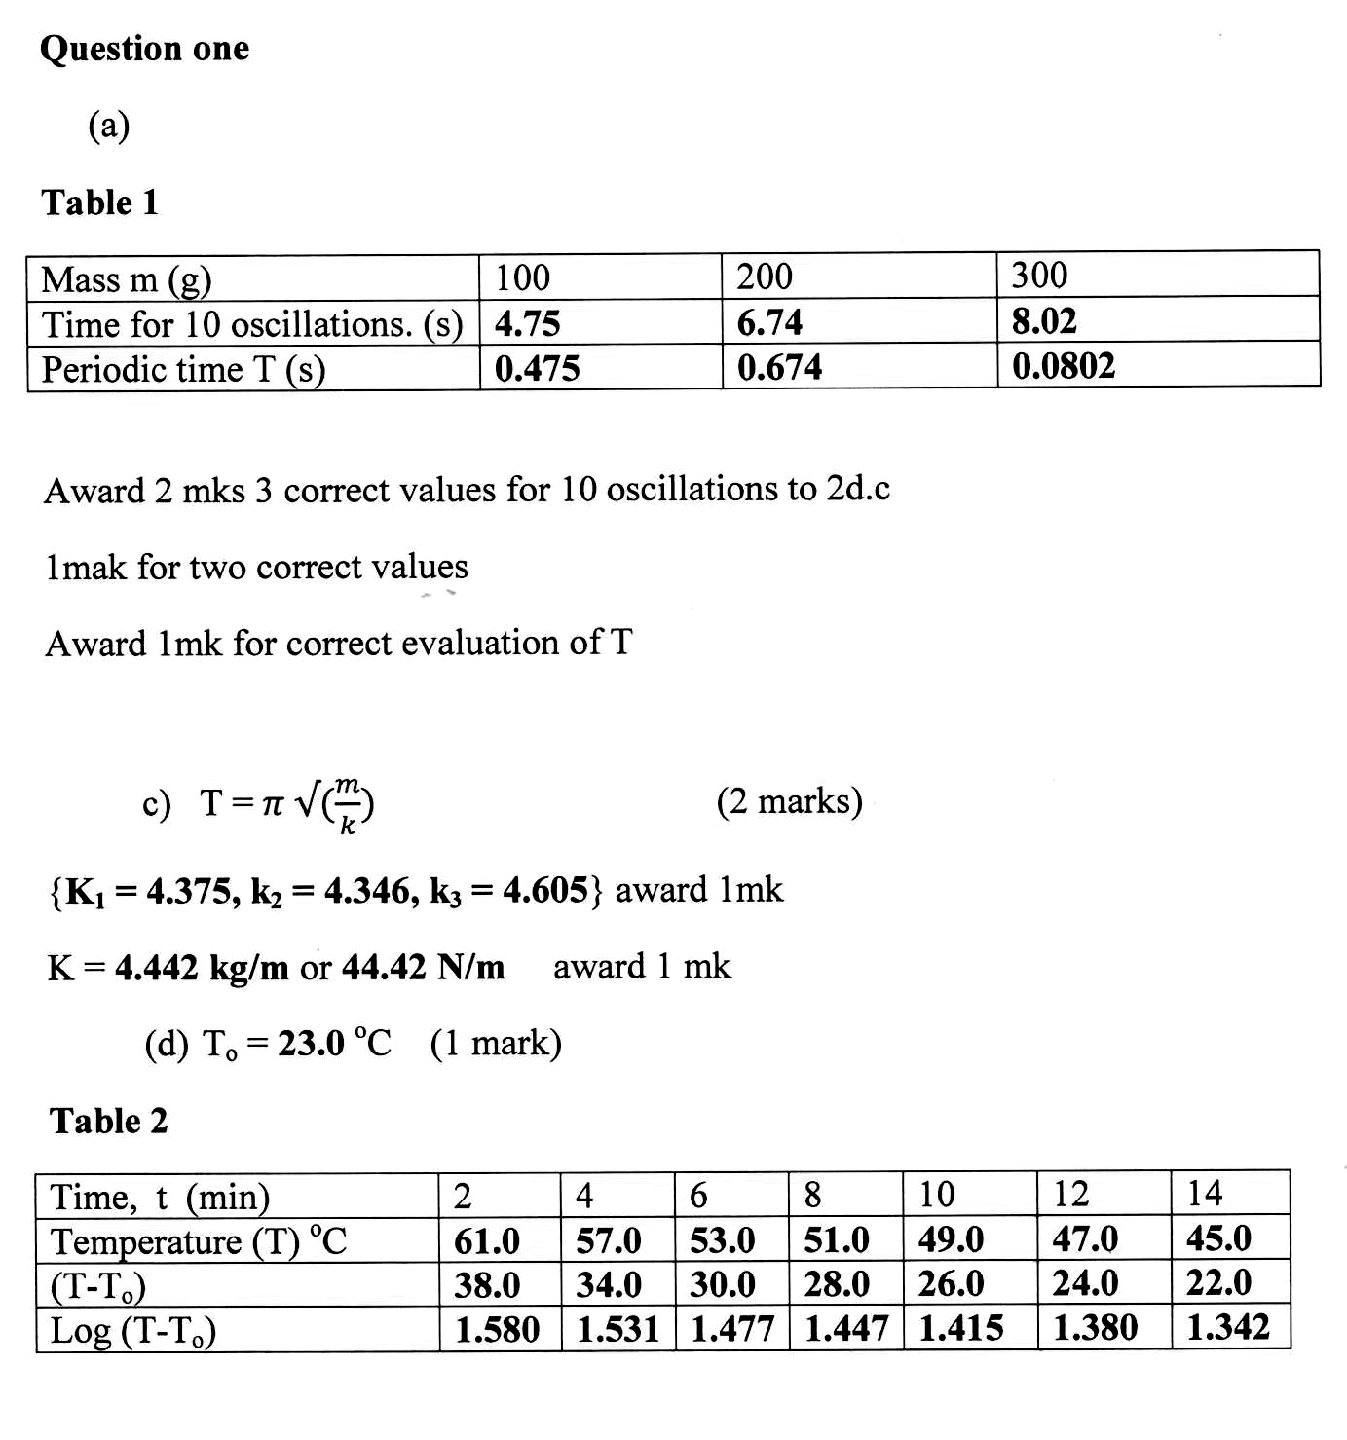

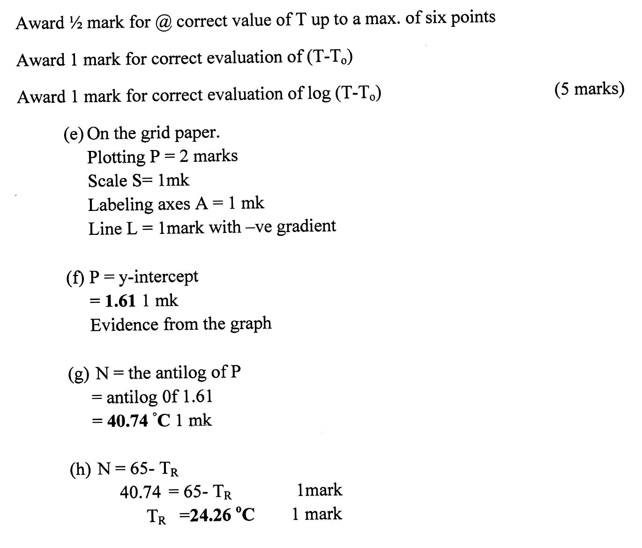
1(e)
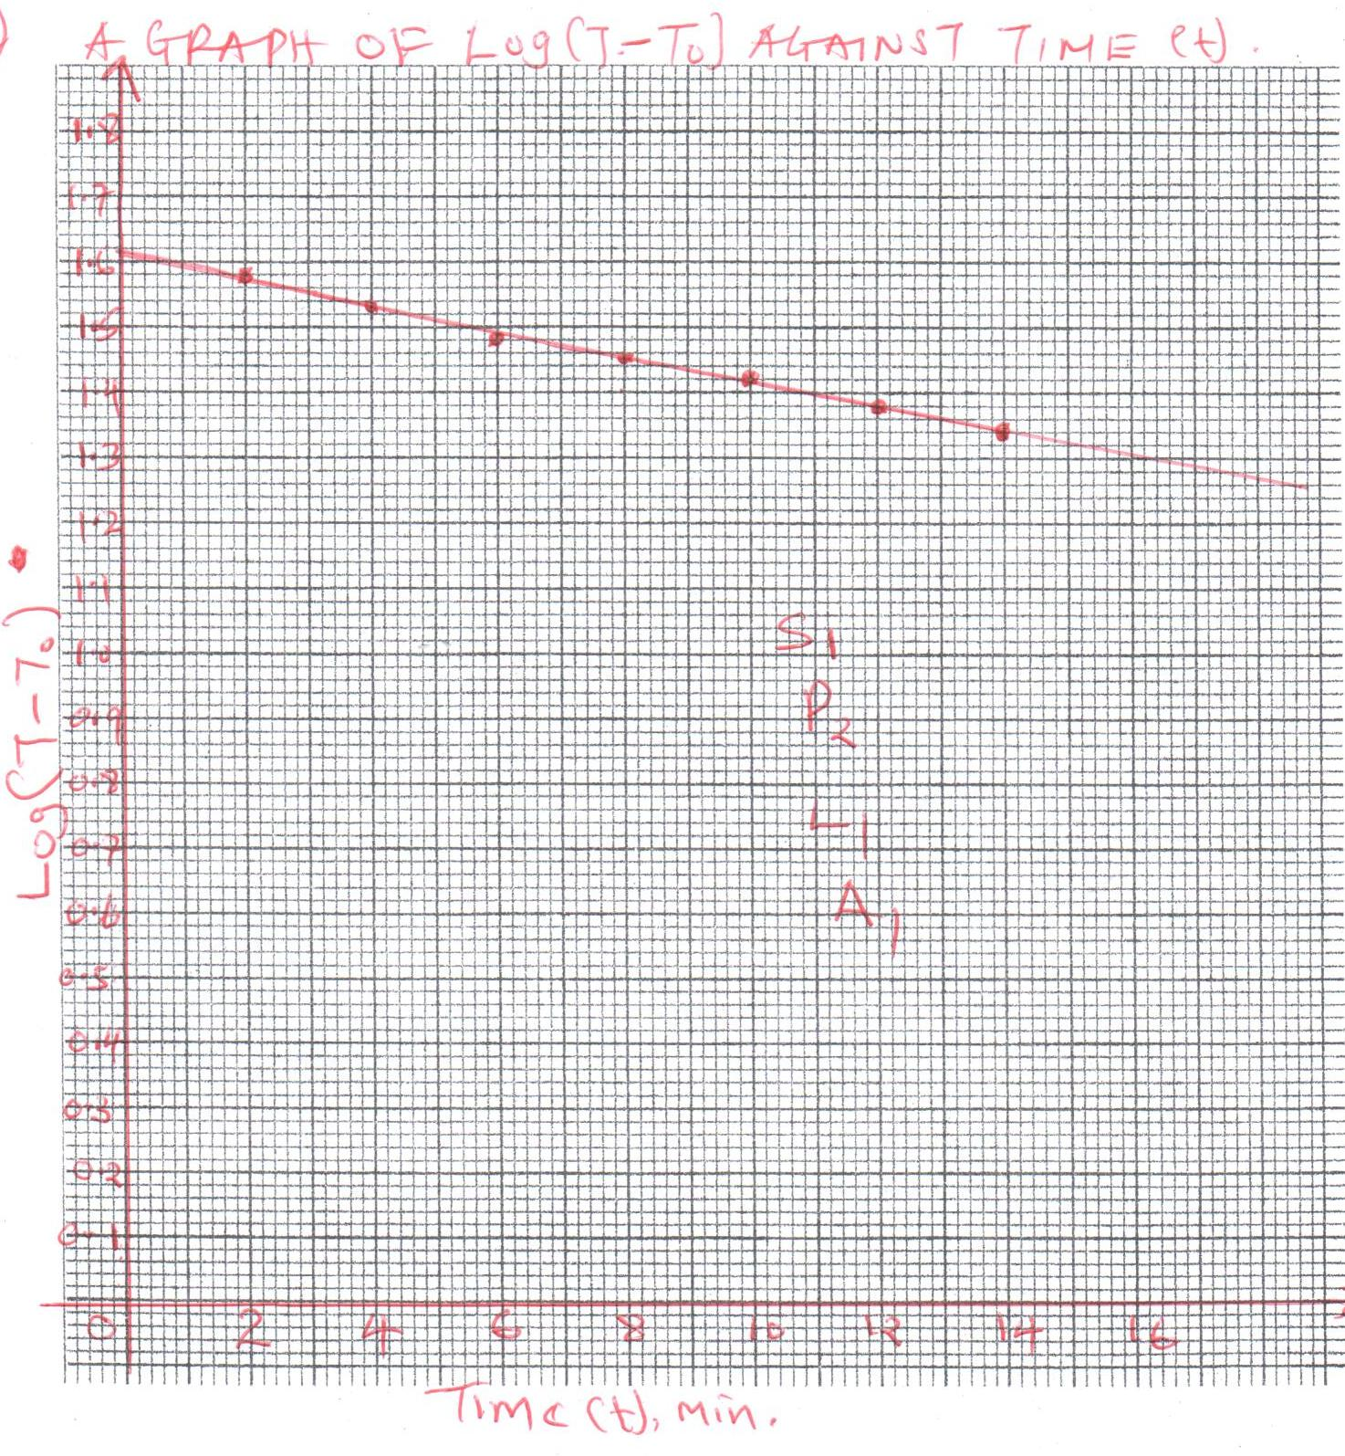
- (e) Table 2
x(cm) | 100 | 95 | 90 | 85 | 80
u₁(cm) | 25.0 | 27.0 | 29.0 | 30.0 | 32.0 | +1.0cm
u₂(cm) | 71.0 | 64.0 | 61.0 | 52.0 | 48.0 | +1.0cm
d=u₂-u₁(cm) | 46.0 | 37.0 | 32.0 | 22.0 | 16.0
y = d² (cm)  x (2dp) | 21.16 | 14.41 | 11.38 | 5.69 | 3.20 | (8mks)
u₁ and u₂ values each ½ mk
d value a maximum of 1 mark 4 – 5 = 1mk
3 values = ½ mark
y value a maximum of 2 marks correct to 2d.p
4 – 5 = 2 marks
- = 1 mark
(f) Axes with units = 1 mark (each axis = ½ mark)
Simple and uniform scale = 1 mark (vertical axis only)
Plotting within 1 small square = 2 marks (4 – 5 = 2 marks)
(3 = 1 mark)
Straight line drawn with a ruler = 1mark
(Line should have positive gradient and passes at least 3 plotted points)
(g) Xo = 80cm + 1cm
(h) k = Xo = 80 = 20cm + 0.5cm
4 4
(i) Bo = 3.0v + 0.1v
(k) v = 0.40 volts + 0.05v
(l) 1 = 35 + 1
v x y
= 1 = 35 + 1
0.40 30 y
y = 0.75v

(m) k = 8 = 8 = 0.07619 or 0.0762 v-1
35Eo 35x3

A GRAPH OF y(cm) AGAINST x(cm)
