MANGU HIGH SCHOOL TRIAL 2 MOCK 2021
232/1 – PHYSICS PAPER 1 - MARKING SCHEME

- Actual reading = (6.20 – 0.02)mm
= 6.18mm1

- h, ℓ, g = h₂p₂g1
h x 900 = 0.06 x 12001
h = 0.08m = 8cm1

- 4N
1
Resultant force1 = (10 – 6)N = 4N1 towards the1 right hand side.

- ℓ₁₀₀ – ℓ₀ = 30cm

Ф = ℓ₀ – ℓ₀ = 12
100 ℓ₁₀₀ – ℓ₀ 30

Ф = 12 x 100⁰C1 = 40⁰C1
30

- Mass flux = density x volume flux1
= 1000 x 160 x 10⁻⁶
= 0.16kgs⁻¹

- In liquids the forces are smaller and molecules are able to roll1 over one another while in the gaseous state, the molecules are free to move because gases have the weakest force1 of attraction.

- A1 – loses heat through evaporation because of large surface area and B1 – because dull surface is a good emitter of heat. 1

- Lowered1
As the water fills the vessel the centre of gravity rises and this lowers stability. 1

- It means a cubid centimeter of water has a mass of 1g. 1

- V.R. = R (Radius of the wheel)
r (radius of the axle
- Increase the radius of wheel (R)
- Reduce the radius of the axle (r)
- (a) in a vacuum

(b)
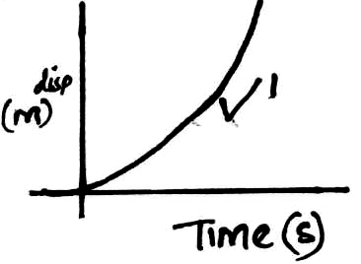

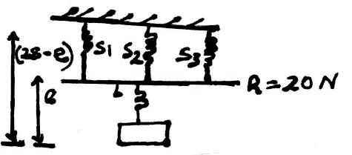
Combined spring constant S₁, S₂, S₃ = 3x5N/m OR
= 15N/m S₁, S₂, S₃
L + 20
e = F 3
K 5N = 1m
(28 – e) = (L + 20) L + 20 = ?
15 3
420 – 15e = L + 20 (L + 20) 1
15
400 = L + 15e … (i) 5N = 1m
L = ?
e = L L1
K 5
e = L Therefore L + 20 + L = 28
5 15 5
5e = L … (ii) L + 20 + 3L = 420
4L = 400
simultaneously (i) and (ii) L = 1001
e = 400
20
= 20m
Therefore L = 5 x 20
100N1

- (a) Vertical projection U = 100m/s g = -10m/s v = om/s
V² = u² – 2gs1
O²= (100)² – 2 x 10 x 5
20s = 10,000
s = 500m1
(b) Horizontal projection h = ½ gt²1
500 = ½ x 10 x t²
t² = 100
t = 10s1

(c) Range R = ut1
R = 20 x 10
= 200m1
(d) Impulse = change in momentum1
Ft = (10N x 35)1 – (20N x 25)
= -10NS1
(e) (i) v – u = a
t
t = (5 ticks x 0.01)s
= 0.05s1
Therefore Δv = 5cm/s²
0.05
Δv = 0.25cm/s1
(ii) v – u = 0.25cm/s
u = 0.125cm
0.01
= 12.5cm/s1

V – 12.5 = 0.25
V = 12.75cm/s1

- (a) (i) M.A = L
E
= 450N1
150N
= 31
(ii) V.R = No. of teeth on driven gear
No. of teeth on driving gear
= 801
20
= 4
(iii) ŋ = m.A x 100%
V.R
= ¾ x 100%
= 75%

(b) (i) Converts electrical energy – sound energy. 1
(ii) Chemical Kinetic Potential

(c) Mass of ice = 0.9g/cm³ x 2000cm³
1800g
1.8kg
+0.2
2.0kg1
w = Fxd
= 20N x 5M
= 100J1
Power = Work done
Time
= 100J
4S
= 25J/S or 25 watts1

- (a) Quantity of heat required to convert a unit mass of liquid to vapour at constant temperature.  (2mks)
- Mass of condensed steam = 123 – (70 + 50) (1mk)
= 123 – 120 = 3g (1mk)
(ii) Heat gained by water = MCΔQ
= 0.07 x 4200 x 25 = 7350J
Heat gained by cal = 50 x 390 x 25 = 487.5J
1000 (1mk)
Total heat gained = 487.5 + 7350 = 7837.5J (1mk)

(iii) (i) Heat lost by steam = ml + MCΔE
= 0.003l + (0.003 x 4200 x 70) = 7837.5J
0.003L = 6955.5

(ii) L = 6955.5
0.003
= 2318500J

- (i) At P = 2.5 x 10⁵Pa, ^{I}/_{V} = 50m⁻³(read from graph)
Therefore V = ¹/₅₀ = 0.02m³1

(ii) Gradient = 2RT grad = 3 – 2 = 1 = 0.05
60 – 40 20
R = gradient
2T
R = 0.05 = 8.3 x 10⁵N ^{m}/_{k} or JK⁻¹1
2x 300

- (a) Floating object displaces its own weight of the fluid in which it floats.

(b) Mass of water displaced by wood = 80kg
Volume of water displaced = 80 = 0.08m³
1000
but 0.08m³ = 0.6 of the volume of block.

Volume of wood = 0.08 = 0.1333m³;
0.6
Volume displaced by rods = 0.08 – 0.1333 = 0.0533
Mass of he rods = 0.053 x 1000 = 53.3kg;

Mass of one rod = 20g = 0.02kg

Number of rods = 53.3;
0.02
= 2,665 rods;
- (i) Up thrust force
Weight Max. 2 or 3;;
Tension on the string 1
Up thrust = weight + tension on the string;

(ii) Up thrust = weight + tension
(50 x 40 x 20) 1000 x 10 = 50 x 40 x 20 x 6000 + tension;;
1000000 100000
Tension = 200 – 240
= -40N

- Sum of clockwise Moments = Anti clockwise Moments1
37.5 x 40 + W x 40 = 140 x 15
1500 + 40W = 2100
40W = 2100 – 1500
40W = 600
W = 6N1
W = 15N
M = 1.5Kg or 1500g

- (a) (i) Roughness / smoothness of surface / radius of path / angular velocity /
speed. (any two)

(ii) W_{A} > W_{B} > W_{C}1

