Organic chemistry II (alkanoic acids and alkanols)
1. A student mixed equal volumes of Ethanol and butanoic acid. He added a few drops of
concentrated Sulphuric (VI) acid and warmed the mixture
(i) Name and write the formula of the main products
Name………………………………….
Formula……………………………………..
(ii) Which homologous series does the product named in (i) above belong?

2. The structure of the monomer phenyl ethene is given below:-
HC = CH₂
O

a) Give the structure of the polymer formed when four of the monomers are added together
b) Give the name of the polymer formed in (a) above
3. Explain the environmental effects of burning plastics in air as a disposal method
4. Write chemical equation to represent the effect of heat on ammonium carbonate
5. Sodium octadecanoate has a chemical formula CH₃(CH₂)₆ COO⁻Na⁺, which is used as soap.
Explain why a lot of soap is needed when washing with hard water
6. A natural polymer is made up of the monomer:
O

CH₃CH₂CH C OH

NH₂

(a) Write the structural formula of the repeat unit of the polymer
(b) When 5.0 x 10⁻⁵ moles of the polymer were hydrolysed, 0.515g of the monomer
were obtained.
Determine the number of the monomer molecules in this polymer.
(C = 12; H = 1; N = 14; O =16)
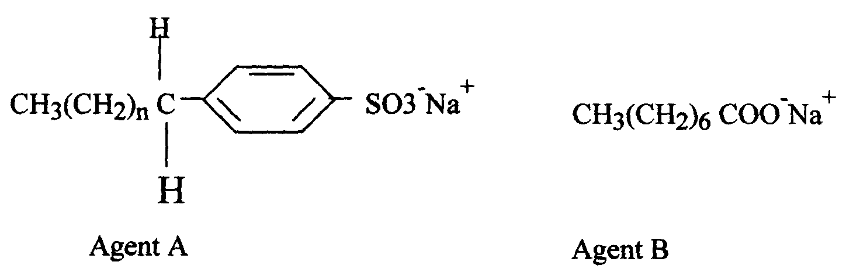
7. The formula below represents active ingredients of two cleansing agents A and B

Which one of the cleansing agents would be suitable to be used in water containing magnesium
hydrogen carbonate? Explain

8. Study the polymer below and use it to answer the questions that follow:
H H H H

CCCC

O H OH n

(a) Give the name of the monomer and draw its structures
(b) Identify the type of polymerization that takes place
(c) State one advantage of synthetic polymers
9. Ethanol and Pentane are miscible liquids. Explain how water can be used to separate a mixture
of ethanol and pentane

10.
GLUCOSE SOLUTION
CRUDE ETHANOL
95% ETHANOL
ABSOLUTE ETHANOL
G
H

(a) What is absolute ethanol?
(b) State two conditions required for process G to take place efficiently

11. (a) (i) The table below shows the volume of oxygen obtained per unit time when hydrogen
peroxide was decomposed in the presence of manganese (IV) Oxide. Use it to answer
the questions that follow:-
Time in seconds | Volume of Oxygen evolved (cm³)
0  30  60  90  120  150  180  210  240  270  300 | 0  10  19  27  34  38  43  45  45  45  45
(i) Plot a graph of volume of oxygen gas against time
(ii) Determine the rate of reaction at time 156 seconds
(iii) From the graph, find the time taken for 18cm³ of oxygen to be produced
(iv) Write a chemical equation to show how hydrogen peroxide decomposes in the presence
of manganese (IV) Oxide
(b) The diagram below shows how a Le’clanche (Dry cell) appears:-
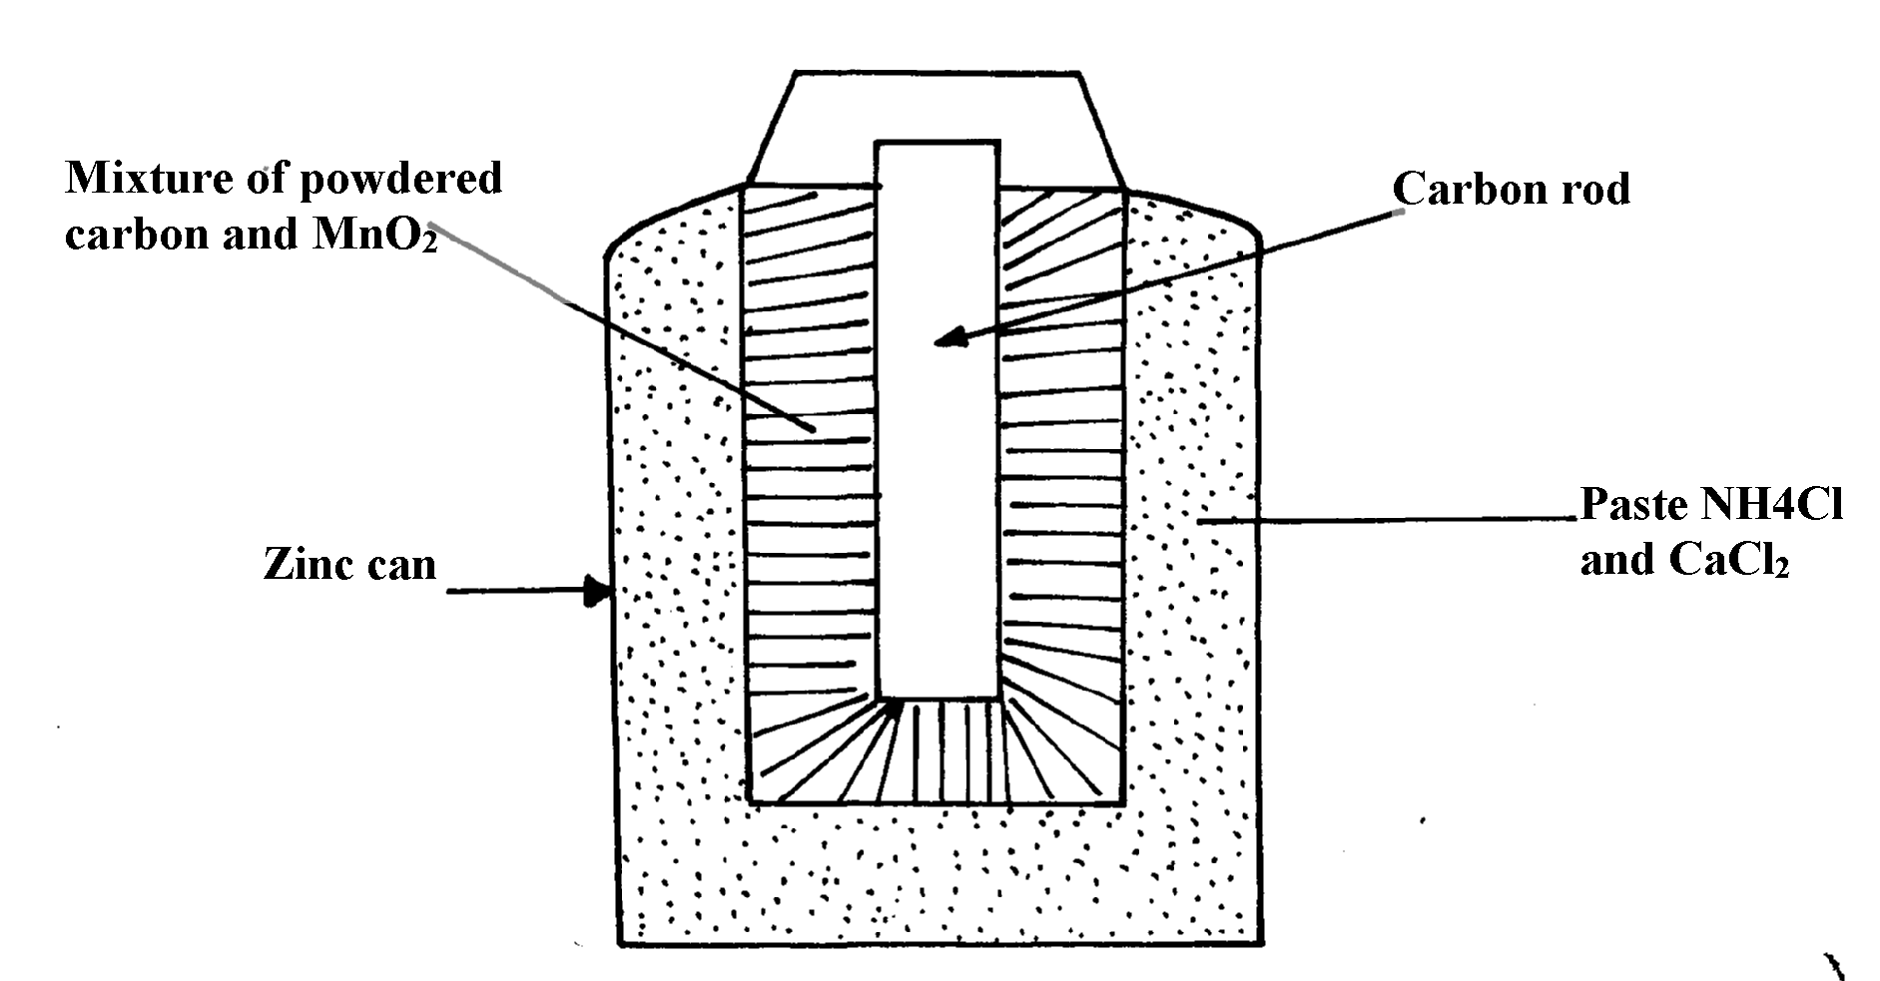

(i) What is the function of MnO₂ in the cell above?
(ii) Write the equation of a reaction that occurs at the cathode
(iii) Calculate the mass of Zinc that is consumed when a current of 0.1amperes flows
through the above cell for 30minutes (1F =96500c Zn =65)
12. (a) Give the IUPAC names of the following compounds:
(i) CH₃COOCH₂CH₃ *
CH₂ = C – CHCH₃

Br
(ii)

(b) The structure below shows some reactions starting with ethanol. Study it and answer
the questions that follow:
CH₃COOH
CH₃COONa
CH₃CH₂OH
CH₂=CH₂
CH₃CH₃
CH₂ CH₂
n
S
P
CH₄
T
Na Metal
Compound U
Step II
Step I
Step III
CH₃COOH

Drops of Conc. H₂SO₄
Reagent R
NaOH_{(aq)}
Heat
Excess Cl₂ /U.V

(i) Write the formula of the organic compounds P and S *
(ii) Name the type of reaction, the reagent(s) and condition for the reactions in the following steps :-
(I) Step I *
(II) Step II *
(III) Step III *
(iii) Name reagent R …………………………………………………………… *
(iv) Draw the structural formula of T and give its name *
(v) (I) Name compound U………………………………………………………..
(II) If the relative molecular mass of U is 42000, determine the value of n (C=12, H=1)
(c) State why C₂H₄ burns with a more smoky flame than C₂H₆ *
13. a) State two factors that affect the properties of a polymer
b) Name the compound with the formula below :
CH₃CH₂CH₂ONa
c) Study the scheme below and use it to answer the questions that follow:-
CH₃CH₂CH₃
P
Step

V
CH₃CH = CH₂
Step

W
CH₃CH₂CH₂OH
CH₃CH₂COOH
Step R
Gas F
CH₃CH₂COONa
NaOH

Step J
K₂CO₃
Step X
NaOH
Heat
CH₃CH₂COOCH₃
G
Product T
+ Na₂CO₃
H H

C – C

CH₃ H
n
K

i) Name the following compounds:-
I. Product T ………………………… II. K ………
ii) State one common physical property of substance G
iii) State the type of reaction that occurred in step J
iv) Give one use of substance K
v) Write an equation for the combustion of compound P
vi) Explain how compounds CH₃CH₂COOH and CH₃CH₂CH₂OH can be distinguished chemically
vii) If a polymer K has relative molecular mass of 12,600, calculate the value of n (H=1 C =12)
14. Study the scheme given below and answer the questions that follow:-

H_{2 (g)} Ni
High temp
Polymer Q
Polymerization
Compound P
CH₃CH₂CH₃
CH₃CH₂CH₂ONa + H₂

Na(s)
Propan-l-ol
Step I
Propylethanoate
CH₃CH₂COOH

Solution T + CO_{2 (g)}

Step III
Na₂CO_{3(aq)}
Conc. H₂SO₄ 180ºC
Step II

(a) (i) Name compound P ……………………………………………………………………
(ii) Write an equation for the reaction between CH₃CH₂COOH and Na₂CO₃
(b) State one use of polymer Q
(c) Name one oxidising agent that can be used in step II …………………………………..
(d) A sample of polymer Q is found to have a molecular mass of 4200. Determine the number of
monomers in the polymer (H = 1, C = 12)
(e) Name the type of reaction in step I …………………………………………………………..
(f) State one industrial application of step III
(g)State how burning can be used to distinguish between propane and propyne. Explain your
answer
(h) 1000cm³ of ethene (C₂H₄) burnt in oxygen to produce Carbon (II) Oxide and water vapour.
Calculate the minimum volume of air needed for the complete combustion of ethene
(Air contains 20% by volume of oxygen)
15. (a) Study the schematic diagram below and answer the questions that follow:-
CH₃CH₂COOCH₂CH₂CH₃
CH₃CHCH₂
CH₃CH₂CH₂ONa + Gas P
CH₃CH₂CH₂OH
X
V
HCl Step 5
Step 1 R
Na
Step2
H⁺
Step 3
Q + H₂O
MnO⁻₄
Step 4
Ni H₂

(i) Identify the following:
Substance Q ..............................................................................................................
Substance R...............................................................................................................
Gas P..........................................................................................................................
(ii) Name:
Step 1.................................................................................................
Step 4.................................................................................................
(iii) Draw the structural formula of the major product of step 5
(iv) State the condition and reagent in step 3
16. Study the flow chart below and answer the questions that follow
M
CO_{2 (g)}
KMnO₄/H⁺
CH₂CH₂
J
Ni/H_{2(g)}
Step 4
K
Reagent P
STEP 2
Ethyl Ethanoate
CH₂CH₂OH
Reagent Q
Step 3
KMnO4/H⁺_{(aq)}
L

(a) (i) Name the following organic compounds:
M……………………………………………………………..……..
L…………………………………………………………………..
(ii) Name the process in step:
Step 2 ………………………………………………………….….
Step 4 ………………………………………………………….…
(iii) Identify the reagent P and Q
(iv) Write an equation for the reaction between CH₃CH₂CH₂OH and sodium

17. a) Give the names of the following compounds:
i) CH₃CH₂CH₂CH₂OH ……………………………………………………………………
ii) CH₃CH₂COOH …………………………………………………………………
iii) CH₃C – O- CH₂CH₃ ……………………………………………………………………

18. Study the scheme given below and answer the questions that follow;
Step I
Products
C₂H₅COONa
Step V
Complete combustion
CH ≡CH
Step II
Step IV + Heat
CH₂ = CH₂
C₂H₆
Step III

CH₂ = CHCl
n
i) Name the reagents used in:
Step I: ………………………………………………………………………
Step II ……………………………………………………………………
Step III ………………………………………………………………………
ii) Write an equation to show products formed for the complete combustion of CH = CH
iii) Explain one disadvantage of continued use of items made form the compound formed
in step III
19. A hydrated salt has the following composition by mass. Iron 20.2 %, oxygen 23.0%,
sulphur 11.5%, water 45.3%
i) Determine the formula of the hydrated salt (Fe=56, S=32, O=16, H=11)
ii) 6.95g of the hydrated salt in c(i) above were dissolved in distilled water and the total
volume made to 250cm³ of solution. Calculate the concentration of the resulting salt solution
in moles per litre. (Given that the molecula mass of the salt is 278)
20. Write an equation to show products formed for the complete combustion of CH = CH
iii) Explain one disadvantage of continued use of items made form the compound formed
in step III

21. Give the IUPAC name for each of the following organic compounds;
i) CH₃ - CH - CH₂ - CH₃

OH
ii)CH₃ – CH – CH₂ – CH₂ - CH₃

C₂H₅
iii)CH₃COOCH₂CH₂CH₃

22. The structure below represents a cleansing agent.
O

R – S – O⁻Na⁺

O
a) State the type of cleansing agent represented above
b) State one advantage and one disadvantage of using the above cleansing agent.

23. The structure below shows part of polymer .Use it to answer the questions that follow.
CH₃ CH₃ CH₃
⎪ ⎪ ⎪
― CH - CH₂ – CH- CH₂ - CH – CH₂ ―
a) Derive the structure of the monomer
b) Name the type of polymerization represented above
24. The flow chart below represents a series of reactions starting with ethanoic acid:-
Ethanol
B
process I
Ethanoic acid

Na₂CO₃
Salt A + CO₂ + H₂O

(a) Identify substances A and B
(b) Name the process I

25. a) Write an equation showing how ammonium nitrate may be prepared starting with
ammonia gas
(b) Calculate the maximum mass of ammonium nitrate that can be prepared using 5.3kg of
ammonia (H=1, N=14, O=16)

26. (a) What is meant by the term, esterification?
(b) Draw the structural formulae of two compounds that may be reacted to form ethylpropanoate

27. (a) Draw the structure of pentanoic acid
(b) Draw the structure and give the name of the organic compound formed when ethanol
reacts with pentanoic acid in presence of concentrated sulphuric acid

28. The scheme below shows some reactions starting with ethanol. Study it and answer the questions
that follow:-
Q
P
CH₃COONa
Ethanol
CH₃CH₂ONa
C
H₂SO_{4(l)}

170ºC step 1
Cr₂O_{7(aq)} / H+_{(aq)}
Na_{(s)}
Step 2
Step 4
CH₃CH₂OH/H₂SO₄
Step 3
²⁻

(i) Name and draw the structure of substance Q
(ii) Give the names of the reactions that take place in steps 2 and 4
(iii) What reagent is necessary for reaction that takes place in step 3
29. Substances A and B are represented by the formulae ROH and RCOOH respectively.
They belong to two different homologous series of organic compounds. If both A and B
react with potassium metal:
(a) Name the common product produced by both
(b) State the observation made when each of the samples A and B are reacted with sodium
hydrogen carbonate
(i) A
(ii) B
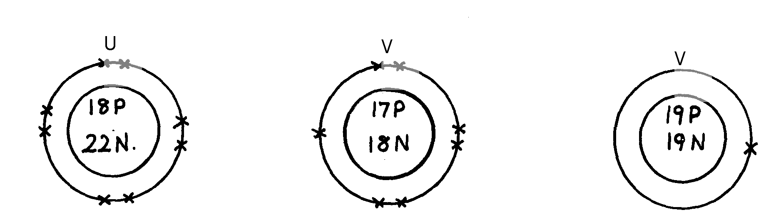
30. Below are structures of particles. Use it to answer questions that follow. In each case only
electrons in the outermost energy level are shown
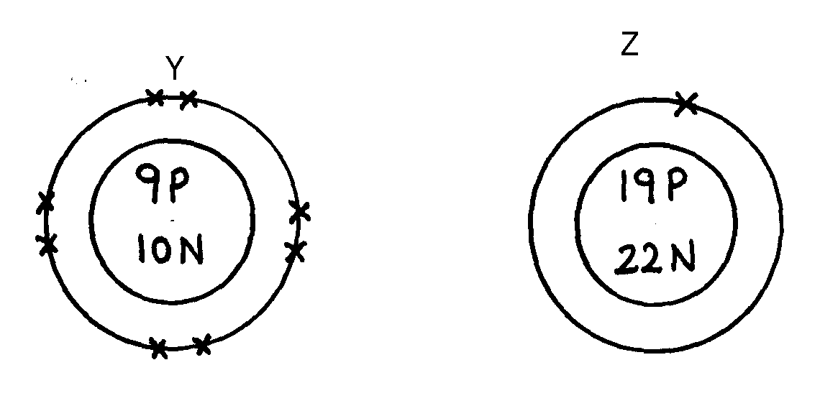
key
W
U
V
19P
20N
Z
Y
P = Proton
N = Neutron
X = Electron

(a) Identify the particle which is an anion
31. Plastics and rubber are extensively used to cover electrical wires.
(a) What term is used to describe plastic and rubbers used in this way?
(b) Explain why plastics and rubbers are used this way

32. The scheme below represents the manufacture of a cleaning agent X

R
Conc.

H₂SO₄
R

SO₃H
Cleaning agent X

(a) Draw the structure of X and state the type of cleaning agent to which X belong
(b) State one disadvantage of using X as a cleaning agent
33. Y grams of a radioactive isotope take 120days to decay to 3.5grams. The half-life period
of the isotope is 20days
(a) Find the initial mass of the isotope
(b) Give one application of radioactivity in agriculture
34. The structure below represents a polymer. Study and answer the questions that follow:-
H H

-C – C -

CH₃ H
n
n

(i) Name the polymer above..................................................................................
(ii) Determine the value of n if giant molecule had relative molecular mass of 4956
35. RCOO⁻Na⁺ and RCH₂OSO₃⁻Na⁺ are two types of cleansing agents;
i) Name the class of cleansing agents to which each belongs
ii) Which one of these agents in (i) above would be more suitable when washing with water
from the Indian ocean. Explain
iii) Both sulphur (IV) oxide and chlorine are used bleaching agents. Explain the difference
in their bleaching properties

36. The formula given below represents a portion of a polymer
H H H H

C C C C

O H O H
n

(a) Give the name of the polymer
(b) Draw the structure of the monomer used to manufacture the polymer

