Organic chemistry 1
1. Use the flow chart below to answer the questions that follow:
U
H₂O

Heat

CH₂BrCH₂Br
CH₂CH₂
CH₃CH₃
Process K
Process J
Nickel catalyst

Process T

H H H

C C C

H H H

n

(a) What observation would be made in process K?
(b) Name another conditions necessary for process J to take place
(c) Give the name of substance V
2. But-z-ene undergoes hydrogenation according to the equation given below

CH₃CH = CHCH₃ _{(g)} + H_{2(g)} CH₃CH₂CH₂CH_{3(g)}

(a) Name the product formed when but-z-ene reacts with hydrogen gas
(b) State one industrial use of hydrogenation
3. Write the structures of the following compounds:-
(a) But—2-yne
(b) 2,2-dimethylpropane
4. a)What is meant by Isomerism?
b) Draw and name two Isomers of butane.

5. Study the information in the table below and answer the questions that follow:

Ion | No. of protons | No. of electrons
P³⁻  Q⁺  R²⁺ | 7  19  12 | 10  18  10

a) Write the electron arrangement of element P.
b) Give the group and period to which elements Q and R respectively.
Q ……………………………………………………
R ……………………………………………………

6. Compound W reacted with chlorine to form compound X only. The structural formula of
X is shown below:
CH₃ - CH - CH - CH₃

Cl Cl
(a) Give the structural formula and name of compound W
(b) Name compound X ……………………………………………………………………
7. In petrol chemical industries, long chain alkanes are broken down in to simpler substances
in a process called cracking
a) Why is cracking necessary?
b) State the two conditions required in cracking
c) Draw the structure of 1-chloro-2, 2-dimethylpropane
8. In a reaction an alcohol K was converted to hex-1-ene
a) Name reagent and condition necessary for the reaction in 6 (a) above to occur
9. (a) Give the IUPAC systematic names of compounds Q and R
Q: CH₂CHClCHlCH₂CH₃
R: CH₃CHClCH₂ClCH₃
(b) The organic compounds Q and R in (b) above, are formed when one mole of hydrocarbon
N reacts with two moles of hydrogen chloride gas;
(i) Structural formula of N
(ii) The IUPAC systematic name of N
10. Distinguish between the isotopes and isomers
11. Polymerisation of ethene takes place as shown in the equation below
H H

C = C

H H
H H

CC

HH

High temperature
pressure
n
n

Name the type of polymerisation undergone by ethene in the reaction above
12. (a) State Gay Lussac’s law
13. 10cm³ of methane (CH₄) gas is exploded with 150cm³ of air containing 20% oxygen
and 80% nitrogen. The products were allowed to cool to room temperature. What will
be the total volume of the gases at the end of the reaction?

14. Give the open structures of:-
(i) 3-chlorohex-l-yne
(ii) CH₃OH
15. A fixed mass of gas occupies 105cm³ at -14ºC and 650mmHg pressure. At what temperature in
degrees Celsius will it have a volume of 15cm³ if the pressure is adjusted to 690mmHg pressure?
16. Write an equation for the reaction that takes place between ethene and concentrated
Sulphuric (VI) acid
17. Petroleum (crude oil) is a mixture of several compounds which are separated in a Changamwe refinery by means of apparatus as shown below:
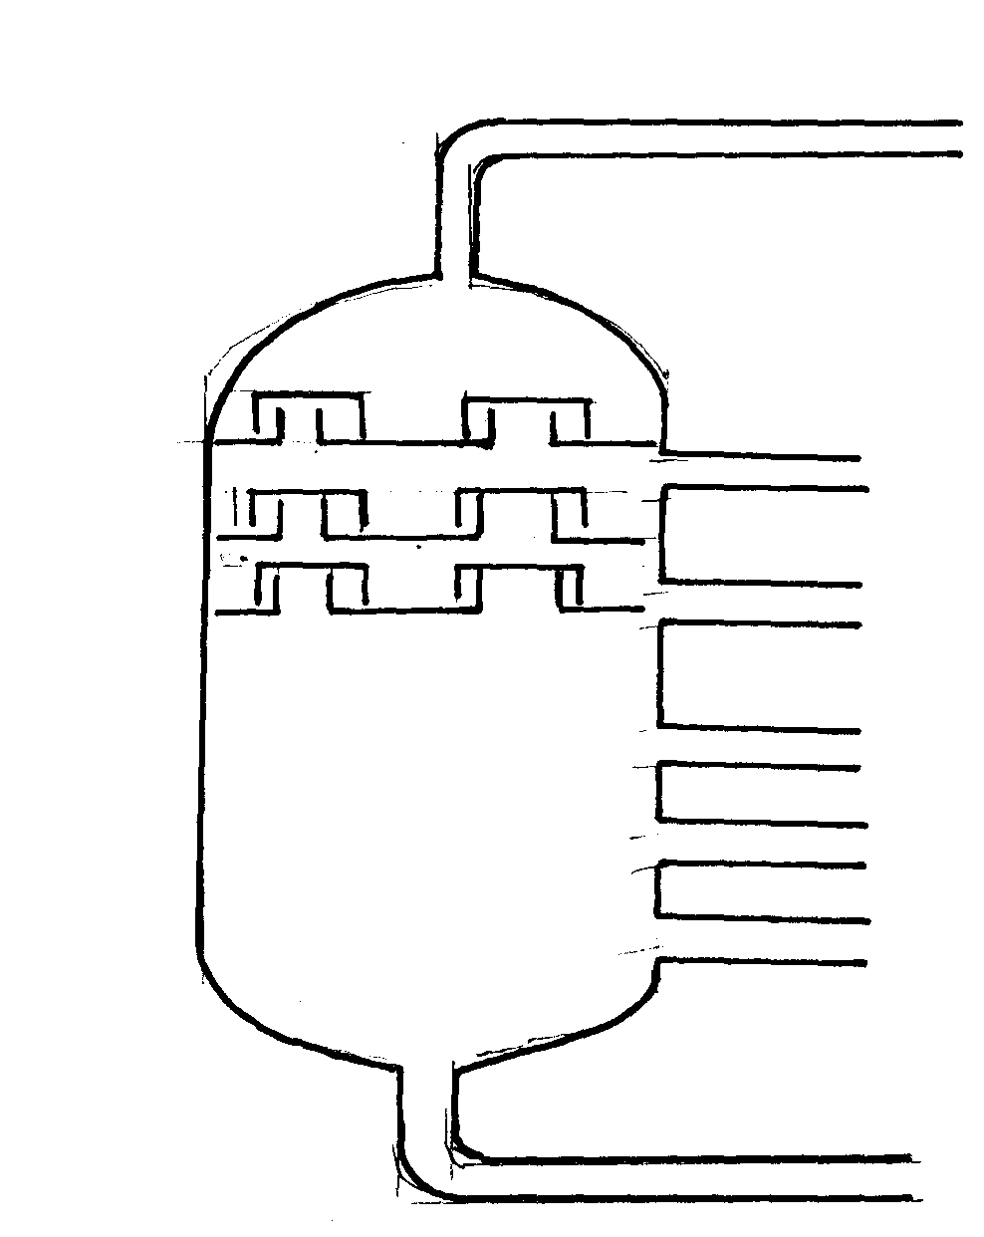
A

B
C
D
E

Crude oil
F

G

(a) (i) What is the name of the apparatus above
(ii) What is the name of the process which is used in separation of crude oil
(iii) What physical property of compounds in the mixture does the separation depend
(iv) Use the letter A to G to describe where the following could be formed:.
I. The fraction that represents gases
II. The fraction that represents the largest molecules
III. The fraction that represents liquids with the lowest boiling points
(b) State the use of product produce at
G………………………………………………………………………………………
C……………………………………………………………………………………….
(c) Draw apparatus for the separation of the product produce at D and water

18. Study the flow chart below and answer the questions that follow:-
A
H₂O + B
CH ≡ CH
CH₃CH₃
Br Br

H- C – C – H

Br Br
HCl
Step I
Step 2
O₂ excess
Br Br

H- C – C – H

Br Br

(i) Give the name of the substance CH ≡ CH …………………………………………
(ii) To which group of hydrocarbons does the substance in (i) above belong?
(iii) Give two reagents that can be used to prepare the substance named in (i) above
(iv) State two physical properties of the substances in (i) above
(v) Give the names to the process in step I and 2
(vi) Write an equation to show how substance A is formed
(iv) Identify substance B ……………………………………………………
19. The diagram below represents a large-scale fractional distillation plant used to separate
the components A, B, C and D in a mixture
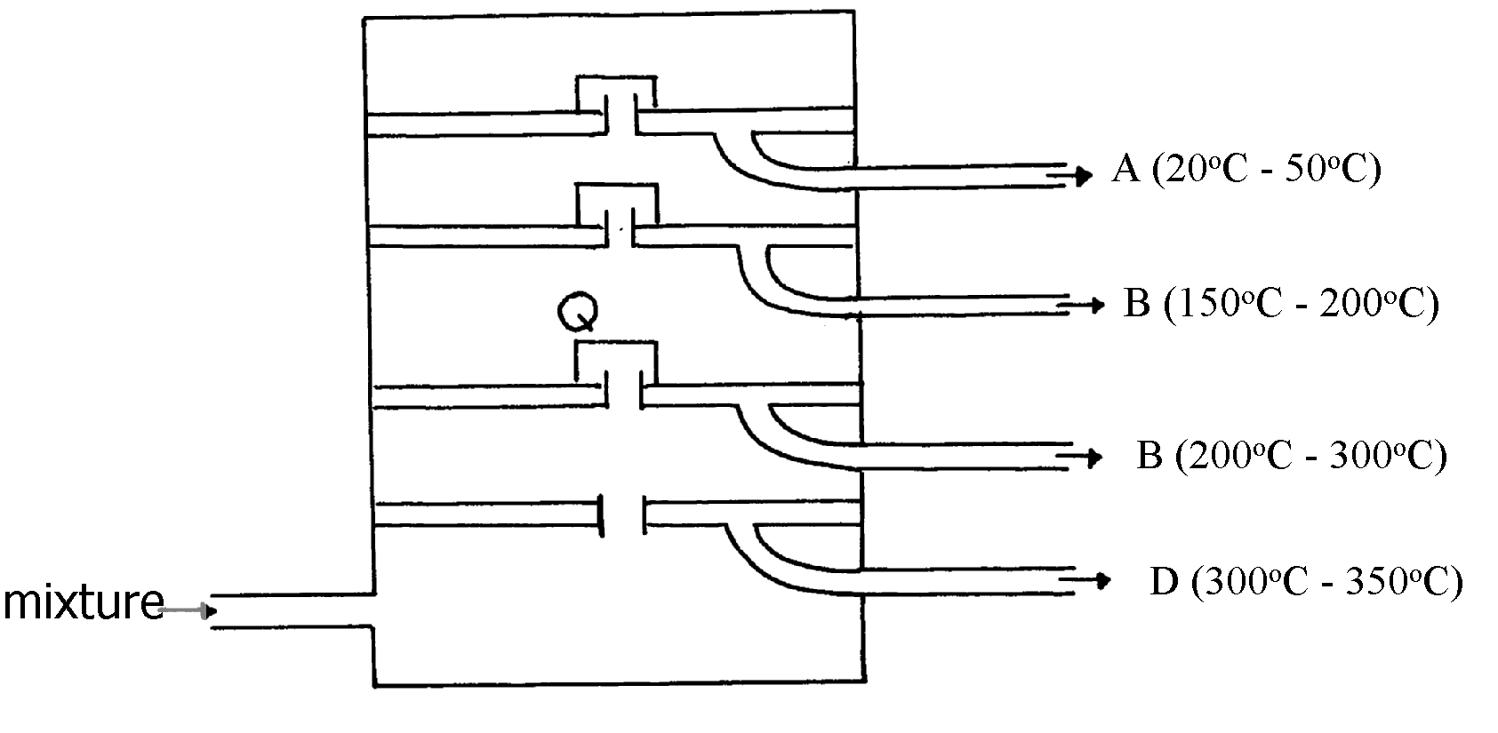
Heat


(a) The components have the following average relative molecular masses not necessarily in that
order; 282, 184, 44 and 128.
(a) (i) What is the physical state of B at the position marked Q?
(ii) Which component has an average relative molecular mass of 128? Explain
(iii) State with a reason whether C is pure or impure
(iv) Explain how the mixture is separated into its components
(v) Name two naturally occurring mixtures that are separated using this process
20. The diagram below represents a large-scale fractional distillation plant used to separate
the components A, B, C and D in a mixture
(a) The components have the following average relative molecular masses not necessarily in that
order; 282, 184, 44 and 128.
(a) (i) What is the physical state of B at the position marked Q?
(ii) Which component has an average relative molecular mass of 128? Explain
(iii) State with a reason whether C is pure or impure
(iv) Explain how the mixture is separated into its components
(v) Name two naturally occurring mixtures that are separated using this process
21. a) The table below gives information about the major constituents of crude oil. Study it and
answer the questions that follow:
Constituent | Boiling point ºC
Gases  Petrol  Kerosene  Diesel  Lubricating oil  Bitumen | Below 40  40-175  175-250  250-350  350-400  Above 400
i) Which of the constituents of crude has molecules with the highest number of carbon
atoms? Explain
ii) Name the process you would use to separate a mixture of petrol and diesel and explain how
the separation takes place
iii) Explain why the constituents of crude oil do not have a sharp boiling point
iv) Name the gas that is likely to be a constituent of crude oil and write its formula
b) i) What condition could cause a poisonous gas to be formed when kerosene is burnt.
Explain
ii) Give one use of bitumen
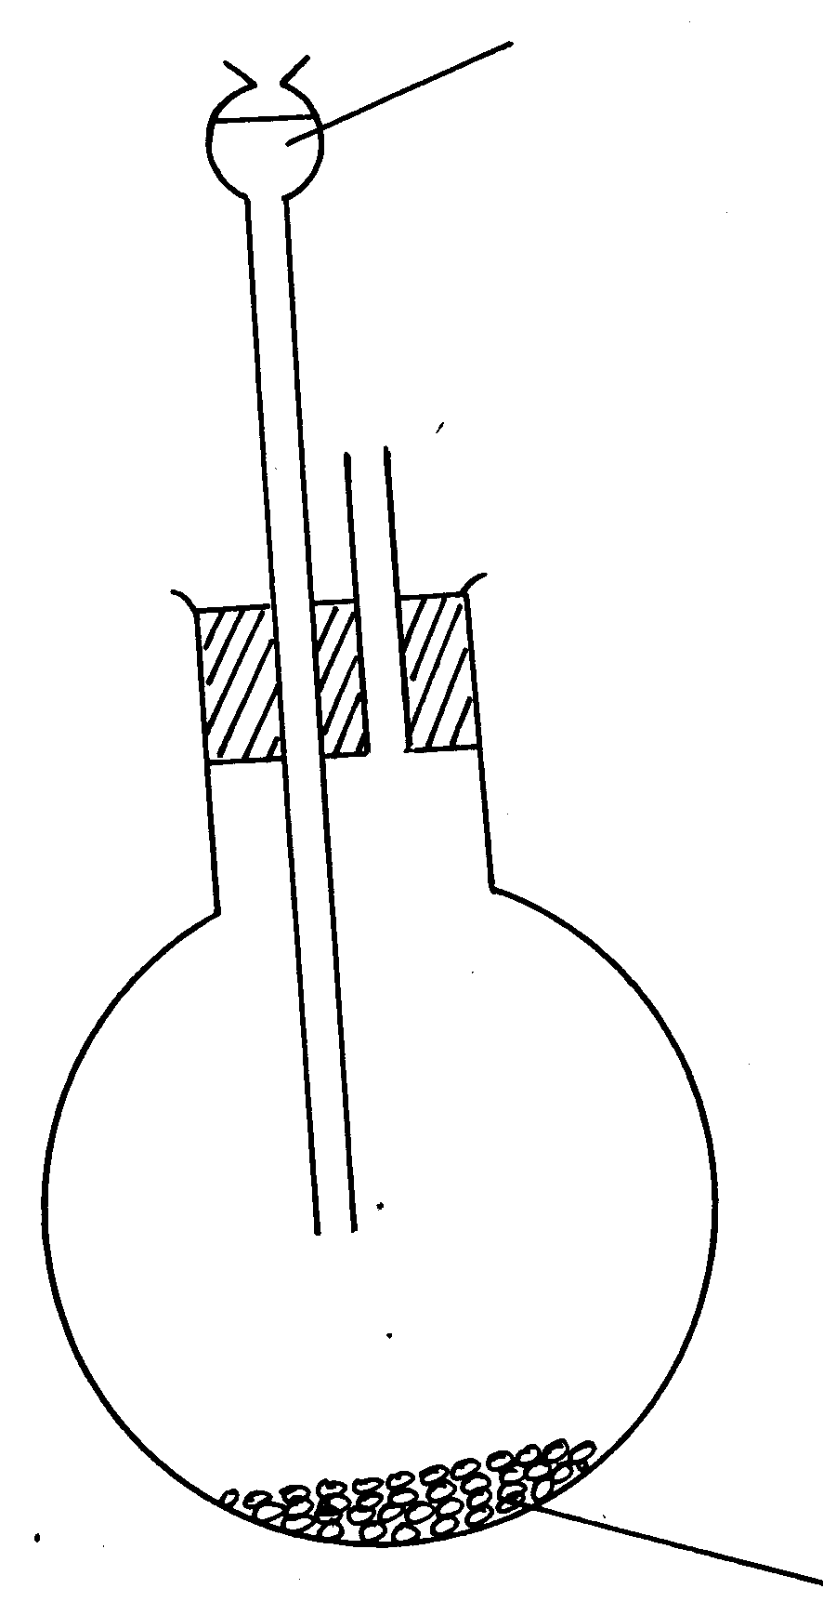
22. (a) The set-up below was used to prepare ethyne gas
Water
Solid E + sand

(i) Identify solid E
(ii) Complete the diagram to show how the gas can be collected
(iii) Write an equation to show how the gas is formed
(iv) Complete the equation below: )
C₂H₂ + 2I₂
(v) What is the role of sand in the experiment?
(b) (i) Explain the meaning of esterification
(ii) Complete the equation below :
CH₃COOCH₃ + H₂O
(iii) What type of reaction is occurring above
(c) Given the reaction:
Solid F
C₈H₁₈ N + C₂H₄
(i) Identify substance:
F………………………………… N………………………………
(ii) Name the process represented above?
(d) Give one use of substance N

Step II
Electrolysis Step I

Water

Nitrogen (IV) Oxide
Step 4 Air Platinum-rhodium catalyst at 900ºC
Step 5 Air
N₂
Ammonium Nitrate
Air

H₂

Ammonia
Colourless gas Q
Step 6
Nitric (V) acid
Step 7
Step III

23.

(i) Name another source of hydrogen apart from electrolysis of water
(ii) What conditions are necessary for step III to occur?
(iii) Write the equation for the formation of colourless gas Q
(iv) Give one use of nitric (V) acid
(b) State and explain the observations that would be made if a sample of copper metal is
heated with concentrated nitric (V) acid
24. (a) Give the systematic names of the following compounds:-
(i) CH₂ = C – CH₃ ..........................................................................

Br
(ii) CH₃CH₂CH₂C ≡ CH .................................................................
(b) State the observations made when buton-l-ol reacts with:-
(i) Acidified potassium dichromate (VI) solution
(ii) Potassium metal
(c) Ethanol obtained from glucose can be converted to ethene as shown below:-
Step I
Step II
C₆H₁₂O₆ C₂H₅OH C H₂ = CH₂

Name and describe the processes that take place in steps I and II
(d) Compounds A and B have the same molecular formula C₃H₆O₂. Compound A librates
Carbon (IV) Oxide on addition of aqueous sodium carbonate while compound B does not.
Compound B has a sweet smell. Draw the possible structures of:-
(e) Give two ways how the disposal of polymers such as polychloroethene by burning pollutes
the environment

25. (a) Name the following compounds (CH₃)₃ C CH₂ CH₂ CH₃
Use the flow chart below to answer the questions that follow:-
L
Polymer K
Substance M
R
Gas P
Sodium Metal

Concentrate H₂SO_{4(l)}
H⁺_{(aq)} / KMNO_{4(aq)}
Step II
Step I

N₁/H₂
High temperature

High pressure
J
CH₃CHCH₂
HBr
Q
Substance N
NaOH
Step II
Soda lime
Heat
Step III
CH₃CH₂CH₂Cl
Gas S

(b) (i) Name the following :-
I. Gas S ……………………………………………………………….……. ( )
II. Gas P …………………………………………………………………
III. J ……………………………………………………………………….
(ii) Name the processes involved in the following steps:
I. Step I …………………………………………………………………………..
II. Step II …………………………………………………………………………….
III. Step III …………………………………………………………………………….
(iii) Write a chemical equation for the complete combustion of substance M
(iv) Name the condition and reagent in step III
Condition ……………………………………………………………………………………
Reagent …………………………………………………………………………………….
(v) Calculate the mass of salt R that would be formed by using 21.9 tonnes of N when it reacts
with excess sodium hydroxide ( C= 12.0 H= 1.0 Na = 23)
(vi) Draw the structure of polymer K
II. State one use of the above polymer
………………………………………………………………………………………………….
(c) (i) Name the class to which the following cleansing agents belong:-
R – COONa⁺
i) ……………………………………………………

(ii) ……………………………………………………….
R – O-SO₃ Na
O

II. Which cleaning agent above is not environmental friendly? Explain

26. The molecular formula of a hydrocarbon is C₆H₁₄. The hydrocarbon can be converted into two
other hydrocarbon as shown by the equation below:
C₆H₁₄ C₂H₆ + X
(i) Name and draw the possible structural formula of X
(ii) State and explain the observations that would be made if a few drops of bromine water
were added to a sample of X
(iii) Write an equation for the complete combustion of C₃H₈

27. (a) Give the names of the following
(i) CH₃CH₂CH₃
(ii) CH₃CCCH₃
(b) Ethene is used in making polyethene bag in a process called polymerization
(i) Name the type of polymer that is formed when ethane polymerise
(ii) Describe a simple chemical test that can be used to identify ethane gas in the laboratory
(c) Study the information in the table below and answer the questions that follow:-
No. of carbon atoms | R.M.M of the Hydrocarbon
2  3  4 | 28  42  56
i. Write the general formula of the hydrocarbons in the table above
ii. Determine the molecular of a hydrocarbon with 5 carbon atoms and draw its structural formula
Molecular formula
Structural formula
(d) Study the scheme below and answer the questions that follow
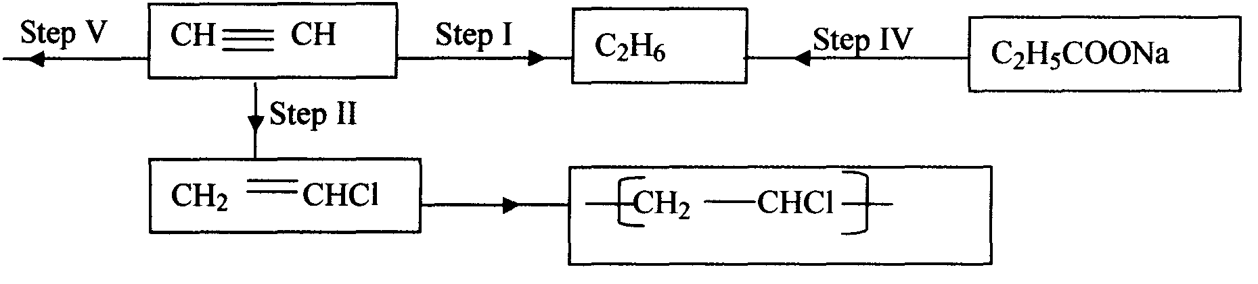

(i) Name the reagents in
Step I ……………………………
Step II ……………………………
Step IV ………………
(ii) Write an equation for the complete combustion of CH ≡CH
(iii) Give two uses of CH₄
28. Give the systematic names of the following compounds;
i)CH₃ = C-CH₃

CH₃
ii)CH₃CH₂CH₂C≡ CH

29. Study the data given in the following table and answer the questions that follow. The letters
are not the actual symbols of elements.

Element | Number of protons | Melting point | Bpt ºC
A | 11 | 98 | 890
B | 12 | 650 | 1110
C | 13 | 60 | 2470
D | 14 | 1410 | 2360
E | 15 | 442  590 | 280
F | 16 | 113  119 | 445
G | 17 | -101 | -35
H | 18 | -189 | -186

(i) State and explain the trend in melting point in A B C
(ii) Explain why the melting point and boiling points of element D is the highest
(iii) Explain why the element represented by letter E has two melting point values
(iv) Write down the chemical formula between element C and sulphate ions
(v) Name the chemical family in which H belong and state one use of the element
(vi) What is the nature of the oxide of the elements represented by letters C and F?

30. a) The table below gives information about the major constituents of crude oil. Study it and
answer the questions that follow:
Constituent | Boiling point ºC
Gases  Petrol  Kerosene  Diesel  Lubricating oil  Bitumen | Below 40  40-175  175-250  250-350  350-400  Above 400
i) Which of the constituents of crude has molecules with the highest number of carbon
atoms? Explain
ii) Name the process you would use to separate a mixture of petrol and diesel and explain how
the separation takes place
iii) Explain why the constituents of crude oil do not have a sharp boiling point
iv) Name the gas that is likely to be a constituent of crude oil and write its formula
b) i) What condition could cause a poisonous gas to be formed when kerosene is burnt.
Explain
ii) Give one use of bitumen
31. Study the information in the table below and answer the questions that follow
Number of carbon atoms per molecule | Relative molecular mass of the hydrocarbon
2  3  4 | 28  42  56
i) Write the general formula of the hydrocarbons in the table
ii) Predict the relative atomic mass of the hydrocarbons with 5 carbon atoms
iii) Determine the relative atomic mass of the hydrocarbon in (ii) above and draw its
structural formula (H=1.0, C=12.0)
32. Substance “M” with a general formula C₂Hy burnt in chlorine gas with a red flame producing
a cloud of black specks and colourless gas G.
(a) State the collective name for compounds which ‘M’ belongs
(b) With reason, state the identity of the black specks and colour gas “G”.

33. 2.63g of a solution of sodium chloride at 20.0ºC was reacted with silver nitrate. After filtration,
washing and drying, 2.36g of silver chloride was obtained. Determine the solubility of sodium
chloride at 20.0ºC . (Na=23, Cl= 35.5, Ag = 108)
(b) Determine the number of moles of carbon (IV) Oxide gas produced when sodium
carbonate reacted with dilute sulphuric (VI) acid (Molar gas volume =24dm³)
34. Write down all the isomers of but-z-ene and give their IUPAC names
35. (a) A hydrocarbon compound Z decolourizes bromine liquid in the presence of light but
does not decolourize acidified potassium manganate (VII). Name and draw the structural
formula of the eighth member of this homologous series
36. (a) What is meant by isomerism?
(b) Draw and name two isomers of Butyne

