**NAME……………………………………… INDEX NO.……………………………….…**

**SCHOOL……………………………………. DATE ………………………………………**

**CANDIDATE’S SIGNATURE………………………………………………………………**

**233/1**

**CHEMISTRY**

**PAPER 1**

**THEORY**

**SEPTEMBER 2024**

**TIME: 2 HRS**

**NYAHOKAKIRA SET 2**

***Kenya certificate of secondary education (K.C.S.E)***

**233/1**

**CHEMISTRY**

**PAPER 1**

**THEORY**

**SEPTEMBER 2024**

**TIME: 2 HRS**

**for examiner’s use only**

|  |  |  |
| --- | --- | --- |
| **QUESTIONS** | **MAXIMUM SCORE** | **CANDIDATE’S SCORE** |
| **1 - 28** | **80** |  |

***This paper consists of 12 printed pages.***

***Candidates should check the question paper to ensure that all***

***pages are printed as indicated and no questions are missing***

1. The table below indicates the PH value of solutions labelled M, L, N, P and Z.

|  |  |  |  |  |  |
| --- | --- | --- | --- | --- | --- |
| PH | 4 | 14 | 1 | 10 | 7 |
| Solution | M | L | N | P | Z |

* 1. **Which** solution has the highest concentration of hydrogen ions? (1mk)

………………………………………………………………………………………………

* 1. **Which** solution can be used as an anti-acid? **Give** a reason for your answer. (2mks)

………………………………………………………………………………………………

………………………………………………………………………………………………………………………………………………………………………………………………

1. The diagram below represents the apparatus used to react steam with magnesium.

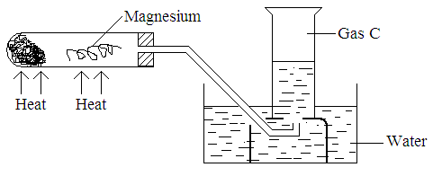

* 1. **State** the observation made in the boiling tube. (1mk)

………………………………………………………………………………

* 1. **Write** an equation for the reaction that takes place in the tube. (1mk)

………………………………………………………………………………

* 1. What property makes it possible for gas C to be collected as shown? (1mk)

…………………………………………………………………………………

1. In which homologous series do the following compounds belong?

(i) CH3 CH CH2 (2 marks)

………………………………………………………………………………………………

(ii) CH3 CH2 CH2 OH

………………………………………………………………………………………………

1. The structures shown below represent two cleansing agent A and B.

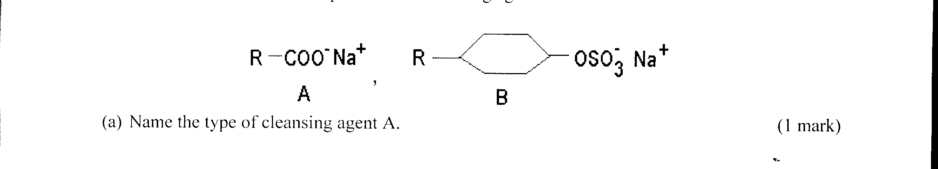

(a) Name the type of cleansing agent A. (1 mark)

……………………………………………………………………………………………………………………………………………………………………………………

(b) Which of the two cleansing agents is more suitable for washing in water containing calcium chloride? Give a reason. (2 marks)

………………………………………………………………………………………………………….…………………………………

………………………………………………………………………………………………………….……………………………………

………………………………………………………………………………………………………….……………………………………

1. (a) Name the two common ores from which Zinc metal can be extracted. (1mk)

………………………………………………………………………………..……………………………………………………………

………………………………………………………………………………………..…………………………………………………….

……………………………………………………………………………………………………………………………………………..

(b) Taking one of the ores named in (a) above, write a chemical equation for the

roasting process to get the required oxide. (1mk)

…………………………………………………………………………………………………………………………………

………………………………………………………………………………………………………………………………….

(c) Outline any two uses of Zinc metal. (1mk)

…………………………………………………………………………………………………………………………………

………………………………………………………………………………………………………………………………….

………………………………………………………………………………………………………………………………..

1. Paper chromatography was carried out to investigate presence of amino acids in beans. Study the chromatograms below to answer the question that follow:-

Beans Chromatogram

Amino acids Chromatogram

Solvent front

Origin

What conclusion can be drawn from these results? (2marks)

………………………………………………………………………………………………………….…………………………………………….

………………………………………………………………………………………………………….……………………………………………

………………………………………………………………………………………………………….……………………………………………..

1. Starting with Zinc metal describe how you would obtain a sample of solid zinc carbonate. (3marks)

……………………………………………………………………………………………………………….……………………………………………………………………………………………………..……………………………………………………………………………………………………………………………………………………………………………………………………………………………………………………………………………………………………………………………………………………………………………………………………………………………

1. i) The percentage of ${69 \atop 31}$ X is 60% and ${71 \atop 31}$ X is 40% for an isotopic element X. Calculate the relative atomic mass of X. (2mark)

………………………………………………………………………………………………………….…………………………………………….. ………………………………………………………………………………………………………….……………………………………………..

………………………………………………………………………………………………………….…………………………………………….

ii) Why do the two species have the same chemical properties? (1mark)

……………………………………………………………………………………………………………………………………………………..

……………………………………………………………………………………………………………………………………………………..

1. 15.8g of Sodium nitrate saturated 29.3cm3 of water at 320C. Determine the solubility of Sodium nitrate at 320C. (Density of water =1g/cm3). (3marks)

……………………………………………………………………………………………….………….………………………………………………………………………………………………………………………………………………………………………………………………………………………………………………………………………………………………………………………………………………………………………………………………..

10. Calculate the oxidation number of manganese in:

i) KMnO4 (1mark)

……………………………………………………………………………………………………………………………………………………..

……………………………………………………………………………………………………………………………………………………..

…………………………………………………………………………………………………………………………………………………….

ii) MnCl2 (1mark)

……………………………………………………………………………………………………………………………………………………

……………………………………………………………………………………………………………………………………………………

…………………………………………………………………………………………………………………………………………………..

1. Study the diagram below to answer the questions that follow.



Name the radiations p, q and r

i) p ………………………………………………………………………………………………… (1mark)

ii) q…………………………………………………………………………………………………. (1mark)

iii) r……………………………………………………………………………………............... (1mark)

1. a) Name **two** types of flame of the Bunsen burner. (1mk)

………………………………………………………………………………………………………….………………………………….

………………………………………………………………………………………………………….……………………………………

………………………………………………………………………………………………………….……………………………………

b) Which is the better flame for heating in the laboratory. Give **two** reasons. (2mks) ………………………………………………………………………………………………………….……………………………………

………………………………………………………………………………………………………….……………………………………

………………………………………………………………………………………………………….……………………………………

13. a) State Boyle’s law. ………………………………………………………………………………………………………….……………………………………………………………………………………………………………………………………………………………………………………

………………………………………………………………………………………………………………… ………………. (1 mk)

b) 60cm3 of oxygen gas diffused through a porous portion in 50 seconds. How long would it take 60cm3 of sulphur (IV) oxide gas to diffuse through the same portion under same conditions. (S=32.0, O=16.0) (2mks)

………………………………………………………………………………………………………….………………………………….

………………………………………………………………………………………………………….……………………………………

………………………………………………………………………………………………………….………………………………….

………………………………………………………………………………………………………….……………………………………

………………………………………………………………………………………………………….………………………………….

………………………………………………………………………………………………………….……………………………………

1. A student set up the apparatus as shown below to prepare and collect dry ammonia.

**Ammonium chloride + Calcium Hydroxide**

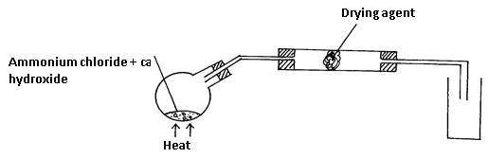

i) Identify **two** mistakes in the set up and give a reason for each mistake. (2mks)

I………………………………………………………………………………………………………….………………………………….

………………………………………………………………………………………………………….……………………………………

II………………………………………………………………………………………………………….………………………………….………………………………………………………………………………………………………….………………………………

ii) Name a suitable drying agent for ammonia (1mk) ………………………………………………………………………………………………………….………………………………….

………………………………………………………………………………………………………….…………………………………

15. Chlorine gas was bubbled through potassium iodide solution.

a) State the observation that would be made. (1mk)

………………………………………………………………………………………………………….………………………………….

………………………………………………………………………………………………………….……………………………………

b) Write the ionic equation for the reaction that took place in (a) above. (1mk)

………………………………………………………………………………………………………….………………………………….

………………………………………………………………………………………………………….……………………………………

c) Identify the oxidizing agent in the ionic equation (b) above. (1mk)

………………………………………………………………………………………………………….………………………………….

………………………………………………………………………………………………………….……………………………………

1. In the Haber process, the optimum yield of ammonia is obtained when a temperature of 4500C, pressure of 200 atmospheres and an iron catalyst are used. Equation for the reaction is shown below.

N2(g) + 3H2(g) 2NH3(g) Δ H= -92kJ.

How the yield of ammonia would be affected if:

i) Temperature raised to 6000C . (1mk)

………………………………………………………………………………………………………….………………………………….

………………………………………………………………………………………………………….……………………………………

ii) Pressure raised to 250 atmospheres. (1mk)

………………………………………………………………………………………………………….………………………………….

………………………………………………………………………………………………………….……………………………………

iii) The amount of catalyst doubled (1mks)

………………………………………………………………………………………………………….………………………………….

………………………………………………………………………………………………………….……………………………………

1. Use the standard electrode potentials for the elements to answer the questions that follows. The letters do not represents the actual symbols.

**Eθ (V)**

D2+(aq) + 2e- D(s) +0.34

B2+(aq) + 2e- B(s) + -2.38

E2(g) + 2e- 2e–(aq) +0.54

2C+(aq) + 2e- C2(g) +0.00

i) Which element is likely to be hydrogen? Explain (1mk)

………………………………………………………………………………………………………….………………………………….

………………………………………………………………………………………………………….……………………………………

………………………………………………………………………………………………………….………………………………….

ii) Identify **two** half cells from the above that when combined will give an electrochemical cell with the largest e.m.f. calculate the e.m.f. (2mks)

………………………………………………………………………………………………………….………………………………….

………………………………………………………………………………………………………….……………………………………

………………………………………………………………………………………………………….………………………………….

………………………………………………………………………………………………………….…………………………

1. The table below gives melting points and ionization energies of 3 metallic elements A, B, and C. The metals are arranged as they occur in the periodic table.

|  |  |  |
| --- | --- | --- |
| Element | Melting point (°C) | First ionization energy KJ/mol |
| A | 180 | 520 |
| B | 98 | 496 |
| C | 64 | 419 |

a. Which of these elements is the strongest reducing agent? (1mark)

………………………………………………………………………………………………………….………………………………….

………………………………………………………………………………………………………….……………………………………

b. Are these elements members of the same group or period? (1mark)

………………………………………………………………………………………………………….………………………………….

………………………………………………………………………………………………………….……………………………………

c. Using ‘dot’ and ‘cross illustrate bonding in Carbon (II) Oxide (1 mark)

………………………………………………………………………………………………………….………………………………….

………………………………………………………………………………………………………….……………………………………

………………………………………………………………………………………………………….………………………………….

………………………………………………………………………………………………………….……………………………………

………………………………………………………………………………………………………….………………………………….

………………………………………………………………………………………………………….…………………………………

1. Silicon (iv) oxide is a solid at room temperature whereas carbon (iv) oxide

is a gas at room temperature. Explain. (2mark)

………………………………………………………………………………………………………….………………………………….

………………………………………………………………………………………………………….……………………………………

………………………………………………………………………………………………………….………………………………….

………………………………………………………………………………………………………….……………………………………

1. 20.0cm3 of a solution containing 4g per litre of sodium hydroxide was

Neutralized by 8.0cm3 of dilute sulphuric (vi) acid. Calculate the concentration of sulphuric (vi) acid in moles per litre

(Na = 23**.**0, O = 16**.**0 H = 1**.**0 ) (3mark)

………………………………………………………………………………………………………….………………………………….

………………………………………………………………………………………………………….……………………………………

………………………………………………………………………………………………………….………………………………….

………………………………………………………………………………………………………….……………………………………

………………………………………………………………………………………………………….………………………………….

1. When a sample of concentrated sulphuric (vi) acid was left in an open

beaker in a room for two days, the volume was found to have increased slightly.

a. Name property of concentrated sulphuric (vi) acid shown by the above

reaction? Explain (2mark) ………………………………………………………………………………………………………….………………………………….

………………………………………………………………………………………………………….……………………………………

………………………………………………………………………………………………………….………………………………….

………………………………………………………………………………………………………….……………………………………

b. State one use of concentrated sulphuric (vi) acid that depends on the

property named above. (1mk) ………………………………………………………………………………………………………….………………………………….

………………………………………………………………………………………………………….……………………………………

22. The standard heat of combustion of carbon is -393kJ/mol, for hydrogen is

- 286kJ/mol and that of Butane is -2877kJ/mol. Calculate the heat of formation of Butane and draw an energy level. (3mark)

………………………………………………………………………………………………………….………………………………….

………………………………………………………………………………………………………….……………………………………

………………………………………………………………………………………………………….………………………………….

………………………………………………………………………………………………………….……………………………………

23. Barium nitrate and Barium chloride were mixed with water to form solution ‘X’ Sodium carbonate and potassium chloride solutions were mixed to form solution ‘Y’. Solution ‘X’ and ‘Y’ were then mixed. Write an ionic equation of the reaction that took place when the two solutions were mixed. (1mark)

………………………………………………………………………………………………………….………………………………….

………………………………………………………………………………………………………….……………………………………

24. An iron sculpture was produced to commemorate the anniversary of founder of a certain village. To prevent it from rusting, the village elder attached it by a wire to a block of zinc which was stored underground out of sight.

(i).Explain how the village elder’s action would prevent the rusting of the sculpture. (1mk)

………………………………………………………………………………………………………….………………………………………………..

………………………………………………………………………………………………………….………………………………………………

………………………………………………………………………………………………………….………………………………………………

(ii).What name is given to this method of preventing rusting? (1mk)

………………………………………………………………………………………………………….

(iii).List down **two** other ways in which rusting of the statue could be prevented. (1mk)

…………………………………………….……………………………………………………………………………………………………………..

………………………………………………………………………………………………………….………………………………………………..

…………………………………………………………………………………………………………………………………………………………..

25. The grid below is part of the periodic table. Use it to answer the questions that follow. (The letters do not represent the actual symbols of elements.)

|  |  |  |  |  |  |  |  |  |  |
| --- | --- | --- | --- | --- | --- | --- | --- | --- | --- |
|  |  |  |  | | | | | |  |
|  |  |  |  |  |  | **R** | **S** |  |
| **N** | **Q** |  |  |  |  | **T** | **U** |
| **P** |  |  | |  |  |  |  |  |  |
|  |  |  | |  |  |  |  |  |  |

(a) Indicate in the grid the position of an element represented by letter V, whose atomic number is 14. (1mk)

(b) Select a letter which represents a monoatomic gas. (1mk) ………………………………………………………………………………………………………….………………………………….

………………………………………………………………………………………………………….…………………………………

(c) Write an equation for the reaction between Q and T (1mk)

………………………………………………………………………………………………………….………………………………….

………………………………………………………………………………………………………….…………………………………

26. A student set up the apparatus for the preparation of carbon (IV) oxide gas as shown below.

Study the set up and answer the questions that follow.

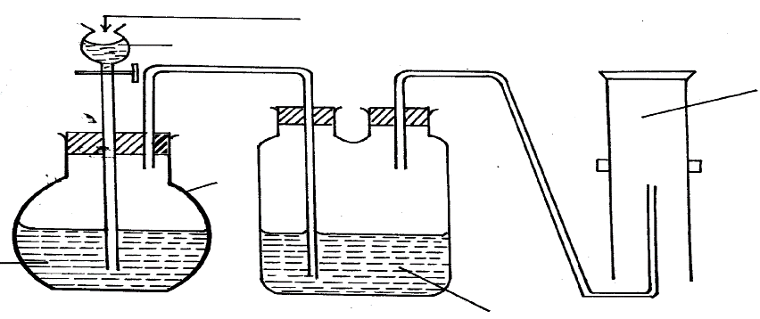

**X**

**Y**

Calcium

Carbonate

Potassium hydrogen carbonate

**Gas**

Dilute sulphuric(iv)acid

(a) Explain using an equation why the reaction in apparatus Y occurs for a very short time then stops. (1mk)

………………………………………………………………………………………………………….………………………………………………..

………………………………………………………………………………………………………….………………………………………………..

(b) What is the purpose of passing the gas through potassium hydrogen carbonate? (1mk)

………………………………………………………………………………………………………….…………………………………………………

………………………………………………………………………………………………………….………………………………………………..

(c) **State** and **explain** why there is no sample of carbon (IV) oxide gas collected. (1mk)

………………………………………………………………………………………………………….………………………………………………..

………………………………………………………………………………………………………….……………………………………………….

………………………………………………………………………………………………………….………………………………………………

27. 3.1g of an organic compound containing carbon, hydrogen and oxygen only produced 4.4g of carbon (iv) and 2.0 of water on combustion

a) Calculate its empirical formulae (2mk)

………………………………………………………………………………………………………….………………………………….

………………………………………………………………………………………………………….……………………………………

………………………………………………………………………………………………………….………………………………….

………………………………………………………………………………………………………….……………………………………

………………………………………………………………………………………………………….………………………………….

b) Calculate its molecular formular if its mass 90. (1mk)

………………………………………………………………………………………………………….………………………………….

………………………………………………………………………………………………………….……………………………………

………………………………………………………………………………………………………….………………………………….

………………………………………………………………………………………………………….……………………………………

28. 50g of a radioactive substance was reduced to 6.25g in 36.3years. Calculate the half-life of the substance. (2mks)

………………………………………………………………………………………………………….………………………………….

………………………………………………………………………………………………………….……………………………………

………………………………………………………………………………………………………….………………………………….

………………………………………………………………………………………………………….……………………………………

………………………………………………………………………………………………………….………………………………….

29. Explain the effect of the following on the rate of reaction in terms of the collisions theory; (3mks)

a) Increase in concentration

………………………………………………………………………………………………………….………………………………….

………………………………………………………………………………………………………….………………………………….

………………………………………………………………………………………………………….……………………………………

………………………………………………………………………………………………………….……………………………………

b) Change in pressure

………………………………………………………………………………………………………….………………………………….

……………………………………………………………………………………………………………….………………………………

………………………………………………………………………………………………………….……………………………………

…………………………………………………………………………………………………….……………………………………

c) Use of catalyst

………………………………………………………………………………………………………….………………………………….

………………………………………………………………………………………………………….……………………………………

………………………………………………………………………………………………………….………………………………….

………………………………………………………………………………………………………….……………………………………