Metals
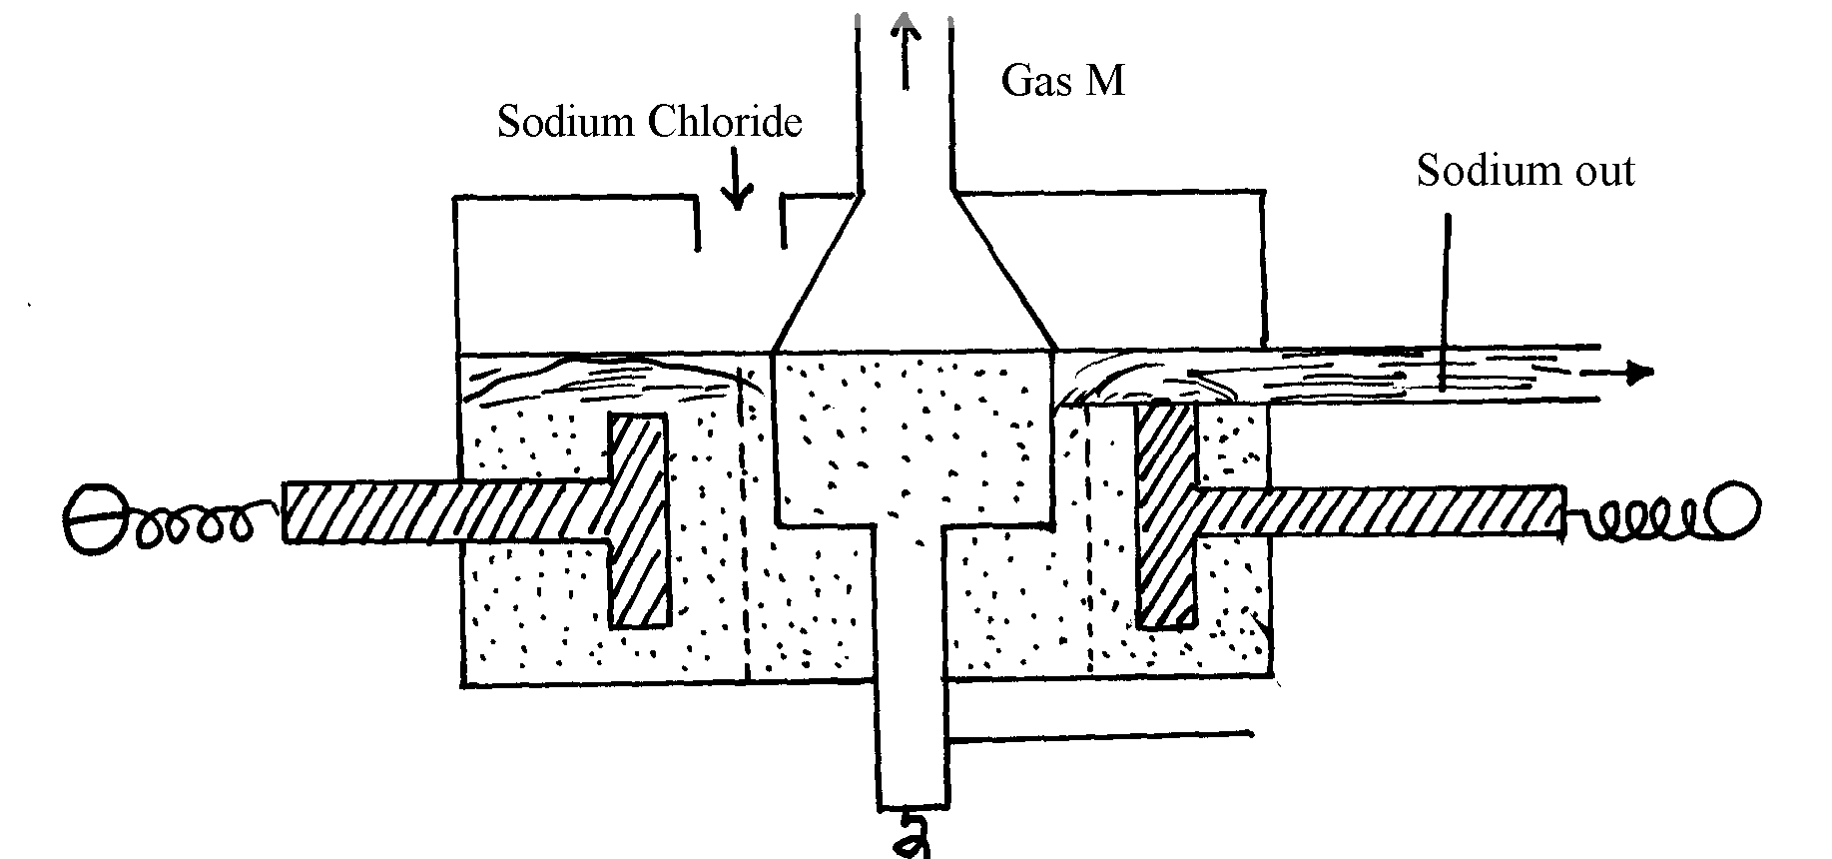
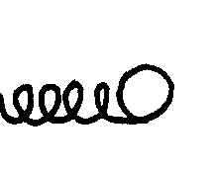
1. The following diagram represents extraction of sodium by the Down’s cell
+

(a) Why is the anode made of graphite in this case instead of steel which is a better conductor
of electricity?
(b) How are the electrolytic products separated from reacting?
(c) Give reasons why large quantities of electricity is required for this process
2. a) Give one environmental hazard associated with the extraction of zinc metal
b) Suggest one manufacturing plant that can be set up near zinc extraction plant. Give
reasons for your answer
c) What properties of aluminium and its alloys make it suitable for use in making aircraft parts
3. Aluminium is used in making overhead cables. State two properties of aluminium that
makes it suitable for this use
4. The stages shown in the following diagram can be used to extract zinc from its oxide:-
Name the stage and the process taking place in it:-
stage 3
C_{(s)} + O_{2(g)}
ZnO_{(s)} + CO_{(g)}
Zn_{(s)}
CO_{(g)} + O_{2(s)}
stage 2
stage 1

Name each sage and the process taking place in it:
Stage 1............................................................................................................................
Stage 2............................................................................................................................
Stage 3...................................................................................................................................

5. Study the flow chart below and answer the questions that follow:

Copper Pyrites
CuFeS₂
Step (I)
Froth floatation,
Air
Gas Q
Gas Q
Step (II)
Cu₂S_{(s)}
Cu₂O
Cu_{(s)}
Pure Copper
Air
Step (III)
Cu₂S
Step (IV)
FeO
Step (V)

(a) Name gas Q …………………………………………………………… .
(b) With the help of diagram, describe how step (V) is carried out

6. Name the following compounds using IUPAC system
(i) CCl₄
(ii) HOCl
7. Study the information provided:-
Element | Atomic radius (nm) | Ionic radius (nm) | Melting point of oxide (ºC )
W  Y  Z | 0.381  0.733  0.544 | 0.418  0.669  0.489 | -117  849  1399

(a) Explain why the melting point of the oxide of W is lower than that of the oxide of Z
8. The flow chart below shows steps used in the extraction of zinc from one of its ores.
Lead (II) Carbonate ore
Crushing

Step I
Powdered Lead (II)
Carbonate ore
Step 3 Heat
Gas
Lead (II) Metal
Concentrated Lead (II) Carbonate ore
Lead (II) Oxide
Coke

Step 4

Step 2

(a) Name the process that is used in step 2 to concentrate the ore
(b) Write an equation for the reaction which takes place in step 3
(c) Name one use of lead
9. Name the chief ores from which the following metals are extracted
a)Aluminium ……………………………………………………………………
b) Copper ………………………………………………………………………
10. The diagram below represents the second stage in extraction of aluminium metal

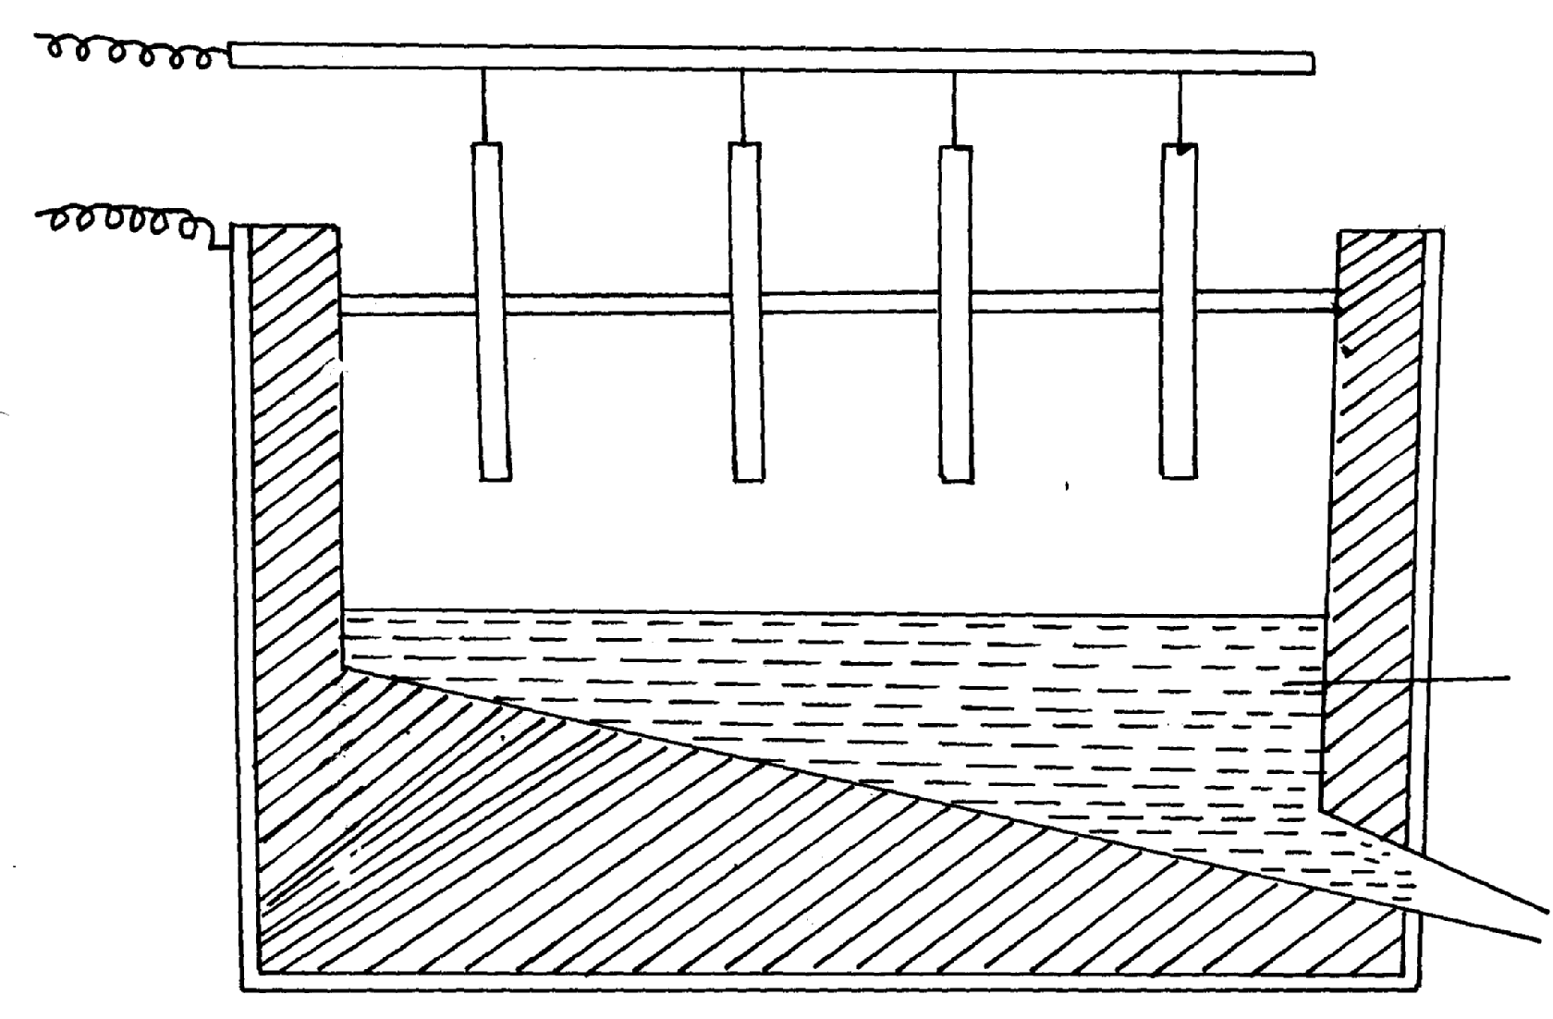
Aluminium

i) On the diagram label the: Anode, cathode and the electrolyte region (s)
ii) The melting point of aluminium oxide is 2054ºC, but the electrolysis is carried out at between
800-900ºC
a) Why is the electrolysis not carried out at 2054ºC
b) What is done to lower the temperature?
iii) The aluminium which is produced is tapped off as a liquid .What does this suggest about its
melting points?

11. The extraction of aluminium from its ore takes place in 2 stages. Purification stage and electrolysis stage. Below is set-up for the electrolysis stage:-

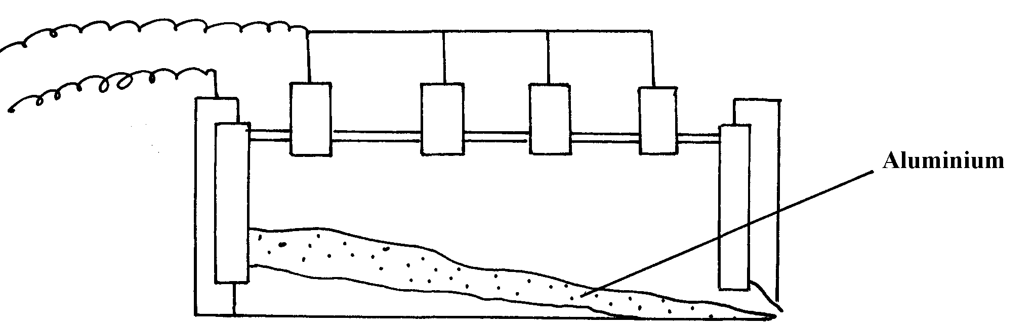

(a) (i) Name the chief ore from which aluminium is extracted
(ii) Name one impurity which is removed at the purification stage
(b) (i) Label on the diagram each of the following:-
I – Anode
II- Cathode
III- Region containing electrolyte

(ii) The melting point of aluminium oxide is 2054ºC but the electrolysis is carried out at between
80ºC and 900ºC
I. Why is not carried out at 2050ºC
II. What is done to lower the temperature
12. Aluminium is the most abundant metal in the earth crust and it is widely extracted for
its wide range of uses.
(i) Name one major ore of aluminium and give its formula
(ii) Name two main impurities found in the ore
(iii)Aluminium oxide is heated first before it is electrolysed. Explain
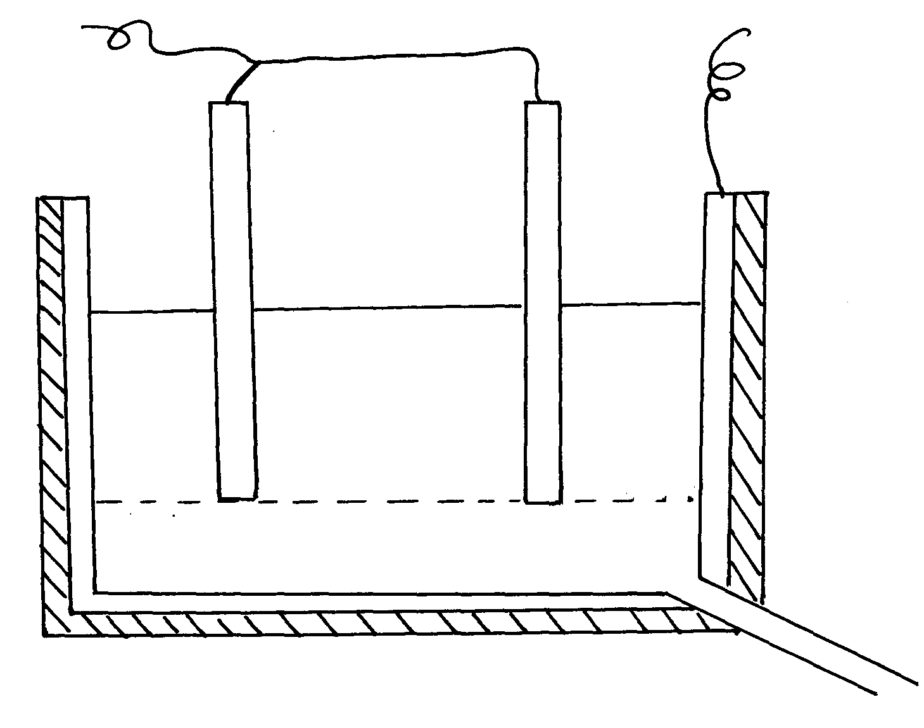
(iv) Electrolysis of aluminium oxide is done as shown below:

Molten aluminium oxide with cryolite

(a) Identify the anode and cathode on the diagram
(b) What is the role of electrolyte in the extraction ?
(c) Write half equations for the reactions that occur at the anode and cathode
(d) State two uses of aluminium
13. The diagram below is a flow chart for the extraction of copper. Study it and answer the questions
that follow:
Ore
Crushed
I
Powdered Ore
Mixed with water, oil & air
II
Concentrated Ore
Copper (I) Sulphide
Roasted in presence of sand
IV
Copper (I) Sulphide and iron (II) Oxide
Liquid Copper
Cooled
VI
Blister Copper
Pure Copper
Electrolysis
VII
Heated in a converter
Slag
Roasted in air

SO₂
III

SO₂

(a) Write the formula of the major ore of copper metal
(b) Name process II
(c) Give an equation for the reaction that occurs in stage III
(d) Explain what happens in stage IV
(e) Write half cell equations occurring at the anode and cathode in stage VII
(f) Draw a simple diagram showing the set-up that is used in electrolytic purification
of copper
(g) A green rocky materials suspected to be the ore malachite CuCO₃. Cu (OH)₂.
14. The flow chart below illustrates the extraction of Zinc. Study it and answer the questions that follow:
Sulphide ore
Roaster
Mixer
Reaction chamber 1
Cooling chamber
Zn⁺ impurities
Air
Reaction chamber II
Filtration chamber
Crystallization chamber
ZnSO₄. XH₂O
Residue S
Liquid R
Separation chamber
ZnO
SO₂
Coke
Gas Q
Zn_{(s)}
Zn_{(s)}

Zn_{(s)}

a) Name:-
i) Gas Q .............................................................................
ii) Liquid R .....................................................................................................................
(iii) Residues S ..............................................................................................................
b) Name the sulphide ore used
c) Before the ore is roasted, it is first concentrated;
(i) Explain why it is necessary to concentrate the ore
(ii) Explain briefly the process of concentrating the ore
d) Write an equation for the reaction that takes place in the:-
(i) Roaster
(ii) Reaction chamber
(e) (i) Name one major impurity present in the sulphide ore used
(ii) Write an equation to show how the impurity in (e)(i) above is removed
f) Given that the sulphide ore contains only 45% Zinc sulphide by mass, calculate :
(i) The mass in grams of Zinc sulphide that would be obtained from 250kg of the ore.
(ii) The volume of Sulphur (IV) oxide that would be obtained from the mass of sulphide
ore at room temperature and pressure
(Zn = 65.4, S = 32.0, O= 16.0, I mole of gas occupies 24.0 liters at r.t.p)
15. The flow chart below represents the extraction of zinc from its ore and a by-product used in the
manufacture of sulphuric (VI)acid. Study it and use it to answer the questions that follow:-

Zinc Ore
Concentration
Roasting furnace
Hot air blast
Reduction chamber
Solid A

SO_{2(g)}
Cleaners and driers
Chamber L
Molten Zinc
Catalytic chamber
Air
Chamber N
H₂SO₄
W
M
Z
P

a) Name;
i) The suitable zinc ore used.
ii) The main impurity in the ore
b) Describe how zinc ore is concentrated
c) Write an equation for the reaction taking place in the roasting furnace
d) Describe what happens in the reduction chamber
e) Identify substances:-
W…………………………………(½mk) M………………… (½mk)
f) Write the equation for the reaction that occurs in chamber N.
g) Explain why sulphur (VI) oxide is not dissolved directly in water
h) Explain the danger caused by this process to the environment
(2 marks)

16. The diagram below is for extraction of Aluminium from its ore. It takes place in stages.
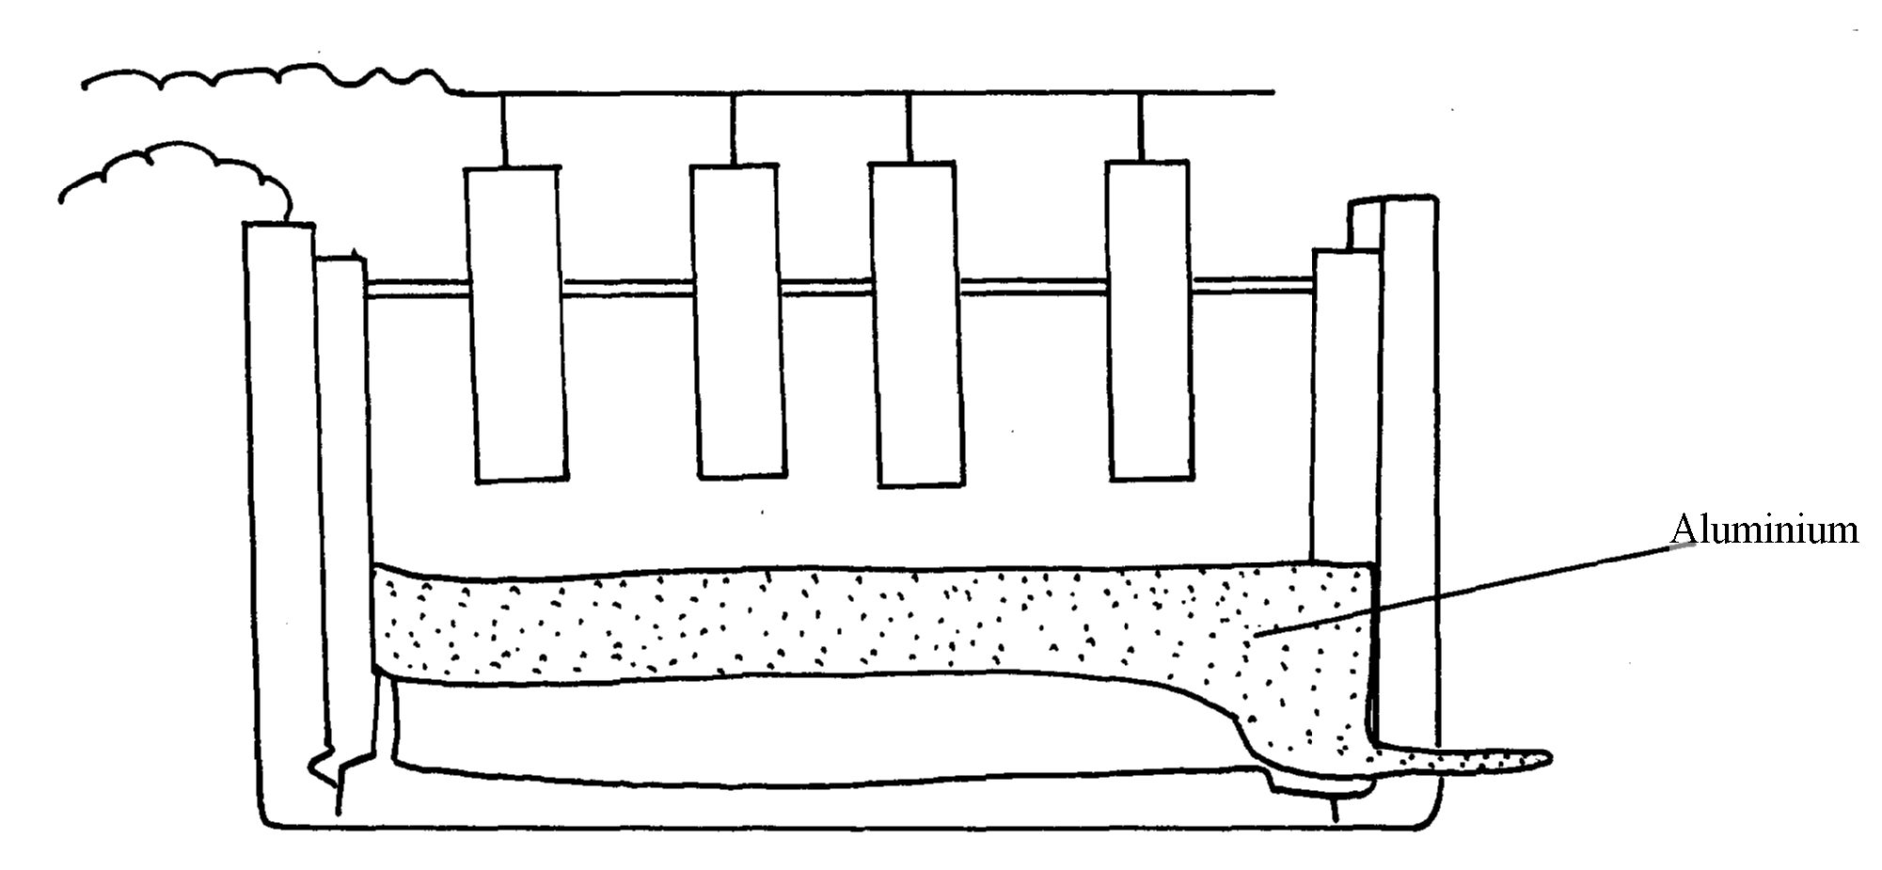
Use it to answer the questions that follow:-

(a) Name the two stages mentioned above *
(b) Name:-
(i) The ore from which Aluminium is extracted
(ii) The impurities removed during the extraction of Aluminium *
(c) On the diagram label:-
(i) The electrodes *
(ii) The region containing the electrolyte *
(d) Molten cryolite is added to Aluminium Oxide during extraction. Explain *

17. A current of 3A was passed through fused aluminium oxide for 10minutes. Calculate
the mass of Aluminium obtained at one electrode (Al = 27.0, IF = 96500C) *

18. (a) Name one ore that can be used to commercially extract Zinc metal
(b) The flow chart below illustrates the extraction of zinc and preparation of zinc sulphate
crystals.

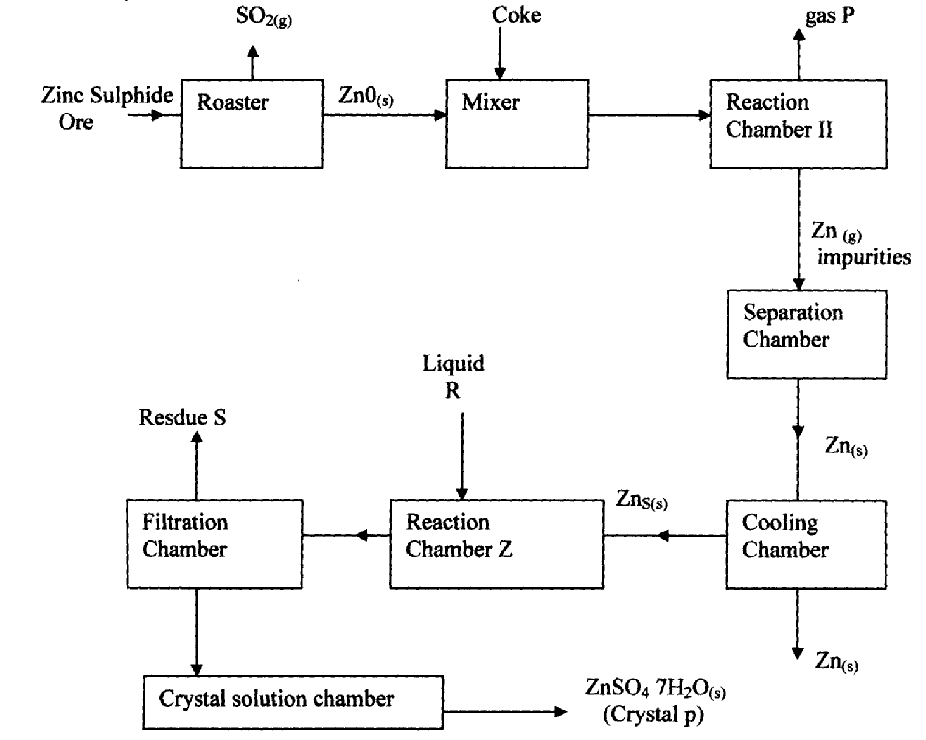

Zn_{(s)}

(i) Name :
(1) Gas P …………………………………………………………………………………..
(11) Liquid R ………………………………………………………………………………..
(III) Residue S ………………………………………………………………………………..
(ii) What is the role of coke in the above process?
(iii)Name the main impurity removed in the separation chamber
(iv) Write an equation for the reaction that takes place in ;
(1). Roaster

(11). Reaction chamber II
(v) Write an equation for the reaction that takes place between Zinc metal and liquid R
(vi) Given that zinc Suiphide ore contains only 45% of zinc Suiphide by mass, calculate
the mass in grams of zinc Sulphide that would be obtained from 250kg of the ore .
(vii) Give one commercial use of Zinc metal

19. The flow chart below shows a sequence of chemical reactions starting with Zinc.
Study it and answer the questions that follow:-
Zn_{(s)}
Step 1
Zn²⁺_{(aq)}
Step 2

NaOH_{(aq)}
Zn(OH)_{2(s)}
Step 3

Heat
Zn_{(s})
Zn²⁺_{(aq)}
Step 5

Metal T
Step 4 H₂SO_{4(aq)}
ZnO_{(s)}
Dilute hydrochloric acid

a) In step 1, excess 3M hydrochloric acid was added to 0.5g of Zinc powder
i) State two observations which were made when the reaction was in progress
ii) Explain why hydrogen gas is not liberated when dilute nitric acid is used in step 1
iii) a) Write the equation for the reaction that took place in step 1
b) Calculate the volume of 3M hydrochloric acid that was needed to react completely with
0.5g of Zinc powder (Zn = 65.0)

20. The diagram below is a simplified apparatus for extraction of sodium. Study it and answer the
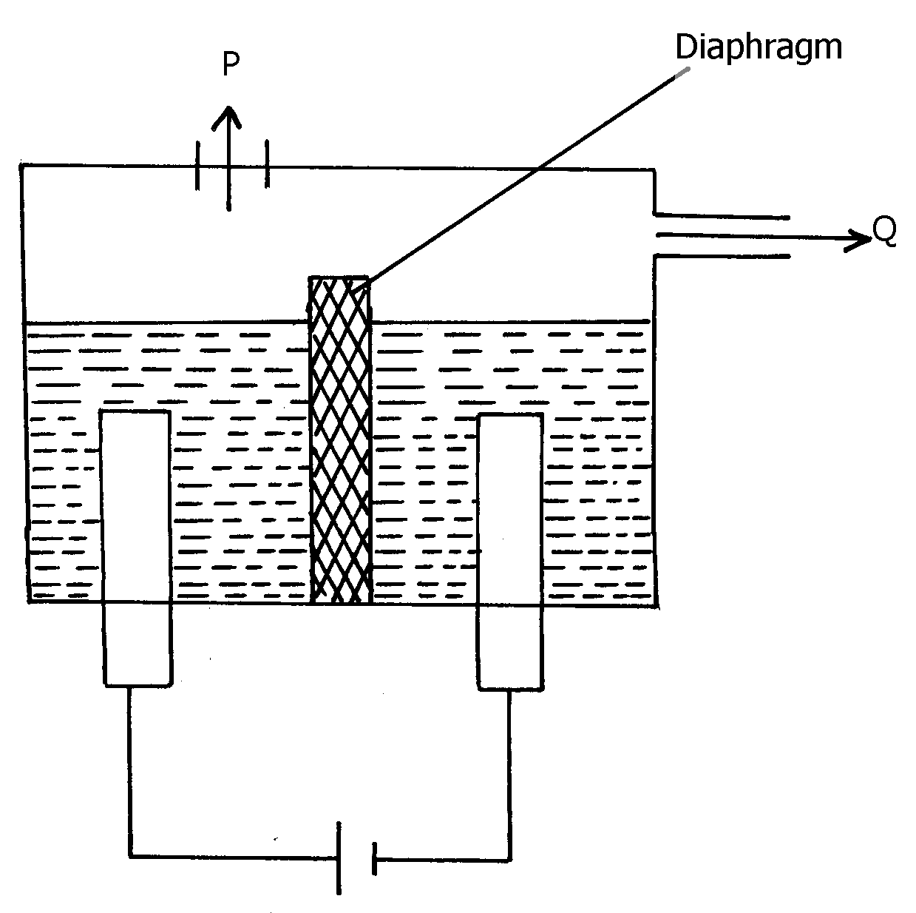
equations that follow:-

(a) Which substances come out at:- P & Q
(b) What is the role of the diaphragm
(c) Write the equation of the reaction forming sodium
21. The set-up below was used to investigate electrolysis of a certain molten compound;-
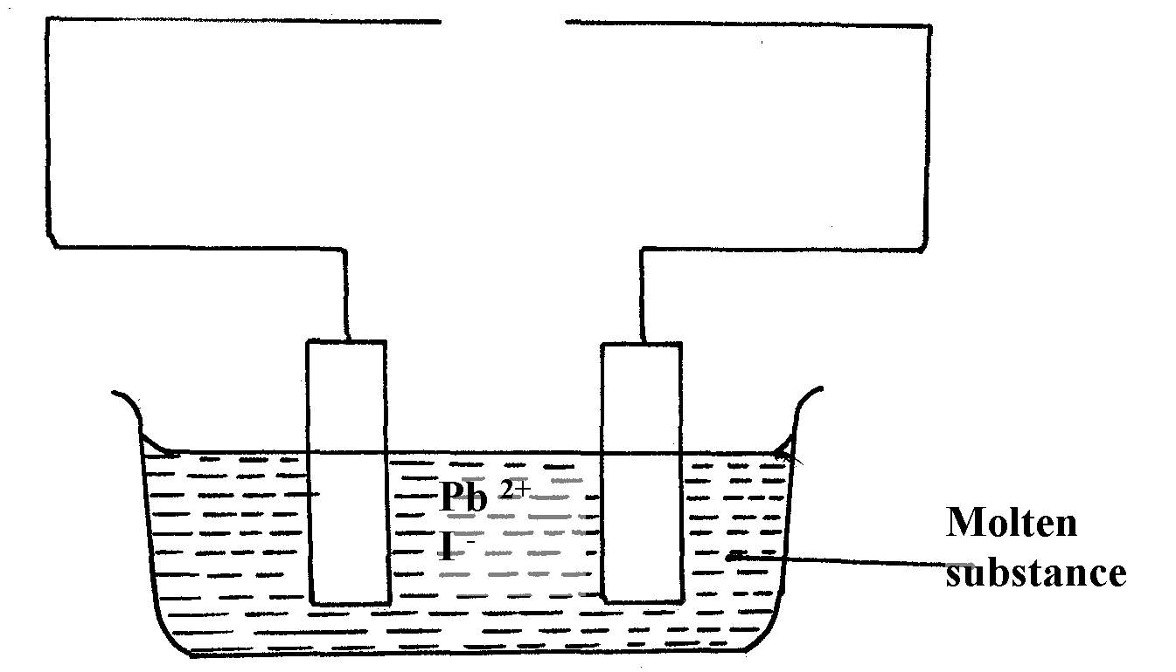

(a) Complete the circuit by drawing the cell in the gap left in the diagram
(b) Write half-cell equation to show what happens at the cathode
(c) Using an arrow show the direction of electron flow in the diagram above

22. (a) Name two ores from which Zinc metal is mostly extracted
(b) One of the steps in the extraction of Zinc metal from its ore is roasting of the ore in excess
oxygen. Write equations for the reactions that take place when the ore in (a) above is roasted
23. Aluminum metal is mainly extruded from molten Bauxite by electrolysis.
a) Name the main impurity in this ore.
b) Briefly describe how the impurity is removed from the ore before electrolysis process. (2 mks)
24. (a) In the extraction of aluminium form its ore by the use of electrolysis, explain the
following observations:-
(i) the graphite anode is replaced from time to time
(ii) the steel tank which can also serve as an electrode is also lined with graphite cathode
(b) Sodium and aluminium metals both conduct electricity, but aluminium is a better
conductor of electricity than sodium. Explain

