- Measures of central tendency

1. 4 + 6 + 10 + 14 + x + 24 + 14 + 6 = 100
78 + x = 100
(i) x = 22
(ii) Modal class = 55 -59

Marks | x | ƒ | ƒx | cƒ
30-34  35-39  40-44  45-49  50-54  55-59  60-64  65-69 | 32  37  42  47  52  57  62  67 | 4  6  10  14  22  24  14  6 | 128  222  420  659  1144  1368  868  462 | 4  10  20  34  56  80  94  100
B₁ |  | Σƒ = 100 B₁ | Σƒx = 5210 | B₁

Σƒx = 5210
- Mean = 5210
100
= 52.10

(ii) Median = 49.5 + 50-34 x 5
22
= 53.14
2. Log₁₀ 5² – log₁₀ 2³ + log 2⁵
4
√ Application of logarithmic laws.
√ Application
C.A.O

C.A.O √Radius
Log₁₀ 25 x 32
8
1
2
Log₁₀ 100 = log₁₀¹⁰
= 2 log ₁₀¹⁰
But log₁₀¹⁰ = 1
∴ = 2
3. Modal class 150-154
Height | Frequency | c.f
140- 144  145 – 149  150 – 154  155 – 159  160 -164 | 3  15  19  11  2 | 3  18  37  48  50
Height Frequency c.f
= 149.5 + (25-18) x 5
19
= 149.5 + 7 x 5
19
= 149.5 + 1.842
= 15.34

4.
H | 20-24 | 25-29 | 30-34 | 35-39 | 40-44 | 45-49
F | 3 | 19 | 25 | 20 | 18 | 15
CF | 3 | 22 | 47 | 67 | 85 | 100

Md = 34.5 + (50 – 47) x 4
20
= 34.5 + ¹²/₂₀ = 35.1

5. a) 2x² + 6x – 2x = 0
32 – 24 – 2x = 0
-2x = -8
x = 4

b) 2x² + 6x – 8 = 0
x² + 3x – 4= 0
x² + 4x – x - 4 = 0
x(x – 4) – (x + 4) = 0
(x – 1) (x + 4) = 0
∴ the other root is 1

6. ∑xf = 61 x 10 + 65.5 x 20 + 71 x 40 + 77 x 15
= 610 + 1310 + 2840 + 1155
= 5915
∑xf = 5915
∑f 85
X Mean = 69.59

7.
Marks | 30-39 | 40-49 | 50-59 | 60-69 | 70-79 | 80-89 | 90-99
No. of candidates | 2 | 3 | 10 | 12 | 8 | 3 | 2
C.F | 2 | 5 | 15 | 27 | 35 | 38 | 40

- Number who sat = 40
- The modal class = 60 – 69

Marks | x | f | X – 64.5= d | fd
30-39  40-49  50-59  60-69  70-79  80-89  90-99 | 34.5  44.5  54.5  64.5  74.5  84.5  94.5 | 2  3  10  12  8  3  2  £f = 40 | -30  -20  -10  0  10  20  30 | -60  -60  -100  0  80  60  60  £ fd = -20
Mean = 64.5 + -20
40
= 64.0
d) The median mark
= ½ (20th and 21st ) marks
= ½ (59.5 + 5 x 10 + 59.5 + 6 x 10)
12 12
= ½ (59.5 + 4.16666 + 59.5 + 5)
= ½ (128.16666667) = 64.083

8. 1, 1, 2, 2, 3, 4, 4, 6
a) Mode = 4
b) Median = 3
c) Mean = 1 x2 + 2 x 2 + 3 x 1 + 4 x 3 + 6 x 1
9
= 3
9. a) i) Modal class = 60 – 69

ii) class where medium lies
median class 50- 59
Class  0 - 9  10 – 19  20 – 29  30 – 39  40 – 49  50 – 59  60 – 69  70 – 79  80 – 89  90 – 99 | Centre X  4.5  14.5  24.5  34.5  44.5  54.5  64.5  74.5  84.5  94.5 | Fd  -50  -80  -120  -140  -100  0  200  120  90  40  εfd -40 | D= x – A  -50  -40  -30  -20  -10  0  10  20  30  40

Mean = 54.5 – 40
70
= 53.93

10. Cumulative frequency
3,11, 30, 44, 50
Median = L1t (^{n}/₂ – cfa)
Fn
= 8 + (25 – 11) X 4
19

= 10.947
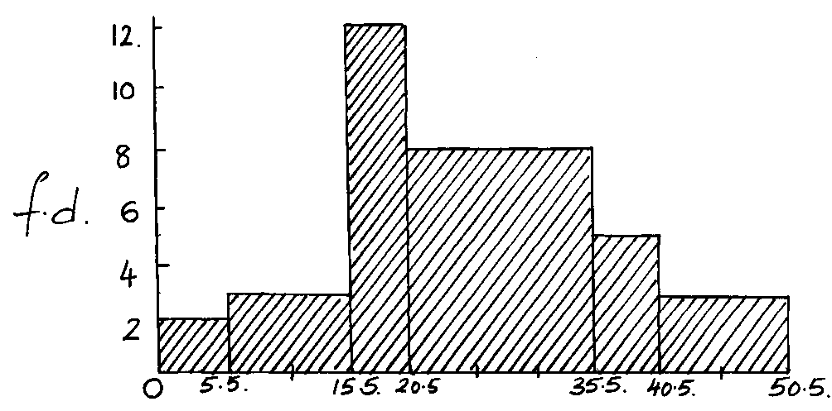
11.

