- Matrices and Transformations
1 | a) (i)  (ii)  (iii)  b) (i)  (ii) Enlargement center (0,0) s.f = 5 | B₁  M₁  A₁  B₁  B₁  B₁  B₁  B₁  B₁  B₁ | Square S drawn  ✓coordinates given  Square T drawn  ✓coordinates (implied)  Square U drawn  ✓coordinates (implied)  Square V drawn
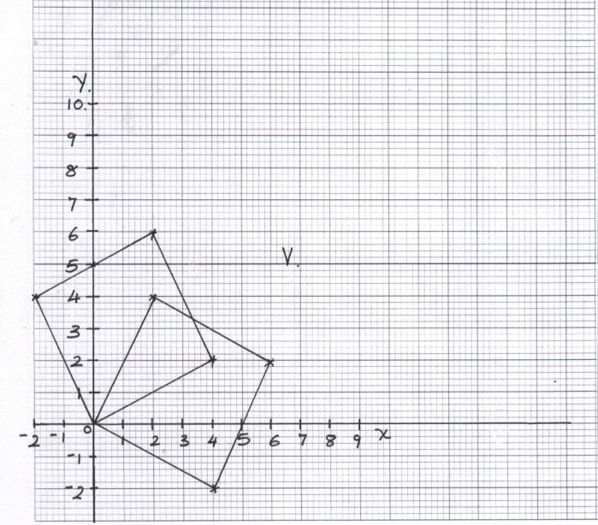
 |  | 10
2. | 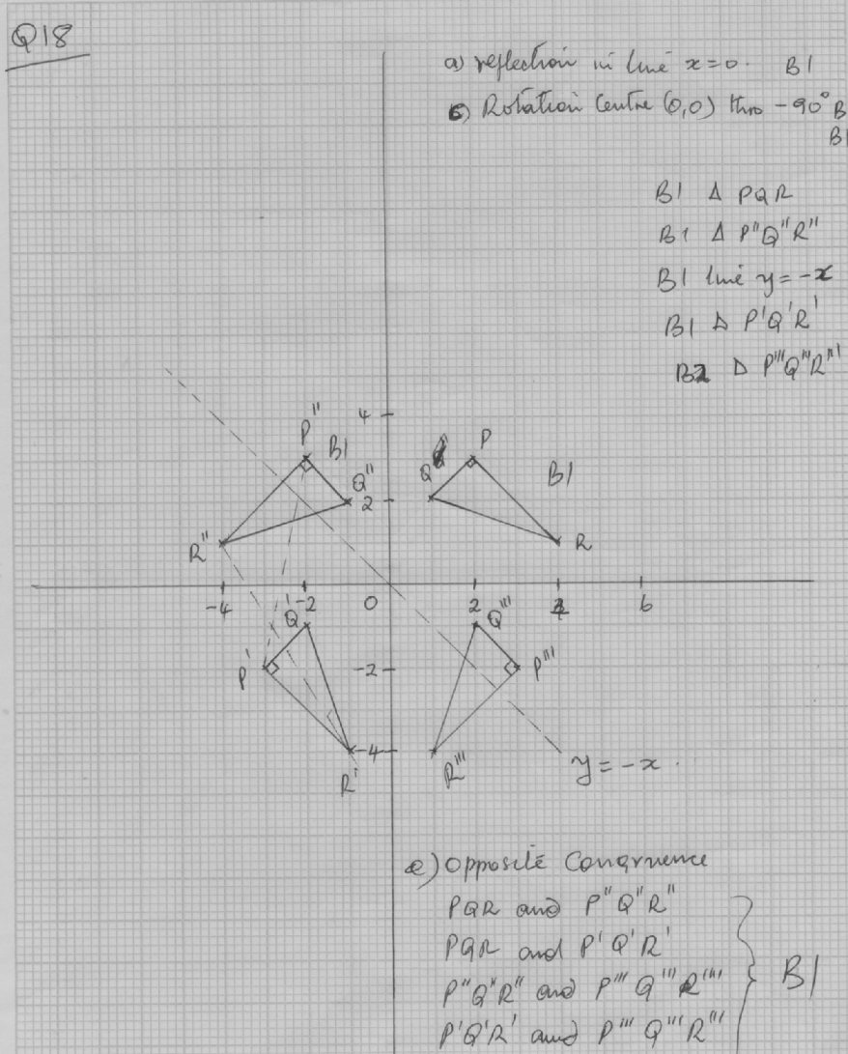  Total 10
 |  | 10

1. a) B (4,-5), C (3,6 ½ )
∆ ABC drawn
∆ ABC drawn

a) ii) Shear maps
1
I (1, 1½ )
Matrix = 1 0
1 ½
1
1
1
b) i) A B C
-1 0 -6 -4 3
³/₂ -1 -4 -5 6 ½

= A¹¹ B¹¹ C¹¹
6 4 -3
-5 -1 -2

∆ A¹¹ B¹¹ C¹¹ D¹¹ drawn

ii) Half turn about (0,0)

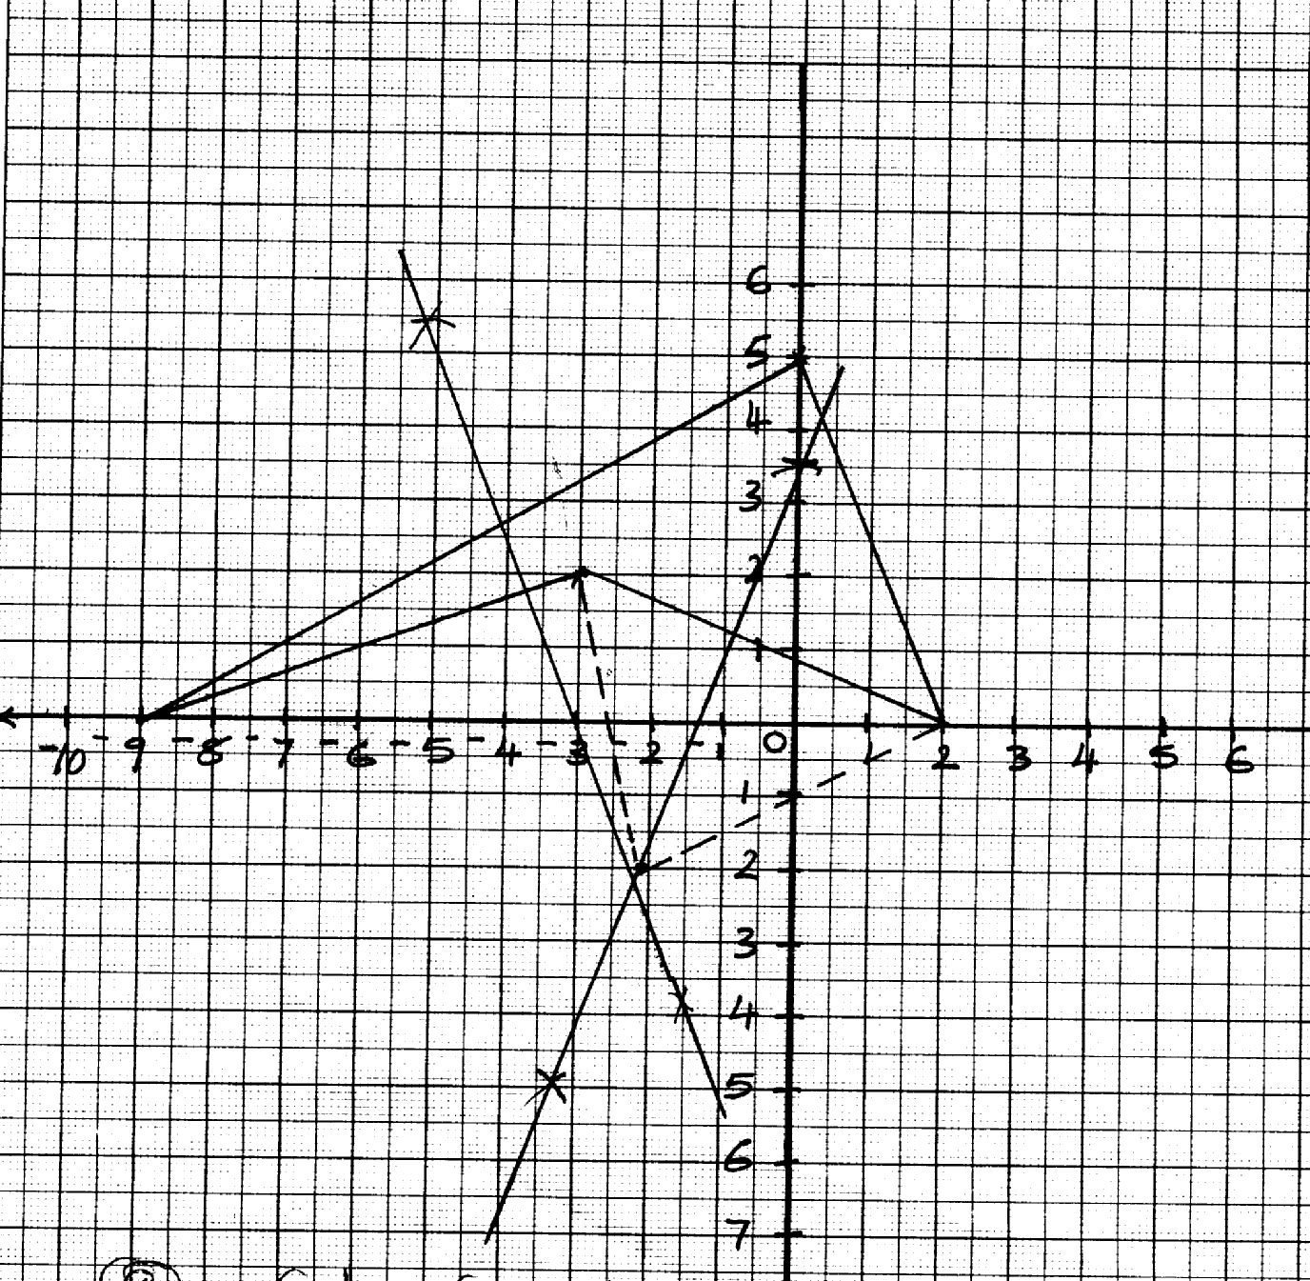
2.

A¹

B¹
^{A}

(a) Centre (-2, -2) 90º
(b) A11 (-2 , -4) , B11 (0, 9)
(c) Half-turn about the centre (0, 2)

3.
0 -1
-1 0
A B C D
1 6 6 1
2 2 4 4
A¹ B¹ C¹ D¹
-2 -2 -4 -4
-1 -6 -6 -6
A₁ B₁ C₁ D₁
-2 -2 -4 -4
-1 -6 -6 -6

A₂ B₂ C₂ D₂
-1 -6 -6 -6
2 2 4 4

A₁ (-2, -1)
B₁ (-2, -6)
C₁ (4, -6
D₁ (-4, -1)
A₂ (-1, 2)
B₂ (-2, -6)
C₂ (-6, 4)
D₂ (-6, 4)
0 1
-1 0

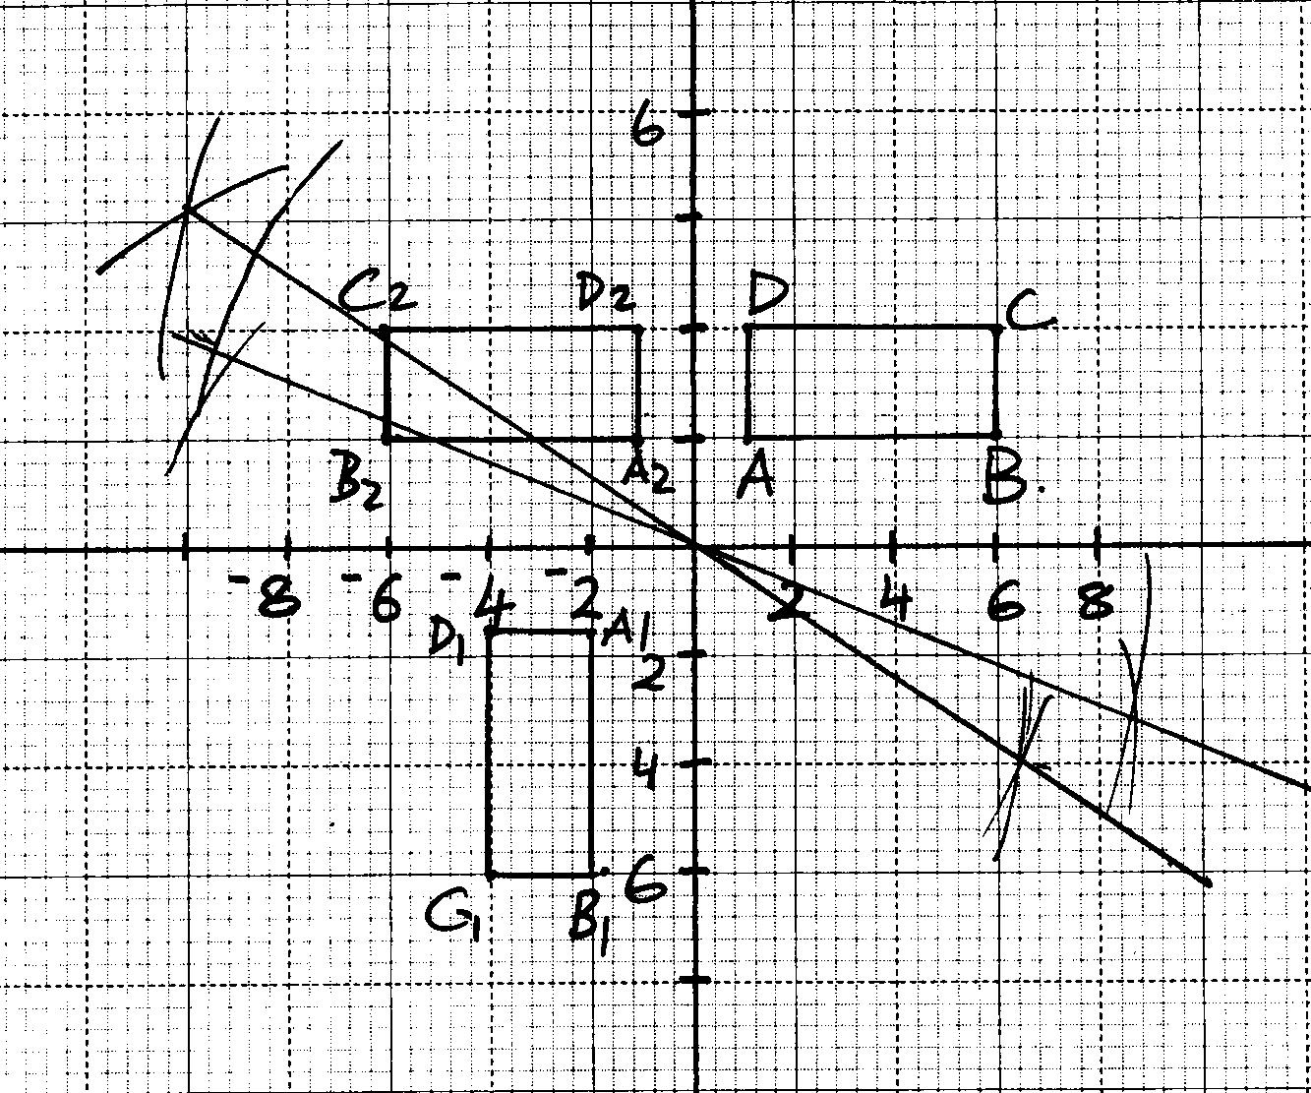
(b)

(c) (i) U - - positive three-quarter turn about the origin
(ii)UT – Reflection I the line x = 0
(d) IdetI = I2.5 x -2 – 1x 0 I= 5
∴Area = 5x(5x2) = 20sq. units

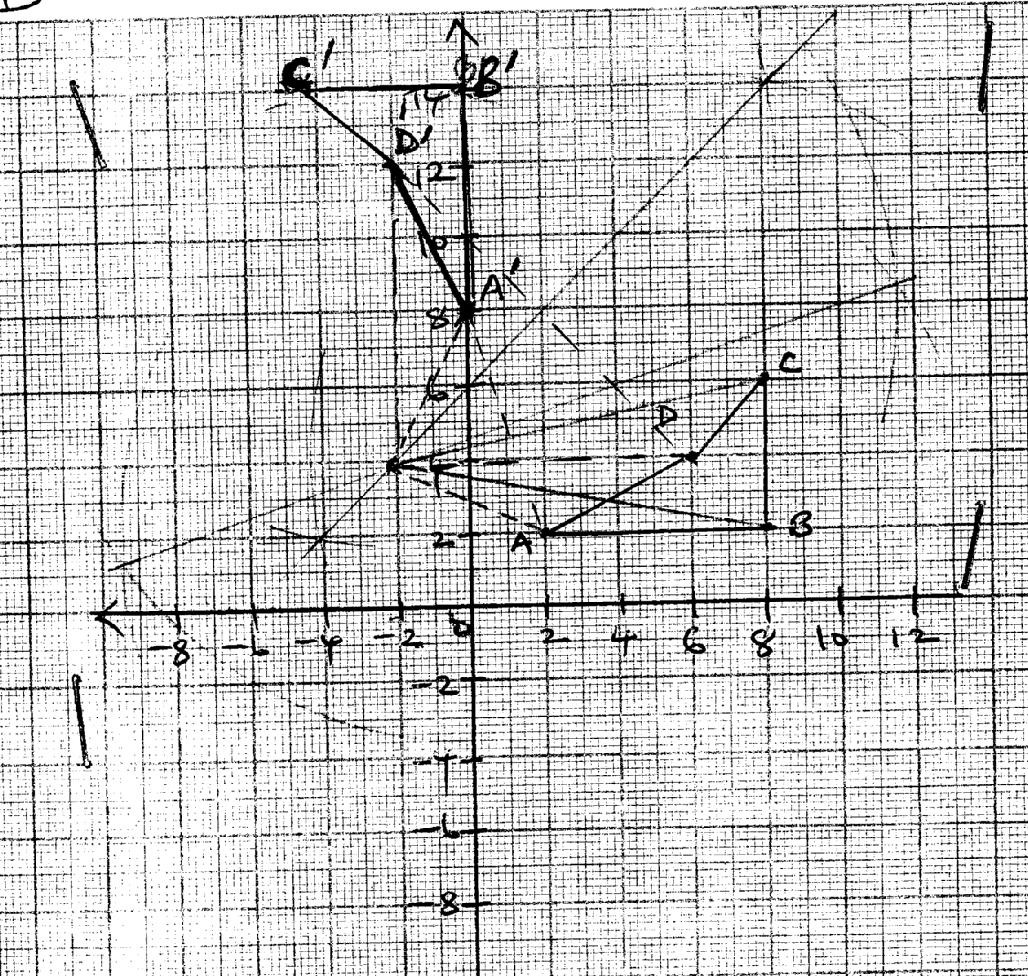
4. (a)

b) Centre (-2, 4)
Angle + 90°
5. P(5,-3) P¹ (2, -5)
5 + a = 2
-3 b -5

a = -3
b -2

R¹= -2 + -3
-3 -2

= -5
-5
P¹R¹ = -5 - -2
-5 -5
= -7
0
Mag. = 7units
6. A¹ = (0+1, -1-2) = (1, -3)
B¹ = (4 + 1) , 3-2) = (4, 1)
C¹ = ( 2 +1, 2-2) = (3-0)
Matrix 3 0
0 3
3 0 1 5 3 = 3 15 9
0 3 -3 1 0 -9 3 0
A¹¹ (3, -9) B¹¹(15, 3) C¹¹(9,0)

Determinant (0-9) =-9
Area = 9x24 = 216cm²
a b 3 15 = 1 5
c d -9 3 -3 1
5(31 -9b =1 5(3c-9d=-3
-15a+3b =5 15c +3d=1
-48b =0 -48d = -16
b = 0 d = ¹/₃
a = ¹/₃ c=0
matrix ¹/₃ 0
0 ¹/₃
7. Scale used S₁
ΔABC drawn B₁
ΔA₁B₁C₁ drawn B₁
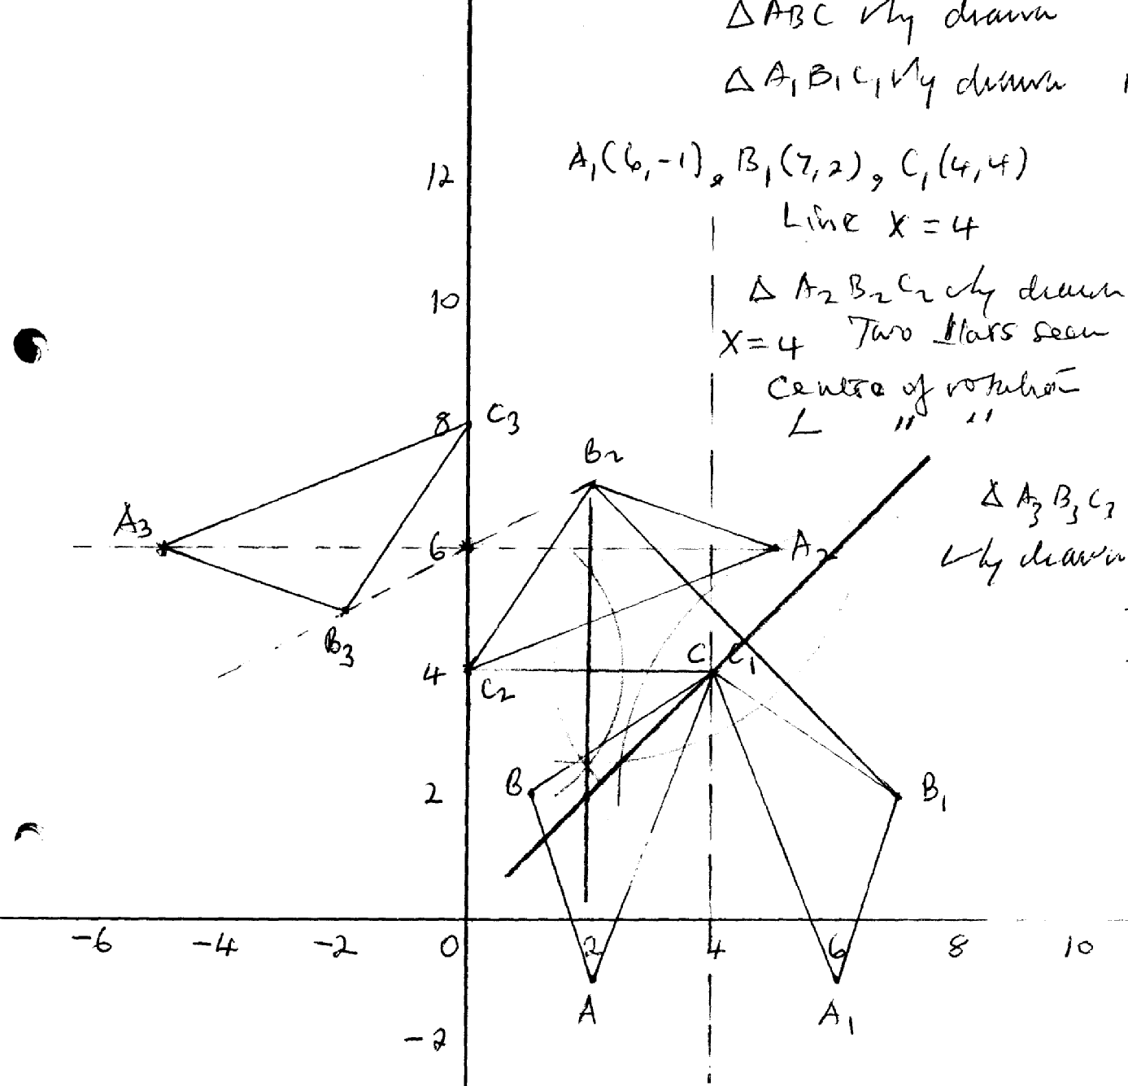
A, (6, -1), B(7, 2) C, (4, 4) B1
Line x = 4 L₁
ΔA₂ B₂ C₂ drawn B₁
Two seen B₁
Centre of rotation
Angle of centre of rotation B₁
A₃B₃C₃ drawn B₁

Scale used S₁
ΔABC drawn B₁
ΔA₁B₁C₁ drawn B₁
A, (6, -1), B(7, 2) C, (4, 4) B1
Line x = 4 L₁
ΔA₂ B₂ C₂ drawn B₁
Two seen B₁
Centre of rotation
Angle of centre of rotation B₁
A₃B₃C₃ drawn B₁

8. (a) P(6, -2)
X¹ = 6 -3 (-2) = 12
Y¹ = 2(6) = 12
(X¹, Y¹) = (12, 12)

(b) (i) A¹(3, 4)
(ii) B¹ (3, 2)
C¹ (1, 4)
D¹(4, 3)
1 -2
0 1
A¹ B¹ C¹ D¹
3 3 1 4
4 2 4 5
A¹¹ B¹¹ C¹¹ D¹¹
-5 -1 -7 -6
4 2 4 5
(c) (i)

=

A¹¹ (-5, 4) , B¹¹(-1, 2), C¹¹(-7, 4) and D¹¹(-6, 5)
(ii) A stretch with y-axis invariant and a sketch factor (3)
2h = 6
h = 3
-5a + 4b = 4 -5c + 4d = -3
- a + 2b = 2 -c + 2d = 3
-5a + 4b = 4 -5c + 4d = -3
-a + 4b = 4 -c + 4d = -6
-4a = 0 - 4c = 3
a = 0 c = - ¾
b = 1 d =¹⁵/₈
9. (a) X1(5, -1) y₁(7, -1) Z₁ (-2, 2)
xyz & x₁y₁z₁ well drawn

(b) 1-3 xyz x1y1z1
0 -2
2, 0
5, 7 -2
-1, -1, 2
5, 7 -2
-1, -1, 2
0 -2
2, 0
1 -1
0, 1
0, -2
2, -6
X₂(2, 10) y₂(2, 14)
X₂y₂Z₂ well drawn
(c)

(d)) Area of ΔX₂y₂Z₂
= 4x15 = 60cm²
10. a b 2 4 4 2 = 7 14 14 8
c d 1 1 4 4 8 7 16 16
2a + b = 8
4a + b = 14
-2a = -6
6 + b -= 8
b = 2
∴6 + b = 8
b=2
2c + d = 7
4c + d = 7
-2c = 0
c = 0
d = 7
3 2
0 7
∴

- it is an enlargement with scale factor 3 with centre (-1, -2)

(c) 8 + a = 7
7 b 9
a + 8 = 7 7 + b = 9
a =-1 b = 2
∴T = -1
2
11. a) ABCD drawn B₁
Name – Parallelogram B₁

b) A¹B¹C¹D¹ drawn B₁
Attempt to joining any two points and bisecting. B₁
Description – Rotation + 90⁰. B₁ or quarter turn about (0,0)

c) A¹¹B¹¹C¹¹D¹¹ drawn. B₁
Description – Enlargement centre (0, 0) Scale factor –Z. B₁

d) A¹¹¹B¹¹¹C¹¹¹D¹¹¹ – drawn. B₁
Attempt to reflect. B₁
Coordinates
A¹¹¹ = 9-2, 4) C¹¹¹ = (-8, 4) B₁ All correct
B¹¹¹ = (-6, 0) D¹¹¹ (-4, 8)
12. - 1 1 4 0 -2
2 -3 1 -2 4

-3 -2 6
5 6 -16
A| (-3, 5) B|(-2, 6) C|(6, -16)

2 -1 -3 -2 6
1 2 5 6 -6

=
A|| B|| C||
-11 -10 18
7 10 -6
A¹(-11, 7) B¹(-10, 10) C” (18, -6)

MN
= 2 -1 -1 1
1 2 2 -3
= -4 5
3 -5

p-1 = 1 5 -7
-12 -4 8
-⁵/₁₂ ⁷/₁₂
¹/₃ -²/₃

13. Det = 2 – 6
= - 4
A.S.F = 4
25.6 = 4
x
x = 6.4cm²
Area of ΔABC = 6.4cm²

14. T + (2) = (4)
-4 0

T = (4 - 2) = (2)
0 + 4 4

∴ (2) + (-1) = (1)
4 2 6
Q (1,6)

16. 5x² + 6 = ¹¹⁰/₁₀
5x² + 6 = 11
x² = 1
x = ±1

