- Matrices
1 | Let | M₁  M₁  A₁  3 | Alternative  C = B⁻¹A  ✓equations B⁻¹ allow any two  ✓solving of equations or equivalent
2. |  | M1  M1  A1
 |  | 03

1.
3 2 a = 12
4 -1 b 5
Premultiplication by the inverse.

Simplification.

C.A.O

1 2 3 2 a 1 2 12
11 11 = 11 11

4 -3 4 -1 b 4 -3 5
11 11 11 11

1 0 a = 2
0 1 b 3

a = 2
b 3

a = 2 √ and b = 3 √

x = 3
2. (x-3) – (2x) = 0
x-3-2x = 0
-2x + x – 3 = 0
-x -3 = 0

3. 1 5 7 3 = -13 -7
3 7 -4 -2 -4 -2
Determinant = + 65 – 49 = 16
C⁻¹ = 1 -5 7
7 -13
4.
3 2 a b = 9 -3
2 2 c d 2 1

3a + 2c = 9
2a + 2c = 2
a = 7
c = -6
3b + 2d = -3
2b + 2d = 1
b = -4
d = 4.5
A = 7 - 4
~
-6 4.5

5. 20x (-3 - ⁻8)
100 area of 1st image.
100 x (4 - ⁻3)
700 area of 2nd image
6. Det. 9 + 2 = 11

A¹ = 1 3 -2
11 1 3

3 2 x = 10
3 -1 y 4

x = 1 3 -2 10
y 11 1 3 4

x = 1 22
y 11 22

x = 2
y 2

P (2, 2)

7 PQ = 1 0
0 1
2 -3 x = 5
-1 2 y -3

2 3 2 -3 x = 2 3 5
1 2 -1 2 y 1 q -3

x = 1
y -1
x =1 y= -2
8. ½ x – ¼ y = 2
²/₅ + ¹/₆ = 6
2x _ y = 8
12x + 5y = 180
10x – 5y = 40 +
22x = 220
x = 10
¼ y = ½ (10) ⁻²
¼ y = 5-2 = 3
Y = 12
1 0
0 -1
-1 -2 -6
1 4 9
X¹ Y¹ Z¹
-1 -2 -6
1 4 9
0 1
1 0
9.

=

=
1 4 9
-1 -2 -6

Final image X¹¹ Y¹¹Z¹¹
X¹¹(1, -1) Y¹¹(4, -2), Z¹¹(9, -6)

10. P Q R A B C
a|: 2 2 5 6 4 = 6 8 6
0 4 -1 -1 - ½ -2 2 -1

(c) Centre (-3,2)
Angle + 90º
A B C
a) 2 4 5 6 4 = 6 8 6
0 2 -1 -1 - ½ 2 2 -1

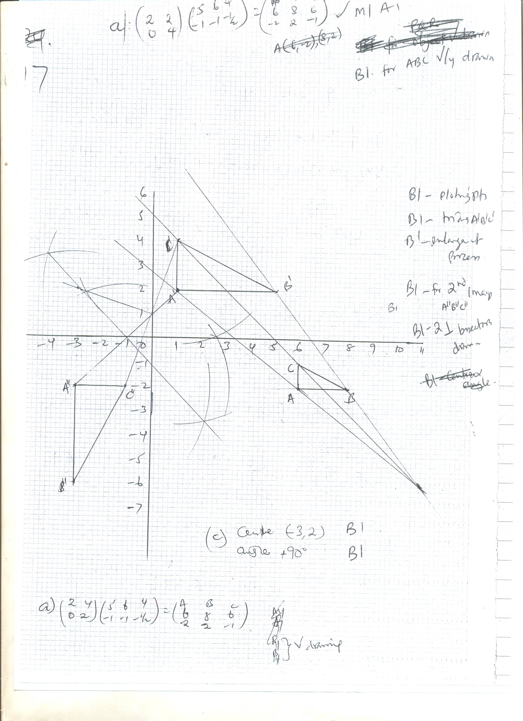

11. Det 2 - -3 = 5
Area of A^{I}B^{I}C^{I} = 5 x 15
= 75 cm²

12. A.S.F = 110 = 11
10
5X (X) - -6 = 11
5X² + 6 = 11
5x² = 5
X² = 1
X = ± 1
13. Area of the image = Area of the object x Det.
Det. (∆) = 15 – 18 = -3
54 cm² = A x -3
54 cm² = A
3
Area of ∆ ABC = 18 cm²
14. Det. 9 + 2 = 11

A¹ = 1 3 -2
11 1 3

3 2 x = 10
3 -1 y 4

x = 1 3 -2 10
y 11 1 3 4

x = 1 22
y 11 22

x = 2
y 2

P (2, 2)

