**THE MOKASA II JOINT EXAMINATION.**

**Featuring Kenya Certificate of Secondary Education (K.C.S.E.) 2024.**

$121/2$ $-$**MATHEMATICS $-$ $Paper 2$**

ALT A

FORM FOUR

MOCK

July/August. 2024 $-2\frac{1}{2} hours$

**NAME……………………………….……………. …INDEX NUMBER….…………….**

**CLASS…………CANDIDATE’S SIGNATURE………………..DATE…………………**

**Instructions to candidates**

1. Write your name and admission number in the spaces provided above.
2. Sign and write the date of examination in the spaces provided.
3. This paper consists of two sections: **Section I** and **Section II**.
4. Answer all questions in **section I** and **only five** questions from section **II**.
5. **Show all the steps in your calculations, giving the answers at each stage in the spaces provided below each question.**
6. Marks may be given for correct working even if the answer is wrong.
7. **Non-programmable** silent electronic calculators and KNEC mathematical tables may be used, except where stated otherwise.
8. **This paper consists of 16 printed pages.**
9. **Candidates should check the question paper to ascertain that all the pages are printed as indicated and that no questions are missing.**
10. **Candidates should answer the questions in English.**



**For Examiner’s Use Only**

**Section I**

|  |  |  |  |  |  |  |  |  |  |  |  |  |  |  |  |  |
| --- | --- | --- | --- | --- | --- | --- | --- | --- | --- | --- | --- | --- | --- | --- | --- | --- |
| $$1$$ | $$2$$ | $$3$$ | $$4$$ | $$5$$ | $$6$$ | $$7$$ | $$8$$ | $$9$$ | $$10$$ | $$11$$ | $$12$$ | $$13$$ | $$14$$ | $$15$$ | $$16$$ | $$Total$$ |
|  |  |  |  |  |  |  |  |  |  |  |  |  |  |  |  |  |

**Section II**

|  |  |  |  |  |  |  |  |  |
| --- | --- | --- | --- | --- | --- | --- | --- | --- |
| $$17$$ | $$18$$ | $$19$$ | $$20$$ | $$21$$ | $$22$$ | $$23$$ | $$24$$ | $Total$**Grand Total** |
|  |  |  |  |  |  |  |  |  |

**SECTION I** (50 marks)

*Answer* ***all*** *the questions in this section in the spaces provided.*

1. The expression $ax^{2}-60x+18$ is a perfect square, where $a$ is a constant. Find the value of $a$. (2 marks)
2. A rectangular plot of land has length of 125.8 m and an exact width of 84 m. Find the percentage error in calculating area of the plot *correct to 3 decimal place*. (3 marks)
3. Find the area of a sector of radius 10.5cm subtended by an angle of $\frac{1}{3}π^{C}$ at the center.(3 marks)
4. Without using a calculator or mathematical tables, evaluate; (3 marks)
$$\frac{\sin{45°}+\cos{30°}}{\tan{30°}}$$

5. Simplify the logarithmic expression;  (3 marks)

1. A man who deposited Sh.50,000 in an investment account compounded semi-annually had at a total amount of Sh.70,925 after three years. Calculate the rate of interest per annum to the nearest whole number. (3 marks)
2. A quantity $P$ is partly constant and partly varies as the square of $Q$. If $Q=2$ when $P=9$ and $Q=4$ when $P=33$, find the value of $P$ when $Q=1.5$. (4 marks)
3. Expand and simplify hence evaluate . (4 marks)
4. A committee of 3 people is to be chosen randomly from 5 men and 3 women. If every gender must be represented in the committee, find the probability of choosing more women than men. (3 marks)
5. An inlet tap can fill an empty tank in $8$ hours. It takes $12$ hours to fill the tank when the inlet tap and an outlet tap are both opened at the same time. Calculate the time the outlet tap takes to empty the full tank when the inlet tap is closed. (3 marks)
6. The table below shows the relationship between the quantities P and Q.



1. On the grid provided, draw a line of best fit. (2 marks)

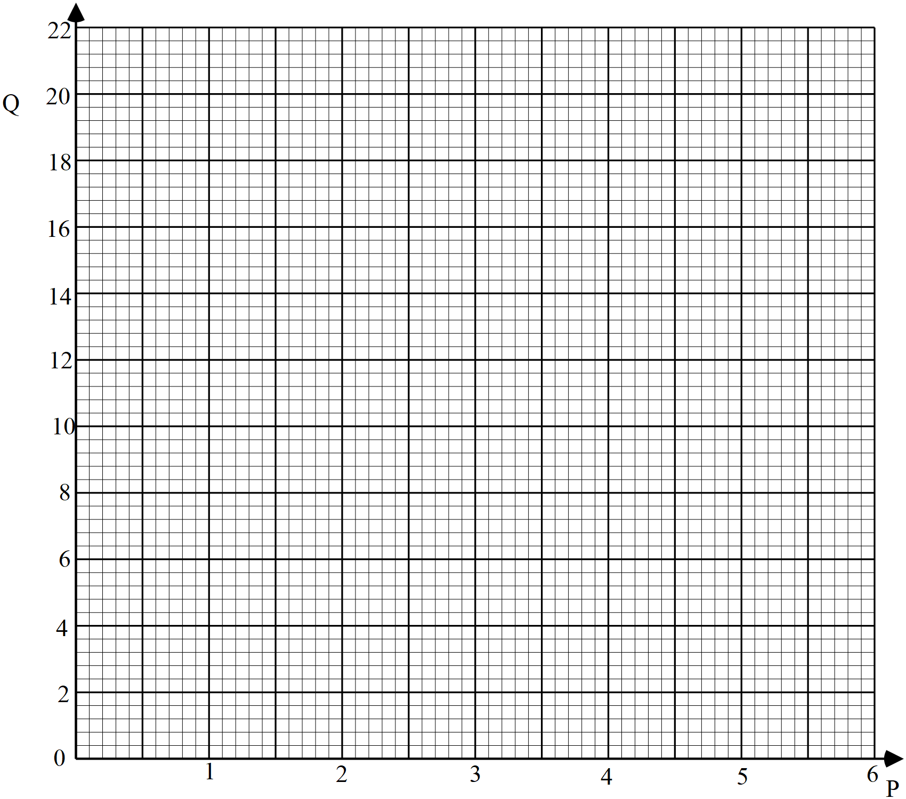

1. Using the graph, find the law connecting P and Q. (1 marks)
2. Solve the equation 8Sin2x = 12Cosx for O ≤ x ≤ 3600. (4 marks)
3. In a transformation. An object with an area of $6 {cm}^{2}$ is mapped onto an image whose area is $36 {cm}^{2}$. Given that the matrix of the transformation is $\left(\begin{matrix}4 & x-1 \\ 2 & x\end{matrix}\right)$, find the value of $x$. (3 marks)
4. The gradient of curve at any given point is given by , given that the curve passes through , find the equation of the curve. (3 marks)
5. AB is a fixed line segment 6cm long. Point P moves on one side of the plane of AB such that <APB is always 600. Construct the locus of P. (3 marks)
6. The figure below represents a cuboid $ABCDEFGH$. $AB=32 cm$, $BC=24 cm$ and $CF=12 cm$.

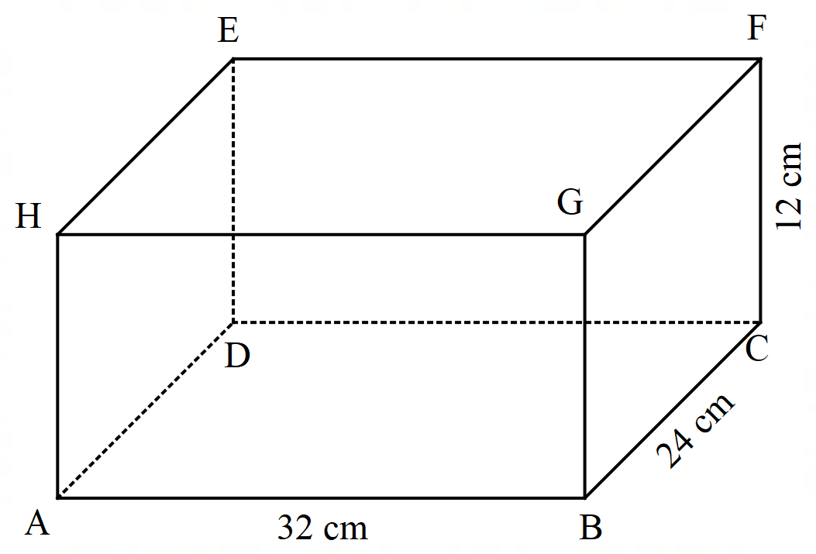

Given that M is the mid-point of EF, calculate the angle between AM and plane ABCD, correct to $2$ decimal places. (3 marks)

**SECTION II** (50 marks)

*Answer only* ***five*** *questions from this section in the spaces provided.*

1. The table below shows income tax rates for the year 2023



In November 2023, Silas earned a basic salary of Sh. 38 320. In addition, he was entitled to a house allowance of Sh. 12 800 per month and medical allowance of Sh. 6 850. He also has a non – taxable risk allowance of Sh. 5 000 per month. He contributes to a provident fund of Sh. 3 500. He also has tax relief of Sh. 1 480 monthly.

1. Calculate Silas’ taxable income in that month. (2 marks)
2. Calculate Silas’ Pay As You Earn (P.A.Y.E) for November 2023. (5 marks)
3. In the month of December 2023, Silas’ tax in the last band was Sh. 2 556. Calculate his net salary in December. (3 marks)
4. In the figure below PQR is a tangent to the circle at point Q <SQR = 540, <VTQ = 410 <UST = 220 and <SUT = 400.

T

U

400

410

220

X

S

V

P

540

Q

R

Giving reasons, find the value of

(i) <PQV

(ii) <UVT

(iii) <PQT

(iv) <SUV

(v) <QXS

1. (a) The first term of an Arithmetic Progression (AP) is $3$. The sum of the first $6$ terms of the AP is $78$.
2. Find the common difference of the AP. (2 marks)
3. Given that the sum of the first n terms of the AP is $406$, find n. (2 marks)
4. The $2^{nd}, 4^{th} and 7^{th}$ terms of another AP form the first three terms of a Geometric Progression (GP). If the common difference of the AP is $2$, find;
5. The first term of the GP; (4 marks)



1. The sum of the first $7$ terms of the GP, to $4$ significant figures. (2marks)
2. In the figure below C is a point on AB such that **BA** = 3**BC** and D is the mid – point of OA. OC and BD intersect at X. Given that **OA** = **a** and **OB** = **b**.

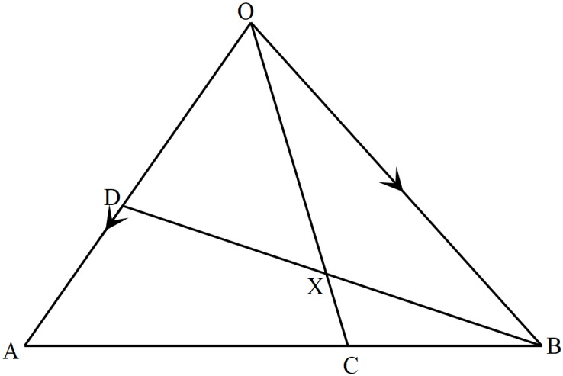

1. Write down in terms of **a** and **b** the vectors;
2. **AB** (1 mark)
3. **OC** (2 marks)
4. **BD** (1 mark)
5. If , express OX in terms of **a**, **b** and *h* . (1 mark)
6. If , find *h* and *k*. (3 marks)
7. Show that B, X and D are collinear. (2 mark)

21.Triangle A’B’C’ is the image of triangle ABC with vertices A(3,-1), B(1,3) and C(4,2) transformation represented by matrix M = $\left(\begin{matrix}-0.6 & -0.8 \\ -0.8 & 0.6\end{matrix}\right)$

(a) Find the coordinates of triangle A’B’C’. (2 marks)

(b) (i) on the grid below draw Triangles ABC and A’B’C’. (2 marks)

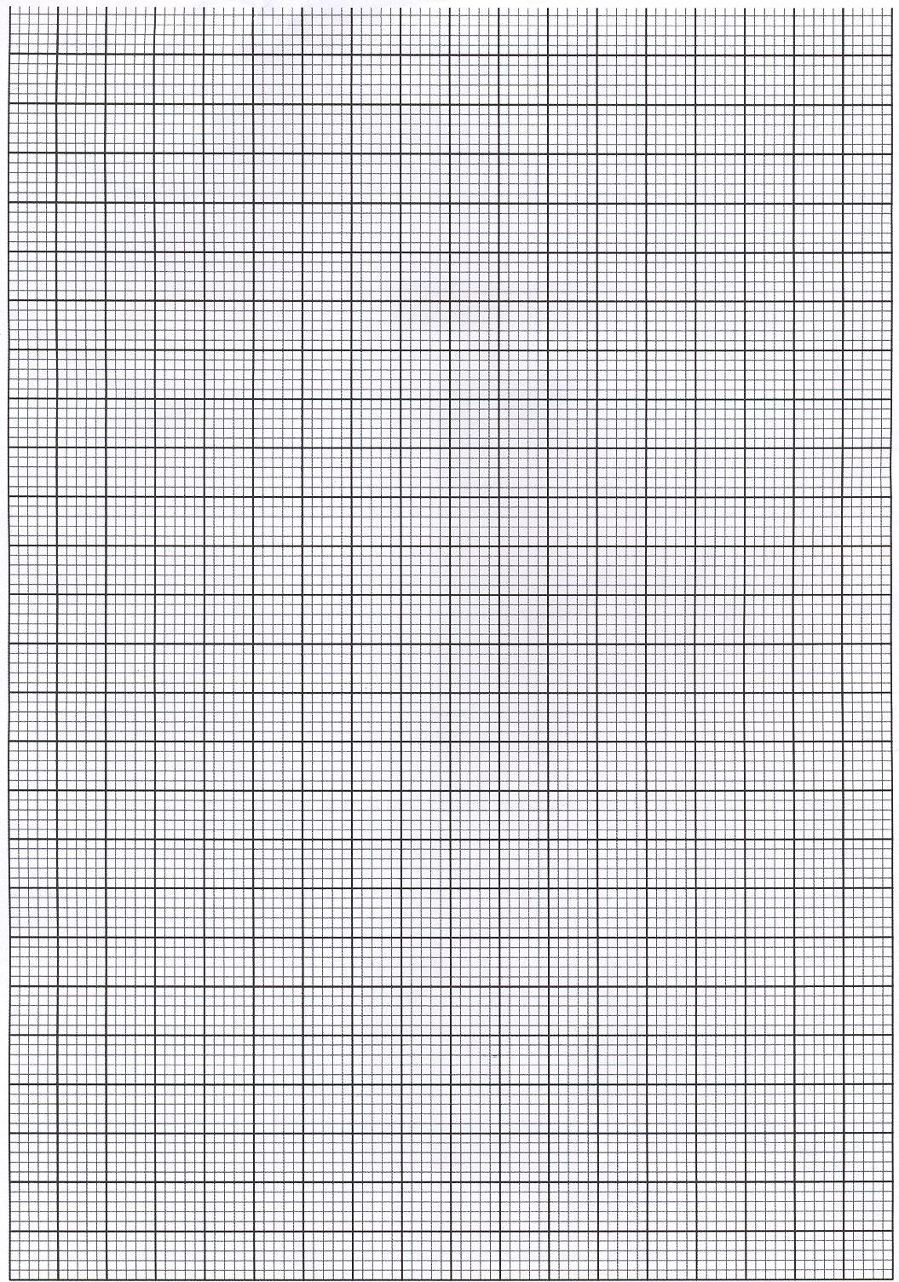 (ii) describe fully the transformation M. (2 Marks)

(c) Triangle A”B”C” is the image of triangle A’B’C’ and a transformation represented by the matrix N = $\left(\begin{matrix}2 & -1 \\ -4 & 3\end{matrix}\right)$

(i) Find the coordinates of Triangle A”B”C” and draw on the same axis. (2 marks)

(ii) Determine a single matrix that maps triangle ABC onto triangle A”B”C”. (2 marks)

1. The position of two towns P and Q are given as $P(40°N,10°W)$ and $Q(40°N,170°E)$. (use $π=\frac{22}{7}, Radius of the Earth=6371km)$.
2. Find the difference in longitude between the two towns. (1 mark)
3. Find the shortest distance from P to Q in Kilometres correct to two decimal places. (2 marks)
4. (i) A ship sailed from town P towards town R which is directly east of P covering a distance of 2000km. Determine the position of R. (3 marks)

(ii) If the ship departed P at 2.00pm, sailing at an average speed of 150 knots, find the local time at R when the ship arrived. (4 marks)



23.The masses of 64 hybrid goats in a ranch in Laikipia were recorded as follows:



1. On the grid provided, draw a cumulative frequency curve to represent the above information. (4 marks)

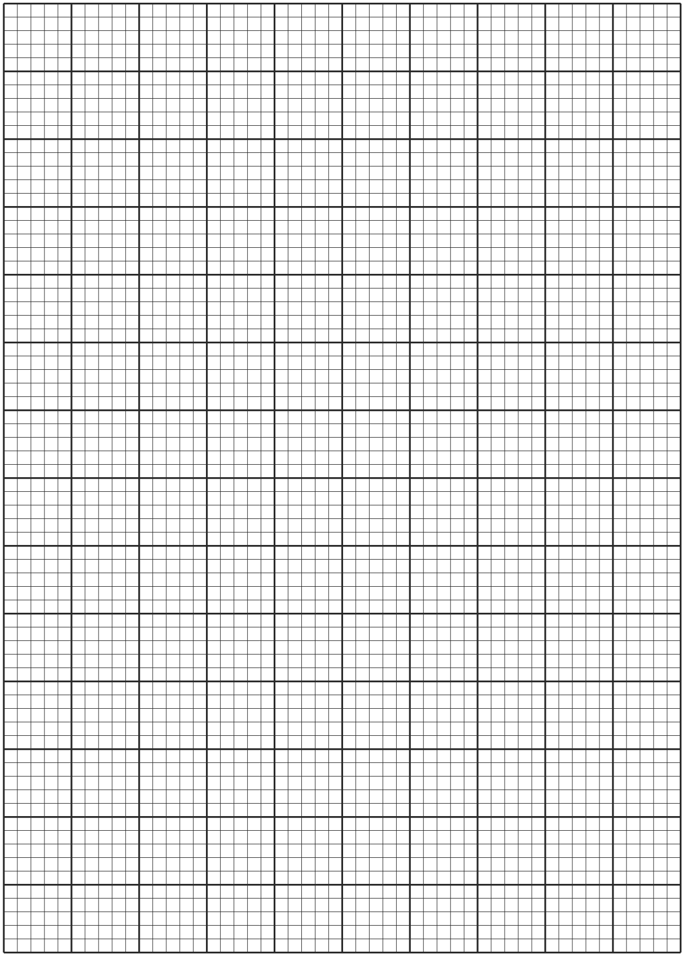

1. Use your graph to estimate:
2. The median (1 mark)
3. The number of goats that were overweight if 36 kg is the recommended healthy weight. (2 marks)
4. The range of weight of the middle 40% of the goats. (3 marks)

24. The dimensions of a rectangular flow of a proposed room are such that

- The length is greater than the width but at most twice the width

- The sum of the width and length is more than 4 meters but less than 10 meters

If x represents the width and y the length.

(a) Write inequalities to represent the above information. (4 marks)

(b)Represent the inequalities in (a) above on a linear programming diagram.(4 marks)



(c) Using the integral values of x and y, list all the possible dimensions of the floor hence find the maximum possible area of the floor. (2 marks)