MOKASA II JOINT EXAMINATIONS – 2024

**Kenya Certificate of Secondary Education**

121/1 – MATHEMATICS Paper 1 (Alt. A)**FORM FOUR**



**Name …………………………………………………………………………ADM NO………… IndexNumber…........………......…………...Class………..Date……………Signature………..**

**MOKASA II MATHEMATICS JOINT EXAMINATION, TERM 2 2024**

**Instructions to candidates**

1. Write your name and Index number in the spaces provided above.
2. Write your class, date of examination and sign in the spaces provided above.
3. This paper consists of **two** sections; **Section I** and **Section II**.
4. Answer all the questions in **Section I** and only **five** questions from **Section II**.
5. **Show all the steps in your calculations, giving your answers at each stage in the spaces provided below each question.**
6. Marks may be given for correct working even if the answer is wrong.
7. **Non – programmable** silent electronic calculators **and** KNEC Mathematical tables may be used, except where stated otherwise.
8. **This paper consists of 15 printed pages.**
9. **Candidates should check the question paper to ascertain that all the pages are printed as indicated and that no questions are missing.**

**For Examiner’s Use Only**

**Section I**

|  |  |  |  |  |  |  |  |  |  |  |  |  |  |  |  |  |
| --- | --- | --- | --- | --- | --- | --- | --- | --- | --- | --- | --- | --- | --- | --- | --- | --- |
| **1** | **2** | **3** | **4** | **5** | **6** | **7** | **8** | **9** | **10** | **11** | **12** | **13** | **14** | **15** | **16** | **Total** |
|  |  |  |  |  |  |  |  |  |  |  |  |  |  |  |  |  |

**Section II**

|  |  |  |  |  |  |  |  |  |  |  |
| --- | --- | --- | --- | --- | --- | --- | --- | --- | --- | --- |
| **17** | **18** | **19** | **20** | **21** | **22** | **23** | **24** | **Total** | **Grand Total** |  |
|  |  |  |  |  |  |  |  |  |

**SECTION I (50 marks)**

*Answer* ***all*** *the questions in this section*

1. Express 21952 and 3136 as a product of the prime factors, hence evaluate

$\frac{\sqrt[3]{21952}}{\sqrt{3136}} of 26$ (3 marks)

1. The LCM and GCD of three numbers are 7560 and 18 respectively. If two of the numbers are 360 and 540, find the least possible value of the third number. (3 marks)
2. Without using a calculator, evaluate; (4 marks)
$$\frac{0.\dot{3}+0.1\dot{5}}{0.\dot{6}}$$

3. Solve using tables of square roots and reciprocals to the nearest 4 s.f. (3 marks)

$\frac{38.21}{\sqrt{0.02548}}$

1. Simplify the expression;  (3 marks)
2. A two digit number is such that, the sum of its digits is $11$. When the digits are interchanged,the original number exceeds the new number by $9$. Find the original number. (3 marks)
3. A Kenyan company received 103 800 sterling pounds. The money was converted in a bank which buys and sells foreign currencies as follows;

Buying (in Ksh.) Selling (in Ksh.)

1 Sterling Pound 145.78 146.64

US Dollar 110.66 110.86

Calculate the amount of money received to the nearest US dollar. (3 marks)

1. In the figure below, O is the centre of the circle. FG is parallel to JH and angle GJH = 26o. Calculate the size of angle FJG. (2 marks)

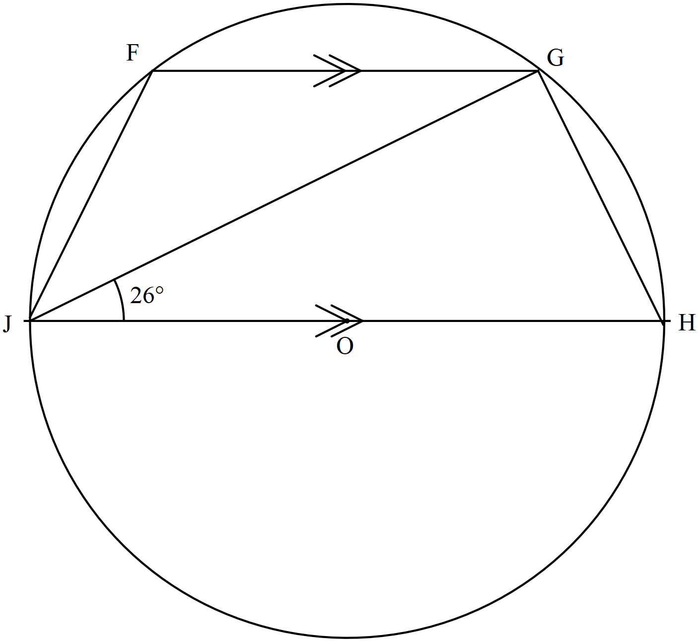

1. Three towns A, B and C are such that B is $50 km$ on a bearing of $N70°W$ from A and C is $70 km$ east of B.
2. Using a scale of 1 cm to represent 10 km, draw a diagram to show the relative position of towns A, B and C. (2 marks)
3. Determine the distance, in km, of C from. (1 mark)
4. Solve for x in the equation.

9 $\left(2^{\left(2x+2\right)}\right) -41\left(2^{x}\right)+8=0.$ (4 marks)

1. In the figure below, triangle  is the image of triangle ABC under a rotation. By construction, determine the angle and centre of rotation. (3 marks)

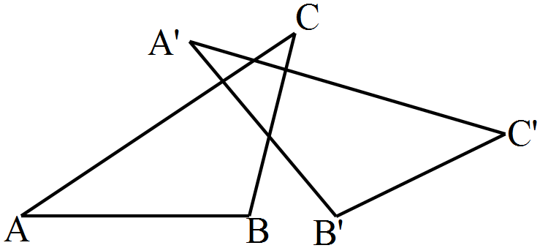

1. Points $A\left(-1,-6\right)$ and $B\left(-4,-5\right)$ are mapped onto $A^{1}\left(5,-5\right)$ and $B^{1}\left(-1,-3\right)$ respectively by an enlargement. Find the coordinates of the centre of enlargement. (3 marks)
2. Solve the inequality x + 2 ≤ 2x + 6 < -x + 8, and hence list all the integral values of x. (3 marks)
3. The equation of a straight line, L1 is given as; 
   * 1. Find gradient of line L1. (1 mark)
     2. Find equation of line L2 which passes through  and perpendicular to L1 in the form  where a, b and c are positive integers. (3 marks)
4. The displacement, s metres of a moving particle after t seconds are given by $s=t^{3}-9t^{2}+40t+8$. Find the maximum velocity of the particle. (3 marks)
5. Given the position vector $\vec{OA}$ = 4i – 2j – 3k and $\vec{OB}$ = -3i + 4j + 2k, express $\vec{AB}$ in terms of i, j, k and hence find the magnitude of $\vec{AB}$ to the nearest 1decimal place. (3 marks)

**SECTION II** (50 marks)

*Answer* ***only five*** *questions in this section in the spaces provided.*

1. (a) Complete the table below for the function  in the range. (2 marks)



(b) On the grid provided draw a graph of in the range . Use a scale of 1 cm to represent 5 units on *y* – axis and 1 cm to represent 1 unit on *x* – axis. (3 marks)

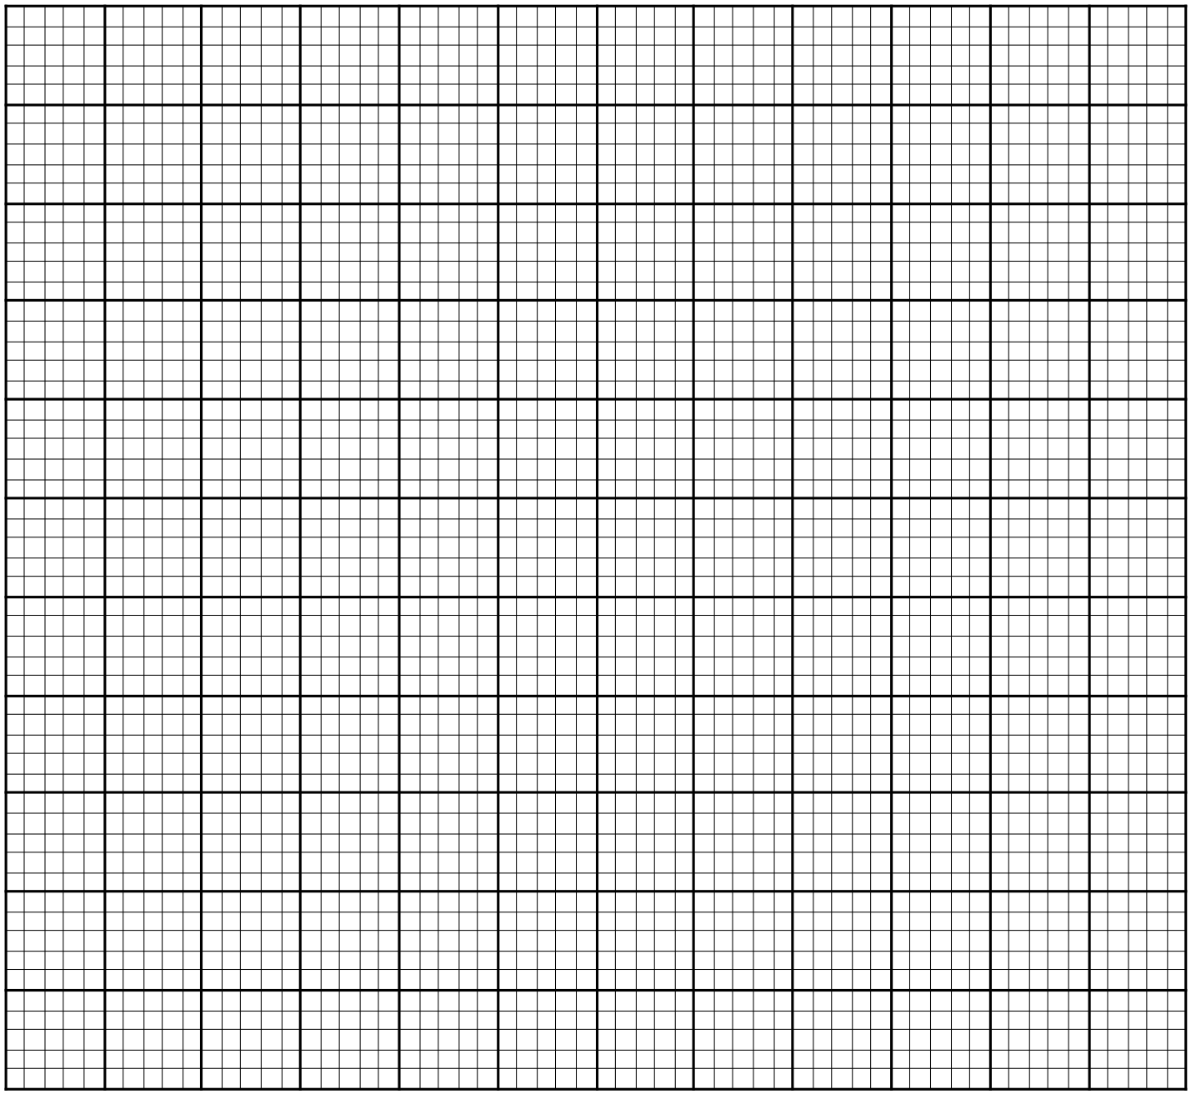

(c) Use your graph to solve the equations; (2 marks)

i) 

ii)  (3 marks)

1. (a) Given the matrix M= $\left(\begin{matrix}3 & 5 \\ 1 & 2\end{matrix}\right)$, find $M^{-1}$ the inverse of M. (2 marks)

(b)John bought 15 textbooks and $25$ exercise books for a total of $ksh. 10 000$. If John had bought $10$ textbooks and $20$ exercise books, he would have spent $ksh. 3000$ less. Take $x$ to represent the price of a textbook and $y$ to represent the price of an exercise book.

(i) Form two equations to represent the information above. (1 mark)

(ii) Use the inverse $M^{-1}$ of matrix M in (a) above to find the price of one textbook and one exercise book. (3 marks)

1. John later sold a textbook at a profit of 20 $\%$. If John received a total of Ksh. 11 875 from the sale of all the books, find the percentage profit of an exercise book. (4 marks)

19. The figure below (not drawn to scale) represents flower garden PQR in which PQ = 6m, QR = 8m and angle QRP = 350. Point S lies on PR such that QS = 6m and <QSR is obtuse. 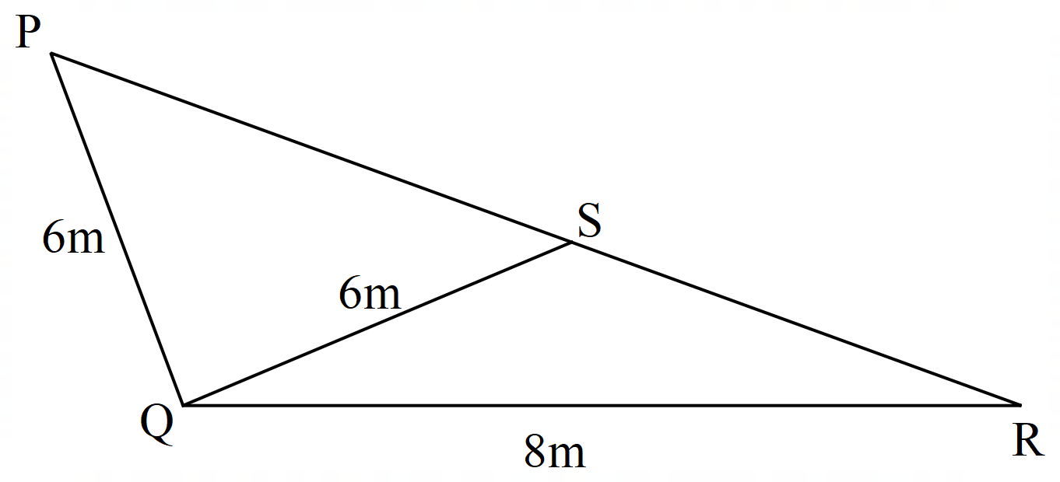

Find correct to do 2 decimal places;

(a) the size of angle QSR (3 marks)

(b) The length of PS. (3 marks)

(c) The length of SR. (2 marks)

(d) The area of the flower garden PQR in Hectares. (2 marks)

1. The frequency table below shows the daily wages paid to casual workers by a certain company.



1. Calculate the mean wage. (3 marks)
2. On the grid provided below, draw a histogram to represent the above information. (3 marks)

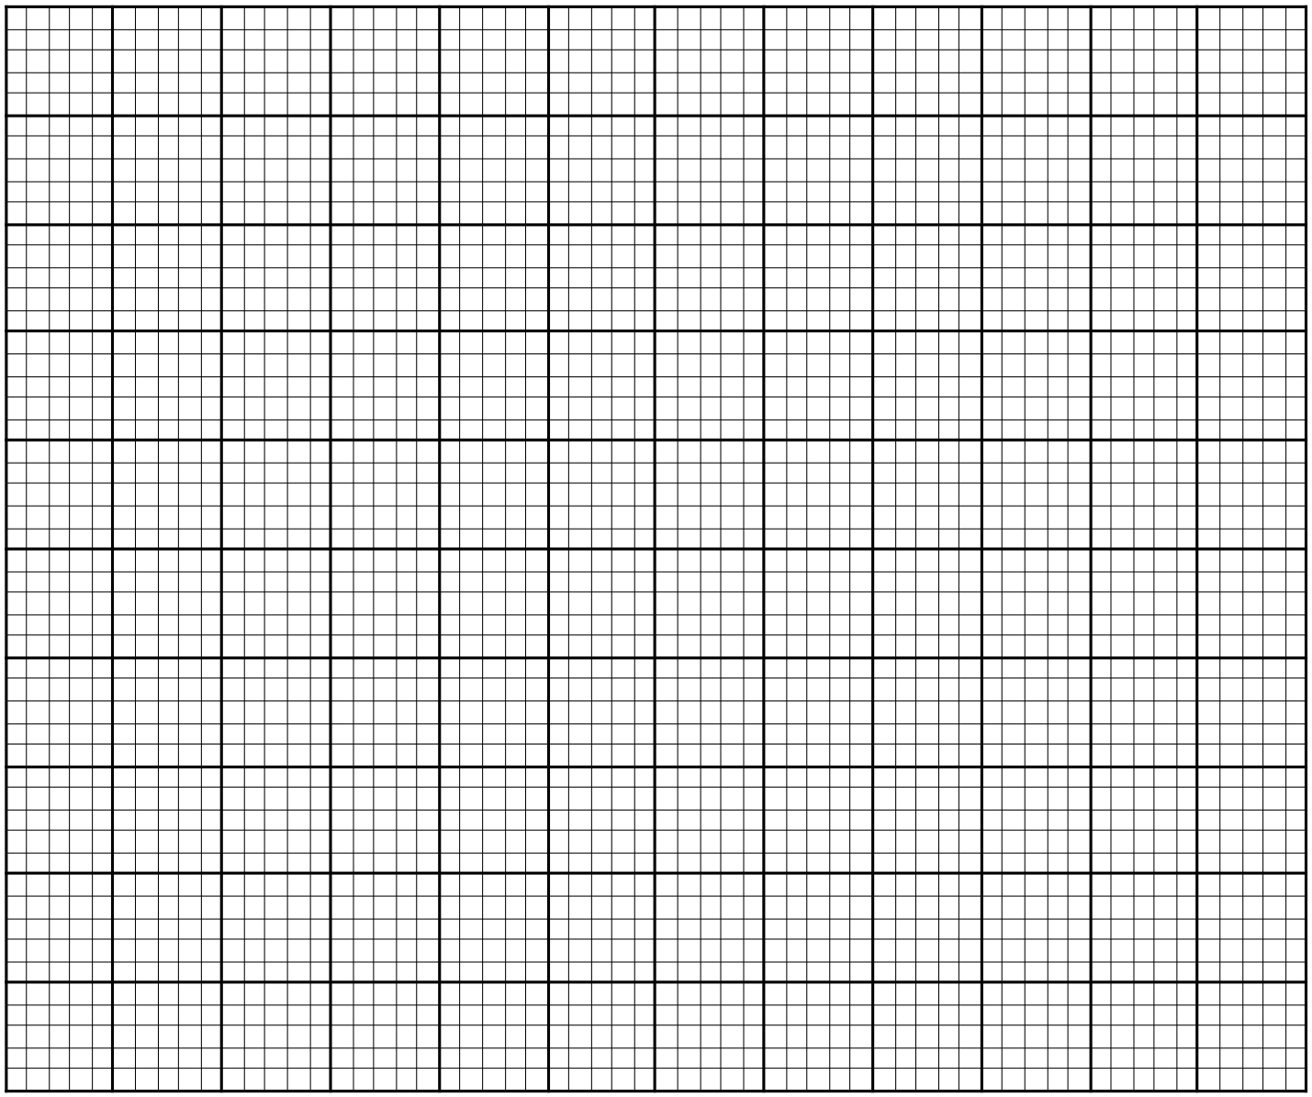

1. (i) State the class in which the median wage lies. (1 mark)

(ii) Draw a vertical line in the histogram, showing where the median wage lies. (1 mark)

1. Using the histogram, determine the number of workers who earn Sh. 500 or less per day. (2 marks)
2. The figure below represents a speed-time graph for a car which covered a distance of $61250metres$ in $1500$ seconds.

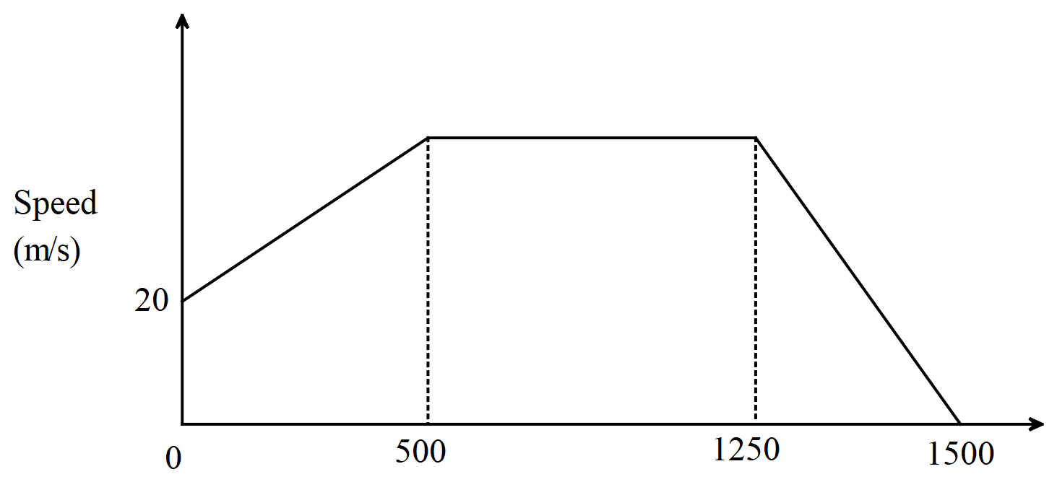

1. State the speed of the car when recording of its motion started. (1 mark)
2. Calculate the maximum speed attained by the car in ${km}/hr$. (4 marks)
3. Calculate the acceleration of the car in;
4. The first $500$ seconds. (2 marks)
5. The last $250$ seconds. (1 mark)
6. Calculate the average speed of the car in the first $1250$ seconds. (2 marks)

22. A solid is in the form of a conical frustum and a hemispherical top. The base radius of the solid is 17.5cm and the top radius is 10.5cm. The height of the frustum is 30cm. ( Use π = $\frac{22}{7}$)

(a) Calculate the vertical height of the solid. (1 mark)

(b) Calculate the total surface area of the solid to one decimal place. (4 marks)

(c) Initially the solid had water to a height of 10cm. A cube is fully immersed and the water level rose by 12. Calculate the length of the side of the cube. (5 marks)

1. (a) Complete the table below for the function . (2 marks)



Estimate the area bounded by the curve  and the lines,  and  using:

(i) Trapezium rule with six strips. (3 marks)

1. Mid – ordinate rule with six strips. (3 marks)
2. Find percentage change in area estimated by mid – ordinate rule given that the exact area of the above region is 39 square units. (2 marks)
3. The equation of a curve is $y=x^{3}+2x^{2}$.
4. Find;
5. The $x-intercepts$ of the curve. (2 marks)
6. The $y-intercept$ of the curve. (1 mark)
7. (i) Determine the stationary points of the curve. (3 marks)
8. For each point in (b)(i) above, determine whether it is a maximum or minimum. (2 marks)
9. Sketch the curve. (2 marks)

**THIS IS THE LAST PRINTED PAGE**