1 | (√2 + 2 √5)(√5 + √2)  (√5 − √2)(√5 + √2)  √  10  +  4  +  10  +  2  √  10  3 | M1  M1  A1
MATHS PAPER 2 MARKING SCHEME
2 | a) 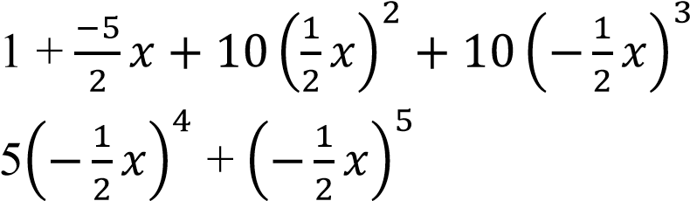 | +
 | 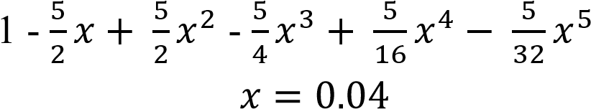  b) 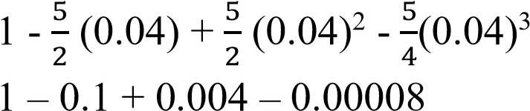  = 0.90392 |  | B1  M1  A1 | ✓Substitution  CAO
 |  |  | 03

3 | Perimeter = 2(l + w)  Absolute error for both length and width = 0.5  Max perimeter = 2(80.5 + 60.5)  = 282  Actual perimeter = 2(80 + 60)  = 280  Percentage error = x 100  = 0.714 0.7 | B1  M1  A1 | For either max, actual or min perimeter
 |  | 03
4 | 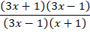  = | B1  B1  B1 | For num  For deno
 |  | 02
5 | (x + 3)² + (-y – 2)² = 3²  x² + 6x + 9 + y² + 4y + 4 = 9  x² + y² + 6x + 4y + 4 = 0 | M1  M1  A1
 |  | 03
6 | 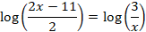  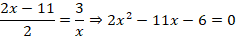  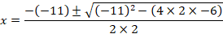  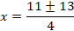  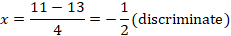  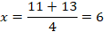  Hence | M1  M1  M1  A1 | Forming quadratic equation   attempt to solve the formed equation  Square root of discriminant  A0 of both values missing
 | Total | 3
7 | 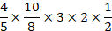  days | M1, M1  A1
 | Total | 3
8 | 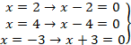  Consider | B1  M1  A1 | All three expressions  Expansion and simplification
 | Total | 3
9 | 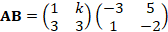  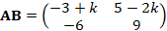 | B1  M1  A1
 | Total | 3

10.  16 =  P =  P = | for 16 =  for  correct value of P.

11.(a)  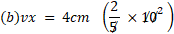  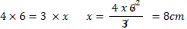 | for  for  for  for
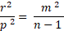  n =  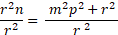 | for  for

13 | SLABS:  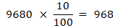 | B1  B1  M1  M1  A1 | CAO  CAO  Acc. Ksh 17, 306.67
 |  | 04
14.Use logarithms tables to evaluate. (4mks)
$$\sqrt[3]{\frac{\text{36}\text{.}\text{72}×{\left(0\text{.}\text{46}\right)}^{2}}{\text{185}\text{.}4}}$$
Log | No
1.5649  $$\frac{\overline{1} \text{.} \text{3256} +}{0\text{.}\text{8905}}$$  $$\frac{2\text{.}\text{2682} −}{\overline{2} \text{.}\text{6223} }$$  $$\frac{\overline{2} \text{.} \text{6223}}{3}$$  $$\frac{\overline{3} + 1\text{.}\text{6223}}{3}$$  $$\overline{1} \text{.} \text{5408}$$ | 36.72  (0.46)²$⇒$2$\left(\overline{1}\text{.} \text{6628}\right)$  3.474 x 10⁻¹  = 0.3474

15 | ) θ  V  D  B  E  2  2  8  V  E  O  Cos θ =  = 0.1936  θ = Cos⁻ 0.1936  θ = 78.84⁰ | M1 Expression for angle  A1

16 | A(50ºS, 25ºE)  B(50ºS, 140ºE) = 140-25  long  º  ^{km =}  x x 6370  = 12,790.56km | B1  M1  A1

17 | - (i) PQ = PO + OQ  = - p + q or q – p  - OR = OP + PR 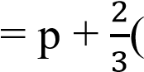-p + q) 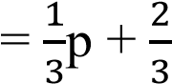q  - SQ = SO + OQ 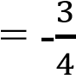OP + OQ  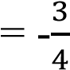p +q or q -p  - OT = n(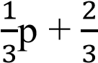 q)  From DOST  OT = OS + ST  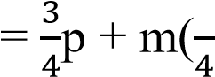p + q)  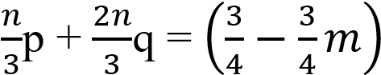p + mq  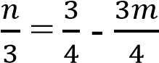  4n + 9m = 9…………………. (i)  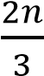= m, M = ^{2𝑛} ……………....(ii)  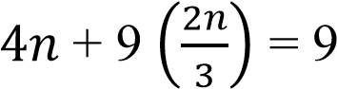  4n + 6n = 9 10n = 9 n =  10  M = 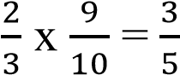 | B1  M1  A1  B1  B1  M1  M1  M1  M1  Both  A1

 | WORKING | MARKS | REMARKS
18 | - Table  - Graph  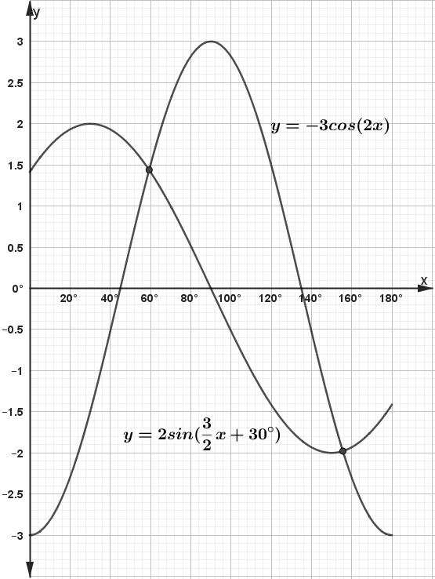  - (i) Period of the period of 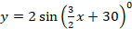  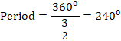  (ii) Solutions | B2  S1  P1  C1  P1  C1  B1  B1  B1 | All points  (B1 for at least 6 points )  Given scales used and consistent  Plotting of 1st curve  Smooth 1st curve drawn  Plotting 2nd curve  Smooth 2nd curve drawn  240⁰ seen
  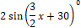

 | WORKING | MARKS | REMARKS
19. | - (i) Let the annual increment be Ksh.  (ii)  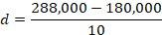  (iii) Sum after 11 years  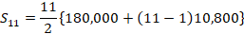  - Let the annual salary in the 10th year be  Monthly salary in year 10  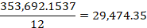  (to the nearest Ksh. 10)  - Let the years be  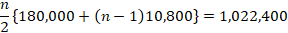  Divide all through by 400  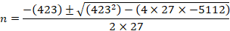  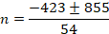  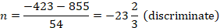  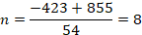  Hence | M1  A1  M1  A1  M1  M1  A1  M1  A1  B1 |  attempt to get  10,800 seen   attempt to get  1,584,000 seen   attempt to get  Attempt for division by 12  29,470 seen  Formation and solution of quadratic equation  Both values seen  8 seen
 | Total | 10

- B and passes and not prefect  (ii) G and prefect and pass  (iii) B or G  B NP passes or G NP passes  = +  =  = | for  for  for  for  for  for +  for  for  for

- (d)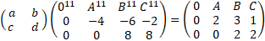  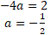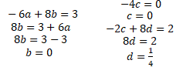  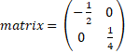 | for  for  for  for  for  coordinates of  for  for  for  for
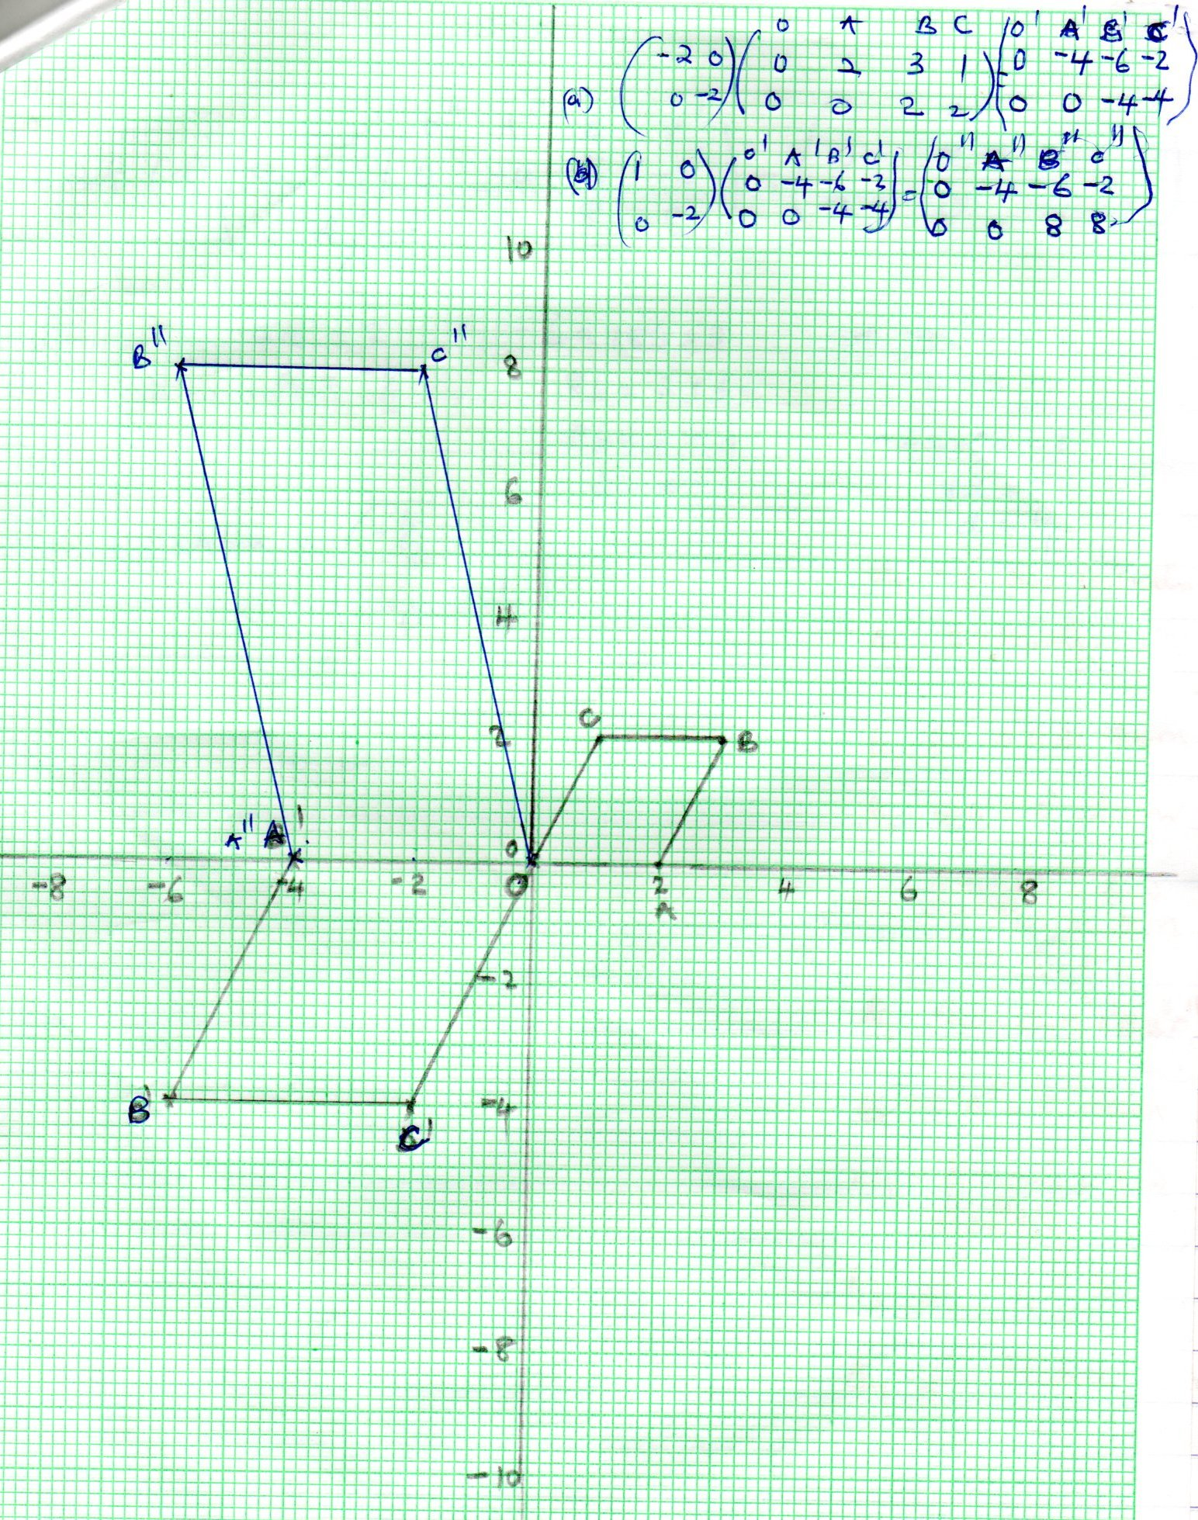

22 | 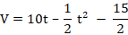  - 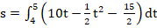  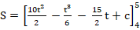  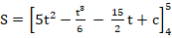  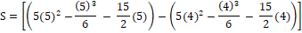  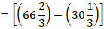  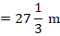  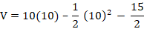 | B1  M1  A1  M1  M1  M1  A1  B1  M1  A1 | ✓velocity (award B0 for wrong units)  ✓substitution  ✓velocity (award A0 for wrong units)  ✓limits  ✓integral  attempt to subst. & subtr.  for t = 10s  ✓subst.  ✓velocity (award A0 for wrong units)
 |  | 10

23.(a) The 1st term and the common difference. (3mks

a + d = 8
$$\frac{a + 4d = \text{17}}{3d = a}$$
d = 3
a = 5

(b) The first three terms of the G.P and the 10th term of the G.P. (4mks)
2nd = 8
10th = 5 + 9 × 3 = 32
42nd = 5 + 41 × 3 = 128
∴GP is 8, 32, 128, - - - -
a = 8
r = 4
n^{th} term of G.P = ar^{n – 1}
∴10th term = 8(4)⁹
= 2097152

(c) The sum of the first 10 terms of the G.P. (3mks)

$$S = \frac{a\left(r − 1\right)}{r − 1}$$
$S = \frac{8\left(4 − 1\right)}{4 − 1}$
$= \frac{8}{3} × \text{1048575}$
= 2796200

24 | (a) Det = 32 – 35  = - 3  P-1 = -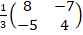  (b) (i) 8b + 14m = 47600  10b + 16m = 57400  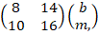 = 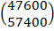  or  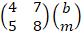 = 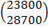  (ii) = 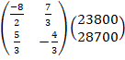  = 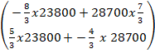  = 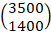  Bag of beans cost Sh. 3500  Bag of maie cost Sh. 1400  (c) x 3500 = 4025  8 x 4025 = 32400  47600 – 32400 = 15400  ∴1400m = 15400  m = 11 bags  Ratio 8:11 | B1  B1  M1  A1  M1  M1  A1  B1  B1  B1 | ü Accept 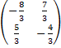  Both

