Term 2 - 2022
MATHEMATICS (121/1) –PAPER 1
FORM FOUR (4)
Time: 2 ½ Hours (MARKING SCHEME)
NO. |  |  | WORKING |  |  |  |  |  |  |  |  | MARKS |  |  |  |  |  |  |  | REMARKS
1. |  |  | √  0  .  4  ×  1  .  28  ×  10  3  0  .  064  ×  10  3  3  =  √  4  ×  128  64  3  √  2  2  ×  2  7  2  6  3  (  2  9  2  6  )  1  3  =  (  2  3  )  1  3  =  2 |  |  |  |  |  |  |  |  | M1  M1  A1 |  |  |  |  |  |  |  | Removal of decimal places  Expressing as product of prime factors
 |  |  | Total |  |  |  |  |  |  |  |  | 3
2. |  |  | 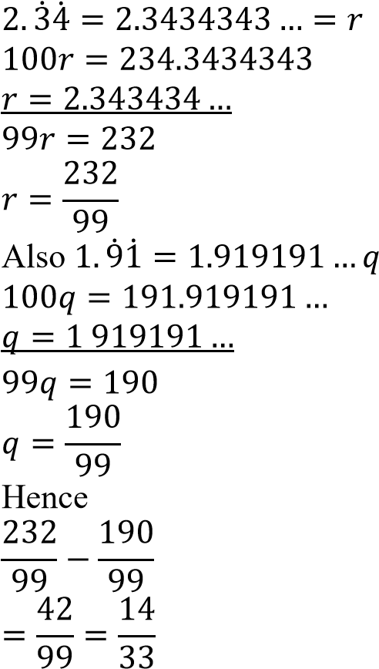  . |  |  |  |  |  |  |  |  | M1  M1  M1  A1 |  |  |  |  |  |  |  | Expressing 2. 3̇4̇ as a fraction  Expressing 1. 9̇1̇ as a fraction  Difference between the 2 fractions
 |  |  | Total |  |  |  |  |  |  |  |  | 4
3. |  |  | HCF → 7920 = 2⁴ × 3² × 5 × 11  GCD → 12 = 2² × 3  48 = 2⁴ × 3  264 = 2³ × 3 × 11  Other number→ 2² × 3² × 5 = 180 |  |  |  |  |  |  |  |  | M1 M1, A1 |  |  |  |  |  |  |  | Expressing HCF, GCD and the 2 given numbers in power form
 |  |  | Total |  |  |  |  |  |  |  |  | 3
4. |  |  | From the graph,  𝑥 = −3 → 𝑥 + 3 = 0 and 𝑥 = 2 → 𝑥 − 2 = 0  (𝑥 + 3)(𝑥 − 2) = 0  𝑥(𝑥 − 2) + 3(𝑥 − 2) 0  𝑥² − 2𝑥 + 3𝑥 − 6  𝑥² + 𝑥 − 6 = 0  Hence  𝑎 = 1, 𝑏 = 1 and 𝑘 = −6 |  |  |  |  |  |  |  |  | M1  A1  B1 |  |  |  |  |  |  |  | Factorization by grouping
 |  |  | Total |  |  |  |  |  |  |  |  | 3
NO. |  |  |  | WORKING |  |  |  |  |  |  |  |  | MARKS |  |  |  |  |  |  |  |  | REMARKS
5. |  |  |  | P: Q = 2: 3 … × 4 = 8: 12  R: Q = 5: 4 … × 3 = 15: 12  Hence P: Q: R = 8: 12: 15  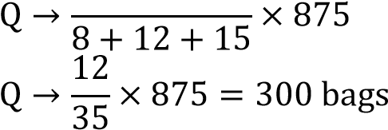12 |  |  |  |  |  |  |  |  | B1  M1  A1
 |  |  |  | Total |  |  |  |  |  |  |  |  | 3
6. |  |  |  | Curved Surface Area of cylinder  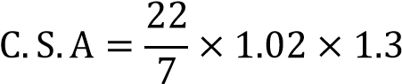  Number of revolutions  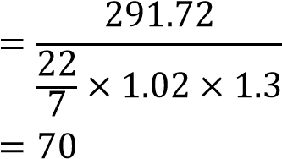 |  |  |  |  |  |  |  |  | M1  M1  A1
 |  |  |  | Total |  |  |  |  |  |  |  |  | 3
7. |  |  |  | Cost  →  120  100  ×  5000  =  USD  6000  Shipping  →  80325  135  =  JPY  USD  Total  →  6000  +  595  =  6  ,  595  Total cost  →  6  ,  595  ×  120  = Ksh.791,400 |  |  |  |  |  |  |  |  | M1  M1  A1 |  |  |  |  |  |  |  |  | Total cost in USD  Conversion of USD to Ksh
 |  |  |  | Total |  |  |  |  |  |  |  |  | 3
8. |  |  |  | Let BC = 𝑥  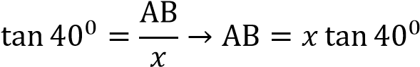  Also  ⁰ = ^{AB} → AB = (𝑥 50) tan 32⁰  tan 32  𝑥 + 50  𝑥 tan 40⁰ = (𝑥 + 50) tan 32⁰  0.8391𝑥 = (𝑥 + 50)0.6249  0.8391𝑥 − 0.6249𝑥 = 31.245  0.2142𝑥 = 31.245  31.245  𝑥 = = 145.9 m  0.2142 |  |  |  |  |  |  |  |  | M1  M1  A1 |  |  |  |  |  |  |  |  | Expressing AB in terms of tan 32⁰ and tan 40⁰  Equating AB to AB  145.9 seen
 |  |  |  | Total |  |  |  |  |  |  |  |  | 3
9. |  |  |  | 1  V = { × 8(13 + 20)} × 12  2  V = 1 584  3.5 × 1 584 Mass =  1000 = 5.544 kg
 |  |  |  | Total |  |  |  |  |  |  |  |  | 3
NO. |  | WORKING |  |  |  |  |  |  |  |  |  |  |  |  | MARKS |  |  |  |  |  |  | REMARKS
10. |  | 32𝑥+2 + 32𝑥 = 810  32 × 32𝑥 + 32𝑥 = 810  9(3^{2𝑥}) + 3^{2𝑥} = 810  10(3^{2𝑥}) = 810 → 3^{2𝑥} = 81  32𝑥 = 34  2𝑥 = 4 → 𝑥 = 2 |  |  |  |  |  |  |  |  |  |  |  |  | M1  M1  A1 |  |  |  |  |  |  | Expressing right hand side in terms of base 3
 |  | Total |  |  |  |  |  |  |  |  |  |  |  |  | 3
11. |  | Let the slant length of the smaller cone be  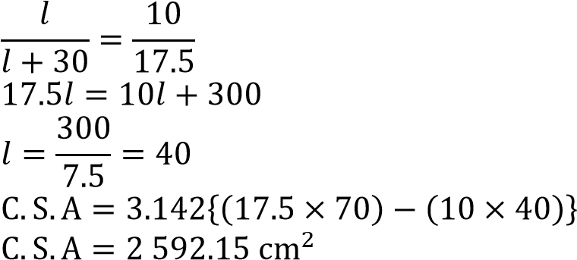 |  |  |  |  |  |  |  |  |  |  |  |  | M1  M1, M1 A1
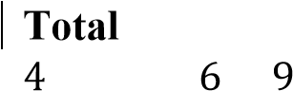 |  |  |  |  |  |  |  |  |  |  |  |  |  |  | 4
12. |  | 𝑥 − 𝑥 ≤ +  3𝑥 ≤ 15 → 𝑥 ≤  𝑥 + 3𝑥 ≥ 8 − 4
 |  | 4𝑥 ≥ 4 → 𝑥 ≥ 1  1 ≤ 𝑥 ≤ 5  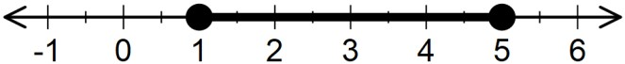 |  |  |  |  |  |  |  |  |  |  |  |  | B1  B1  B1 |  |  |  |  |  |  | For 𝑥 ≤ 5 and 𝑥 ≥ 1  Compound inequality shown  Number line drawn
 |  | Total |  |  |  |  |  |  |  |  |  |  |  |  | 3
13. |  | Frequency distribution table |  |  |  |  |  |  |  |  |  |  |  |  | B1  B1  B1 |  |  |  |  |  |  | All classes/class boundaries   All frequencies   Total frequency30 seen
 |  |  |  |  | Marks |  |  | 7 + 12 + 4 = 30
 |  |  |  |  | 10 – 14 | 2
 |  |  |  |  | 15 – 19 | 5
 |  |  |  |  | 20 – 24 | 7
 |  |  |  |  | 25 – 29 | 12
 |  |  |  |  | 30 – 34 | 4
 |  |  |  |  | Ʃ𝑓 = 2 + 5 +
 |  | Total |  |  |  |  |  |  |  |  |  |  |  |  | 3
14. |  | Logarithms |  |  |  |  |  |  |  |  |  |  |  |  | M1  M1  M1  M1 |  |  |  |  |  |  | All logs   Correct +/- of logs  Correct multiplication by 2 and division by 3 Accuracy
 |  |  |  |  | Number |  | Std Form |  |  | Logarithm
 |  |  |  |  | 7.089 124.5 |  | 7.089 × 10⁰  1.245 × 10² |  |  | 0.8506 2.0952
 |  |  |  |  |  |  |  |  |  | 2.9458
 |  |  |  |  | 86.73 |  | 8.673 × 10 |  |  | 1.9382
 |  |  |  |  |  |  |  |  |  | 1.0076 ÷ 3
 |  |  |  |  | 2.167 |  | 2.167 × 10⁰ |  |  | 0.3359
 |  | Total |  |  |  |  |  |  |  |  |  |  |  |  | 4
NO. |  | WORKING |  |  |  |  |  |  |  |  |  |  |  |  | MARKS |  |  |  |  |  |  | REMARKS
15. |  | Commission 20 000 − 12 400 = 7 600  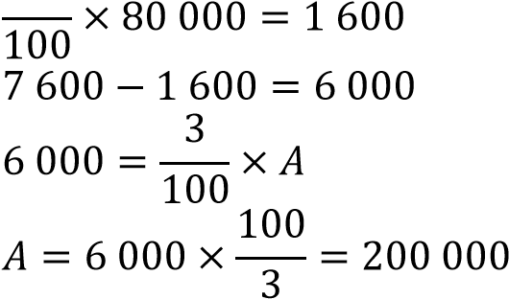  Total value  200 000 + 80 000 = 280 000 |  |  |  |  |  |  |  |  |  |  |  |  | M1  M1  A1 |  |  |  |  |  |  | Amount from commission  Expression for excess of 80 000
 |  | Total |  |  |  |  |  |  |  |  |  |  |  |  | 3
16. |  | (a) Lines of symmetry
 |  | 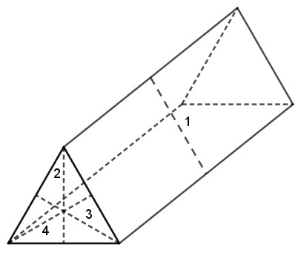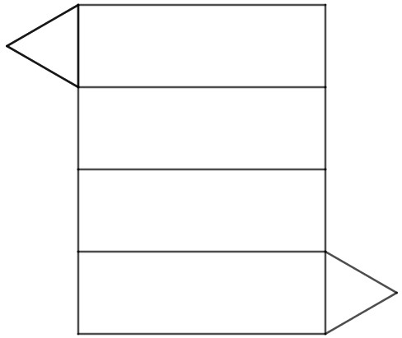  (  b  )  Net |  |  |  |  |  |  |  |  |  |  |  |  | B1  B1  B1 |  |  |  |  |  |  | For all the 4 lines of symmetry drawn  Correct net drawn  Correct measurements transferred from the solid
 |  | Total |  |  |  |  |  |  |  |  |  |  |  |  | 2
NO. |  | WORKING |  |  |  |  |  |  |  |  |  |  |  |  |  |  | MARKS |  |  |  |  |  |  | REMARKS
17. |  | (a) (i) Equation of 𝑙₁
 |  | 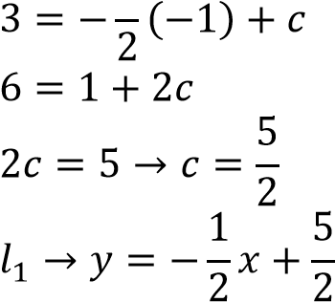  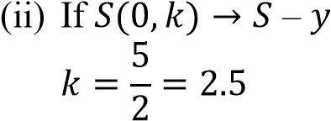  - (i) Gradient of 𝑙₂  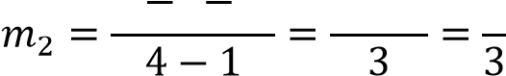5 ( 3)  (ii) Equation of 𝑙₂  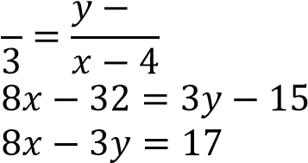  - Equation of 𝑙₃  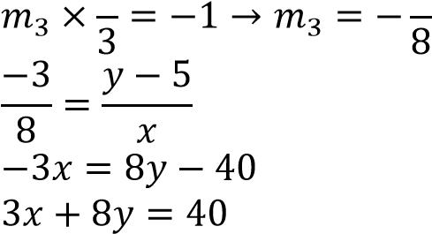  - Acute angle of 𝑙₃ and  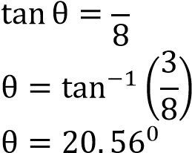 |  |  |  |  |  |  | -intercept  5 + 3 8  -axis |  |  |  |  |  |  |  | M1  A1  B1  B1  M1  A1  B1  M1  A1 |  |  |  |  |  |  | Substituting (−1,3) in 𝑦 = 𝑚𝑥 + 𝑐  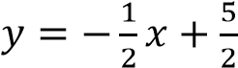 seen 2.5 or equivalent seen  seen
 |  | Total |  |  |  |  |  |  |  |  |  |  |  |  |  |  | 10
NO. |  | WORKING |  |  |  |  |  |  |  |  |  |  |  | MARKS |  |  |  |  |  |  | REMARKS
18. |  | (a) Amount of water delivered in 1 minute  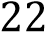
 |  | 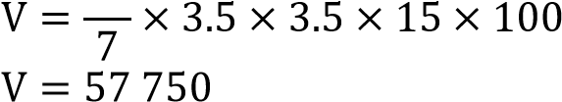  Capacity  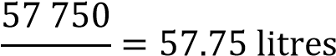  1 000  - Area of base of tank  Time difference  1310 hrs  0630 hrs  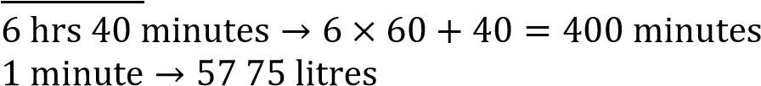  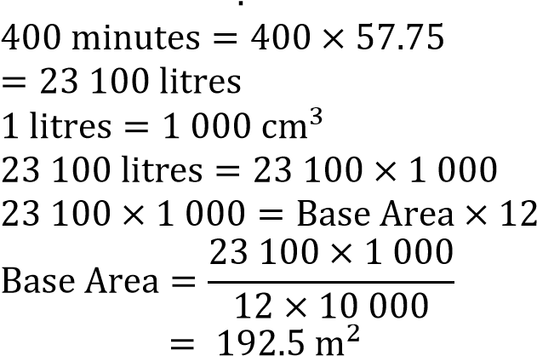  - Monthly water bill  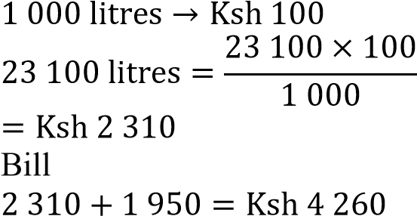 |  |  |  |  |  |  |  |  |  |  |  | M1  A1  B1  M1  M1  M1  A1  M1  M1, A1 |  |  |  |  |  |  | Time difference  Capacity in 400 minutes  Expression for base area
 |  | Total |  |  |  |  |  |  |  |  |  |  |  | 10
NO. | WORKING |  |  |  |  |  |  |  |  |  |  |  |  |  |  |  |  |  | MARKS |  |  |  |  |  |  | REMARKS
19. | 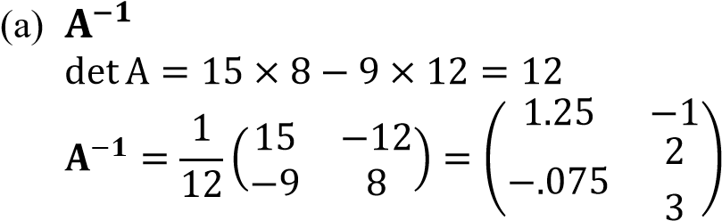  - (i) Equations  𝑝 + 12𝑐 = 294 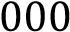  - + 1)𝑝 + (12 + 3)𝑐 = 294 000 + 43 500  9𝑝 + 12𝑐 = 337 500  (ii) Cost of each item  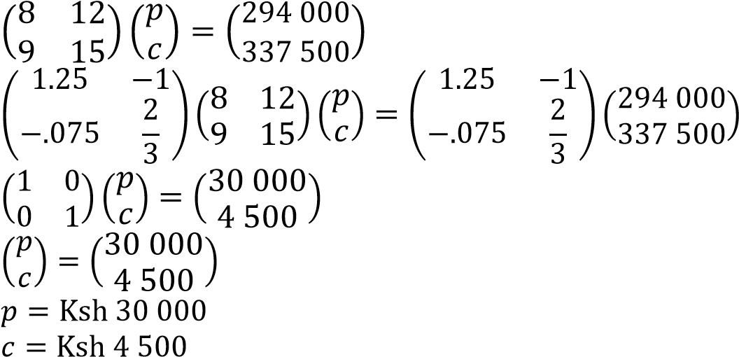  - Let the number be 𝑎𝑏  𝑎 − 𝑏 = 1  (10𝑎 + 𝑏) + (10𝑏 + 𝑎) = 165  11𝑎 + 11𝑏 = 165 → 𝑎 + 𝑏 = 15  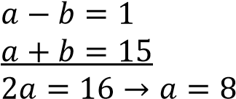  - − 𝑏 = 1 → 𝑏 = 8 − 1 = 7  Hence the number is 87 |  |  |  |  |  |  |  |  |  |  |  |  |  |  |  |  |  | B1  B1  B1  M1  M1  M1  A1  M1  M1  A1 |  |  |  |  |  |  | Accept if all elements as fractions  Matrix equation  Premultiplying by  𝐀−𝟏  Both values   Forming 2 equations in and  Solution for and using any method
 | Total |  |  |  |  |  |  |  |  |  |  |  |  |  |  |  |  |  | 10
NO. |  | WORKING |  |  |  |  |  |  |  |  |  |  |  |  |  |  |  | MARKS |  |  |  |  |  |  | REMARKS
20. |  | 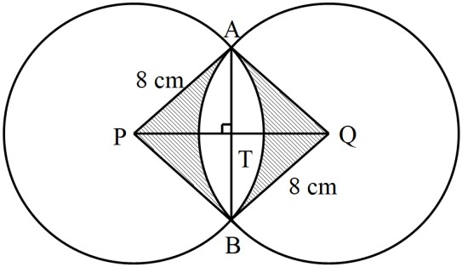  (a) Consider APT
 |  | 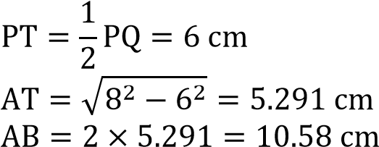  (b) Shaded area  Let APT = θ in APT  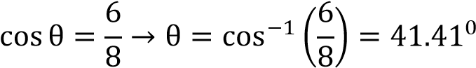  APB = 2 × 41.41⁰ = 82.82⁰  Area of segment  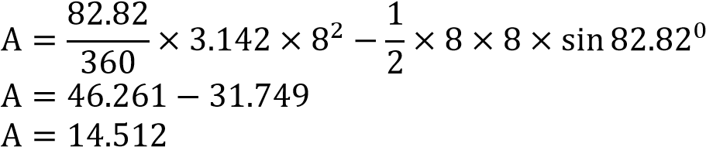  Both segments  14.512 × 2 = 29.024 Area of APBQ  A = 2 × 31.749 = 63.498  Shaded area= 63.498 − 29.024  = 34.74 cm² |  |  |  |  |  |  |  |  |  |  |  |  |  |  |  | M1  A1  B1  M1, M1  A1  M1  M1  M1  A1 |  |  |  |  |  |  | Angle APT  Area of sector, area of APB  Area of both segments Area of APBQ  Shaded Area
 |  | Total |  |  |  |  |  |  |  |  |  |  |  |  |  |  |  | 10
NO. |  | WORKING |  |  |  |  |  |  |  |  |  |  |  |  |  |  |  | MARKS |  |  |  |  |  |  | REMARKS
21. |  | (a) (i) RTP
 |  | RQT= 180⁰ − 100⁰ = 80⁰ – opposite angles of  cyclic quadrilateral QRST are supplementary  TQPUPT= 28⁰ – angle between a chord and a  tangent is equal to the angle subtended by the same chord on the circumference of the alternate segment.  RQP= 80⁰ + 28⁰ = 108⁰  Hence  RTP= 180⁰ − 108⁰ = 72⁰ – opposite angles of  cyclic quadrilateral QRTP are supplementary  (ii) Join O to Q and consider RQO  RQO= 50⁰ – base angles of isosceles RQO ROQ= 180⁰ − 2 × 50⁰ = 80⁰ – sum of angles in RQO is 180⁰  RTQ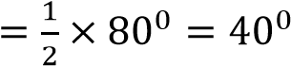 – angle at the centre is twice angle at the circumference Hence  QTP= 72⁰ − 40⁰ = 32⁰  (b) Consider  QPT= 180⁰ − (28⁰ + 32⁰) = 120⁰  TQO= 80⁰ − 50⁰ = 30⁰  In QPT  QT  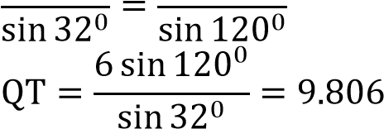  Let M be the midpoint of QT  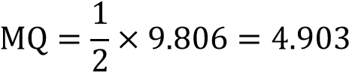  Consider OQM OQ  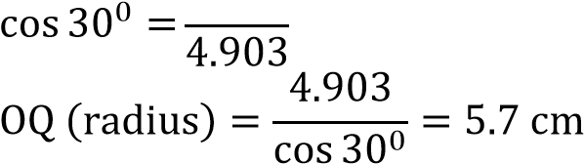 |  |  |  |  |  |  |  |  |  |  |  |  |  |  |  | B1  B1  B1  B1  B1  B1  M1  M1  M1  A1 |  |  |  |  |  |  | RQT  RQP  RTP  ROQ  RTQ  QTP  Sine Rule applied  Half of QT  Attempt to get radius
 |  | Total |  |  |  |  |  |  |  |  |  |  |  |  |  |  |  | 10
NO. |  | WORKING |  |  |  |  |  |  |  |  |  |  |  | MARKS |  |  |  |  |  |  | REMARKS
22. |  | (a) Time
 |  | Total length = 40 + 100 + 160 = 300 m  Relative speed= 60 − 40 = 20 km/h  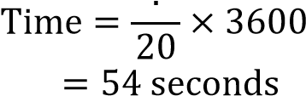0 3  (b) (i) Value of m  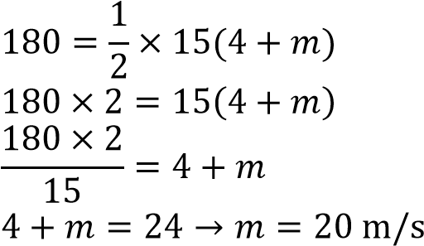  - No acceleration  - Deceleration  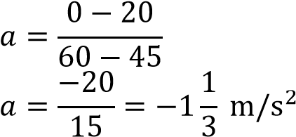  Hence, a deceleration of 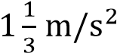 |  |  |  |  |  |  |  |  |  |  |  | M1  M1  M1  A1  M1  M1  A1  B1  M1  A1 |  |  |  |  |  |  | Total length  Relative speed  Equation distance to area of trapezium  Collecting like terms
 |  | Total |  |  |  |  |  |  |  |  |  |  |  | 10
NO. |  | WORKING |  |  |  |  |  |  |  |  |  |  |  |  |  | MARKS |  |  |  |  |  |  | REMARKS
23. |  | (a) Sketch
 |  | 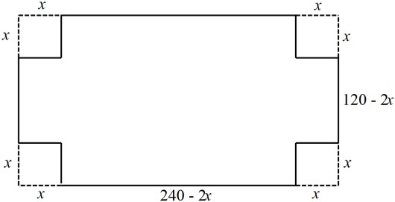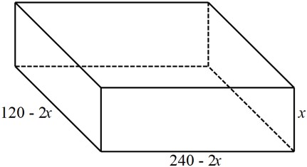  (  b  )  Value of  𝑥  for maximum volume  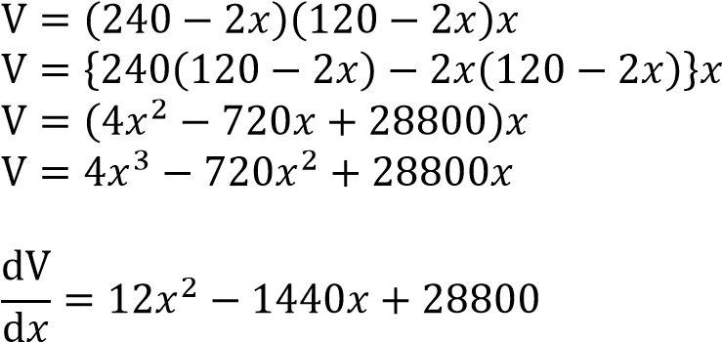  For maximum volume  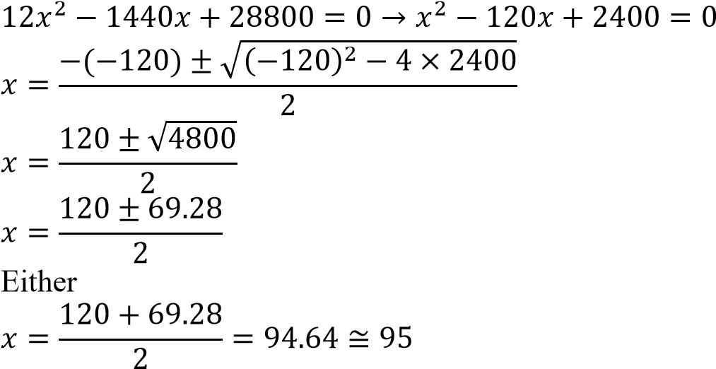  And  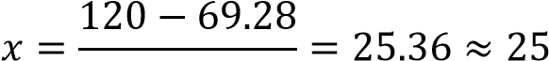  2  Hence 𝑥 = 25  (c) Mass of empty box External dimensions  (240 − 2 × 25) cm by (120 − 2 × 25) cm by 25 cm  190 cm by 70 cm by 25 cm  Internal dimensions  188 cm by 68 cm by 24 cm  = (190 × 70 × 25) − (188 × 6824)  V = 332500 − 306816 = 25684  Mass = 25684 |  |  |  |  |  |  |  |  |  |  |  |  |  | B1  B1  M1  M1  A1  B1  M1  M1  A1 |  |  |  |  |  |  | Correct sketch  Dimensions shown on the sketch  Expression for volume  Equating volume to 0 at maximum volume  Both values of  Value of  Internal and external dimensions
 |  | Total |  |  |  |  |  |  |  |  |  |  |  |  |  | 10
NO. |  | WORKING |  |  |  |  |  |  |  |  |  |  |  |  |  | MARKS |  |  |  |  |  |  | REMARKS
24. |  | - Table  - Graph  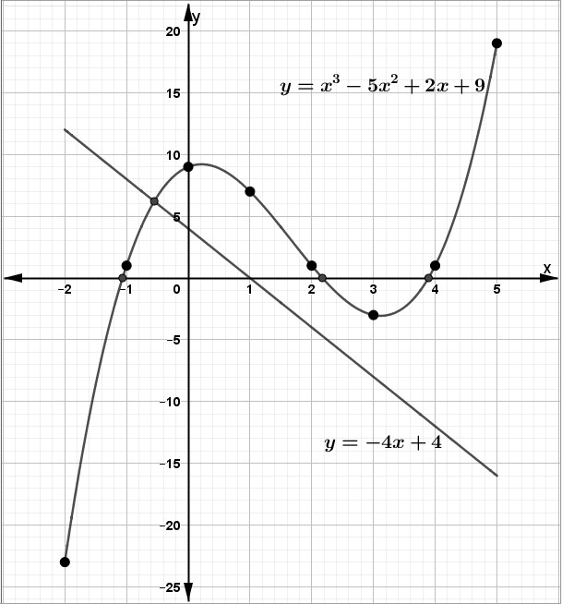  - Roots  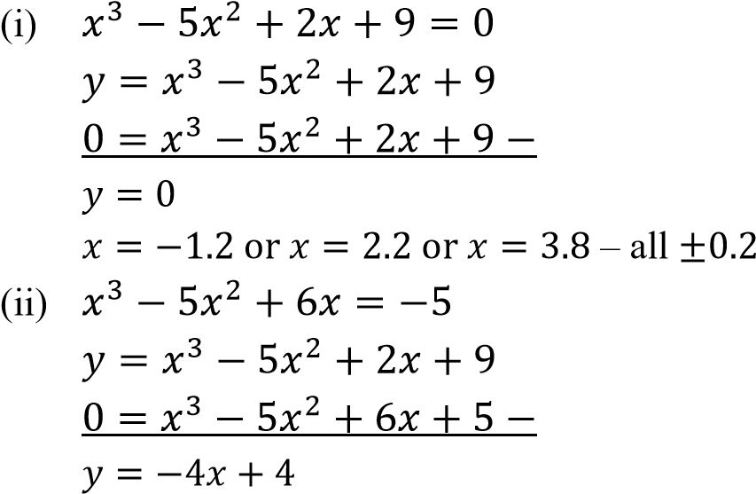  𝑥 = −0.6 ± 0.2 |  |  |  |  |  |  |  |  |  |  |  |  |  | B2  S1  P1  C1  B1  B1  M1  L1  B1 |  |  |  |  |  |  | All the values  (B1 for at least 5 values )  Linear scales used on both axes – accommodates all table values  All points plotted within the graph paper  Smooth curve drawn  𝑦 = 0 shown or  implied in the roots  All the values of    attempt to get  𝑦 = −4𝑥 + 4  Line 𝑦 = −4𝑥 + 4  drawn  value of
   | −2 | −1
   | −23 |  |  |  |  | −3 |  | 19
 |  | Total |  |  |  |  |  |  |  |  |  |  |  |  |  | 10

