25. MANAGEMENT AND CONSERVATION OF THE ENVIRONMENT
This topic entails :-
- Definition of management and conservation
- Explaining why it is necessary to manage and conserve the environment
- Naming/identifying environment hazards
- Assessing the impact of selected environmental hazards and suggesting measured for combating them.
- Discussing the measures taken in managing and conserving the environment.

1. i) Define the term land pollution
ii) Explain four causes of land pollution
iii) Explain four effects of land pollution

2. a ) Reasons why National parks are located in marginal areas.
(b) Explain three ways in which water pollution affect wildlife
(c) (i) State three causes of floods in Kenya
(ii) Explain two methods used to control flooding in Kenya
(d) State six reasons why it is important to manage and conserve environment

3. (a) Give three causes of sound pollution
(b) State two major health effects caused by sound pollution

4. (a) Apart from flooding, name three other environmental hazards experienced in Kenya
(b) (i) Name two rivers to the west of Rift valley which causes large scale flooding
(ii) Explain four problems caused by floods
(c) Explain three effects of land pollution on the environment
(d) (i) State three ways through which land pollution can be controlled
(ii) Give three effects of wind as an environmental hazard in Kenya
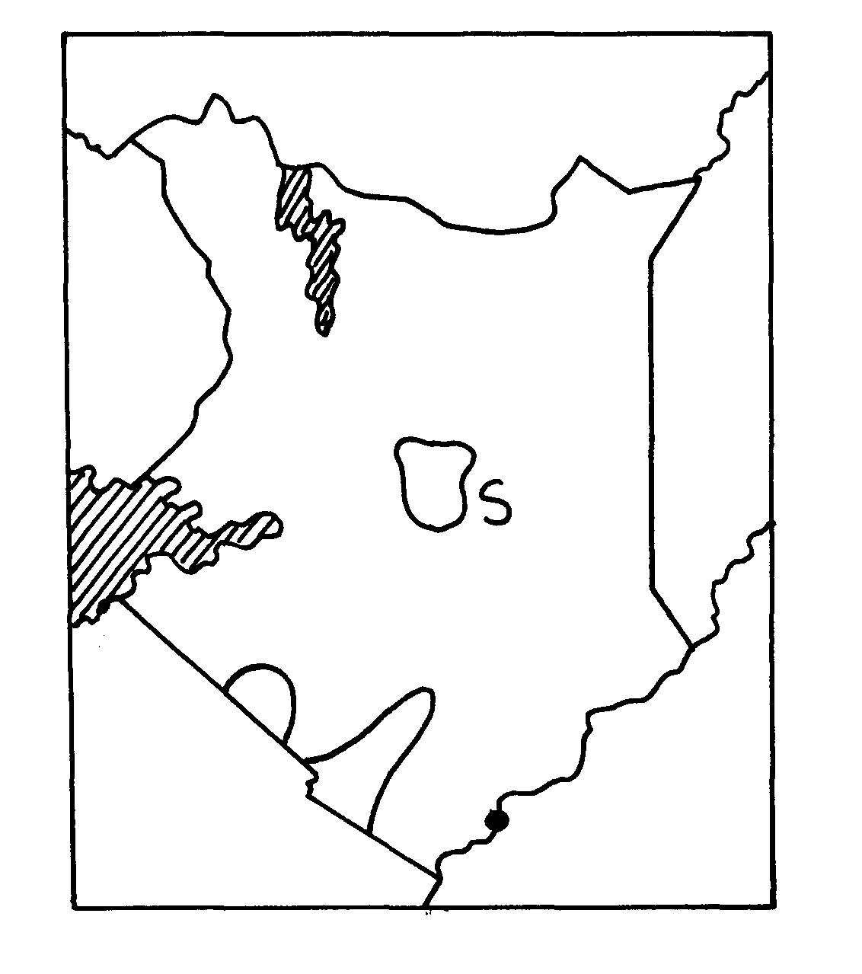
5. Use the map of Kenya below to answer question (a)
Mombasa
U
V
T

(a) (i) Name the wildlife conservation areas marked S, T, and U
(ii) Identify the Marine National Park marked V
(b) (i) Apart from Marine and Wildlife name three other tourist attractions along the coastal
strip of Kenya
(ii) Give four reasons for wildlife conservation in Kenya
(iii) Explain four problems facing wildlife conservation in Kenya

6. (a) Give three reasons why it was necessary to conduct a pre-visit before the actual study (3mks)
(b) State three measures that they could propose to be taken to promote domestic tourism
in Kenya (3mks)

7. (a) Apart from floods, name any other environmental hazard experienced in Kenya
(b) State two causes of desertification
(c) Give two reasons why it is necessary for Kenya to conserve her environment

8. (a) Differentiate between management and conservation of the environment.
(b) Give four reasons why we need to manage and conserve the environment.
(c) Explain four effects of air pollution on the environment.
(d) (i)Give five measures that can be put in place to combat pollution.
(ii) Identity three human characteristics you may learn from the garbage;

9. (a) Define the term pollution as used in Geography.
(b) Dither their air pollution name three forms of pollution.

10. Apart from desertification, name two other environmental hazards experienced in Kenya

