- Linear inequalities
1. Find without using a calculator, the value of :
12 0.0625 – 12.4 ÷ 0.4 x 3
¹/₈ of 2.56 + 8.68
2. Solve and write down all the integral values satisfying the inequality.
X – 9 ≤ - 4 < 3x – 4

3. Solve the inequality and show the solution on the number line.
3 – 2x ∠ x ∠ 2x + 5
4. Show on a number line the range of all integral values of x which satisfy the following pair
of inequalities: 3 – x ≤ 1 – ½ x
-½ (x-5) ≤ 7-x
5. Solve the inequalities 4x – 3 ≤ 6x – 1 < 3x + 8; hence represent your solution on a number line

6. Find all the integral values of x which satisfy the inequalities
2(2-x)< 4x -9< x + 11
7. Find the inequalities that define the unshaded region
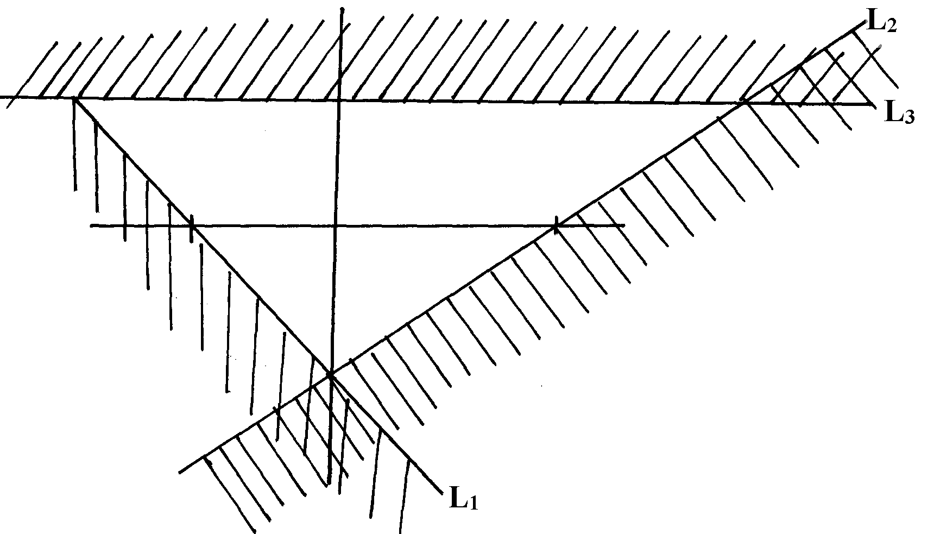
y
-1
-1
+1
x

8. Given that x + y = 8 and x²+ y²=34
Find the value of:- a) x²+2xy+y²
b) 2xy
9. Find the inequalities satisfied by the region labelled R
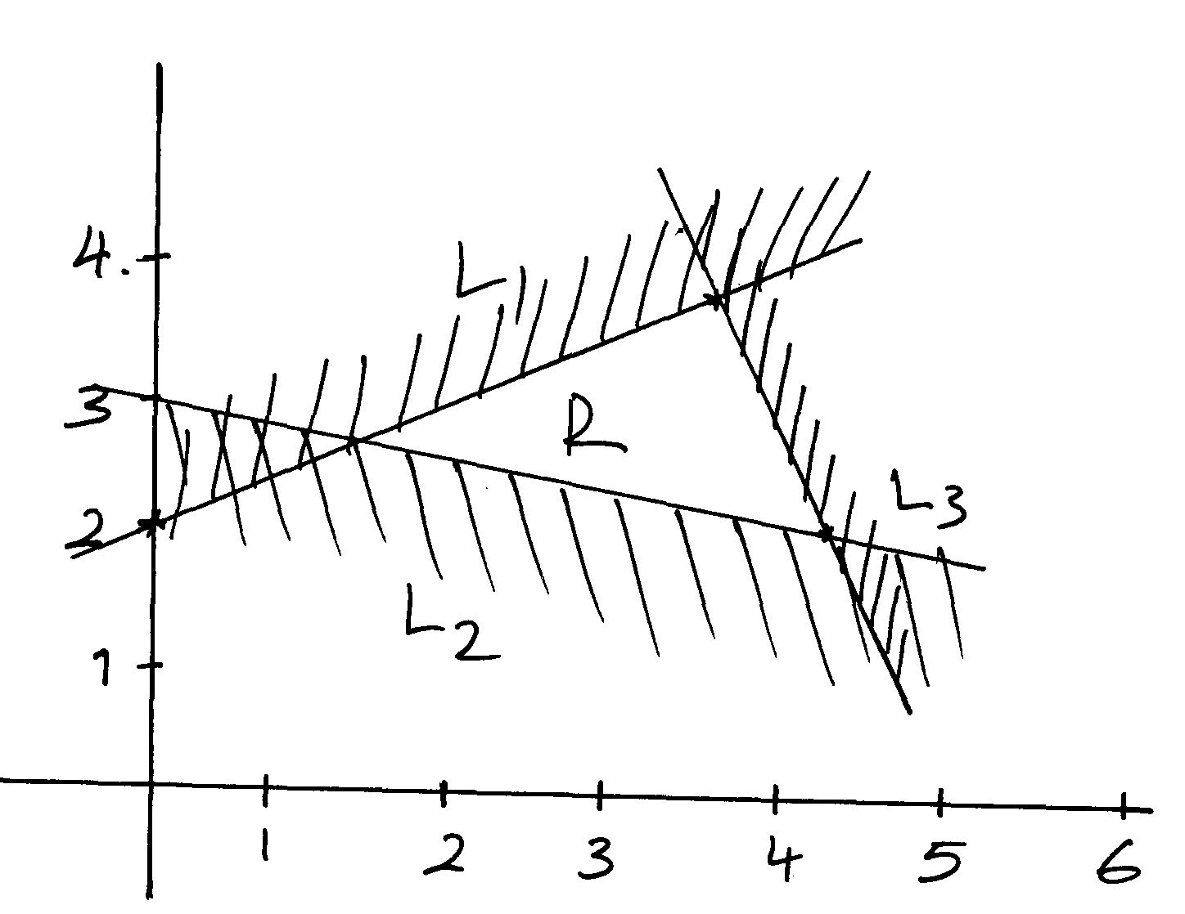

10. The region R is defined by x ≥ 0, y ≥ -2, 2y + x ≤ 2. By drawing suitable straight line
on a sketch, show and label the region R
11. Find all the integral values of x which satisfy the inequality
3(1+ x) < 5x – 11 < x + 45

12. The vertices of the unshaded region in the figure below are O(0, 0) , B(8, 8) and A (8, 0).
Write down the inequalities which satisfy the unshaded region
A(8, 0)
O(0, 0)
B(8, 8)
y
x

