LIVESTOCK HEALTH III
(LIVESTOCK DISEASES)

This topic entails the following:

- Description of causes and vectors of the main livestock diseases.
- Signs of each stated livestock disease
- Stating predisposing factors where applicable
- Control measures of livestock disease

The following relevant questions and their answers in this topic will greatly motivate and help the user to comprehend and understand the required concepts and practices.

1. Name two diseases that affect female animals only
2. Give four pre disposing factors of foot rot disease in sheep
3. i) Name the causative organism of contagious abortion in cattle
ii) Give four symptoms of contagious abortion in cattle
iii) State three methods of controlling contagious abortion in cattle
4. What is a vaccine?
5. (a) Discuss black quarter under the following sub-headings:-
(i) Animal affected
(ii) Casual organism
(iii)Symptoms of disease
(iv) Control measures
(b) (i) Explain four measures used to control liver flukes
(ii) Name an intermediate host of liver fluke
(c) Explain the following terms as used in livestock production
(i) Embryo transfer
(ii) Artificial insemination
(iii) Line breeding
(iv) Cross breeding
(v) Up-grading
6. Give four predisposing factors of foot rot disease in sheep
7. (a) Discuss coccidiosis disease under the following headings:-
(i) Causal organism
(ii) Livestock species attacked
(iii) Symptoms of attack
(iv) Control measures
(b) (i) What are the characteristics of an effective acaricide?
(ii) Explain three methods of acaricide application
8. Name four ways of controlling coccidiosi in the farm
9. State four predisposing factors of scour in calves
10. Name four notifiable diseases of livestock
11. Name two diseases of poultry that are controlled by vaccination
12. State three signs of anthrax injection disease observed in the carcass of a cattle
13. Differentiate between active immunity and acquired passive immunity
14. Name four systems of a tractor engine
15. State two adjustments that should be carried out on a tractor – mounted mould board plough
in preparation for ploughing
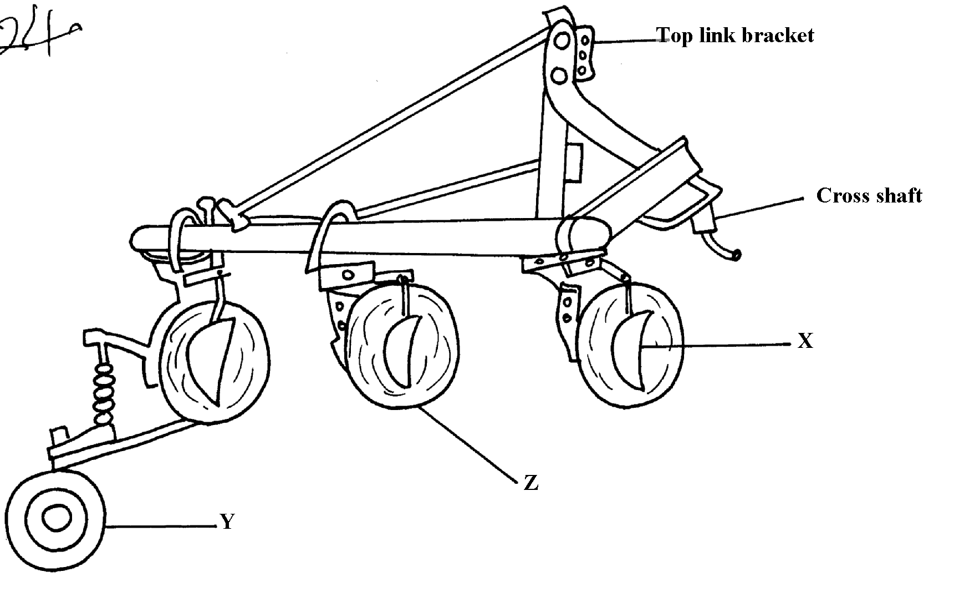
16. The diagram below illustrates a farm implement. Study it and answer the questions that follow

a) Identify the implement
b) Name the parts labeled X, Y and Z
c) State three maintenance practices that are carried out on a disc plough
17. List three causes of ruminal lympany (Bloat) in ruminant animals
18. (a) Give four symptoms of milk fever
(b) State two methods of controlling milk fever

19. (a) Describe East Coast Fever (E.C.F) under the following sub-topics:
(i) Animal attacked
(ii) Causal organisms
(iii) Symptoms of attack
(iv) Control and treatment
(b) Explain ten measures used to control livestock diseases

20. Name two livestock diseases that are spread through natural mating.
21. a) Give the method used in introducing a vaccine to poultry against fowl typhoid b) State other methods introducing vaccines to livestock

LIVESTOCK HEALTH III
(LIVESTOCK DISEASES)
1. -Mastitis
- Milk fever
2. Pre-disposing factors of foot rot.
- Overgrown / untrimmed hooves;
- Tick infestation between hooves;
- Muddy / filthy living / grazing areas;
- Presence of sharp objects e.g. stones;
3. (i) Causative agents of Brucellosis.
-Brucella abort – Cattle
- Brucella suis - Pigs
- Brucella malitensis – sheep and goats; (½ x 1 = ½ mk)
(ii) Symptoms of contagious abortions.
- Retained after birth;
- Sterility in cows;
- Spontaneous abortion;
- Yellowish – brown, slimy discharge, odourless discharge from the vulva after abortion;

(iii) Methods of controlling contagious abortion.
- Use of artificial insemination (A.I).
- Vaccination against the disease in young animals;
- Avoid contact with the aborted fetus;
- Blood tests of all breeding animals before mating;
Cull, slaughter infected animals;

4. A vaccine is an active disease pathogen reduced in strength /virulence or killed and is
introduced into an animals body to induce immunity

5. (a) Discuss black quarter under control predators under the following sub-headings:-
(i) animal affected-cattle, sheep, goats
(ii) casual organism-clostridium chauvei
(iii) Symptoms of disease (5mks)
- Rise in body temperature
- Lameness and swelling of upper part of limbs, making animals lie on side
- Swollen shoulders on either side of body, chest or back, formation of gas under skin
- Difficulties in breathing
- Muscle appear black and spongy
- Grunting and grinding of teeth
- Failure to chew cud
- On exposure to air, muscle of body rapidly darken
(iv) control measures (3mks)
- Annual vaccination using black quarter vaccine
- Burning of carcass
- Carcass should not be skinned or opened
- Cleaning and treating of all wounds with antiseptics (any 3x1=3mks)
(b) (i) Explain four measures used to control liver flukes (4mks)
- Controlling liver flukes
- Draining swampy areas
- Avoid grazing animals in swamps area
- Burning heavily infested pastures
- Apply chemicals (copper sulphate) to kill snails
- Remove and kill snails
- Fencing off swampy area (any 4x1=4mks)
(ii) Name an intermediate host of liver fluke
Water snail (limnea sp.)
(c) Explain the following terms as used in livestock production
(i) Embryo transfer
- Method of breeding which involve removal of ova from a superior animal, fertilize externally in a test tube then transfer to a foster mother which carry pregnancy to term
(ii) Artificial insemination
- Introduction of semen in to the females reproductive system by use of a tube
(iii) Line breeding
- Is mating of distantly related animals but within the same breed
(iv) Cross breeding
- Mating of animals belonging to different breeds e.g. fresian bull and jersey cow
(v) Up-grading
- Is the mating of high grade bull/sire to a low grade cow/dam (05x1=5mks)

6. - Overgrown hooves
- Presence of sharp objects/stores
- Muddy living/grazing areas
- Living infestation between hooves
7. (a) (i) Coccidia
(ii) Poultry, calves, young rabbits, kids, lambs
(iii) -Diarrhea
- Dysentery in the dung
- Euraciation
- Ruffled feathers
- Birds become dull with dropping wings
- sudden death in birds, rabbits and kids
(iv) Drugs such as coccidiostats mixed with food or water
- Isolation of infected animals
- Avoid filthy, unhygienic animal surroundings
- Avoid common dunking points for livestock from different farms
- Avoid overcrowding in poultry houses
(b) (i) – Able to kill ticks
- Harmless to both human beings and livestock
- stable – remains effective even after contamination by dung, mud or hair
(ii) – Spraying animals
- dipping – involves immersing the animal into the acaricide or wetting the animal by the acaricide
- Hand dressing – involves smearing pyegrene on areas not likely to be reached by the acaricide
e.g. in the ears
8. four ways of controlling coccidiosis in the farm
- Avoid overcrowding in poultry
- Provision of coccidiostat in feeds and water
- Use of portable calf pen
- Practicing proper hygiene
9. four predisposing factors of scour in calves
- Unhygienic condition in the house of the young ones
- Feeding the calves on cold milk
- Lack of colostrums and
- Feeding at irregular intervals
10. four notifiable diseases of livestock
- Rinderpest
- Foot and mouth
- Anthrax
- Rift valley fever
- New castle disease: mud cow disease
11. New castle, fowl pox, fowl typhoid, gumboro, marek – injections, pursaa disease
12.
- Signs of anthrax in carcasses
- Blood does not clot
- No rigormatics after death
- Stomach swells/ bloat
- Darkened blood oozes out through the natural opening
13. Differentiate
- Active immunity – animal producing antibodies
- Acquired/ passive immunity – external source of immunity
14.
- Fuel system
- Electrical system
- Cooling
- Lubrication
- Transmission
- Ignition
- Hydraulic

15. 2 adjustment on mould board plough
- Adjust the plough depth
- Front furrow depth
- Lowering/ raising ploughing pitch
- Front furrow width

16. a) Disc plough reject disc alone
b) X – Disc scrapper
Y- Rear wheel/ furrow wheel
Z - Disc
c) - Replace broken discs
- Clean plough after use reject wash plough
- Lubricate hubs and furrow wheel bearing/ moving parts reject movable parts
- Lighten loose nuts and bolts
- Store in a cool dry place
- Apply old engine oil to prevent rusting during long storage/ paint implement
17. Causes of ruminal tympany (Bloat)
- Obstruction of esophagus due to bulky food e.g. potatoes
- Abnormal pressure exerted on esophagus by swelling in wall of chest
Indigestion due to eating poisonous herbs, soft young green foliage

18. a) Symptoms of milk fever
- Muscular twitching
- Staggering
- Animal lies down on its side most of the time
- Animals lies on sternum with rock twisted on one side
- General paralysis
- Breathing becomes slow and weak 4x ½ =2 marks
b) Control measures of milk fever
- Feed animal o diet rich in calcium
- Give intramuscular injection of calcium 2-3 days before cavity
- Partial milking
- Cull susceptible animal

19. East coast fever (ECF)
i) cattle 1x1=1 mark
ii) Theirelia parva Reject if not underlined, spellings are wrong
iii)
- Fever/ high temperature
- Salivation
- Lachrimentim/ tears from eyes
- Difficult in breathing
- Haemorrhages in vulva/ mouth
- Coughing
- Sight impairment 6x1=6 marks
iv)
- Regular spraying/ dipping/ hand dressing with acaricide
- Fencing/ rotational grazing
- Treatment using appropriate drugs 2x1=2 marks

b) Ten measures used to control livestock diseases
i) Proper breeding and selection
- Animals fed on balanced ration adequate in quantity and quality are strong and able to resist diseases
ii) Proper breeding and selection
- Animals selected that are free from diseases or resistant to diseases will prevent transmission of diseases

iii) Proper housing and hygiene’s
- Animals houses should be built to meet construction requirement e.g. ventilation, space, drainage, leak proof, lighting and will prevent and protect animals from contracting diseases
iv) Isolation of sick animals
- Is separation and confinement of animals from health ones while undergoing treatment, this prevents spread of the diseases
v) Imposition of quarantine
- Is restriction of movement of animals and their products from and into affected areas, thus prevents spreads of diseases
vi) Prophylactic measure and treatment
- Involves use of drugs before disease attack to prevent occurrence e.g. use of coccidiostat to control coccichosis, drenching to prevent anti helminites
- Also involve vaccination, spraying with appropriate acaricize and treatment to restore good health
vii) Slaughtering affected animla
- Highly infection and contagious diseases e.g. rinderpest, new cattle foot and mouth animals should be slaughtered and carcasses will dispose to prevent spread
viii) Use of antiseptics and disinfectants
- Applied on skin to kill germs or clean livestock to maintain hygiene
- Vaginitis.
- Brucellosis.
- Trichomaniasis.
20.
- Vaginitis.
- Brucellosis.
- Trichomaniasis.
- Leptospirosis. (2x ½ = 1mk)

21. (a) injection (b)oral

