Introduction to chemistry
1. a) F is place in the middle of the flame while G is placed at the upper region of the flame
b) Non- luminous flame

2. . A,D,C,B, and C all correct
A,D,C,D correct answers are exclusive
A,D,C ½ mk otherwise penalize
3. a) The laboratory gas burns in excess oxygen
OR burns completely or produces CO₂ and H₂O only
- No unburnt carbon remains
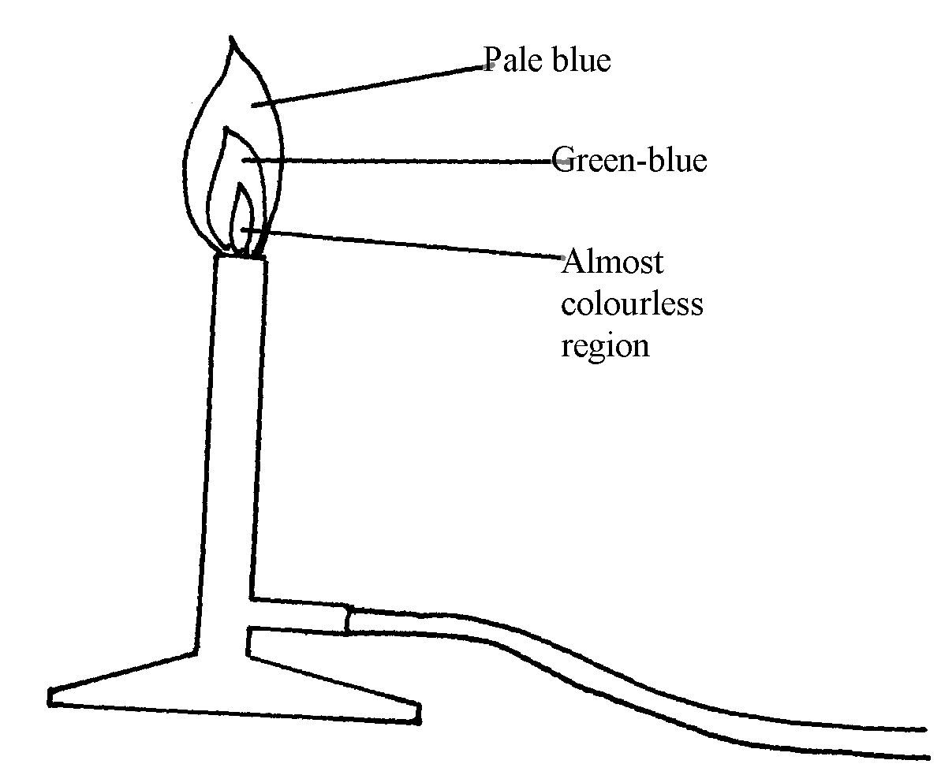
OR No soot is formed// Produced.
b)

4. a) a substance which when taken alters the body chemistry

b) - alcohol
- Tobacco
5. (a) A- Downward delivery /upward displacement of air
 ½
B – Over water
(b) A – Denser than air
6. (i) P – Haxane
(ii) W – Water

7. Name – Mortar. ^{√½}
Use – Holding solid substances being crushed. ^{√½}
Name – Crucible ^{√½}
Use – Holding solid elements being heated strongly. ^{√½}
8. T – has a very small hole which releases the gas in small quantities /in form of a jet.
 1
U – It is heavy for stability
9. (a) It is very hot. (1 mk) √1
(b) The upper√1 part. Because all the gases undergo complete √1 combustion. √1 (2 mk) 3
10. The crystal dissolved√ ½ . Blue colour spreads in water √ ½ . The crystal broke up into
smaller particles of copper (ii) sulphate and diffused in all direction
11. (a) W has more energy levels than S. √1
(b) C has got (12) protons pulling the 10 electrons while A has 11 protons
2 pulling 10 electrons. √1

