- Integration

1. The diagram below, not drawn to scale shows part of the curve y = x²+5 and the line y = 8-2x. The line intersects the curve at points C and D. Lines AC and BD are parallel to the y-axis.
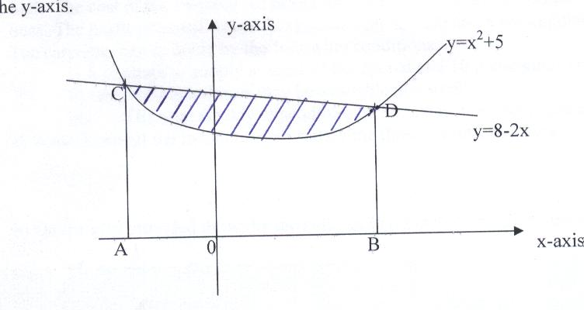
the y-axis
a) Determine the coordinates of C and D (4 mks)
b) Use integration to calculate the area bounded by the curve and the x- axis between the points C and D (3 mks)
c) Calculate the area enclosed by the lines CD, CA, BD and the x-axis (2 mks)
d) Hence determine the area of the shaded region (1 mk)

2. Evaluate:- x² – 3x + 2 dx
5
2
x - 2

3. Find the values of a which satisfy the integral
ª
∫ (x² + 1) dx = 2a
º

