- Graphical methods

1. x² + 4x + y² = 5
x² + 4x + ( ½ x 4)² + y² = 5 + (½ x 4)²

(x + 2)² + (y + 0)² = 5 + 4

(x + 2)² + (y + 0)² = 9
Centre (-2,0)

Radius √9
r = 3 units

2. x² + 6x + (3)² + y² – 10y + (⁻5) = 2 + 9 + 25
Completing of sq. for expression in x and y.
√ Expression.
√Centre
√Radius

(x + 3)² + (y – 5)² = 36
(x – ⁻3)² + (y - +5)² = 6²
∴ centre (-3, 5)
Radius 6 units

3. CBE = 40⁰ ( alt.segiment theoren)
∠BCE = 120⁰ (Suppl. To BCD = 60⁰alt. seg.)
∴(40 + 120 + E) = 180⁰ (Angle sum of Δ )
∠ BEC = 20⁰

4. X² +Y² – 10Y + 25 = 25 – 16
(X -0)² + (Y – 5)² = 9
(X – 0)² + (Y – 5)² = 3²
Centre (0, 5)
Radius = 3

5.
x | -5 | -4 | -3 | -2 | -1 | 0 | 1
x³ | -125 | -64 | -27 | -8 | -1 | 0 | 1
6x² | 150 | 96 | 54 | 24 | 6 | 0 | 6
8x | -40 | -32 | -24 | -16 | -8 | 0 | 8
y | -15 | 0 | 3 | 0 | -3 | 0 | 15
x³ + 6x² + 8x >1
Between
(i) x = -3.85 0.1 and x -2.15 0.1
(ii) x > 0.5 ±0.1

6. y = x³ – 3x + 2
x = 0, y = 2
(0, 2) ⇒ y – intercept.

dy = 3x² – 3 = 0
dx x² = 1
x = ∓ 1

x = 1 y = 0
Point (1, 0) min point
x = -1, y= 4

Point (-1, 4) max point.

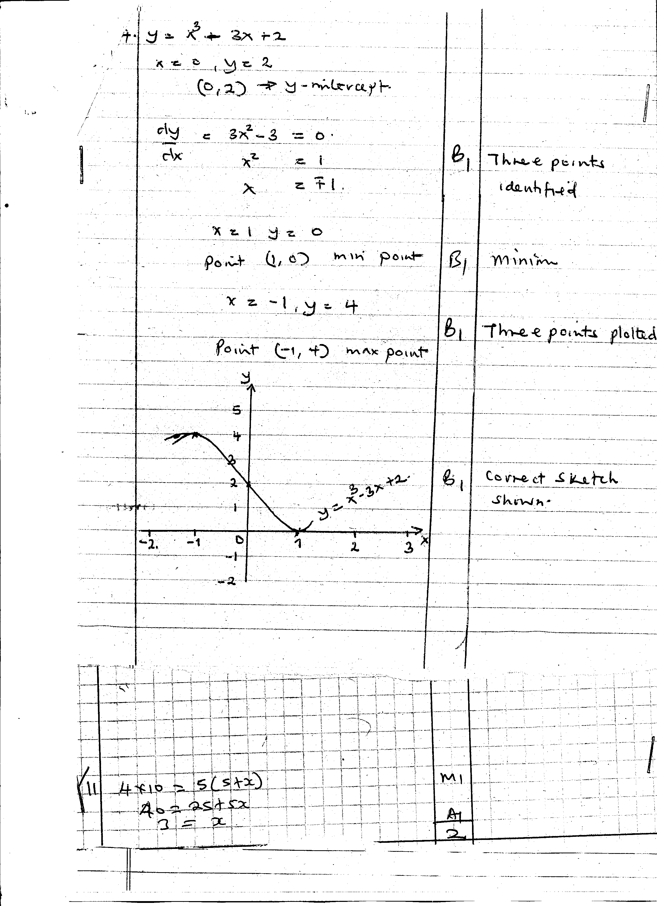

7. 4x₂ – 12x + 4y² + 12y = 7
x² – 3x + y² + 3y = ⁷/₄
x² – 3x + (³/₂)² + y² + 3y + (³/₂)² = ⁷/₄ + ⁹/₄ + ⁹/₄ = ²⁵/₄
(x – ³/₂)² + (y + 3/2)2 = 25/4
∴Centre (1,5, -1.5) Radius 2.5units

8. Log R =nlog p + log K

Log P | 0.48 | 0.54 | 0.60 | 0.65 | 0.70
Log R | 1.56 | 1.69 | 1.81 | 1.91 | 2.00
Gradient = 2 – 0.6
0.7
= 1.4 = 2
0.7
Log R intercepts = 0.6 = logk
K= 4
The law connecting R and P is R=4P²
900 = 4P²
P² = 900
4
225 = P²
9. (x +2)² (y-3)² = 3²
X² + 4x + 4 + y² – 6y + 9 = 3²
X² + y² + 4x – 6y + 4 = 0
10.
V | 0 | 2 | 4 | 6 | 8 | 10
1  T | 2.04 | 3.33 | 4.17 | 5 | 6.25 | 7.30
T = a
b + V
I = b + V
T a
I = 1V + b
T a a
y = mx + C

b) (i) 1 = Grad ⇒ ∆y = 7.3 – 5 = 2.3 = 0.575
a ∆x 10 – 6 4

a = 1.739

b = y – Intercept ⇒2.04
a
b = 2.04 b = 2.04 x 1.739
1.739 = 3.547556
b ≃ 3.548

(ii) T = 0.38
I = 2.63 shown on graph
T
V = 1
-1
(iii) I = 4.45
T
T = (4.45)
= 0.2247
≃0.22

11. y = 2x³ + x² + 3x -1
dy = 6x² + 2x + 3
dx
gradeindent at (1, -5)
= 6 + 2 + 3= 11
y-(⁻5) = 11
x -1
y + 5 =11x -11
y = 11x -16

12. 3⁵ = 3⁻⁴ x 3^{-x}
3⁵ = 3^{-4-x}
-4 –x = 5
-x = 9
x =-9
13. x² + 2x + 1 + y² – 4y + 4 = 4 + 1 + 1
(x+1)² + (y-2)² = 9
Centre (-1, 2)
Radius 3units

14. c)
X | -4 | -3 | -2 | -1 | 0 | 1 | 2
-6 | -6 | -6 | -6 | -6 | -6 | -6 | -6
X | -4 | -3 | -2 | -1 | 0 | 1 | 2
4x² | 64 | 36 | 16 | 4 | 0 | 4 | 16
X³ | -64 | -27 | -8 | -1 | 0 | 1 | 8
Y=-6+x+4x²+x² | -10 | 0 | 0 | -4 | -6 | 0 | 20
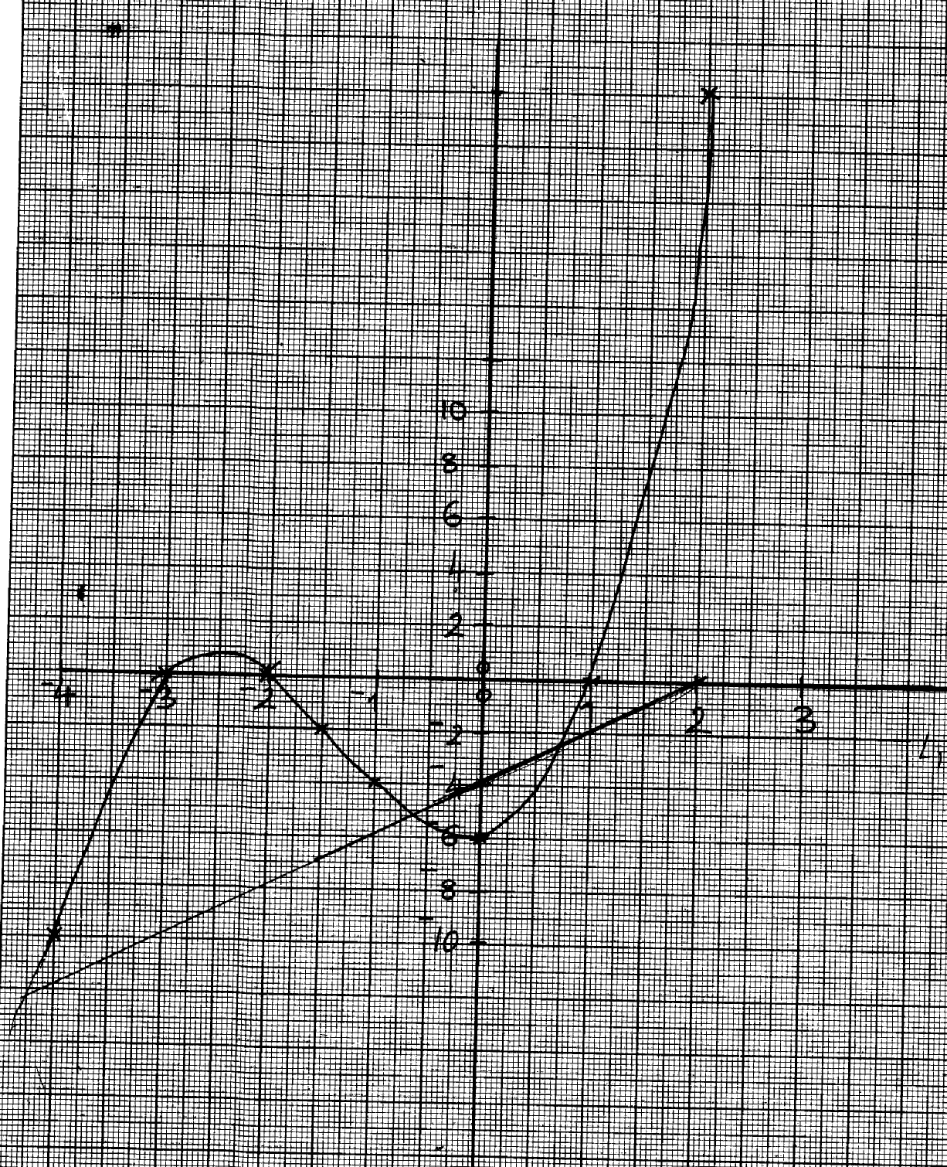
y = x³ + 4x² + x -6
0 = x³ + 4x² + x -4
y = -2

(iii) y = x³ + 4x² + x - 6
0 = x³ + 4x² + 0 – 2
y = x – 4

x 1 0 -2
y -3 -4 -8
-y=-6 + 4x² +x3

-y=x-4

c (i) solution 0.8
-1.5
And -3.2
(c) 1, -2, -3

15.
Perimeter p(cm)
35
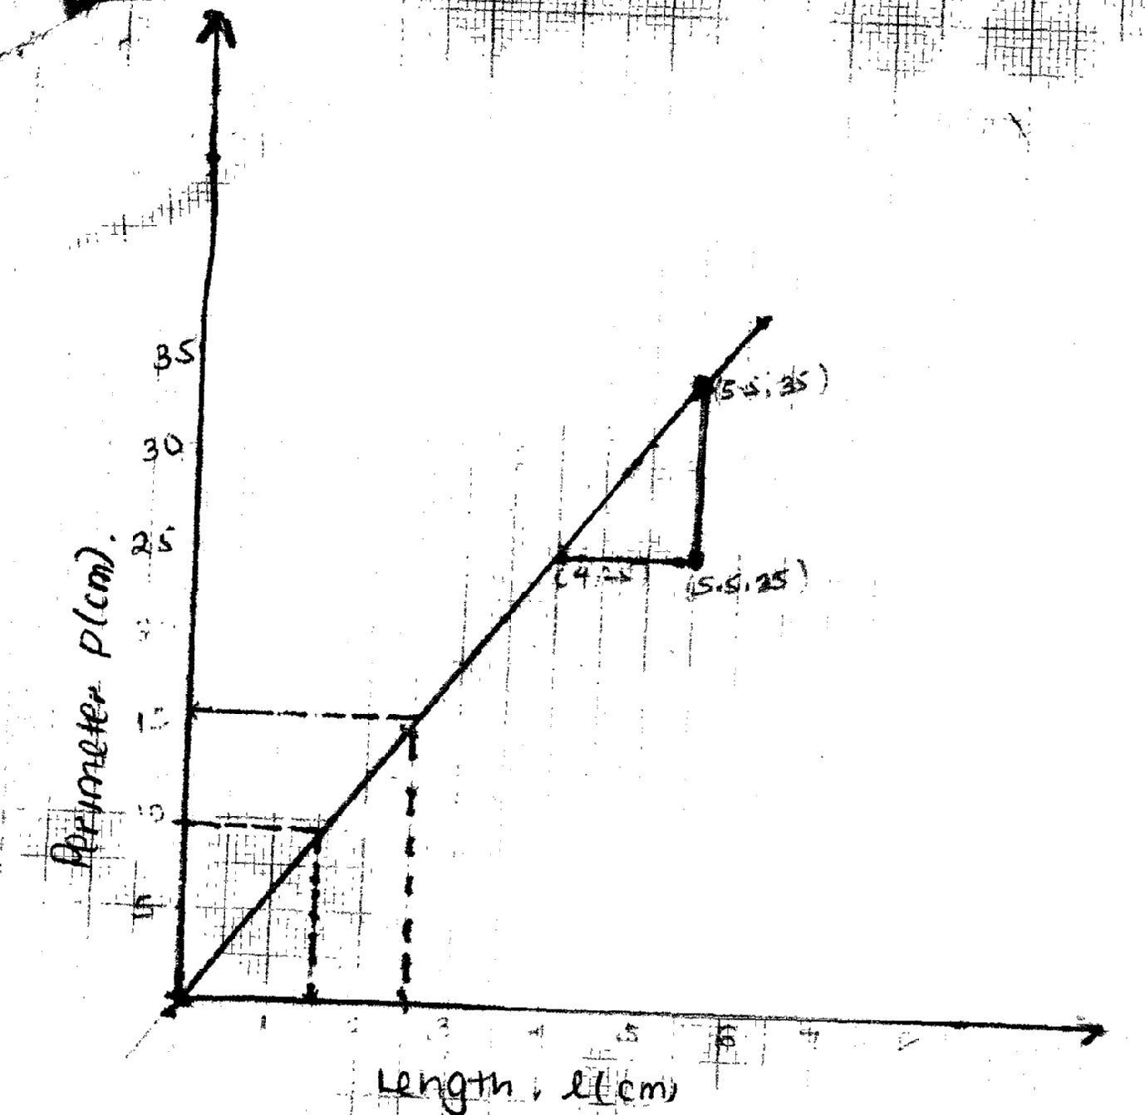

30

25
(5.5, 35)

20

15

(4, 25) (5.5, 25)

10

5

1 2 3 4 5 6 7 8

Length l(cm)

(i) P = 15.75cm
(ii) l=1.5cm
(iii) m = 35- 25 = 10 = 6.667
5.5 – 4.0 1.5

(c) choose P(5,31.4)
p - 31.4 = 10
l -5 1.5
p-31.4 = 100
l-5 1.5
15p – 471 = 100k – 500
15p = 100l – 29
15 15
2k = 100
15
k= 100 = 3.33
2 x 15
c =1.93
P + 0.6 = ar^{h}
Log (P + 0.6) = log a + n log R
= n log R + log 9
P + 0.6 | 1.33 | 2.65 | 3.85 | 8.04 | 11.22
Log (P + 0.6) | -0.13 | 0.42 | 0.59 | 0.91 | 1.05
Log R | -0.05 | 0.05 | 0.12 | 0.25 | 0.30

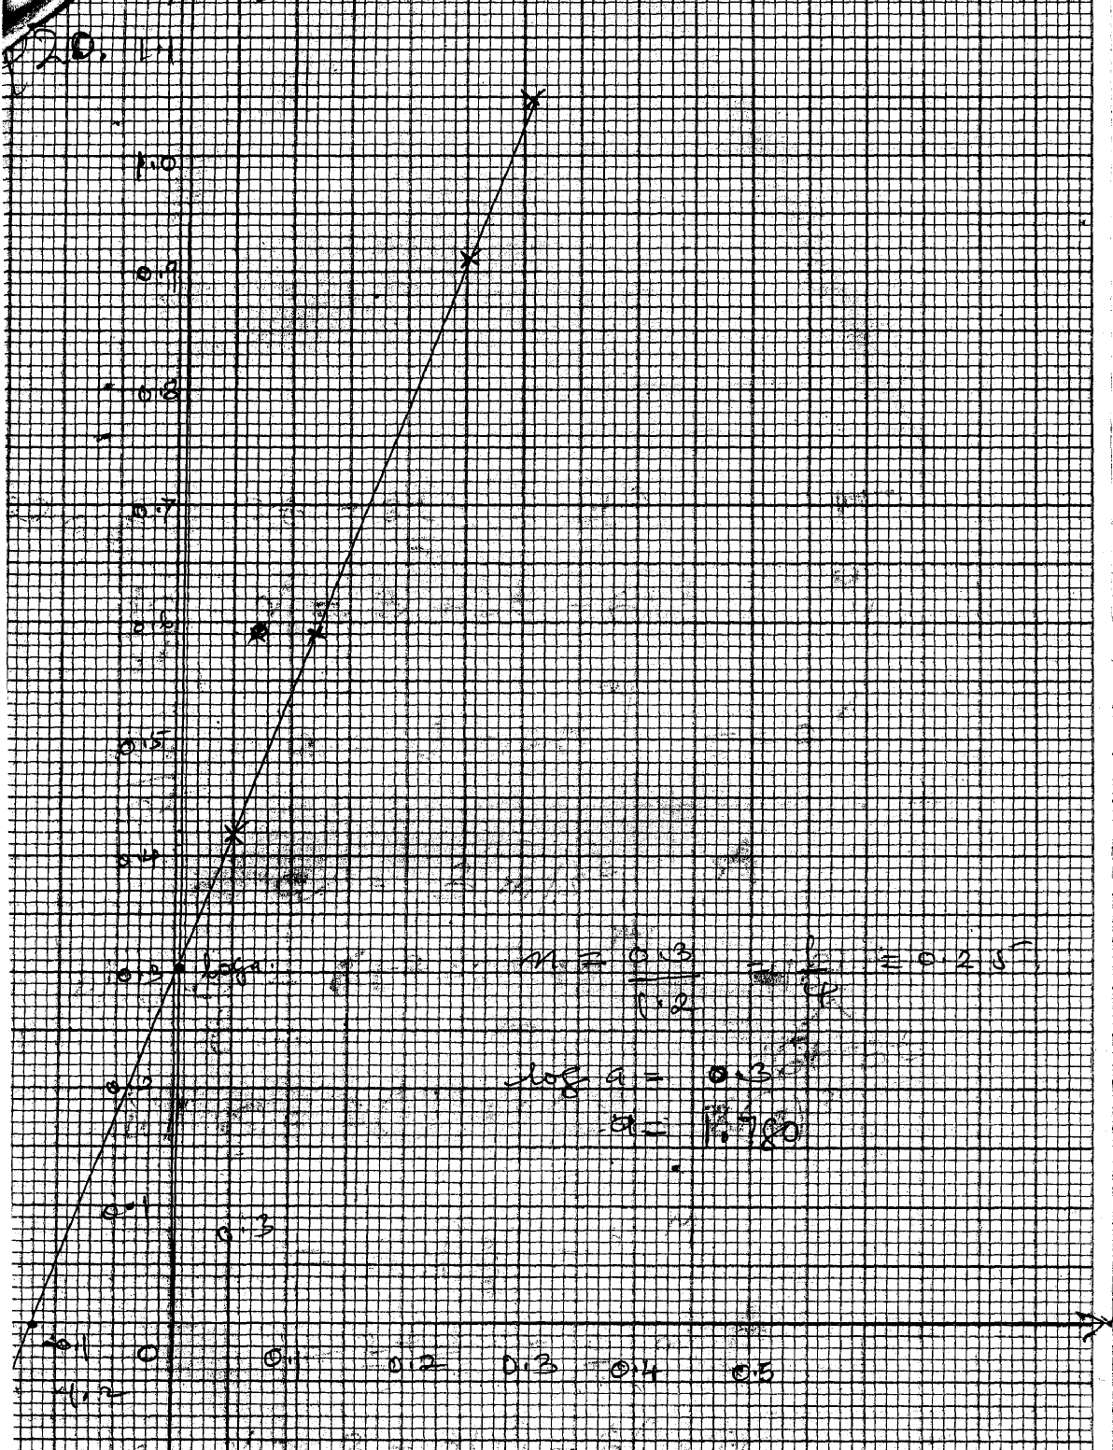

Log 0.3 = ¼ = 0.25
Log a = 0.3

17. x² + y² – 6x = 3 – 4y
x² – 6x + (⁻⁶/₂)² + y² + 4y + (⁴/₂)² = 3 + (⁻⁶/₂)² + (⁴/₂)²

(x – 3)² (y + 2)² = 3 + 9 = 4
(x – 3)² (y + 2)² = 16
C (3, -2)

Gradient ∆y = 7 - -2 = 3
∆x 6 – 3

18.
x | -3 | -2 | -1 | 0 | 1 | 2 | 3 | 4
-x³ | 27 | 8 | 1 | 0 | -1 | -8 | -27 | -64
2x² | 18 | 8 | 2 | 0 | 2 | 8 | 18 | 32
-4x | 12 | 8 | 4 | 0 | -4 | -8 | -12 | -16
2 | 2 | 2 | 2 | 2 | 2 | 2 | 2 | 2
y | 59 | 26 | 9 | 2 | -1 | -6 | -19 | -46

b) Check on the graph paper.
c) x = 0.5 + 0.1
d) –x³ + 2x² – 5x + 3 = 0
Line to allow: y = x – 1

x 0 1
y -1 0

x = 0.65

19. ^{Dy}/_{dx} = 12x² – 12
12x² – 12 = 0
12(x² – 1) =0
x = 1
x = -1

At x = 1 At x = -1
0 | 1 | 2 | -2 | -1 | 0
GRD = 12 | 0 | 36 | 36 | 0 | -12
- 0 + + 0 -

(1,7) (-1, 9)
Minimum maximum
20. (a) table
(b) plotting
scale
smooth curve
(c) (i) -0.5 < x < 1 and x>1
(iii) x = 2.5 ± 0.1

21. 2x² + 2y² – 6x + 10y + 9 = 0
x² + y² – 3x + 5y + 9/2 = 0
x² + y² – 3x + 5y = -9/2
x² – 3x + 9 + y² + 5y + 25 = 8.5 – 4.5
4 4
(x – 3)² + (y + 5)² = 4
2 2
Radius = 2 units
Centre = (1.5, -2.5)

