**Grade 4 Home science notes**

**Topic 1: Healthy practices**

**Sub topic: Play**

To grow healthy,we need food, clothing,play,rest and shelter.

Shelter is housing.

Which games are played in our locality.

Games played in our locality are football, Athletics,tug of warm, swinging, playing darts, playing games on computers.

Pictures of games played in the locality on page 3

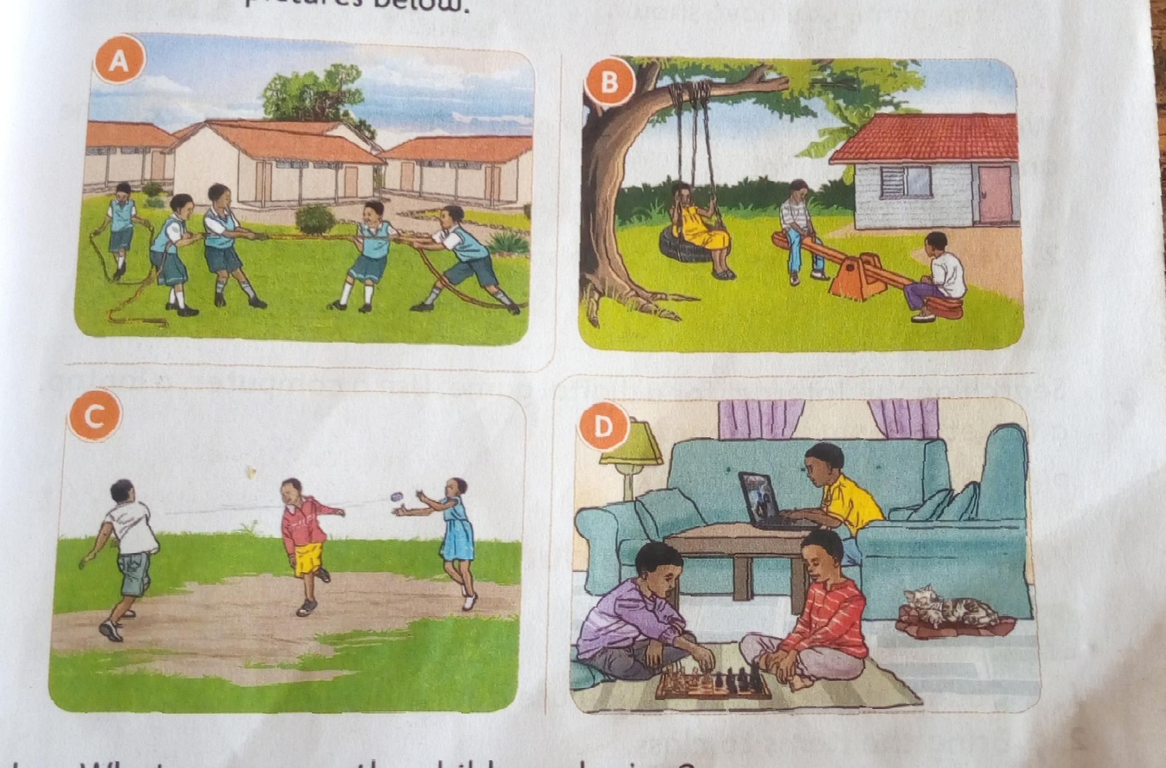

Which items do we use during playing?

Items we use when playing are;

Ropes, computers,bean bags,balls,sacks,phones,mats and marbles.

Pictures of items we use to play on page 5

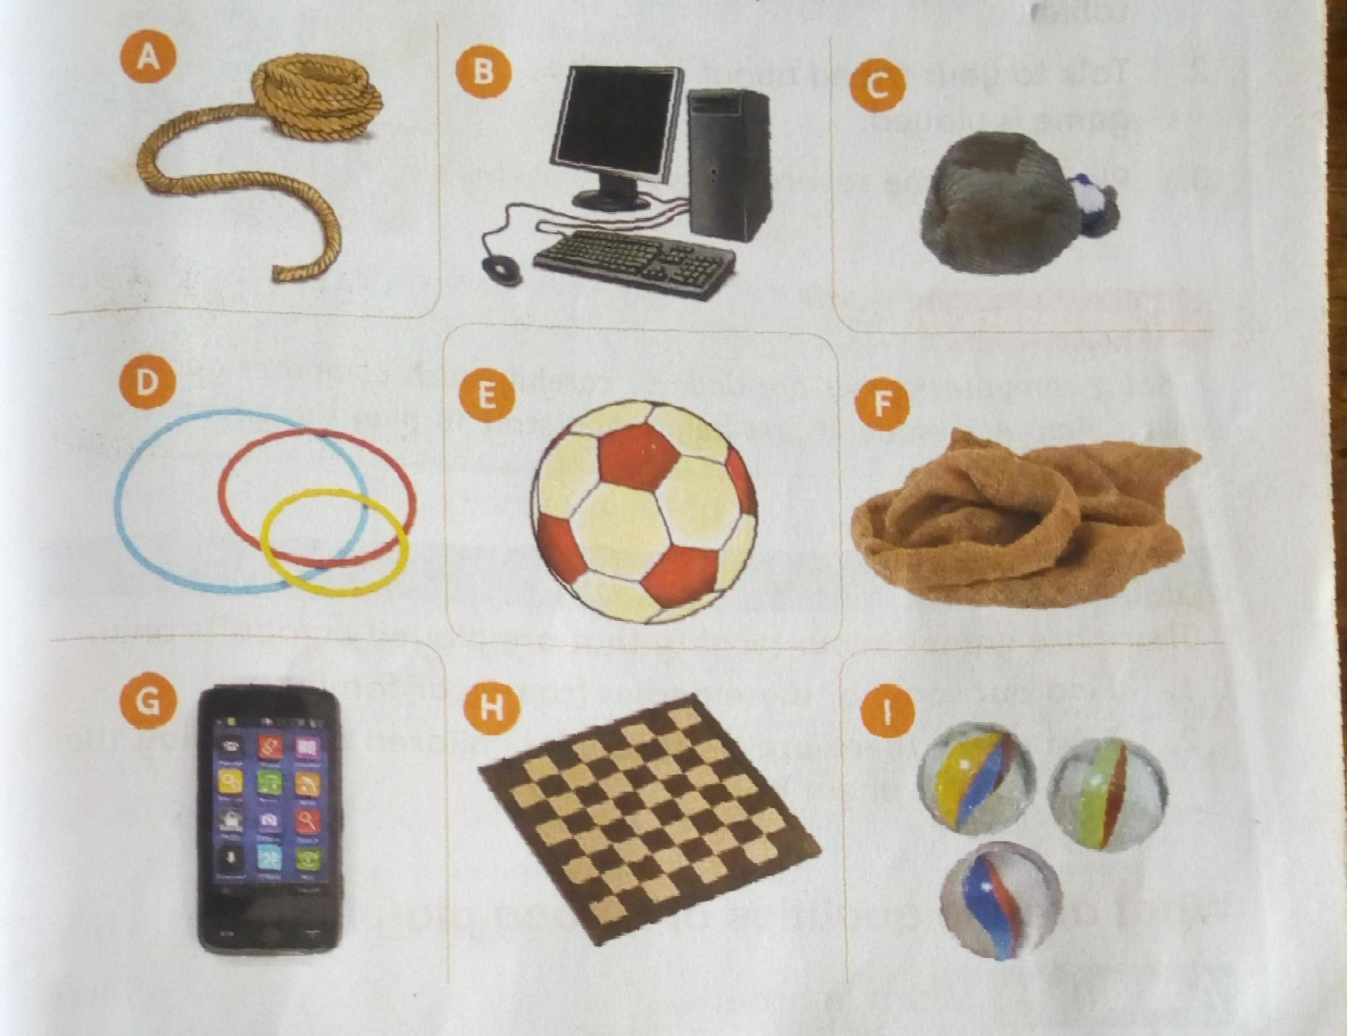

What are the qualities of a good play item?

* Should be durable
* Stronger
* Should be smooth not rough that can hurt people
* Should be safe to play with

How do we make play items?

Making a ball using locally available materials.

Materials needed:

Pieces of cloth or old newspapers,an old clean sock and string

Procedure:

1. Take the old sack
2. Put pieces of news paper or cloth in the old sock. Push them to the Bottom of the sock.
3. Mold the pieces into the shape of a ball.
4. Twist the sock and turn the top side inside out. Tuck in the ball.
5. Tie the end with a string or make a note.

Pictures of the procedure on making a ball

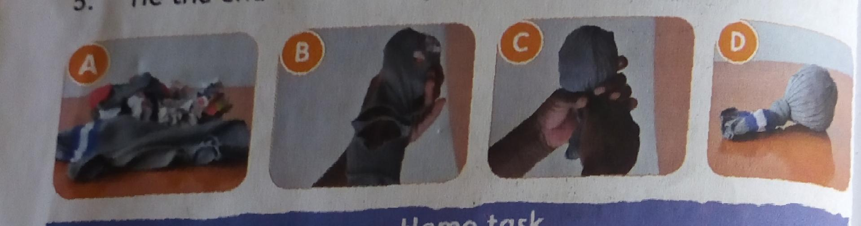

How do we take care of our play items?

Play items should be kept well after use.

Arrange them well on the shelves or put them in cartons neatly.

Always keep them in a clean dry place.

Safety and security during play.

* Remove items like stones,sticks, and broken glass from where you are playing.
* Avoid playing near dangerous areas like water pools and holes.
* Do not play with damaged play items
* Do not play with dangerous objects.
* Never push other children out of a game. Always wait for your turn.
* Always keep your play items safely after playing.

Exercise

1. a) write down three things you need to grow healthy

b) Write down why each of the things is important.

2. Your teacher has asked you to bring the following materials to class.

|  |
| --- |
| Old pieces of clothes,a string, a rope, green sticks |

1. Write three play items you can make using the materials.
2. Which games can you play using the play items?

3.Write two things we should think of when buying a toy.

4. Make a poster on how we can prevent accidents during play.

Show your pooster to other Learners in class

5.Write three ways we should care for a ball.

**Topic 2 : Healthy Living**

**Sub topic: common illness in the locality.**

**What are the common illness in our locality?**

**There are common illness that affect people in our locality.**

**These illness can cause headaches, vomiting, stomachache and general pain in the body.**

**They can also make us feel hot or cold.**

**How do we communicate when feeling unwell?**

**We should always tell other people when we feel unwell.**

**We can tell our parents,our teachers,our friends or a responsible adult.**

**When we tell other people that we feel unwell,we get help**

**What are the causes of illness in our locality?**

**The common illness in our locality are caused by:**

* **Germs- eating using dirty hands or eating fruits without washing.**
* **Coughing without covering your mouth will spread diseases to others**
* **Putting sharp objects in our ears or nose**
* **Drinking dirty water also causes diseases like cholera.**

**Pictures showing common causes of ilness in the locality**

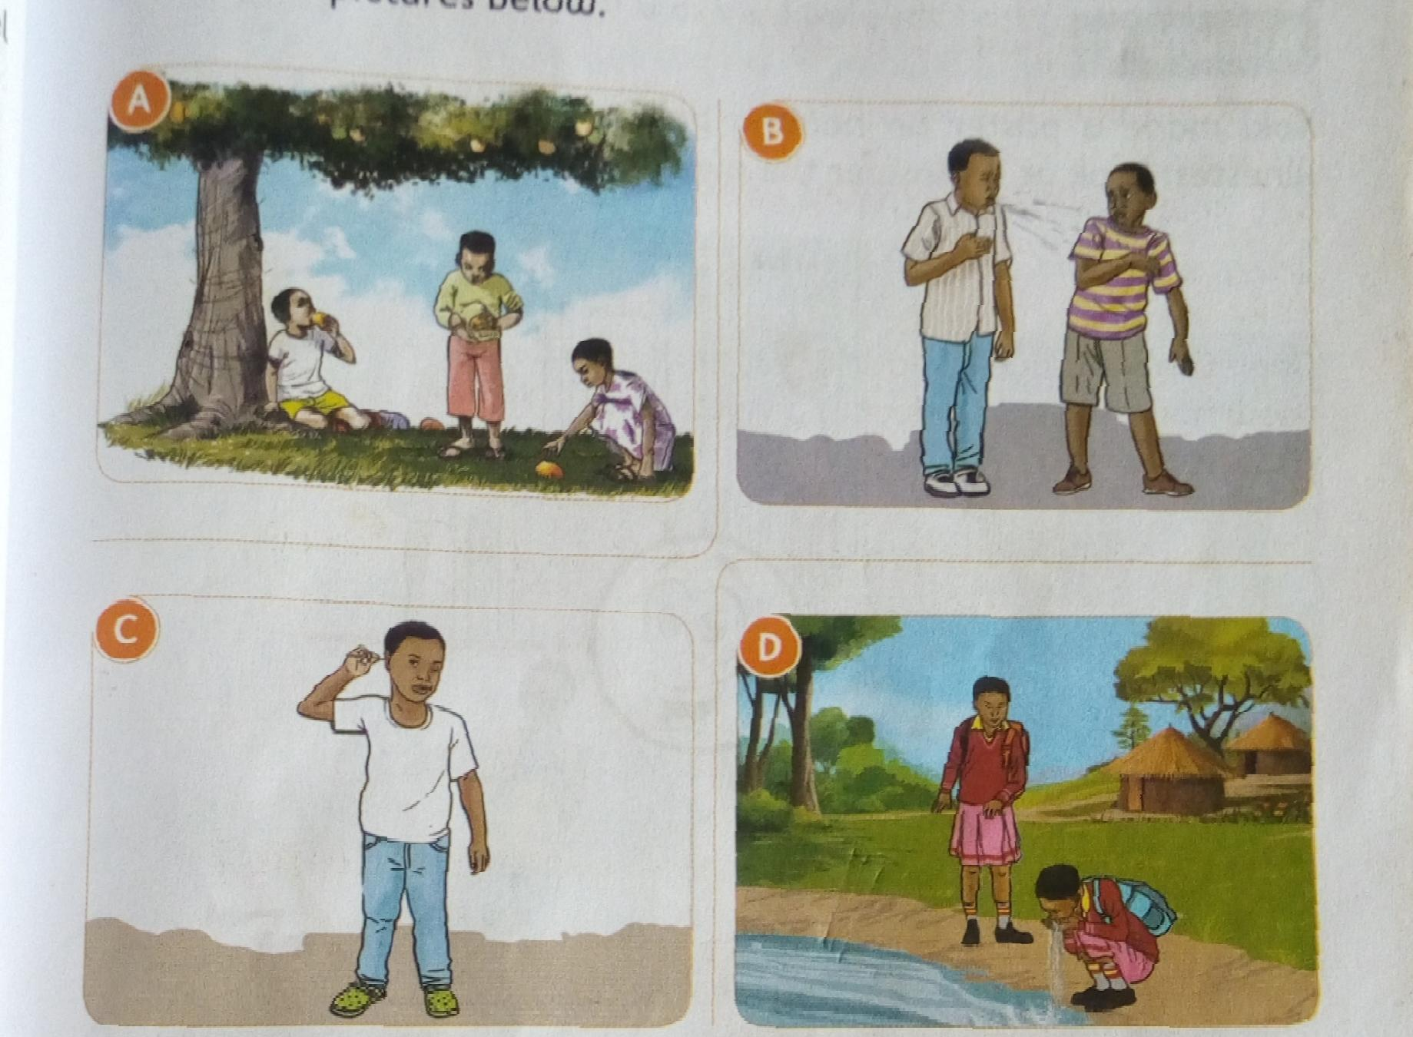

What healthy practices prevent illnesses?

* Washing hands—wash your hands using clean running water.
* Covering the mouth when coughing—cough while covering your mouth.
* Using a handkerchief—clean your nose using a handkerchief.

Exercise

1. Name three common illness that affect people in your locality.
2. Mrefu went to school. During break time,he developed a headache.He told his teacher. His teacher took him to hospital.
3. a) write what you think mrefu told his teacher.

b)Write what you think mrefu told the doctor at the hospital.

3. Shantel and Rayan were given fruits by their father. Shantel washed her fruits before eating. Rayan ate his fruits without washing them.

a) who among the two practised a healthy habit? Which healthy habit was practised?

b) write other heay practices we should practice.

**Subtopic: care of the home.**

**IWhat do we use to clean our home?**

Things we use to clean our home are: brooms,dusters,soap,moppers, brushes,dust pans and dust bins.

Pictures of materials and tools we use to clean our home

I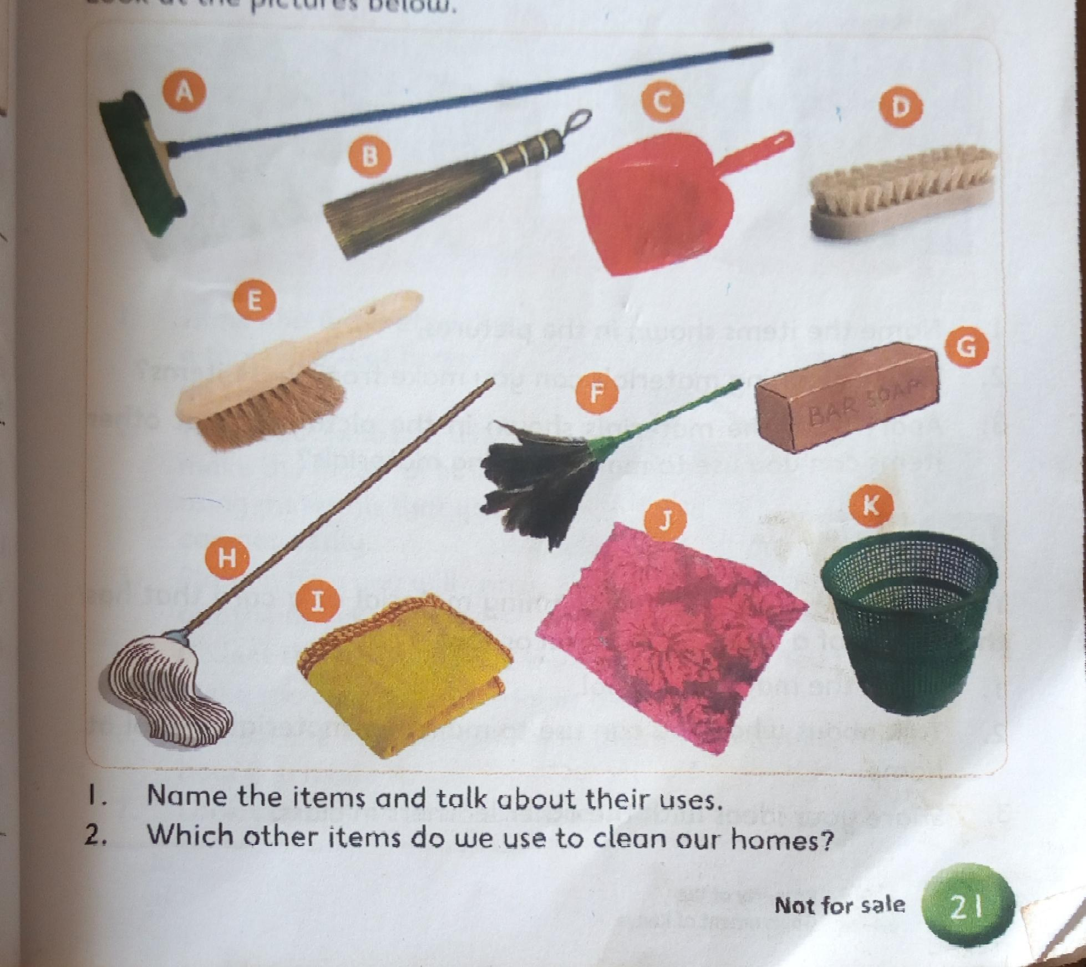

We sweep and mop floors,dust surfaces and dispose refuse to keep our homes clean. We use different materials to do these tasks .

What are the methods of cleaning the home?

The different methods they we use to clean the home are:

* Sweeping
* Dusting
* Mopping
* Disposing of refuse

Pictures showing methods of cleaning the home on page 24.

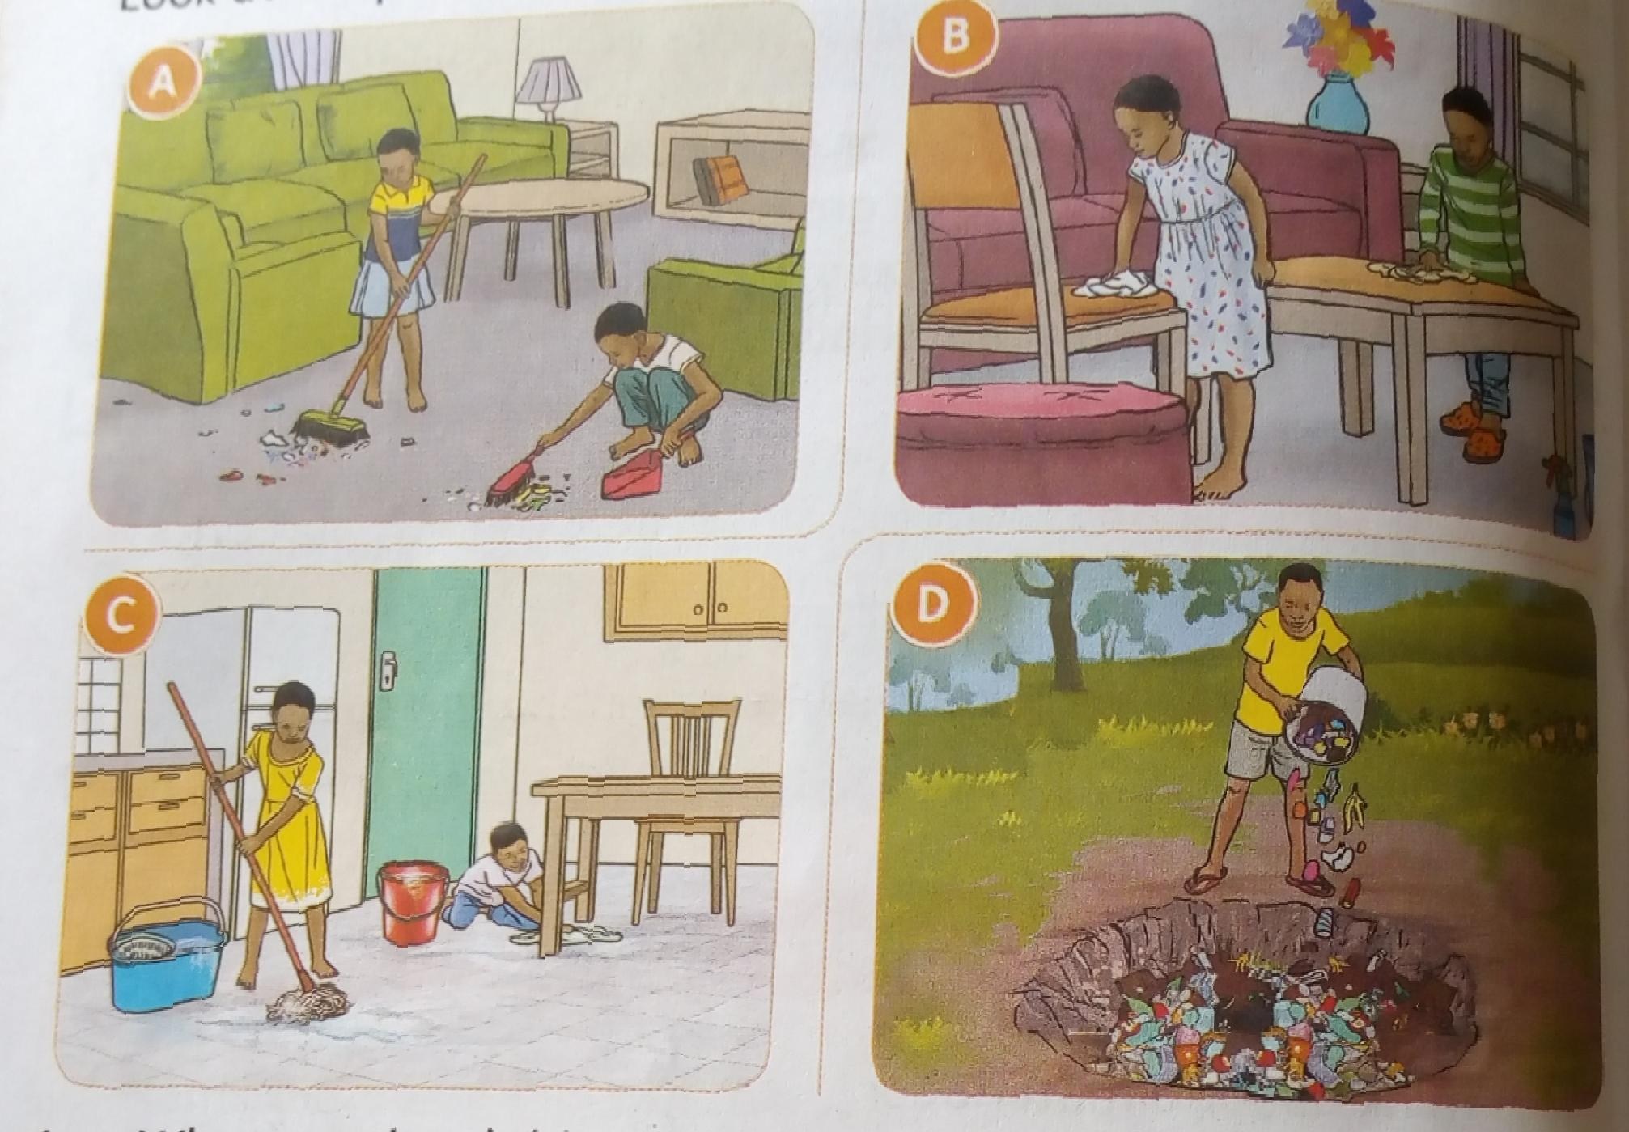

How do we clean our home?

Activity 1.

You will need: brooms, water,soap,mops or floor cloths,basins or buckets,dustpans and cloth dusters.

1. Sweep the class. Dispose of waste in a dustbin and take it to the rubbish pit.
2. Dust the windows,chairs,tables and desks.
3. Mop the class allow it to dry.
4. Arrange the furniture after cleaning.
5. Clean and store the cleaning materials and tools properly.

Safety precautions when cleaning a room

* If the floor is earthen,sprinkle water on it before sweeping.
* Wear an apron and a dust mask when sweeping yor dusting.
* Avoid walking on a wet floor.
* Wait for the floor to dry before arranging the furniture.

How do we care for and store cleaning materials and tools

1. Hang brooms and mops or place them against a Iwall on the handle.
2. Store brushes on a shelf with the bristle facing up
3. Keep basins and buckets in a shade
4. Hang dust pans by the handle.
5. Fold floor cloths and store them on a shelf.

Exercise

1. Write five materials we can use to clean our houses.
2. Name four locally available materials we can use to make cleaning materials and tools
3. Your teacher has asked you to show other Learners in your school how to clean their homes.Write down what you will tell them about being safe when cleaning their homes.
4. Why do we close windows and doors when sweeping and open them after we have finished sweeping.
5. You have been asked to mop your house.Write three materials you will use. How will you use them?

**Subtopic:Care and cleaning of shoes.**

What materials are our shoes made of?

Shoes are made from different materials. They can be made from leather, plastic or canvas.

Pictures of shoes.

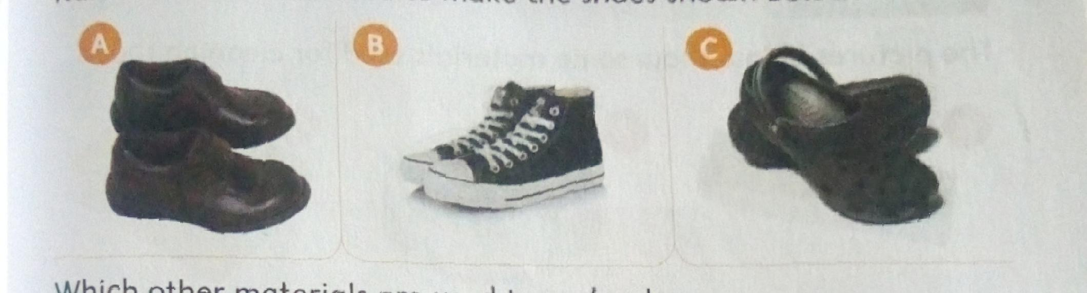

What materials do we use to clean our shoes

Materials used to clean shoes are:

Shoe brush

Shoe polish

A piece of cloth

Water and soap

A piece of stick

Old newspapers

Pictures of materials used to clean shoes

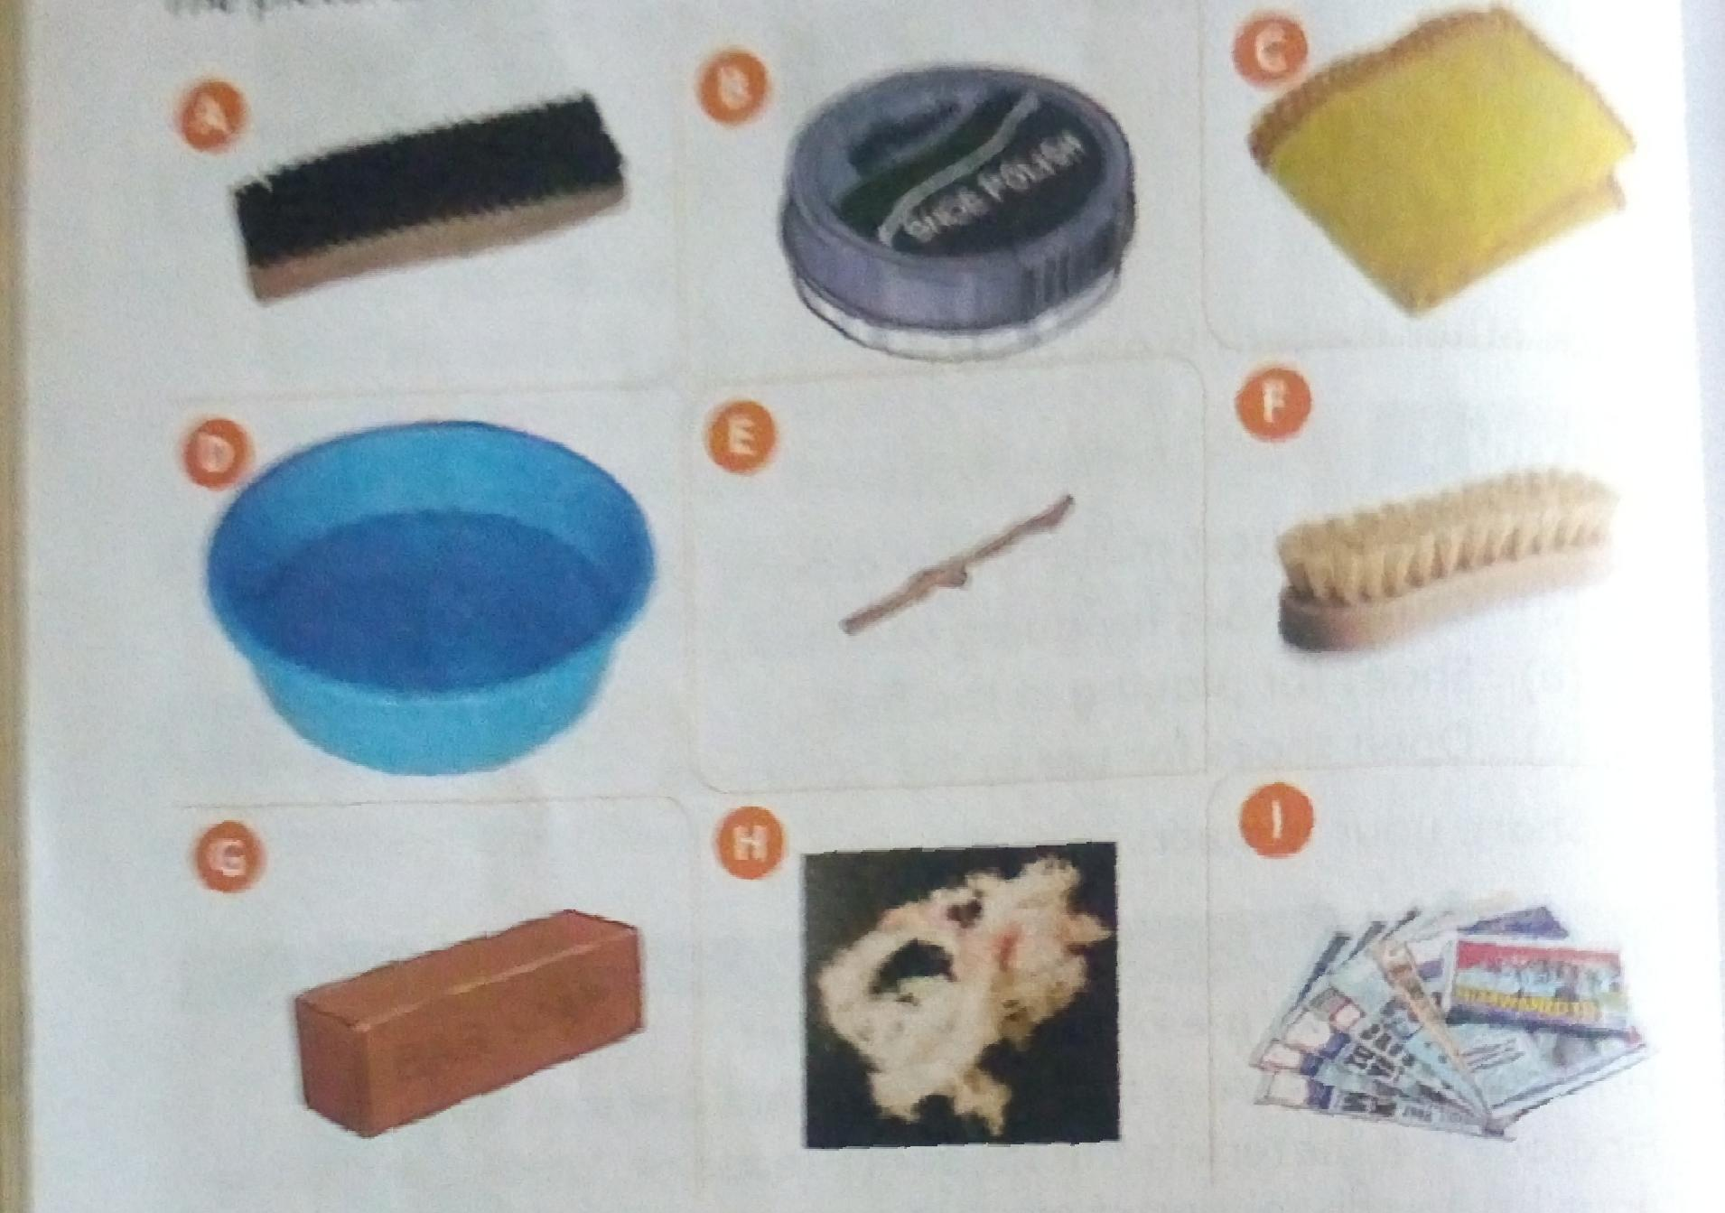

How do we clean leather shoes?

Materials needed:

Leather shoes,shoe polish,two shoe brushes,a piece of cloth,warm water, soap,a blunt stick,a basin or a bucket and old newspapers.

Procedure:

1. If necessary, cover the surface with old newspapers.
2. Remove any mud from the soles using a blunt stick.
3. Dispose of the old newspapers and the mud appropriately.
4. Wipe the shoes using a piece of cloth to remove any dust
5. Remove the shoe laces,if any.If the shoe laces are dirty ,wash them in soapy water,rinse them and hang them to dry.
6. Wipe the shoes with damp cloth dipped in soapy water. Wipe the shoes again using a clean damp cloth. Leave the shoes to dry in the shade for a few minutes.
7. Apply shoe polish using a soft shoe brush.Allow the polish to soak in for a few minutes.
8. Brush the shoes in a dry airy place.Stuff them with newspapers if storing them for a long time.

How do we clean plastic shoes.

Materials needed:

Plastic shoes,a piece of cloth or a soft brush,warm water,soap,old newspapers,a blunt stick and a basin or a bucket.

1. If necessary,cover the surface with old newspapers
2. Remove any mud from the soles using a blunt stick.
3. Dispose of the old newspapers and the mud appropriately.
4. Put some warm water in a basin or bucket.
5. Add some soap and stir.
6. Dip the shoes in the soapy water.Scrub them using a cloth or a soft brush.
7. Rinse e shoes well in clean water.
8. Dry the shoes in the shade.

How do we clean canvas shoes?

Materials needed: Canvas shoes,soap,water,a basin or a bucket,soft brush or a scrubbing cloth.

1. Remove the shoe laces if any. Wash the shoe laces in soapy water if they are dirty.Rinse them and hang them to dry.
2. Remove any mud from the soles using a blunt stick.
3. Hit the shoes gently against each other to remove I dust.
4. Remove the insoles from the shoes.
5. Wash the shoes and insoles in warm soapy water. Scrub them with a cloth or a soft brush.
6. Rinse the shoes and the insoles in Clean water. Shake them to remove excess water.
7. Dry the shoes by placing them against a wall in a slanting position.
8. After they dry ,put the laces and insoles back and store the shoes in an airy place.
9. Put some newspapers in the shoes to prevent them from losing shape.

How can we observe safety when cleaning shoes?

1. Use a blunt piece of stick to remove mud. Do not use a sharp one.
2. Use warm water when cleaning. Do not use hot water.
3. Store cleaning materials in a locked place
4. Store shoes properly after cleaning.

How do we care for and store the materials we use to clean shoes?

The following are some ways of taking care of the materials we use to clean our shoes.

1. Store shoe polish on a shelf away from small children.
2. Store shoe brushes on a shelf with the bristle facing up.
3. Clean the scrubbing brush and store it on a shelf with the bristles facing up.
4. Wash the cleaning cloth in soapy water and dry it.Fold and store it on a shelf.
5. Wash basins and buckets and store them in a shaded area.

Exercise.

Write the materials used for making shoes.

1. Your parent has asked you to clean your canvas shoes.Write down the Materials you will use
2. How do we take care of basins and buckets after cleaning our shoes.
3. You have been asked to teach other children how to clean their shoes.Erite two safety measures you will tell them to observe when cleaning their shoes.
4. Why are shoe brushes stored with the bristles facing up?

**Fuels used at home.**

Which types of fuels are available in our homes?

Fuel is any material that is used to produce heat or light in our homes. Charcoal, firewood, paraffin,gas and electricity are fuels.

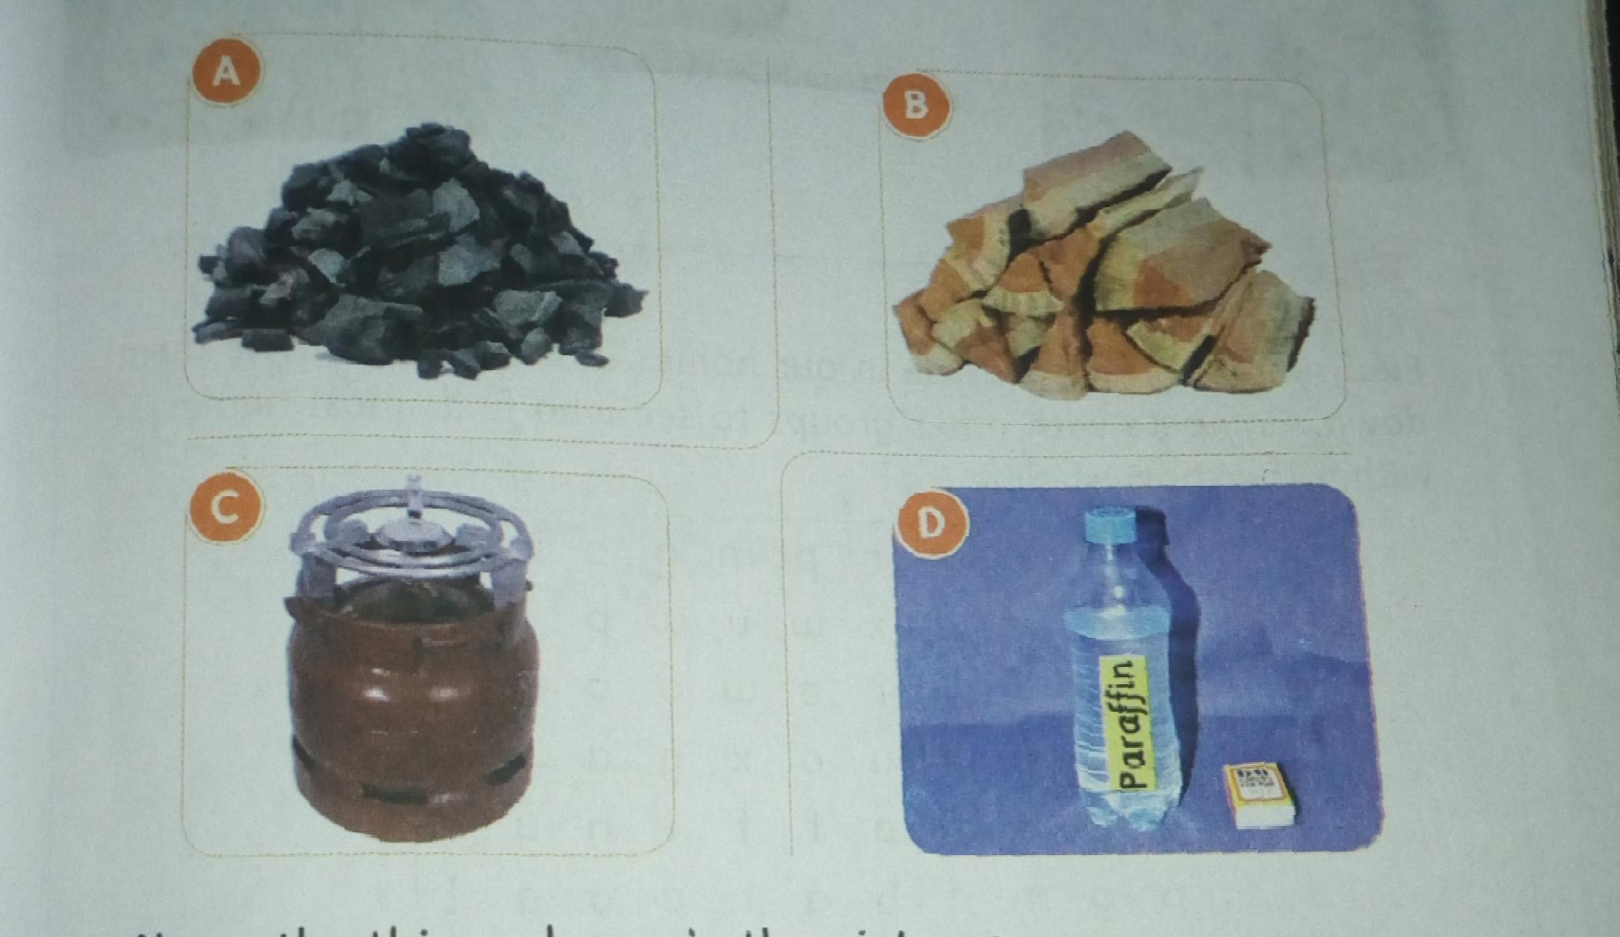

Why do we use charcoal at home?

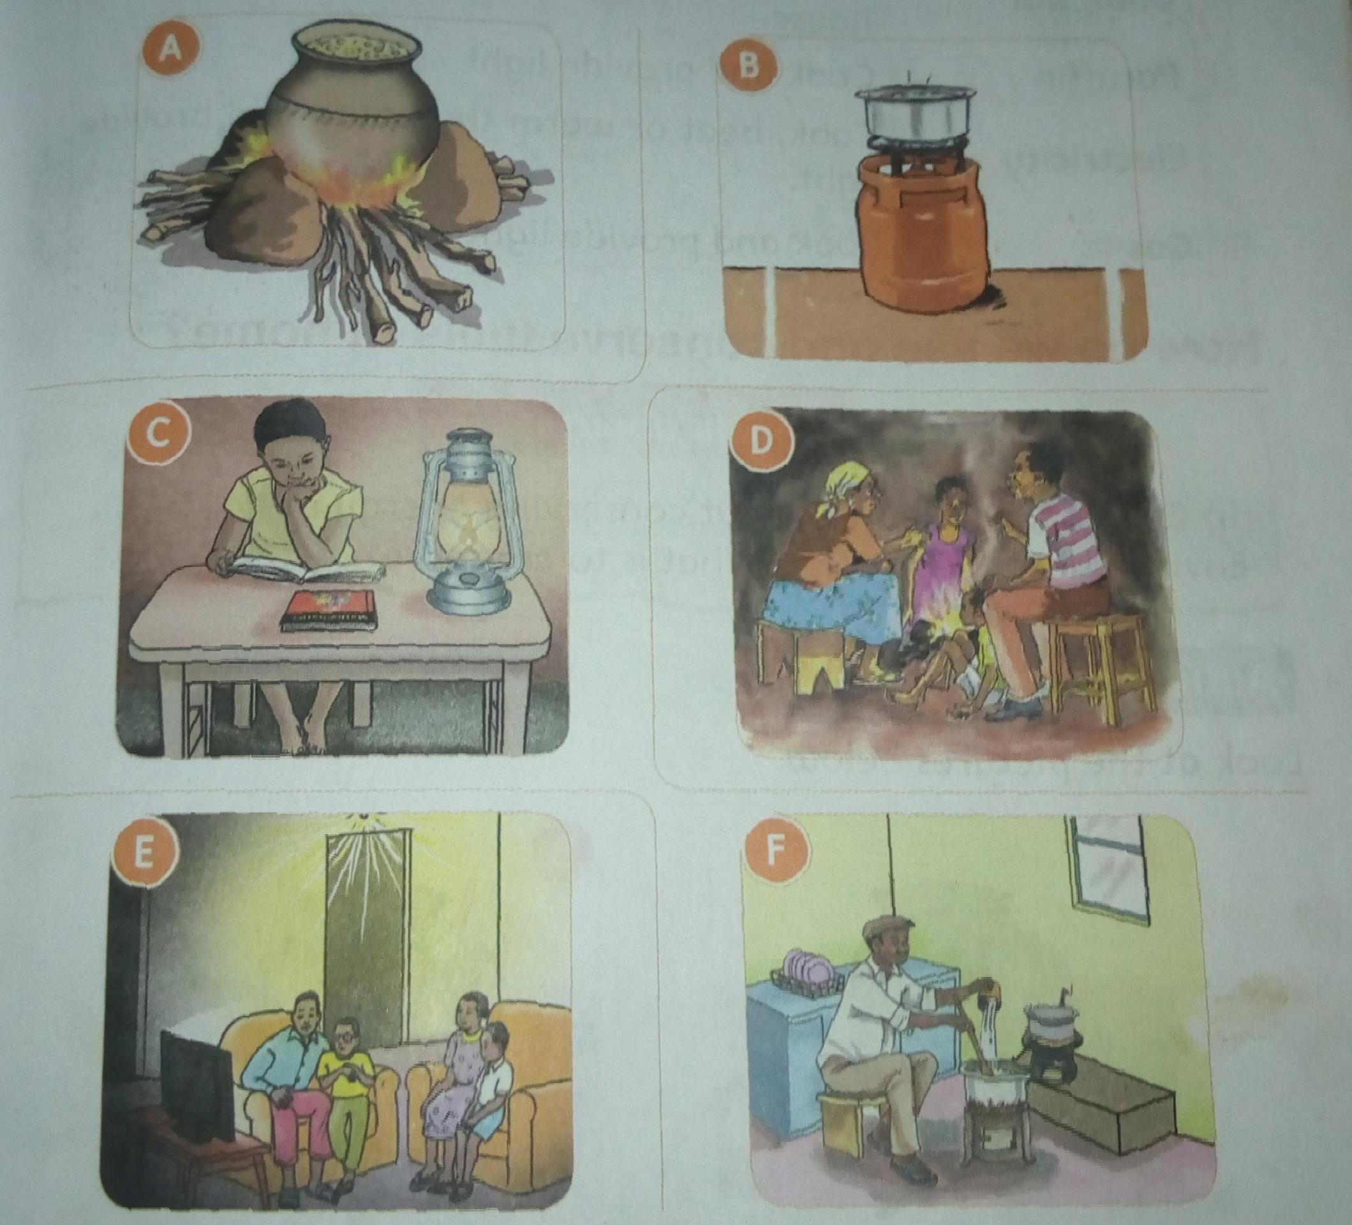

We use charcoal in our homes for various purposes

|  |  |
| --- | --- |
| Fuel | What we can use it for |
| Firewood | Cook,heat or warm the house and provide light |
| Charcoal | Cook and provide heat or warmth in the house |
| Paraffin | Cook and provide light |
| Electricity | Cook,heat or warm the house and provide light |
| Gas | Cook and provide light |

How do we use and conserve fuels at home.

To conserve something is to use it without wasting. Using fuel without wasting it is conserving fuel.

* We can conserve firewood and charcoal by using jikos that use less firewood or charcoal.
* We can conserve electricity by using energy saving bulbs, and using electricity only when we need it.

What challenges can we face when using fuels?

* Some fuels are dangerous and can cause fire,like firewood.
* Some fuels produce so much smoke that is dangerous for our health.
* Fuel like gas can get finished before you start Icooking.
* Electricity is very unreliable as it can be off without notice.

How do we keep safe when using fuels.

1. Do not overload sockets
2. Check the gas cylinder and pipes to ensure they are not working.

Do not sleep in a closed room that has a burning charcoal jiko.

Pictures showing unsafe ways of using fuels.

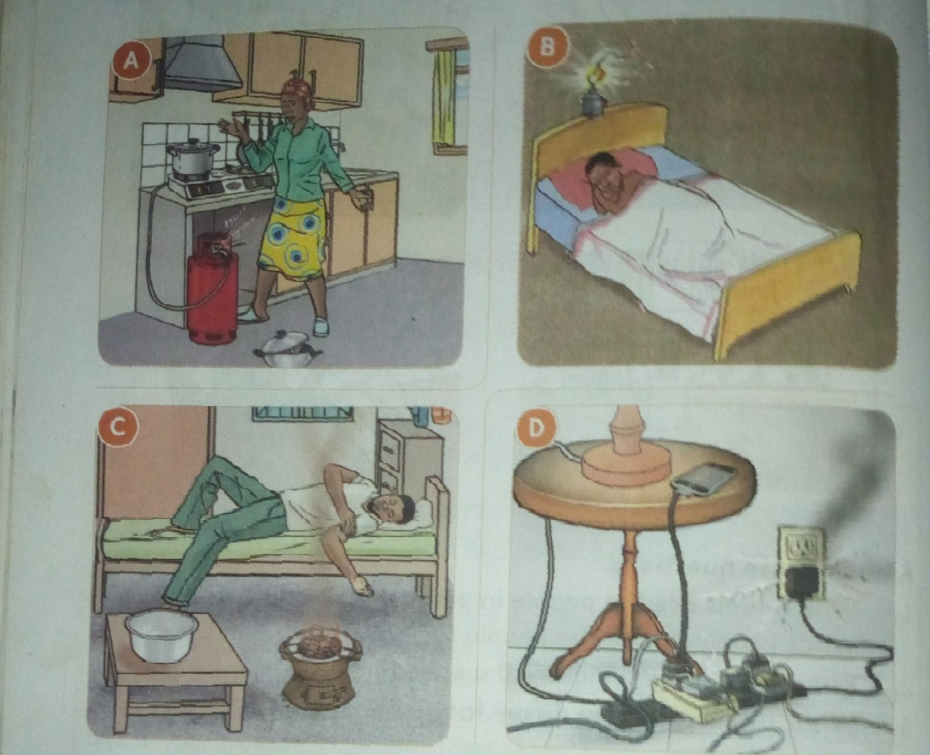

Exercise

1. Name any three fuels you see at your home.
2. A grade four Learner used charcoal for cooking.How else can this Learner use charcoal?
3. Look at the pictures below.

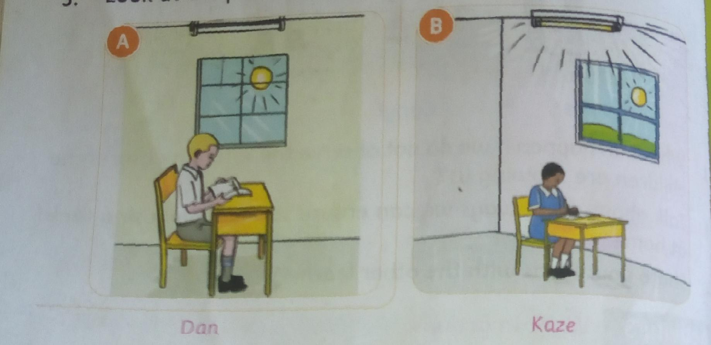

* 1. Who is using fuel well in the pictures?
  2. Who is wasting fuel? Why?

1. Write three ways we can conserve firewood at home.
2. When using gas, what safety measures should you think about?

**Topic 3: Consumer Education**

Sub topic: consumer awareness.

What is a shopping list?

When you want to shop, you should first prepare a list of all the items you want to buy. This list is known as shopping list.

The picture below show a shopping list.

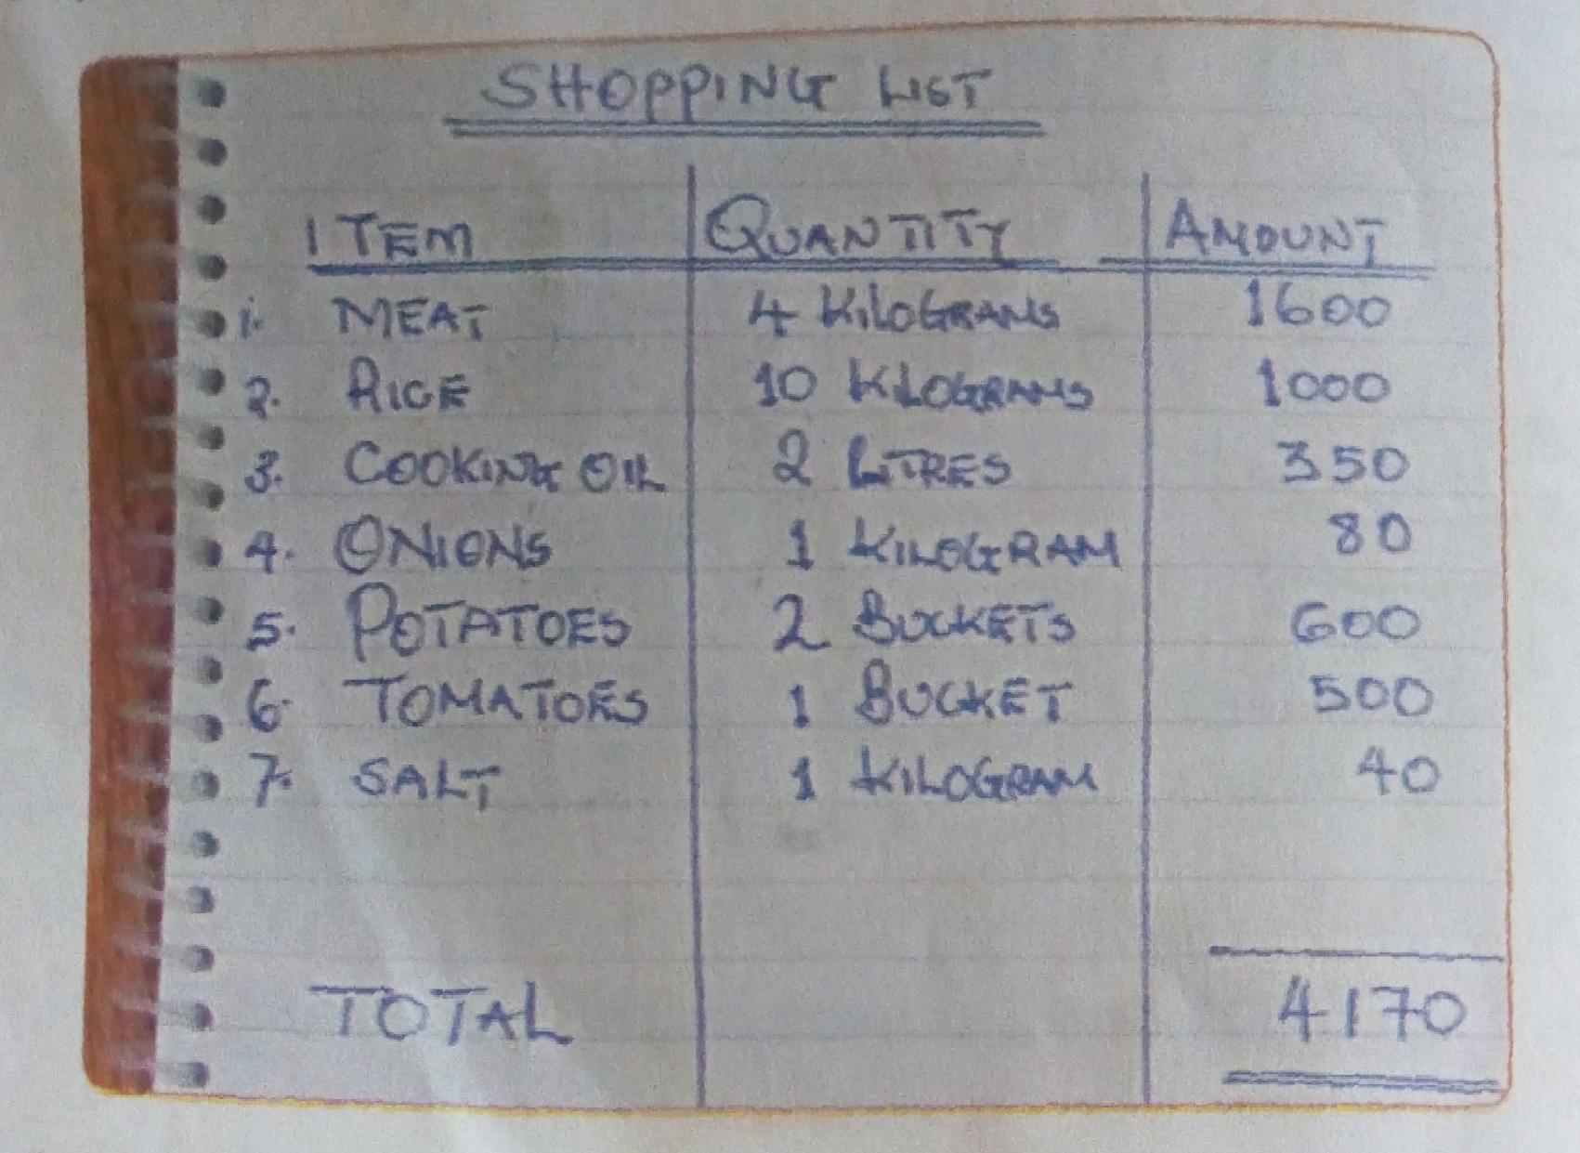

Why is a shopping list important?

1. It saves money by helping a person to buy only the things they need.
2. It saves time when shopping. This is because a person knows exactly what to buy.
3. It reduces by helping a person to choose items that are most important.
4. It enables a person to know the amount of itmoney he or she needs to buy the items.

What are the steps of making a shopping list?

1. Think About all the things you want to buy
2. Consider the money you have
3. Think about important items and the less important items
4. Write your list, starting with the most important items.
5. Write how much each item costs.

Exercise:

1. Barry wanted to do shopping. He wrote the following items on a piece of water.
   1. Cabbage
   2. Tomatoes
   3. Potatoes
   4. Onions
   5. Sukuma wiki

Where should Barry go to buy the items.

1. Write down three important reasons why one should make a shopping list.

**Topic 4: Foods and nutrition**

**Sub topic: Choosing foods**

**What items do we buy from a general grocery?**

A general grocery is a shop that sells food items and small household goods.

A grocery shop that inli sells fruits and vegetables is known a green grocery.

Pictures of some groceries.

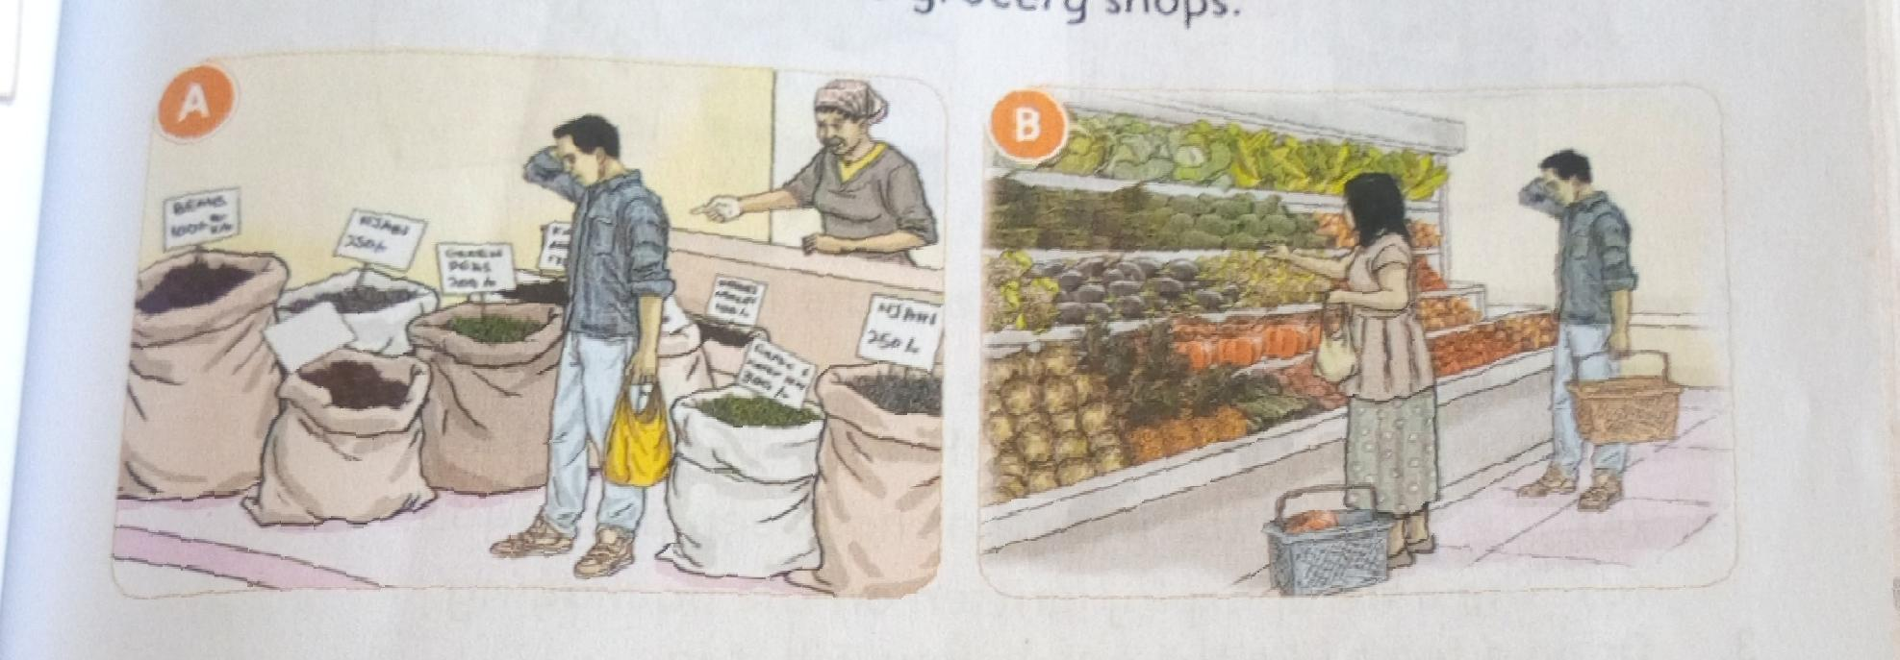

What do we consider when choosing foods from a general grocery?

* The type of material the packaging is made of
* The weight of the item that has been packaged
* The price of the item that has been packaged.
* The date of expiry written on the package.

Exercise

1. You have ksh 500 to buy the items below at the nearby grocery shop

1 packet of maize flour at kshs 120,1 litre milk at kshs 60, 1 loaf of bread at skshs 50 and 1 bunch of spinach at kshs 10 each.

* 1. Prepare a shopping list.
  2. How much money will you use to pay for all the items?
  3. When receiving your balance, the grocery gives you ksh 20 more. What should you dowith the extra ksh 20?

1. What would you look for when buying a packet of maize flour from a grocery shop?
2. Write two things that would happen if there was no grocery shop in your village or town.

**Sub topic: Variety in the diet.**

**What foods are available in our locality?**

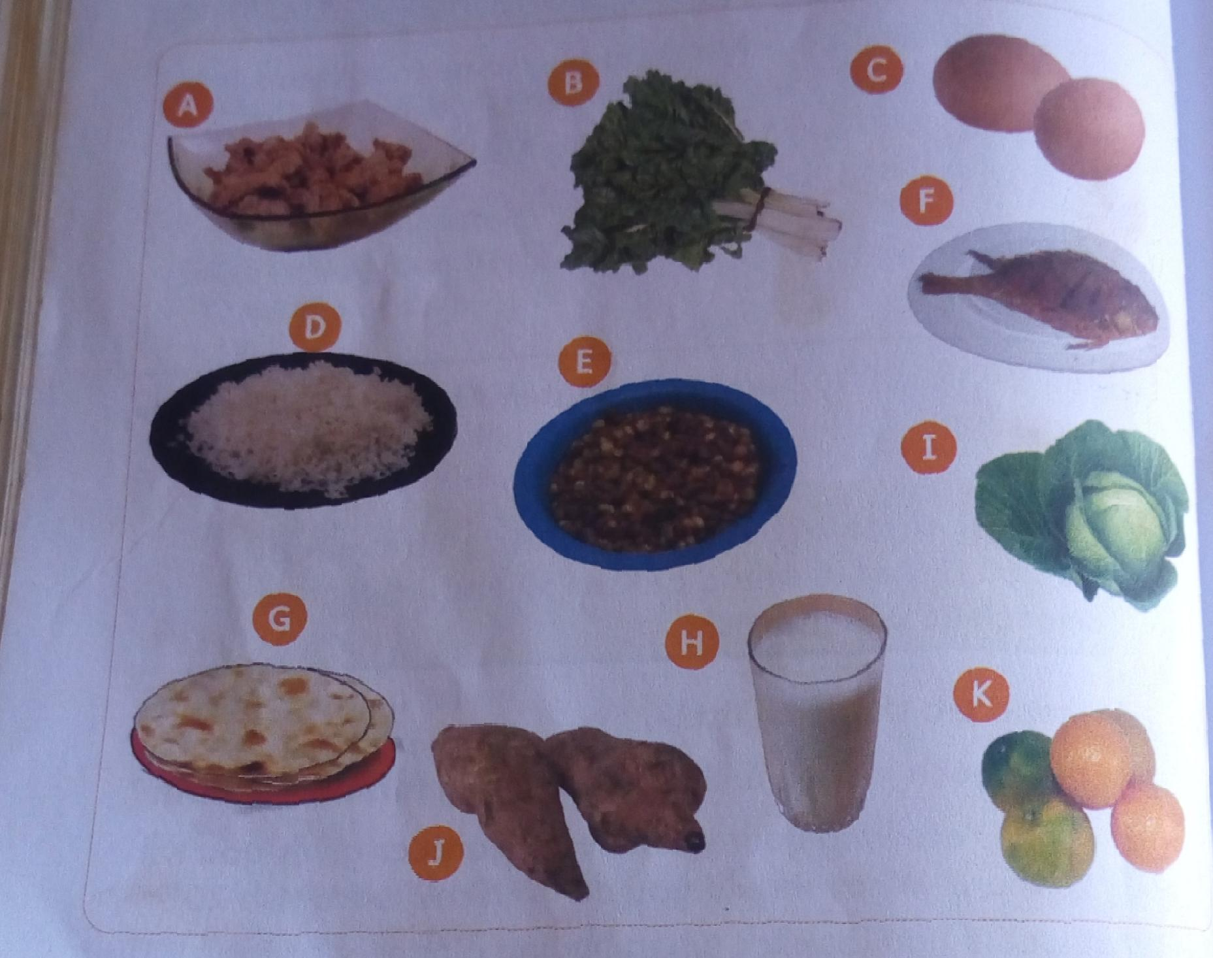The pictures below show the foods that are available in our locality.

How do we classify foods?

Foods can be classified into three groups

* Foods that give us energy

Potatoes,maize,rice,yams,ugali,sorghum.

* Body building foods

Meat, chicken, fish,beans, Imilk, green gram

* Protective foods

Mangoes, oranges,kales, spinach, cabbage,kunde,managu

What is variety in the diet?

Variety in the diet means eating foods from the three food groups.

A healthy meal has variety. It contains foods fry the three groups in the right amount. This is called a balanced meal or a balanced diet.

Exercise

* 1. Who am I?
     1. I am oval in shape and white in colourI can break easily.
     2. You give me to babies. I am good for your teeth too.
     3. Monkeys love to eat me.I turn yellow when I am ripe.
  2. Look at the list of food items below.

|  |
| --- |
| Cassava, groundnut, watermelon,beans,orange, potato,water |

Pick one food item to complete the form groups given below.

* 1. Ripe bananas,cabby,apple,______
  2. Rice,ugali, chapati,_______
  3. Meat,fish,milk,__________

3.What is a balanced meal?

4. Amoit loves to eat chips and sausages, and to drinysoda. She is very happy with her choice of food.

a) Is there variety in Amoit's meal? What is missing?

b)Do you think Amoit has chosen healthy food to eat?why?

c) What would you choose for Amoit to eat?

**Sub topic: Preservation of milk.**

What are the sources of milk in our locality.

We get milk from various sources in our locality. We get milk from vendors,shops and dairy farmers.

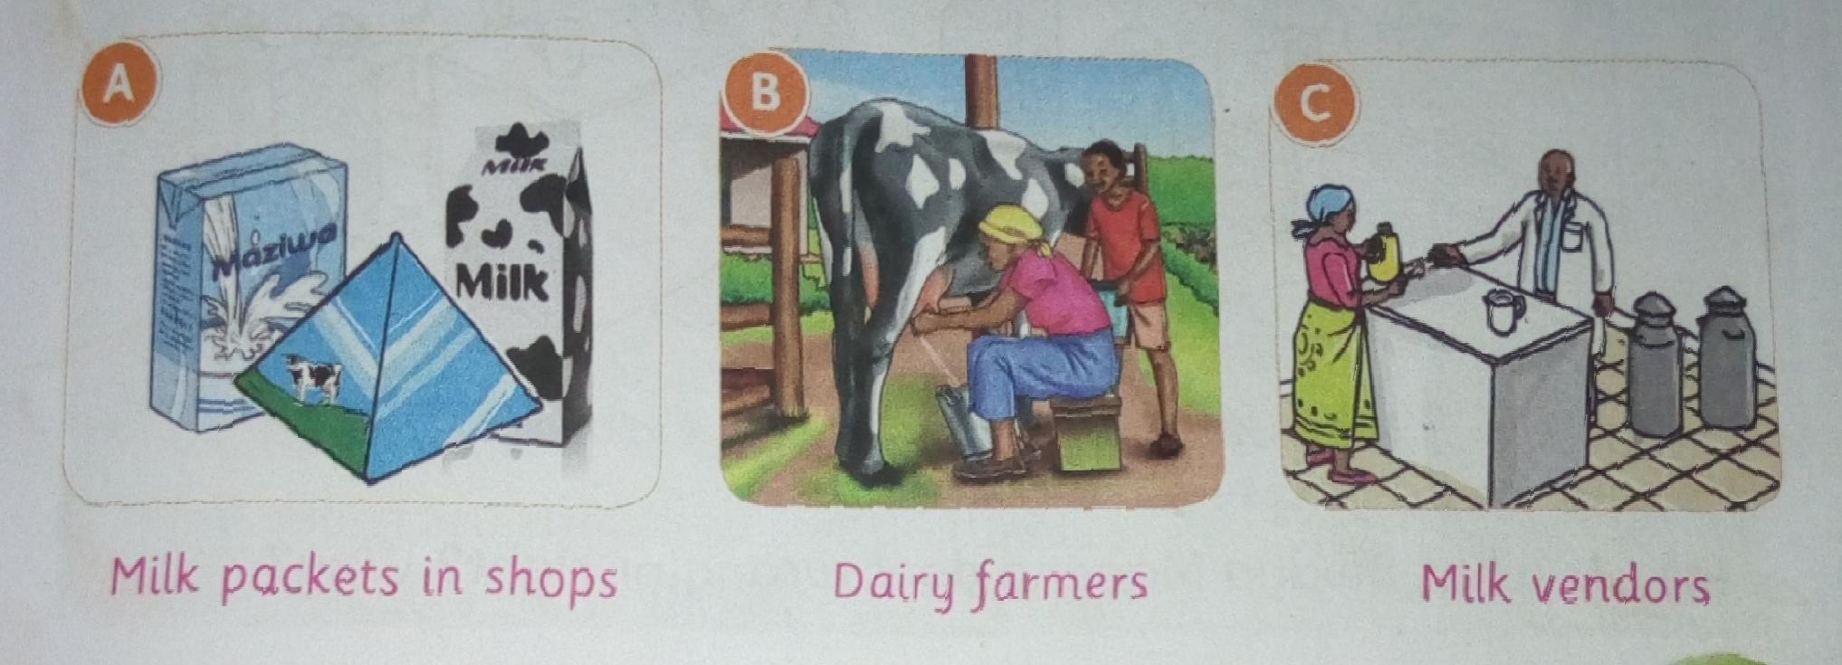

Why do we preserve milk?

Fresh milk should be preserved because it goes bad easily When it goes bad,it goes to waste.

Reasons for preserving milk.

1. To prevent it from getting spoilt.
2. To prevent wastage
3. To make it last longer
4. To make it easy to store and transport.

How do we preserve milk?

Theryare different methods of preserving milk.

1. Boil the milk. Boiling kills germs that make milk to go bad.
2. Put the milk in a refrigerator.The low temperatures prevent the milk from going bad.
3. Ferment the milk. Fermented milk can be used for a longer time than fresh milk.
4. You can also use a home made cooler to preserve milk.

Using different methods to preserve milk.

Preserving milk by boiling it.

You will need: a clean sufuria,a jiko, fresh milk and a sieve.

* 1. Sieve the fresh milk into a clean sufuria.
  2. Light the jiko and place the sufuyon the fire.
  3. Heat the milk until it starts to rise.
  4. Lower the heat and let the milk boil for about one minute.
  5. Remove the sufuria in a clean place and let the milk cool.
  6. Once the milk is cool, cover it with a lid.

Preserving milk by fermenting it.

You will need: fresh boiled milk,a gourd or a plastic container.

1. Pour the fresh milk in a gourd or plastic container plastic container.
2. Cover the mouth of the gourd or the container tightly using a lid or cock.
3. Keep the container or the gourd in a warm place.
4. Do not disturb the milk for around two days to allow it to ferment.
5. Shake it before you serve it.

Exercise

1. Name the sources of milk in your locality.
2. Why do we preserve milk.
3. Name two uses of milk in our bodies.
4. The pictures below show some methods of preserving milk.

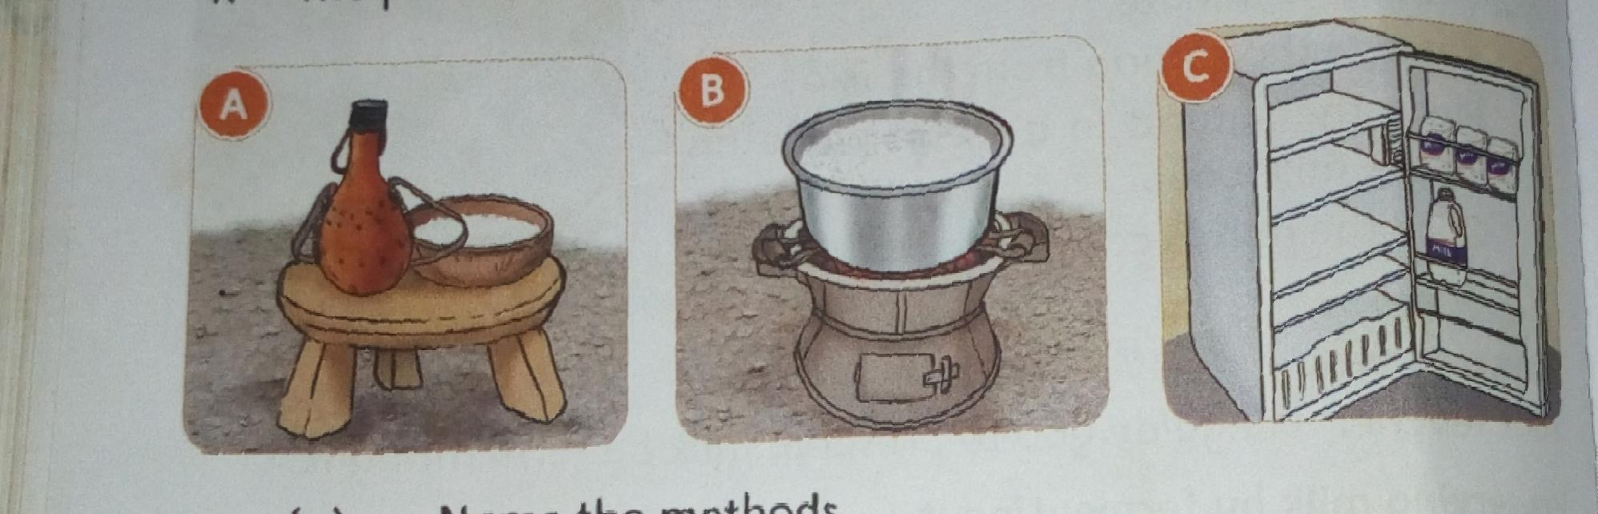

* 1. Name the methods.
  2. How does each method help to preserve the milk?

**Subtopic: Fragile kitchen utensils.**

**What are the uses of the various kitchen utensils.**

Pictures of various kitchen utensils.

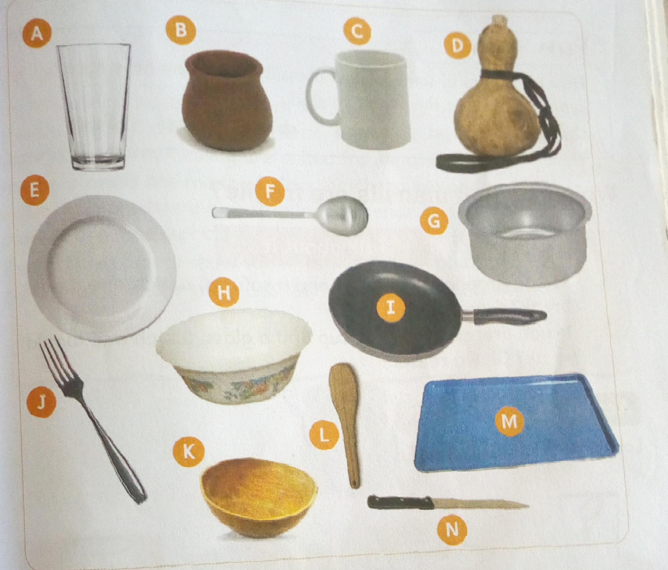

Which kitchen utensils are fragile?

Kitchen utensils are made from different materials. Some kitchen utensils break easily. Other kitchen utensils do not break easily. Utensils that break easily are called fragile utensils.

Fragile utensils are made of glass, earthenware and ceramic material.

Gourds are also fragile. Earthenware and ceramic utensils are made of clay.

The pictures below show some fragile kitchen utensils.

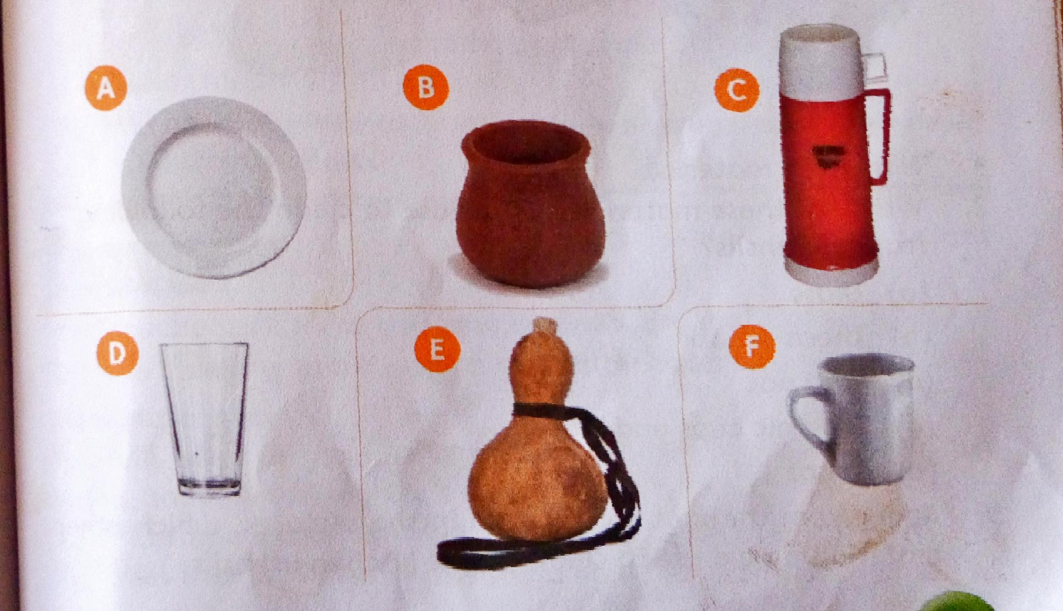

Which materials do we use to clean fragile kitchen utensils?

Pictures of materials used to clean utensils.

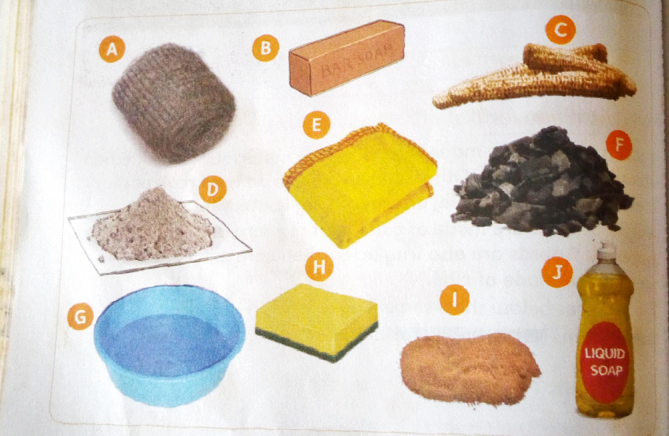

How do we clean,dry and store glasses and thermo flask?

**Cleaning a glass**

**You will need**: a glass,a ponge,sisal fibre or a soft cloth,two basins, warm water,a dish cloth,dish rack.

Procedure

* 1. Put some warm water in a basin
  2. Wet the glass and sponge.
  3. Apply some soap on the sponge.
  4. Wash the glass gently in the warm water.Scrub the inside and outside of the glass.
  5. Rinse it properly in Clean water.
  6. Wipe it using a dish cloth so as to make it shine.You can also place the glass upside down on a dish rack to dry.
  7. Store the glass safely in a cupboard.

**Cleaning a thermo flask**

**You will need:** a thermo flask,a sponge,a soft cloth,two basins, soap,warm water, dishcloth and a dish rack.

1. Put some clean warm water in a basin.
2. Apply soap on a sponge,sisal pad or soft cloth and put it in the flask
3. Pour some of the warm soapy water in the flask and shake it gently.
4. Pour the soapy water and the sponge back in to the basin
5. Scrub the outside of the flask and the mouth of the flask, clean the lid.
6. Rinse the flask and the lid in clean warm water.
7. Dry the flask on a dish rack
8. Store the thermo flask safely in a cupboard once dry.

How do we clean,dry and store earthen and ceramic utensils?

How to clean a clay pot.

**You will need**: a basin,warm water and a sisal pad or a dry maiza cob.

1. Put some water in the pot .Leave it in the pot for a few minutes to sock.
2. Scrape off the food remains using a sisal pad or a dry maize cob.
3. Pour out the dirty water.
4. Put some clean water in the pot.Scrub the inside and then the outside of the pot using a pad of sisal fibre.
5. Rinse the pot using clean warm water.
6. Dry the pot upside down on a drying rack.
7. When it is dry ,store it upside down on a storage rack, or keep it standing in a safe corner.

How to clean a ceramic cup

You will need: a ceramic cup, soap,a sponge,a soft cloth or a pad of sisal fibre,warm water,two basins and a utensil rack.

* 1. Put some clean warm water in a basin
  2. Apply some soap on a sponge
  3. Dip the cup in warm water. Use the sponge to gently scrub the cupon the inside and on the outside.
  4. Rinse the cup properly in Clean warm water.
  5. Dry the cup on a rack
  6. Once it is dry,store it safely in a cupboard.

How do we clean,dry and store a gourd.

How to clean a gourd.

You will need: a gourd,warm water,a basin, small stones and a sponge or sisal pad.

* 1. Put some small stones in the gourd.
  2. Add some clean warm water.
  3. Shake gourd gently several times.
  4. Pour out the water and the small stones.
  5. Scrub the outside of the gourd with a sponge or sisal pad.
  6. Rinse the gourd with the warm water until it is clean
  7. Dry the gourd upside down on a rack. Ensure it is safe.
  8. When it is dry,store it on a rack ,or hang it on a wall using string.

Safety when cleaning fragile utensils.

* Handle fragile utensils with care.
* Do not stack glasses
* Wash one utensils at a time
* Wash the utensils using a soft material.
* Do not put glasses in very hot water.
* Do not use soap when cleaning clay pots and gourds.
* Always dry gourds and earthen utensils well before storage.
* Store fragile utensils safely away from the reach of children.

Exercise

1 a) Name three fragile kitchen utensils you use at your home.

b)Write two things you should do when cleaning glasses to make sure they do not break

2. You have been asked to show the Learners in your class how to wash a glass.

(a) Write down three materials you will use

(b) How will you reuse the water after washing?

**Subtopic: cooking food.**

**Why do we cook food?**

* **We cook food to become soft**
* **We cook food so that it can be easier to eat**
* **We cook food for easier digestion**
* **We cook food for it to taste good**
* **We cook food to kill germs**
* **We cook food for it to last longer.**

**What hygiene practices should we observe when cooking food?**

1. **Wear clean clothes when cooking.**
2. **Cooking food properly**
3. **Washing hands before touching Food.**
4. **Covering head with a cap and wear on apron.**
5. **Cook and serve food in Clean utensils.**
6. **Cover cooked food and keep it in a clean place.**