**COMPETENCE BASED CURRICULUM**

**COMPOSITION GRADE 4**

**ASSESSMENT ONE 2024**

**NAME: . SCHOOL: .**

**GRADE 4: . DATE: . GENDER: BOY GIRL**

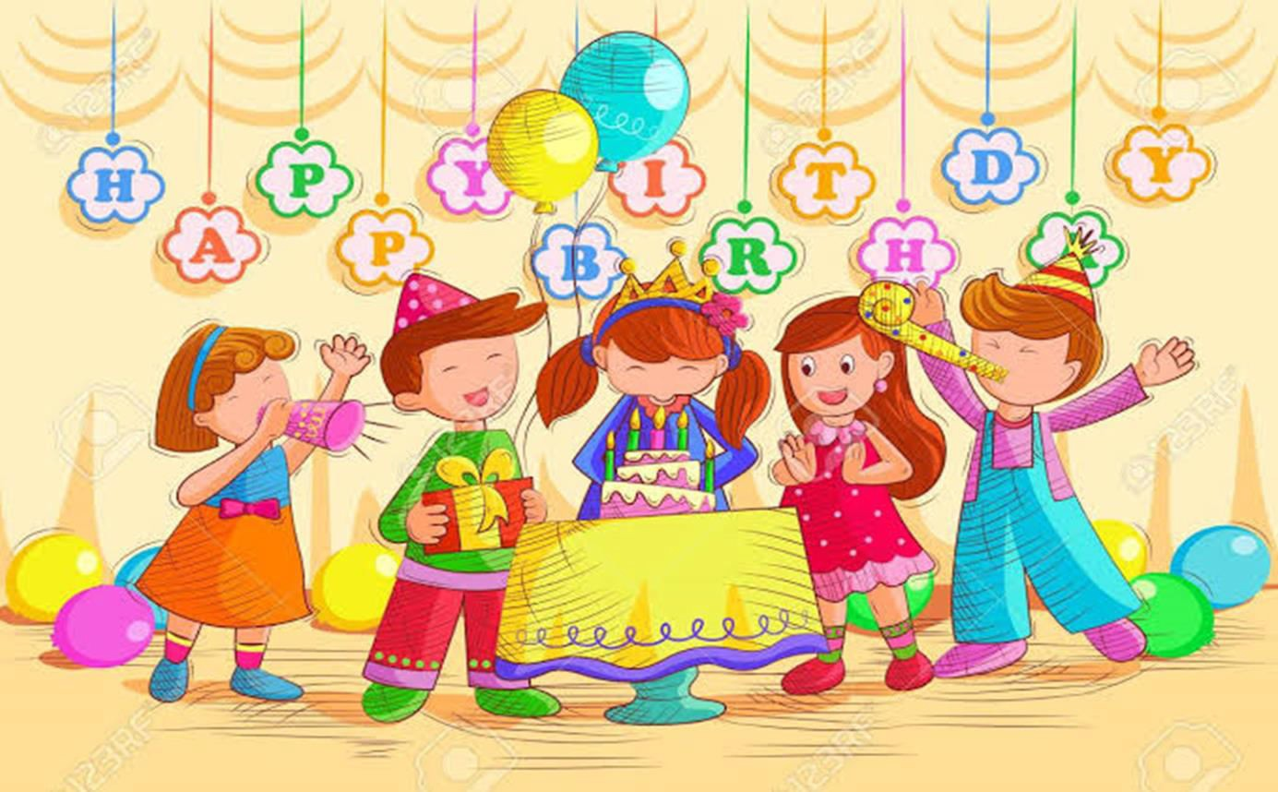

## Look at the picture above.

1. What is happening in the picture?

.

1. In neat handwr iting write an interesting story about the picture above.

## Assessment Rubric

|  |  |  |  |
| --- | --- | --- | --- |
| **Exceeding**  **Expectαtions** | **Meeting**  **Expectαtions** | **Αpproαching Expectαtion** | **Below**  **Expectαtion** |
| 27 - 30 | 21 - 26 | 15 - 20 | 0 - 14 |
| Paragraphs the work and uses correct language structures.  Spells all words correctly.  Uses the correct tense and a wide range of vocabulary in context.  Writes legibly and neatly.  Has some sense of cohesion in presentation of ideas communicates feelings and emotions. | Paragraphs the work and uses correct punctuation and correct language structures.  Spells most of the words correctly.  Uses correct tense and appropriate vocabulary in context.  Writes legibly and neatly. | Does not paragraph the work, uses some correct punctuations and language.  Structures in their work.  Uses some correct tenses and appropriate vocabulary in context.  Uses some correct spellings Writes legibly. | Does not paragraph the work and does not use punctuations marks. Uses broken language and hardly communicates. Uses incorrect tense and inappropriate vocabulary with numerous spellings errors. The handwriting is illegible and untidy. |
|  |  |  |  |