**COMPETENCE BASED CURRICULUM**



01

**ΑSSESSMENT ONE 2024**



CBC

**RELIGIOUS ΑCTIVITIES GRΑDE TWO**

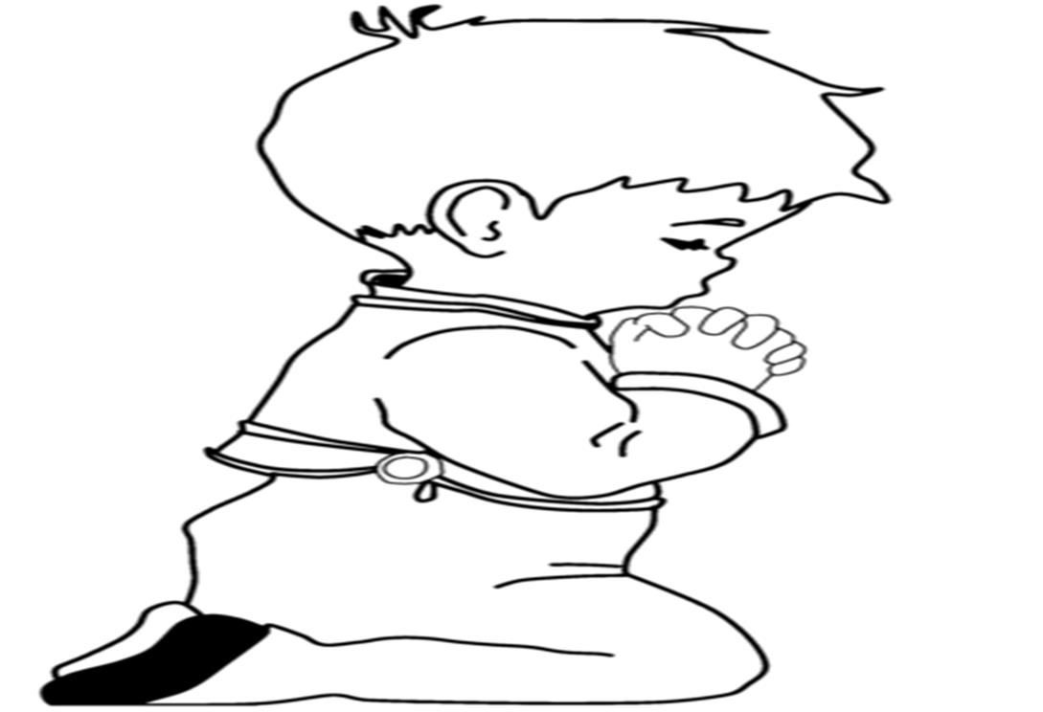

Name:

School:

Grade:

Date: .

**Areas of assessment: Self-awareness, my family, sharing at home and creation story.**

1. Draw the sun, moon and stars. (__/**6marks**)

1. Name the five things that God created in me. (__/**5marks**)

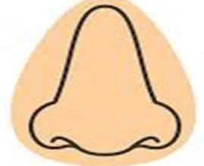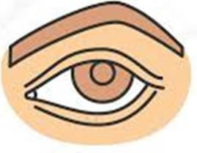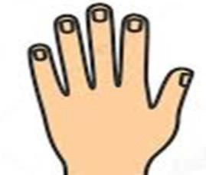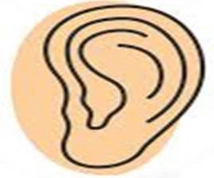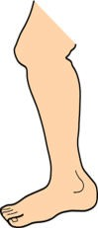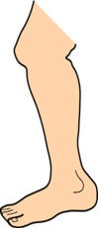

1. List five things we do not share at home. (__/**5marks**)
   1. .
   2. .
   3. .
   4. .
   5. .
2. Name 2 things you see in the sky at night. (__/**2marks**)
   1. .
   2. .
3. Fill in the missing words. (__/**4marks**) Psalms 139: 13

You every part of . You put me

in my womb.

1. Match with the correct answer. (__/**5marks**)

|  |  |
| --- | --- |
|  |  |
| God’s book is the  A family that has a father, mother and children is known as  God created me in I am a child of  The mother of my parents is my | God Grandmother Nuclear family Bible  His own image |

1. Find the members of the family in the word search and circle them. (__/**4marks**)

|  |  |  |  |  |  |
| --- | --- | --- | --- | --- | --- |
| G | A | O | I | M | U |
| R | S | L | E | O | N |
| Z | P | R | F | T | C |
| A | U | N | T | H | L |
| D | K | J | E | E | E |
| F | A | T | H | R | R |
| R | E | T | S | I | S |



AUNT UNCLE SISTER MOTHER

1. Draw and colour one member of your extended family.

(__/**4marks**)

1. Name five things you do at home to help your parents.

(__/**5marks**)

* 1. .
  2. .
  3. .
  4. .
  5. .

1. Fill in the spaces. (__/**5marks**)

I can run with my .

I always use my to write.

I can see because God gave me .

created us like himself.

I am wonderfully created by .

1. Write down five things we should share with our relatives.



(__/**5marks**)

**Assessment Rubric**:

|  |  |  |  |
| --- | --- | --- | --- |
| Exceeds Expectαtion | Meets Expectαtion | Αpproαching Expectαtion | Below Expectαtion |
| 48-50 | 40-47 | 30-39 | 0-29 |
|  |  |  |  |