**COMPETENCE BASED CURRICULUM**

**ASSESSMENT ONE 2024**



CBC



01

**HYGIENE AND NUTRITION GRADE TWO**

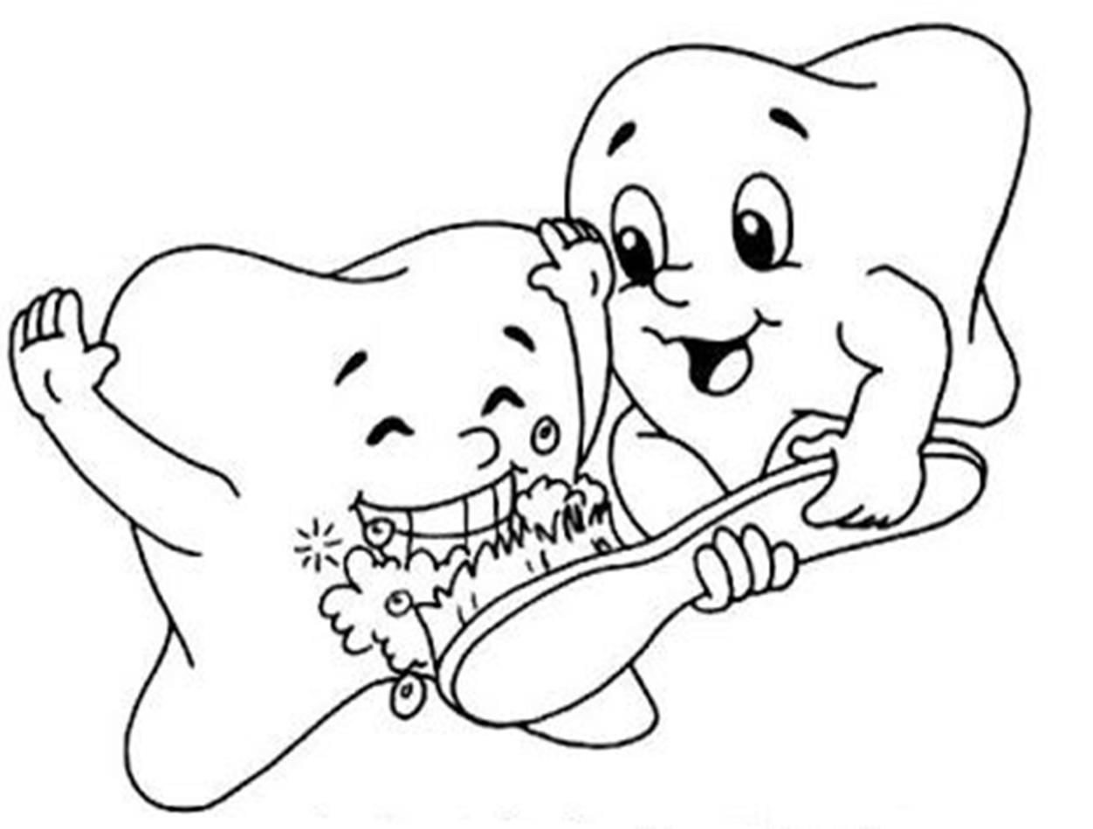

Name:

School:

Grade:

Date : .

**Assessment area: Heath practices, importance of breakfast, oral hygiene.**



A.1. What is breakfast?

(__/**2marks**)

.

1. Why is it important to have breakfast. (__/**6marks**)
   1. .
   2. .
   3. .
2. Food that we eat in the morning is called?

. (__/**2marks**)

1. Draw and name food we eat in the morning. ( /**10marks**)

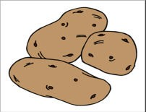

sweet potato



1. Name five things you can do after eating breakfast.

(__/**10marks**)

* 1. .
  2. .
  3. .
  4. .
  5. .

1. Match things I use to brush my teeth. ( /**10marks**)

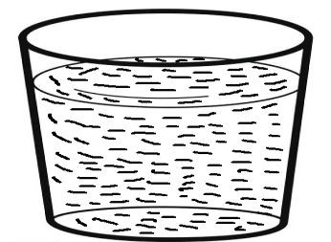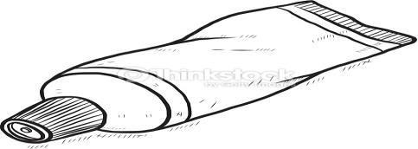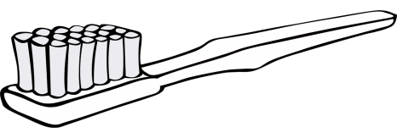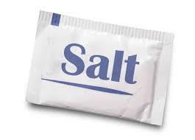

|  |
| --- |
| Salt |
| Water |
| Toothpaste |
| Toothbrush |
| Chewing stick |

* We take meals a day. (__/**2marks**)
* If I do not have a toothbrush I can use a

. (__/**2marks**)

* Clean teeth should be . (white, brown)

(__/**2marks**)

1. Draw and colour yourself being checked teeth by a dentist.

(__/**4marks**)

Assessment Rubric:

|  |  |  |  |
| --- | --- | --- | --- |
| Exceeds Expectation | Meets Expectation | Approaching Expectation | Below Expectation |
| 50 - 48 | 40-47 | 30-39 | 0-29 |
|  |  |  |  |