**CREATIVE ARTS GRADE 2 LESSON NOTES**

**CREATING AND EXECUTING**

**1.1 Hopping**

* **Hopping** - this is a form of movement in which the body is propelled up and down in a continuous motion by same supporting foot, either on the spot or in motion.
* Greater leg strength and dynamic balance is required for hopping as only one foot is used to lift the body and a smaller base of support is involved.
* It is an important skill to master for:
* Safe body management - e.g. when one is pushed off balance or loses footing.
* Sports such as hopscotch basketball lay up shot, triple jump and dances

***Animals that move by hopping***

* Kangaroo
* Praying mantis

***Resources required for hopping***

* Sufficient fields
* Ropes
* Canes
* Balls
* Hoops
* Lime/whitewash/chalk dust.

***How to hop***

* Stand erect, weight on one foot, and the other foot raised in slightly back with the knee bent.
* Keep shoulders level, head high, and toes pointing forward.
* Look straight ahead.
* Bend knee of supporting foot, push from the floor, and extend body upward into the air.
* Land on the same foot, toe first, then ball on the foot, then heel; landing with bent knee.
* Continue hopping on the same foot.

Cues during all hopping activities

* Hop with good forward action
* Keep the weight on the ball of the foot
* Arms are used for balance
* Aim for height as you hop.
* Land softly
* Increase the height of the hop, swing the arms upward fast.
* Increase the height and distance gradually.

***In grade 2 we will perform;***

* Hopping in different directions - forward, backward, to the left and to the right.
* Hopping in different patterns - straight, circular, curved and zigzag.

1. **Hopping in different directions**

All movement can be done in different directions. Children need to be encouraged to vary these.

* Hopping forward
* Hopping backward
* Hopping to the left
* Hopping to the right

1. **Hopping in different patterns.**

* Straight
* ***Circular***

**Organization - individually**

* Learners to find free space where they can hop on the ground.
* On signal, each learner to start hopping in circular motion around the hoop.
* Ask them to hop at varying speed; fast, slowly
* Ask the to change directions; clockwise and anticlockwise.
* Repeat the activity allowing short pauses in between.
* ***Curved***
* Bend your body smoothly in the direction you are moving
* Keep your body curved

■ ***Zigzag***

CREATIVE ARTS GRADE 2 LESSON NOTES

Organization - 3-4 groups

Equipment - Cones, field marker

* Learners are in groups of 8 - 10, each forming a single line behind each other.
* Four cones are arranged at equal distance in front of each line of learners.
* On signal, the first learner start hopping going round each cone using short steps, long steps and at low and high levels as much as possible.
* After reaching the end, the learner goes back to the end of the line.
* After all in the line have taken turns, the activity can start all over again.

Tips in good Hopping

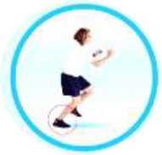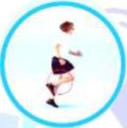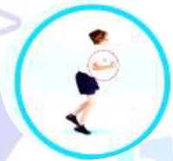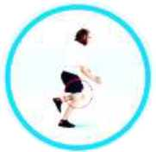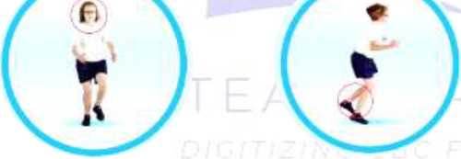

**Take off and land on the same foot, pushing off from the ball of the foot**

The non-hopping leg swings io rhythm with the hopping teg

**Arms bent at the elbow, swing back together then vigorously forward and upwards to assist the leg action in providing force**

**Bend the hopping leg slightly on landing and straighten on take off**

**Head and trunk should be stable with the eyes focused forward**

**Practise on both right and left legs to become proficient on both**

Why is hopping important?

* **Balance**: Hopping helps children develop dynamic balance, which is the ability to maintain balance while moving.
* **Coordination**: Hopping helps children develop coordination and motor skills.
* **Strength**: Hopping helps children engage their leg muscles and develop strength.
* **Spatial awareness**: Hopping helps children develop spatial awareness, which is important for navigating the world around them.

3 | Page

CREATIVE ARTS GRADE 2 LESSON NOTES

• **Building blocks**: Hopping is a building block for more advanced movements, such as jumping and kicking.

1.2 Drawing and painting

***Texture*** - It refers to the physical appearance or feel of an object, and can be seen through bumps, ridges, grooves and other physical details.

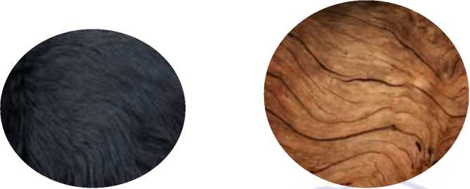

There are lots of different types of texture. Things can be:

* smooth or rough **(Grade 2 focuses on this)**
* hard or soft
* wet or dry
* matt or shiny

Techniques for drawing texture

To make texture in a drawing, you will need some pencils or crayons.

There are different types of pencils.

* Some are marked with an H (for hard).
* Some are marked with a B (for black).
* Some are known as **HB pencils** (a mix of hard and black) and are good for drawing and writing.

Hard and soft pencils produce different types of marks.

* H pencils make fine lines.
* B pencils are usually soft and make darker lines.

Do you think a hard pencil produces a light or a dark mark?

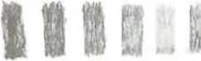

**I * A A A**

Each of these pencils Is different and makes a different mark on the paper.

Activity

You will need a sheet of paper and a wax crayon (or a pencil).

Make some **texture marks** on the paper. With each pencil or crayon, you could make some:

* small and large circles
* zig-zags
* dots and dashes
* a mix of straight neat lines and rough messy lines

Which pencils worked best for each texture?

You could now try making a drawing that shows the texture of an object you can see around you.

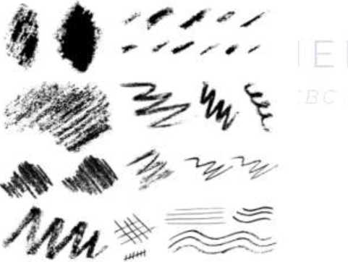

Creating texture by rubbing technique

A technique that involves rubbing pencil, graphite, chalk, crayon, or another medium onto a sheet of paper that has been placed on top of a textured object or surface.

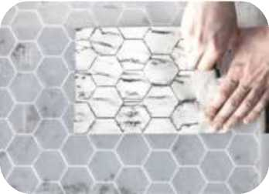Place a piece of paper directly on the surface you intend

**Method**

to take the rubbing from.

1. Use a stick of charcoal to build up a reasonable area of rubbed surface. Experiment with paper of varying weight. A very coarse surface might be revealed by quite a thick weight of paper, for example.
2. Similarly, try using various types of material (pencil, charcoal, graphite sticks). Changing the pressure of the mark can be a way of revealing more sensitive surfaces.
3. Now look at the textured fabrics. These are materials we are unable to take rubbings from, so try to create marks that respond to the pattern or weave of your fabrics.

Drawing Natural forms

Drawing is when you use lines to make a mark on a surface. It could be a *sketch*, a figure or a plan.

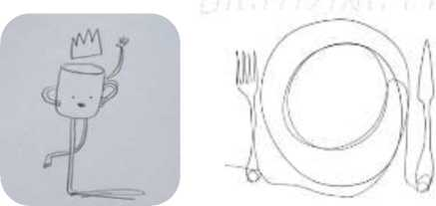It is an important technique used today by many people and in many jobs, including *artists* and *designers*.

You will need the following:

* HB pencil
* Rubber
* Sharpener
* White pencil
* Pen and Coloured pencil
* You also need white and dark coloured paper

Using shapes and lines to draw

1. Choose your *drawing tool* and *materials.* You could use a pencil or something unusual like a stick with some paint.
2. Look around you, e.g. the room or space that you are in right now or even what is right in front of you.
3. Choose something to look at and draw.
4. Use your drawing tool to draw the shapes and lines that you can see.
5. Of course, you can break the line at any point and carry on tracing your drawing.
6. Applying texture on drawn shapes

Mixing colours using bloating techniques

The blotting technique is a watercolor painting technique that uses an absorbent material to remove wet paint from a surface. This technique can be used to create textures, add highlights, and remove excess paint.

Steps

1. **Gather your materials:** Choose high-quality watercolor paper, paint, and brushes for the best results. You’ll also need a clean, absorbent material, such as a paper towel, tissue, or sponge.
2. **Apply your paint:** Paint your desired area or shape on the paper using your chosen watercolor paint.
3. **Blot as needed:** If you need to remove excess paint, lighten an area, or soften an edge, gently press your absorbent material against the wet paint. Be sure to lift the material straight up, rather than dragging it across the paper, to avoid smudging.
4. **Adjust and repeat:** If necessary, adjust your blotting material to a clean area or fold it to create a new surface, then continue blotting until you achieve the desired effect.
5. **Let it dry:** Allow your painting to dry completely before adding any additional layers or details.

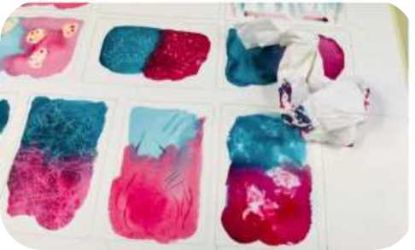

Project for blotting technique

1. **Textured Landscapes:** Use blotting to create interesting textures in your landscape paintings, such as clouds, foliage, or rocks.
2. **Light and Shadow:** Add depth and dimension to your artwork by using blotting to create highlights and subtle shading.^^
3. [**Animal Portraits:**](https://watercolorpaintingacademy.com/watercolor-cute-realistic-cat-step-by-step/)Blotting can help you capture the softness and texture of fur or feathers in your watercolor animal portraits.
4. **Atmospheric Skies:** Use blot ting to create wispy clouds, sunrays, or subtle color variations in your sky paintings.

1.3 Rhythm and pattern making

Rhythm is a pattern of sounds or movements that repeat regularly. It can be found in music, poetry, and everyday activities.

In music

* Rhythm is the pattern of sounds of different lengths.
* It's created by combining short and long durations of sounds.

In everyday activities

* Rhythm is a movement or activity that repeats regularly.
* For example, breathing has a rhythm.

***Ways of creating rhythm in music***

There are three ways of creating rhythm in music. They include:

* **Reciting** it involves using;

**Body percussion**: Using your body to create rhythm patterns

* **Clapping**

Creating rhythm by clapping involves clapping in time with the beat of a song. Clapping in time is a great way to learn rhythms and develop musicality.

* **Humming**

To hum is to make a low, steady, singing sound with your mouth closed.

**Imitating repetitive rhythmic sounds**

* Take learners through activities of identifying and discussing items that make regular beats. These includes: wall clocks.
* Imitate different rhythms e.g. a learner marches like a soldier while others clap or loudly count to the rhythms made by the matching.
* Here is an example of a rhythm exercise:

**Teacher:** the clock ticks ***tik -tak, tik-tak, tik - tak, tik - tak***

**Learners:** The clock ticks ***tik -tak, tik-tak, tik - tak, tik - tak***

**Teacher:** The bell rings ***ding - dong, ding - dong, ding - dong, ding - dong***

**Learner:** The bell rings ***ding - dong, ding - dong, ding - dong, ding - dong***

* Songs on vehicles hooting because of traffic jam may be performed by the learner.

Song on Traffic Jam

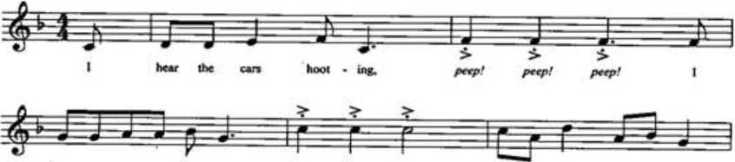

**hc«r (he bus - K3 hoof - ing. *peep! perp! perp!* traf - fie jam io the town.**

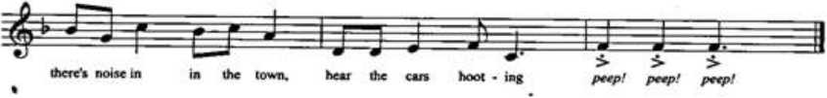

* Repetitive rhythmic sounds are produced by objects and animals in the environment, such as; sirens, chicken, dove, donkey and clock ticking, maintaining a steady beat,

**Reciting/clapping rhythmic patterns of simple words**

* There are several activities that involve clapping syllables in names: these names include:
* Pig, piglet, Mary, Nairobi and Ali
* coffee tea soda;
* cat cat, kitten kitten, cat;
* dog chicken dog elephant,
* Undertake activities to vocalise syllable names and identify shorter and longer rhythms e.g. rhythms for “Abigail” and “ Mississipi” are shorter than those of “Peter” and “ding-dong”.

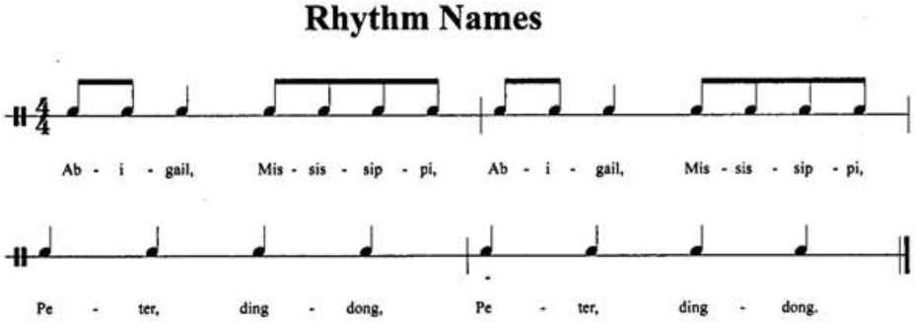

***Clap/ tap/ vocalize***

**Creating rhythmic patterns based on simple words through repetition and variation**

* In vocalizing syllable names, the following names are used: Mary, Nairobi and Ali in the following manner.

1. Pattern A

***“Mary - Ali - Peter - Brenda****”* is a pattern of names that have the same syllables for each name. When this pattern is repeated it becomes **repetition**. This is because it is repeated the same way.

2. Pattern B

“Mary - Ali - Yolanda - Jonathan” is a pattern of names that is slightly different from pattern A. When pattern A and B are done, then pattern B becomes a **variation** of pattern A. This is because of the slight difference.

**Creating simple shape patterns by printing**

*Requirements*

pencil, cutter, paint, paper. Sponge/Lino sheet

**Procedure**

• **Draw out the shapes:**

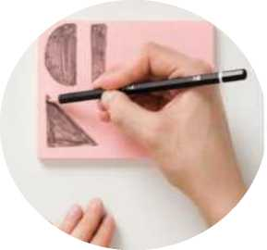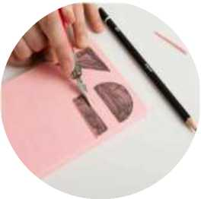

Start by drawing three simple shapes of your choice on the lino block. In this example, we used a triangle, a semi-circle, and a rectangle.

Use the finer blade of your lino cutting tools to carefully cut along the outline of each shape. Take your time and ensure precise cuts and as always, cut away from your body.

• Creating Shape Stamps:

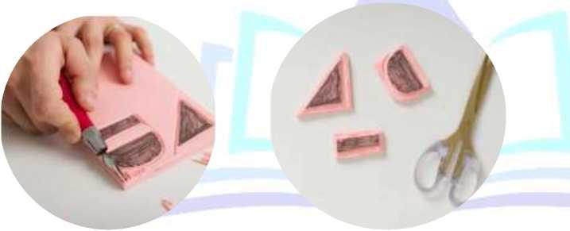

Use scissors to cut out each shape from the lino block. Cut as close to the edges of the shapes as possible. The cut-out shapes will act as stamps for printing.

* Rolling Out the Paint:

Place a small amount of paint on a smooth and non-porous surface, such as a glass or acrylic palette. Use the roller to evenly spread and roll out the ink or paint, creating an even layer on the palette.

* Applying Paint to the Stamps:

Use the roller over the inked surface, ensuring it picks up a sufficient amount of paint. Roll the inked roller onto the surface of each shape stamp, covering the raised areas with paint.

**Printing the Shapes:**

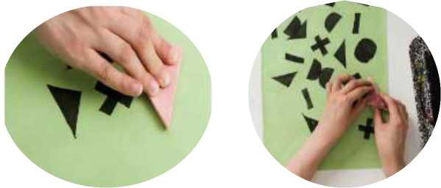

Take a sheet of printing paper, preferably a different coloured sheet such as green in this example. Place the stamps onto the paper randomly.

Apply gentle and even pressure to transfer the paint from the stamp onto the paper. You can use the palm of your hands to press down on the paper.

**1.4. Turning**

* Turning is a movement involving rotation around the long axis of the body
* Turning exercises assist the body to develop flexibility of the spine and strengthen muscles.
* They also help correct he body poise.
* Turning exercises also causes free movement of the ribs and so tends to increase capacity and flexibility of the chest. Maintaining body control balance during turning is important.
* In order to practice turning, the following steps will help:

1. Learners to find free space within the marked space and perform directional turns following signals. E.g. to the left and to the right.
2. From a standing position, turn the body to the right, left, anticlockwise and clockwise, repeat several times ensuring control and balance maintenance throughout.
3. On signal learners respond to teacher’s command, turn north, south, east, west.
4. Learners to make quarter turns, half turns and complete turns (3600)
5. Thy can sing and make patterns while turning in different directions.
6. Repeat the process to ensure learners proficiency

Here's a simple procedure to help them learn how to turn to the left, right, half­turn, full-turn, and in combination:

1. **Turning Left**:

CREATIVE ARTS GRADE 2 LESSON NOTES

o Stand up straight with feet shoulder-width apart.

o Look to your left.

o Pivot on your right foot while lifting your left heel slightly.

o Turn your body to face the left, and place your left foot down.

1. Turning Right:

o Stand up straight with feet shoulder-width apart.

o Look to your right.

o Pivot on your left foot while lifting your right heel slightly.

o Turn your body to face the right, and place your right foot down.

1. Half-Turn (180 degrees):

o Stand up straight with feet shoulder-width apart.

o Look over your shoulder to the left or right.

o Pivot on your opposite foot (right foot for a left turn and left foot for a right turn).

o Turn your body 180 degrees to face the opposite direction.

1. Full Turn (360 degrees):

o Stand up straight with feet shoulder-width apart.

o Choose a direction (left or right) to turn.

o Look over your shoulder and begin to pivot on your opposite foot.

o Continue turning your body in the chosen direction until you've made a full circle and are facing the original direction.

1. Combination Turns:

o Start with a half-turn to the left.

o Once you complete the half-turn, immediately transition into a half-turn to the right.

o Practice combining different turns in sequence, such as a full turn to the left followed by a half-turn to the right.

* 1. **Mosaic**

Mosaic is a picture or pattern produced by sticking different materials such as photographs and pieces of paper or fabric onto a surface.

Materials used for creating mosaic are mostly old newspaper and magazine cuttings or painted paper cuttings.

Mosaic is used in wall hangings and wall units.

**Suggested resources to be used**

* Locally available materials and tools
* Adhesives
* Mounting surfaces
* Cutting tools
* Pencils
* ICT devices

Procedure

**Step 1: Start by Sketching a Design Onto a Piece of Paper**

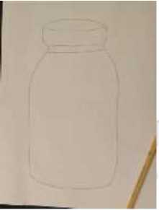

**Step 2: Using a Marker, Transfer Your Design Onto the Wood**

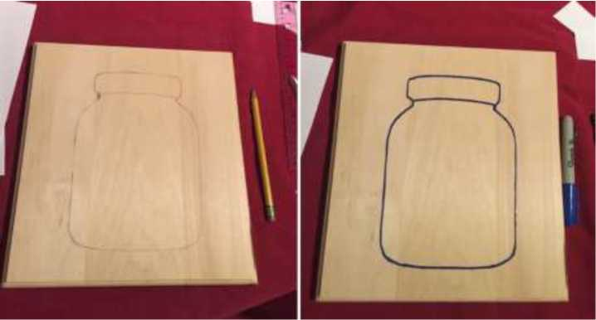

**Step 3: Take Your Tile and Wrap It in a Cloth. Using a Hammer, Break the Tile.**

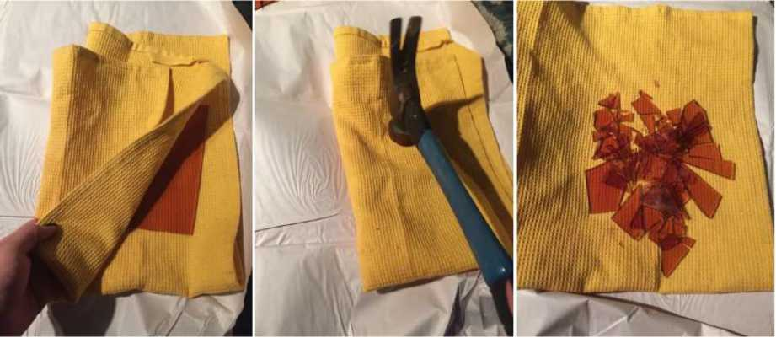

**(Note: It’s important to wrap your tiles in a cloth or wear safety goggles to protect your eyes)**

**Step 4: Gather Your Broken Tiles Into Color Categories**

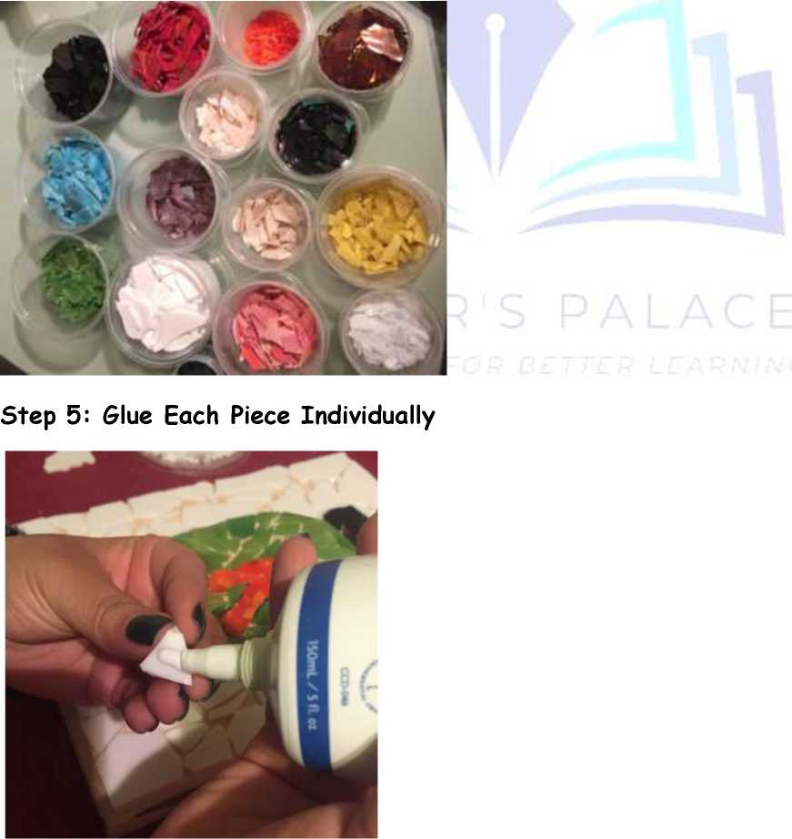

**Note: Make sure the pieces are fairly close together so your grout lines look neat in the end**

**Hint: Using two different colors in one color, gives it a lot of dimension**

**Step 6: Let Glue Sit for 24 Hours**

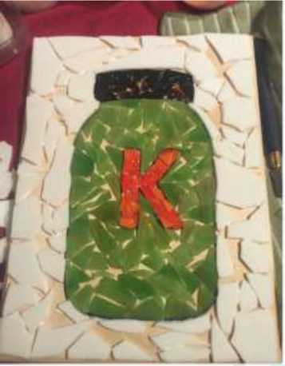

**Step 7: Spread the Grout Using a Grout Float; Press Very Hard to Get in Between All Cracks and Crevices**

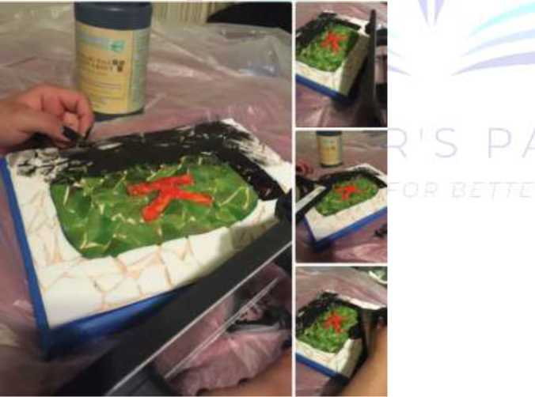

**Allow the grout to set for 20 minutes**

**Note: Don’t hide or completely cover any pieces**

**Hint: Cover the sides of the wood with painters tape to prevent grout stains**

**Step 8: Using a Sponge and Water, Lightly Wipe Off Excess Grout. Let Sit for 24 Hours**

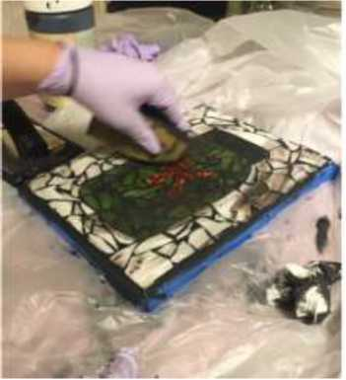

**Step 9: Spray White Vinegar to Get Grout Dust Off Using a Paper Towel or**

**Cloth <**

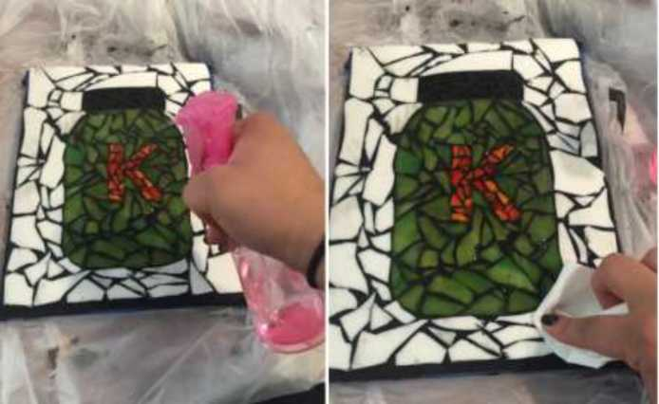

**Step 10: You Now Have a Beautiful Mosaic**

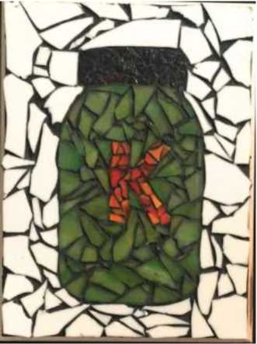

**NOTE: You can use paper while following the same procedure.**

* 1. **Melody**
* Melody is one of the basic elements of music. It is the most recognizable part of music.
* Melody - Is an arrangement or succession of musical sounds that produce a satisfying sequence. It is also known as tune.

**Melodic variations**

* Variation is a one of the commonest ways of developing music and adding flavour.
* Composers use this technique to create new sections in the music while still maintaining the feels of the original melody.
* The tune changes without making it entirely different.
* Below is an example of variation where bars 2 and 4 are variations of bars 1 and 3.

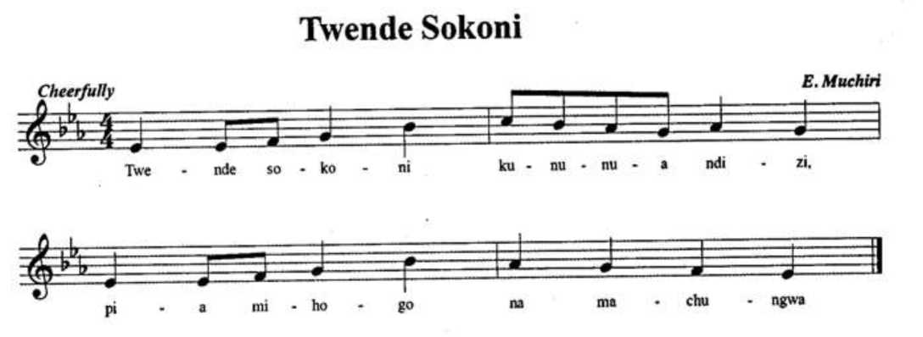

Guide learners to identify sections of melodic variations through singing it out.

**Improvising simple melodic variations**

* This is a technique that learners will use to do slight changes to known melodies.
* Learners to sing a familiar song and guide them to make variations as others sing back.

**Improvising lyrics/texts to tunes**

* With new words, a tune can give the impression that the song is completely new.
* Substituting words can also be used to communicate a different message

**Procedure**

* Guide learners to sing a familiar song then set other words in the same song.
* Guide learners to repeat or imitate the changes. An example of a familiar tune

that could be used is ***“ Are you sleeping”***

* Guide learners to set new words to the tune to create an etiquette song as shown here below:

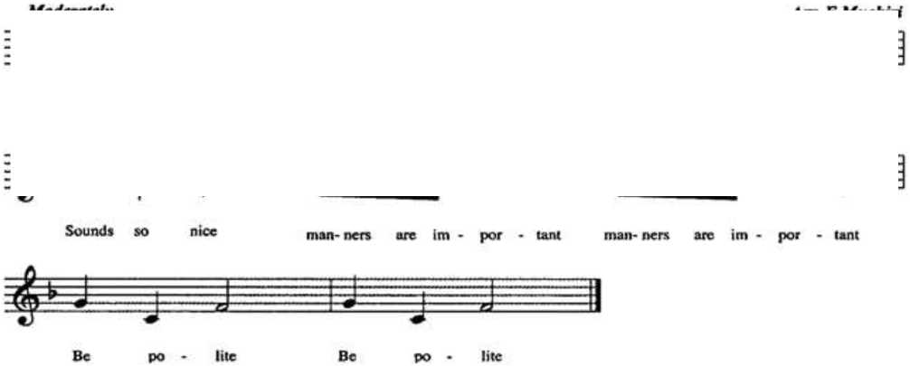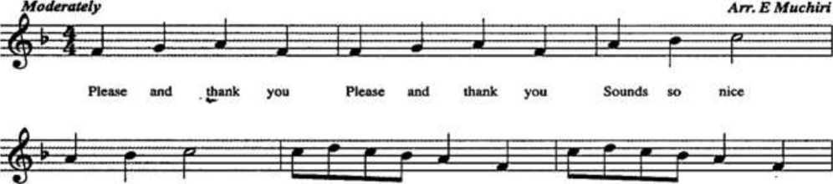

**Please and Thank you** *(adapted from Brother John song)*

* The same tune ***“Are you sleeping",*** may be used to create patriotic songs such as one below:

**Naipenda Nchi Yangu**

*Naipenda nchi yangu*

*Nchi nzuri, nchi nzuri*

*Baraka za Mungu, zimetufikia*

*Kabisa, kabisa*

* Guide learners to use basic shapes (circle, triangle or square) to identify similar tunes and those that are different in a short song.

**PERFOMING AND DISPLAYING**

**2.1 Singing Games - Western Style**

Singing games consist of playing, singing and making body movements. Western style singing games are songs sung in English words by children when singing.

***Examples of singing games in western style***

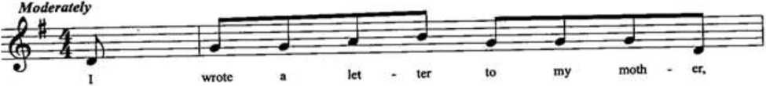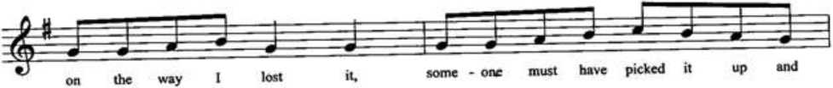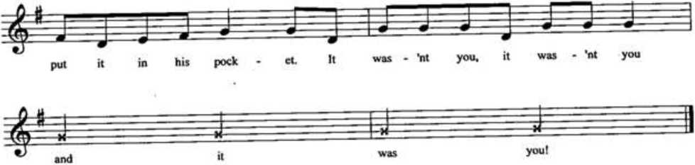I Lost a Letter

Words to 7 lost a letter' song

I wrote a letter to my mother On the way I lost it Someone must have picked it up And put it i# his pocket It Wasn'tyou? It Wasn'tyou? And it was you!

The song is performed in a circle, with all members kneeling except the leader who moves round the circle with a piece of cloth.

On singing “it wasn’t you” , the leader touches the members in rhythm.

The last one to be touched picks the piece of cloth runs round the circle in opposite direction and in competition with the leader.

Whoever gets to the starting point last becomes the leader and starts the song all over again.

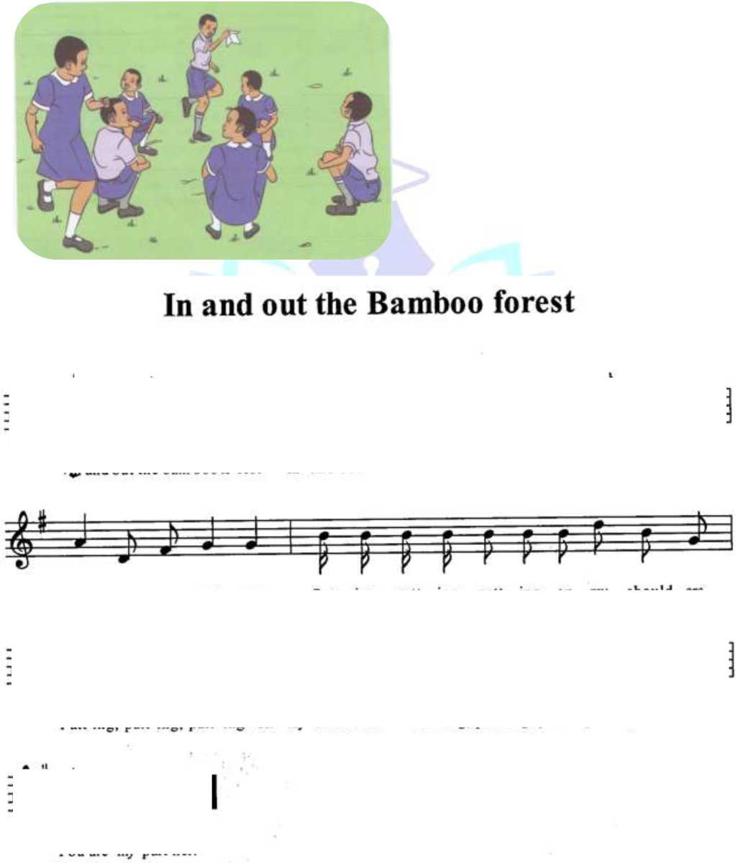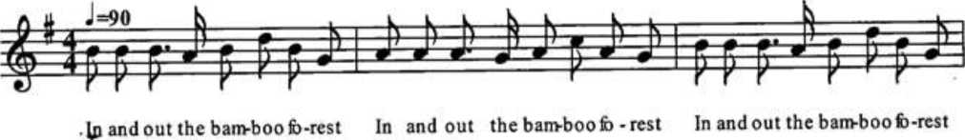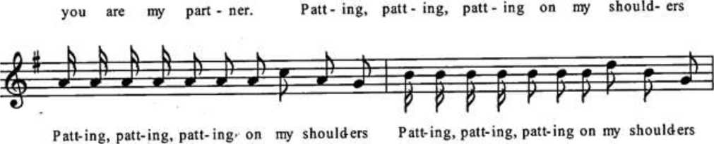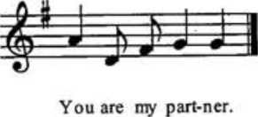

Words to 'In and Out' song

In and out the bamboo forest

In and out the bamboo forest

In and out the bamboo forest

You are my partner

Patting patting patting on my shoulders

Patting patting patting on my shoulder Patting patting patting on my shoulders. You are my partner.

* In a circle, hands joined and raised, the leader moves in and out of the circle. Stops behind the partner and pats his/her shoulders.
* The partner joins the leader as he/she continues with the movement each time the new partner joining the earlier.

• This goes on until all join the leader in one long line.

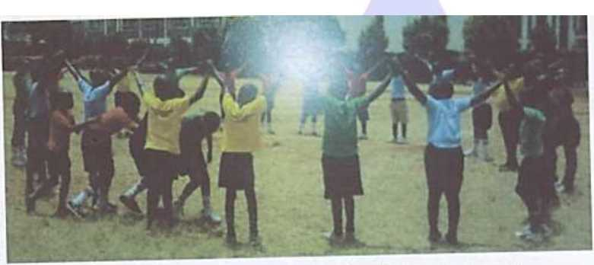

*Figure 1.4: Learners performing "In and out the bamboo forest*

Aspects of a singing game;

Let's break down the key aspects of a singing game for kids:

1. Songs

* **Lyrics and Melody**: Choose catchy and easy-to-remember lyrics with a fun and engaging melody.
* **Themes**: Select themes that are age-appropriate and relatable for kids, such as

animals, nature, friendship, or daily activities.

1. Game Activities

* **Interactive Elements**: Incorporate activities like clapping, jumping, or passing objects to keep the kids engaged.
* **Role-Playing**: Include role-playing elements where kids can act out parts of the song's story.

1. Costumes

* **Themed Costumes**: Dress the kids in costumes that match the theme of the song. For example, animal costumes for an animal-themed song.
* **Simple Accessories**: Use simple accessories like hats, bandanas, or masks to enhance the visual appeal.

1. Props

* **Toy Instruments**: Provide toy instruments like tambourines or maracas for kids to play along.
* **Themed Props**: Use props that are relevant to the song's theme, such as plush animals, scarves, or fake microphones.

1. Formations

* **Circle Formation**: Kids form a circle, holding hands or standing close together.
* **Line Formation**: Kids stand in a straight line facing the audience.
* **Partner Formation**: Kids pair up and perform actions together.
* **Scatter Formation**: Kids spread out randomly within a designated area.

1. Body Movements

* **Gestures**: Use hand movements, body language, and facial expressions to convey the emotions and messages of the song.
* **Dance Steps**: Incorporate simple dance steps that match the rhythm and theme of the song.
* **Turns and Spins**: Teach kids how to turn and spin in different directions, such as left, right, half-turns, and full-turns.

1. Safety

* **Good Posture**: Encourage kids to maintain good posture by standing tall with their shoulders relaxed and back straight.
* **Breath Support**: Teach kids to breathe deeply from their diaphragm to support their singing voice.
* **Correct Physical Technique**: Ensure kids use correct physical techniques to avoid strain or injury, such as using their legs to bend and keeping their movements controlled.
* **Supervision**: Always have an adult present to supervise the activities and ensure safety around water points or other potential hazards.
* props, e.g. Ropes, Dolls, sticks, stones, bottles tops, strings.
* body movements and safety
* Good posture,
* breath support, and
* correct physical technique
* choreography and patterns
* Good use of space
* Being agile

**2.2 Kicking**

* Kicking is a method of striking a ball using the feet.
* Kicking skill involves applying a force to an object with the foot or leg, and require

good eye-foot coordination.

* Kicking with the feet can include: kicking a stationery or moving object like a beanbag, small can or a big soft ball.

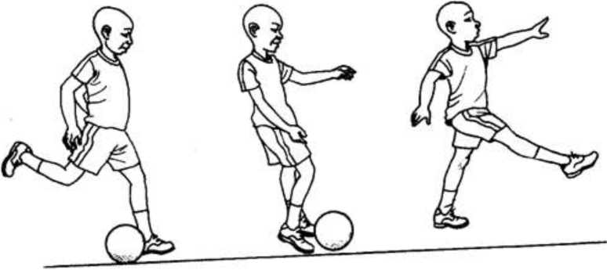

***Different phases of kicking***

**Improvising a softball for kicking**

**To make a ball, you will need:**

* 20 plastic bags
* A newspaper
* String or garden twine
* Scissors

1. Scrunch up some newspaper to form the centre of your football (about the size of a large orange).
2. Place the paper ball in the first bag. Pull the bag around your paper ball and twist a couple of times.
3. Wrap the remaining part of the bag over the ball again, twisting to secure. For larger bags, you may need to repeat this process a few times.
4. Tie the ends off neatly, trying not to create any lumps.
5. Repeat adding more and more bags until you’re happy with the size. Try to space out the tied-off ends, so you keep a circular shape.
6. Use a thicker plastic bag for the last layer, as this will make your ball durable.
7. Wrap your string or twine around the ball a couple of times and knot to secure. Then turn the ball 90 degrees and repeat. Continue to do this until you’ve worked your way around the ball. For added strength try weaving the string in and out.

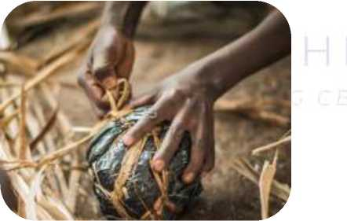

1. Tie off the string in a final double knot, and you’re ready for a game!

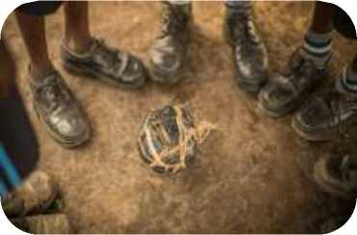

**Kicking in different Directions**

Directions for kicking include:

* Forward
* Backward
* To the right
* To the left.

Procedure

Stand behind the ball and slightly to one side.

1.

2.

3.

4.

5.

6.

7.

8.

Keep eyes on the ball

Step forward placing non-kicking foot next to the ball

Swing kicking leg back, bent at knee and bring through fast to contact ball. Contact/kick ball on the shoelaces for a low ball, with the toe for a high ball, and with the inside of the foot for a ground ball.

Follow through in the direction of the kicking

Repeat the process for other direction until the skill is learner.

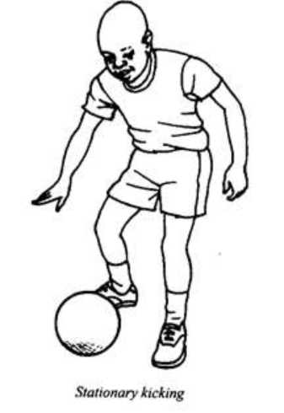Observe safety while kicking in different directions.

Teaching kids how to kick in different directions can be a fun and physically engaging activity. Here are the steps for each direction:

1. Kicking Forward
2. **Stand Tall**: Have the child stand up straight with their feet shoulder-width apart.
3. **Balance**: Ask them to slightly bend their knees and balance on one foot.
4. **Swing**: Swing the other leg forward, aiming to kick with the top of the foot.
5. **Control**: Emphasize controlled movement rather than power, and remind them to keep their upper body steady.
6. **Return**: Bring the kicking leg back to the starting position and repeat.
7. Kicking Backward
8. **Stand Tall**: Have the child stand up straight with their feet shoulder-width apart.
9. **Balance**: Ask them to slightly bend their knees and balance on one foot.
10. **Swing**: Swing the other leg backward, aiming to kick with the heel.
11. **Control**: Encourage them to maintain balance and avoid leaning too far forward.
12. **Return**: Bring the kicking leg back to the starting position and repeat.
13. Kicking to the Left
14. **Stand Tall**: Have the child stand up straight with their feet shoulder-width apart.
15. **Balance**: Ask them to slightly bend their knees and balance on the right foot.
16. **Swing**: Swing the left leg to the side, aiming to kick with the inside of the foot.
17. **Control**: Remind them to keep their body upright and avoid over-rotating.
18. **Return**: Bring the kicking leg back to the starting position and repeat.
19. Kicking to the Right
20. **Stand Tall**: Have the child stand up straight with their feet shoulder-width apart.
21. **Balance**: Ask them to slightly bend their knees and balance on the left foot.
22. **Swing**: Swing the right leg to the side, aiming to kick with the inside of the foot.
23. **Control**: Encourage them to maintain balance and avoid over-rotating.
24. **Return**: Bring the kicking leg back to the starting position and repeat.
    1. **Plaited Ornament (single-stranded)**

* Ornaments - are decorations we wear on the body to appear more beautiful.
* We wear ornaments on the neck, on our wrists, on the feet, in the ears or on the head.
* Many communities in Kenya use such ornaments to showcase their culture, for instance, Turkana, Maasai, Pokot and Samburu,
* Plaiting is a weaving technique that involves interlacing three or more strands of material to create a flat or tubular structure. It can be used in art, textiles, and hair.

**Single stranded bracelet**

**Things You Will Need**

***Materials***

* Waxed Cord
* Wooden Beads with big holes
* Other materials include: treads, reused polythene, banana fibre, sisal among others

Tools

* Ruler
* Scissors
* Lighter (optional)

**Method - 1:** How to Make Adjustable Bracelets With Single Knot

This bracelet has only one adjustable bracelet knot. Follow the steps to make this one.

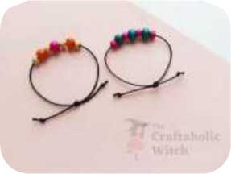

Step 1: Preparing the Cord and Beading

Take the cord bundle and wrap the cord around your wrist loosely 3 times. Measure and cut out the cord (2.5 or 3 times more than your wrist size). Select your wooden beads or any kind of beads which can be inserted into the cord. We’re using small and medium-sized colorful wooden beads. You can fill the cord (a little less than your wrist size’s length) with beads or you can use 5 or 6 beads as we did.

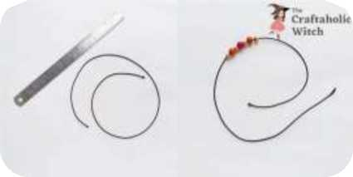

Step 2: Overlap the Open Ends

Form a ring by overlapping both, slightly bigger than your wrist size. Keep an even amount of length on both sides of the overlapped cord and hold the overlapped point firmly.

**Cruftaholic Witch**

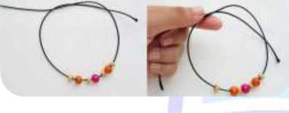

Step 3: Form a Loop Around the Finger Tip

Take any one of the open ends and circle it around your fingertip to form a loop. Draw the open end of the looped side under the main cord ring of the bracelet.

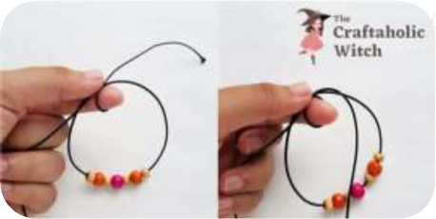

Step 4: Form the 2nd Loop and a Knot

Now, form another loop with the same side. This time, do not draw the open side under the main ring. Draw it through the loop, from left to right.

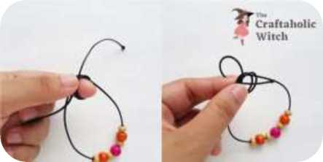

Step 5: Pull the Open Ends and Form the Sliding Knot

Pull both open ends carefully and tighten the knot neatly. Once the knot is tightened, you can check that one open end is adjustable, if you pull, it will slide. Tie knots near the open ends of the 2 sides to finish the bracelet craft.

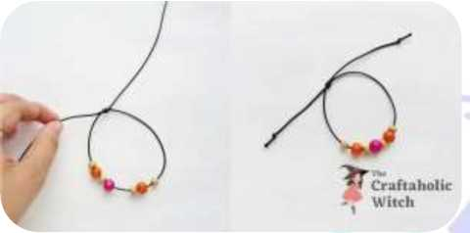

**2.4 Egg Roll and Swan Balance**

• Egg roll/Tuck (tuck shape, knees in and roll over sideways, tuck hands in to chest);

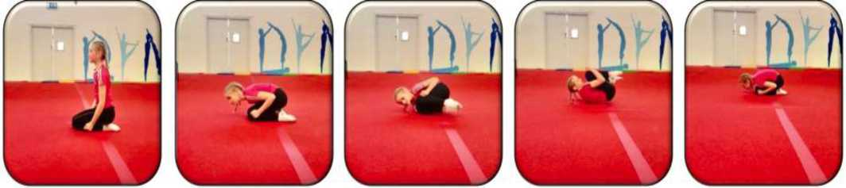

**Teaching Points**

* Kneel on the floor, tuck your knees into your chest and hold your arms tightly to the side of the body.
* Keep your chin tucked in and shoulders just off the floor to keep the rounded shape.
* Roll to the left or right, until you return to your starting position, completing a full rotation of the body.
* Remain in the same position and continue to roll.

**Safety Points**

§ Make as small a shape as possible - as small as a snail!

§ Bodies should be curled up tightly when rolling.

**Preliminary Activities**

* Make a tuck shape lying on the back - as small as a baby turtle!
* Make a tuck shape on your knees - as small as a mouse!
* Go from a tense tucked body position to a loose body position on the back and knees.
* Hold a tense body position for five seconds without moving each time.
* Try and keep a tight tucked position when gently shaken by a partner.

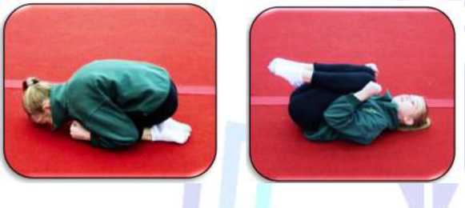

**Swan balance**

* The swan balance is a gymnastics move that involves balancing on one foot while reaching the other foot up and away from the body.

**How to perform a swan balance**

1. Interlace your hands behind your back
2. Transfer your weight to your front foot
3. Slowly lift your back foot off the ground
4. Reach your back foot up and away from your body
5. Keep your standing leg straight and strong
6. Stretch your legs apart
7. Feel the movement in the back of your standing leg
8. Lower your raised leg back to the floor with control
9. Repeat on the other side

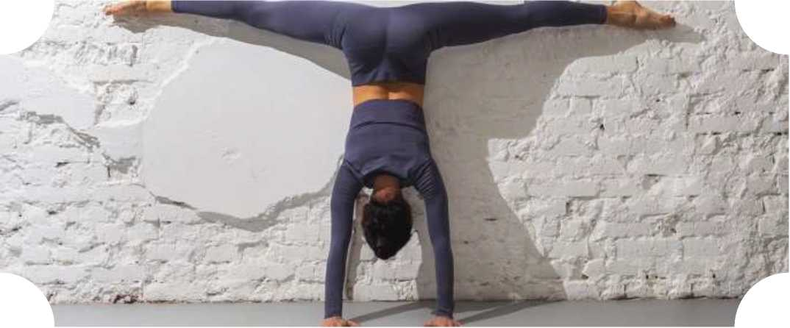

**Improvising markers**

* identify, collect and share reusable materials within the environment to be used as markers as they observe safety precautions,
* improvise the markers using the collected reusable materials,
* mark the field using the improvised marker,

**2.5 Wind Musical Instruments**

Wind instruments are grouped into flutes, horns and reeds.

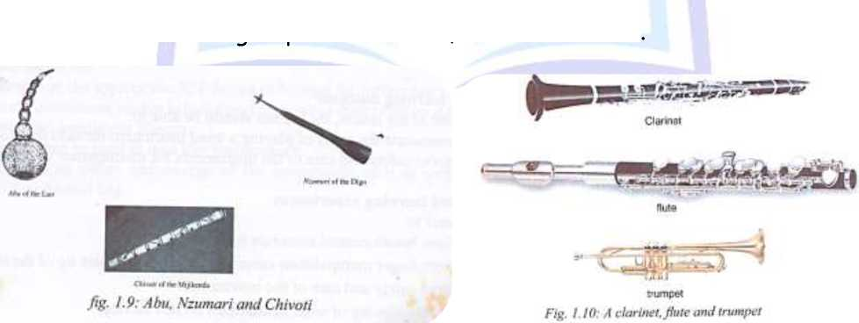

**Improvising wind instrument**

***Requirements***

* Pictures of wind instruments
* Appropriate reusable materials found within the environment such as pipes and straws.
* Reeds
* Cutting tools
* Water
* Plastic bottles
* Paper

***Steps for making a simple wind instrument***

1. Biro pen casing or lollipop straw holder can be blown across to produce some musical sounds, varying the rhythm of the sounds produces a whistle like music sound.
2. For reeds, plastic pipes or tubes, use the cutting tools to cut out a good size, a length of about 6 inches should be sufficient for the learners little hand.

* Bore out a mouth hole on one end.
* Bore out the finger holes
* Test the instrument.

1. The illustration below shows an improvisation of the wind instrument.

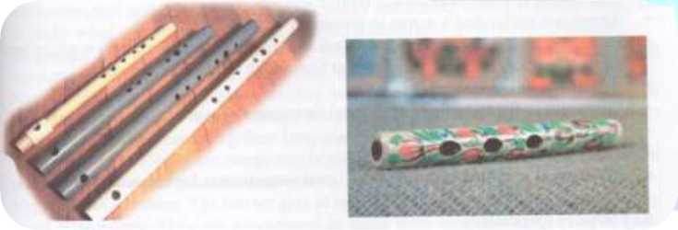

1. Play the instrument while employing the playing skills of:

* Blowing
* Holding
* Placement of lips
* Fingering
* Breath control

**2.6 Modelling (Coiling technique)**

* Modelling is the act of making a representation of something using clay or plasticine.
* The coil technique is a pottery method that involves rolling clay into coils and stacking them to create a vessel.

***Requirements***

1. Clay
2. Water
3. Containers
4. Cleaning rags
5. Sample items made using the coil method

**Procedure**

* Divide the learners into groups of four and let learners sit in a semicircle
* Each group will mould clay at the center and each learner should have small water bowl, a rolling board and a rag.
* Demonstrate to the learners how to go a bout modelling using coiling method:

1. Pinch an amount of clay and roll it into a strip using your palm and the rolling board
2. Make several strips of different sizes, with the first one being the longest. It will create the base when you coil it.
3. Once you have the base, continue adding more layers of coil while creating them into the shape you want by reducing their length.
4. We should not smoothen out coils.
5. You can add a decoration by engraving round the items using a small pointed stick.
6. Learner to follow the same process until they come up with a similar item

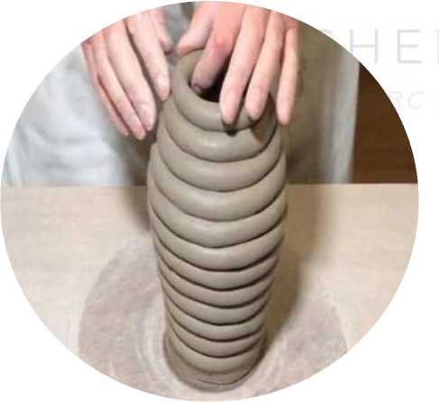

**2.7 Songs**

**Topical Songs**

Here are some popular topical songs for kids in Kenya:

1. Tushangilie Kenya - A lively song performed by Grade 3 students, celebrating Kenya.
2. Kenya Song - A catchy tune from the "Countries of the World" series, highlighting the beauty and culture of Kenya.
3. Jambo, Jambo! - A fun greeting song in Swahili, teaching kids how to say hello and count to three.

Message in Topical songs in Kenya

Let's take a look at the song **Tushangilie Kenya**.

This song celebrates the beauty, culture, and unity of Kenya. It highlights the country's natural wonders, diverse culture, and the spirit of togetherness among its people.

The message is one of pride and joy in being Kenyan, encouraging listeners to appreciate and celebrate their homeland. It's a great way for kids to learn about and appreciate their country's heritage.

**Performance techniques in Topical Songs**

Performing topical songs effectively requires kids to focus on several key techniques. Here's a breakdown of each:

* **Accuracy of Tune**: Maintaining the correct pitch and melody is crucial. Kids should practice regularly to ensure they can hit the right notes and stay in tune throughout the performance.
* **Clarity of Words**: Pronunciation and enunciation are important so that the audience can clearly understand the lyrics. This involves practicing the song's lyrics slowly at first, then gradually increasing the tempo as they become more comfortable.
* **Gestures and Facial Expressions**: Engaging the audience with appropriate gestures and facial expressions can make the performance more lively and relatable. This includes using hand movements, body language, and expressive faces to convey the emotions and messages of the song.

APPRECIATION

**Singing games - Western style**

participants in a Western style singing game

In a Western-style singing game performance for kids, the participants typically include:

1. **Lead Singer**: Often, one child takes the lead in singing the main verses or initiating the song. This role can rotate among the children.
2. **Chorus Group**: The rest of the children join in during the chorus or specific parts of the song, creating a harmonious group performance.
3. **Dancers**: Some children may perform choreographed dance moves or gestures that complement the song, adding a visual element to the performance.
4. **Audience**: Other children, teachers, or parents who watch and sometimes participate by clapping or singing along.

**costumes used in a Western style singing game**

In a Western-style singing game performance, kids often wear costumes that reflect the theme of the song or game. Here are some common costume elements:

1. **Traditional Western Attire**: This includes cowboy hats, boots, and denim outfits. Girls might wear dresses with frills and boys might wear plaid shirts and jeans.
2. **Themed Costumes**: Depending on the song, kids might dress up as characters from the song's story. For example, if the song is about animals, they might wear animal costumes.
3. **Uniforms**: Some performances might have kids in matching outfits, such as school uniforms or coordinated colors, to create a cohesive look.
4. **Props and Accessories**: These can include items like bandanas, scarves, and toy instruments to enhance the performance.

**props used in a Western style singing game**

In a Western-style singing game performance for kids, various props can be used to enhance the visual and interactive elements of the performance. Here are some common props:

1. **Toy Instruments**: Items like tambourines, maracas, or small drums add a musical element that kids can play along with.
2. **Cowboy Hats and Bandanas**: These are classic Western accessories that help set the theme.
3. **Toy Animals**: Depending on the song, plush horses, cows, or other farm animals might be used to act out parts of the song.
4. **Ropes or Lasso**: Kids can use these to mimic cowboy activities, adding an element of fun and authenticity.
5. **Props for Dance Moves**: Items like scarves or sticks can be used for coordinated dance routines.
6. **Fake Microphones**: These can help kids feel like real performers and encourage them to project their voices.

Western-style singing games for kids often carry messages that promote fun, learning, and social interaction. Here are some common themes and messages you might find:

1. **Friendship and Cooperation**: Many singing games emphasize the importance of working together, being kind to one another, and forming strong friendships.
2. **Celebration of Culture**: These games can celebrate Western heritage, traditions, and history, teaching kids about different aspects of their culture.
3. **Learning and Development**: Singing games often incorporate educational elements, such as learning numbers, letters, or new vocabulary in a fun and engaging way.
4. **Imagination and Creativity**: Encouraging kids to use their imagination, these games often involve storytelling and role-playing.
5. **Physical Activity**: Many singing games include movements and actions that promote physical activity, helping kids stay active and healthy.

In Western-style singing games for kids, formations play a crucial role in enhancing the performance and interaction. Here are some common formations used:

CREATIVE ARTS GRADE 2 LESSON NOTES

1. **Circle Formation**: Children form a circle, holding hands or standing close together. This formation is great for games that involve passing an object or taking turns in the center of the circle.
2. **Line Formation**: Kids stand in a straight line, often facing the audience. This is ideal for performances that include choreographed movements or synchronized singing.
3. **Semi-Circle Formation**: Similar to the circle formation but with an open end. This allows all children to see each other and the audience simultaneously, fostering a sense of unity.
4. **Scatter Formation**: Children are spread out randomly within a designated area. This formation is useful for games that require individual movement and interaction.
5. **Rows**: Kids stand in parallel rows, which is often used for larger groups. This formation helps maintain order and allows for complex dance routines.
6. **Partner Formation**: Children pair up and stand in twos. This is perfect for games that involve partner activities, such as clapping games or passing objects back and forth.

Here's a simple and fun Western-style singing game for kids called **"The Cowboy**

**Round-Up"**:

**Objective**: Kids will sing and act out the song while learning about teamwork and cooperation.

**Formation**: Circle Formation

Materials Needed:

* Cowboy hats and bandanas (optional)
* Toy instruments (e.g., tambourines, maracas)

**Lyrics**:

(Verse)

We are cowboys, riding through the town, With our hats and bandanas, we never frown. Clap your hands, stomp your feet, Let's all move to the cowboy beat!

(Chorus)

Yee-haw, yee-haw, cowboys and cowgirls, Round and round, let's give it a twirl. Swing your partner, do-si-do, We're the best cowboys, don't you know!

Instructions:

1. **Circle Up**: Have the kids form a circle, holding hands.
2. **Lead Singer**: Choose one child to be the lead singer who will start the song.
3. **Sing and Act**: As the kids sing the verses, they can clap their hands and stomp their feet to the rhythm.
4. Chorus Actions:

o On "Yee-haw," everyone raises their hands in the air and shouts "Yee- haw!"

o Swing your partner: Kids find a partner and swing around in a circle.

o Do-si-do: Partners link arms and do a do-si-do move (circling around each

other back-to-back).

1. **Repeat**: Continue singing and repeating the actions until the song ends.

**Water Safety Awareness**

different water points in the school environment

Here are some common water points you might find in a school environment:

1. **Water Fountains**: These are typically located in hallways, near restrooms, or in the cafeteria. They provide clean drinking water for students and staff.
2. **Restrooms**: Restrooms have sinks for handwashing and other hygiene purposes.
3. **Cafeteria/Kitchen**: The school cafeteria or kitchen will have sinks and possibly water dispensers for food preparation and cleaning.
4. **Gardens and Outdoor Areas**: If the school has gardens or outdoor areas, you might find taps or hose bibs used for watering plants and maintaining the grounds.
5. **Science Labs**: Science labs often have sinks and faucets for experiments and cleaning equipment.
6. **Sports Facilities**: Gyms or sports fields may have water stations or fountains for athletes to stay hydrated.

Great idea! Singing games are a fun and effective way to teach kids about water safety around different water points in school. Here’s a sample singing game called **"Water Safety Song"**:

**Objective**: Kids learn important water safety tips while engaging in a fun and interactive singing game.

**Formation**: Circle Formation

Materials Needed:

* Water-related props (e.g., toy buckets, sponges)
* Safety signs (e.g., "No Running," "Stay Hydrated")

Lyrics:

IVerse 1J

At the water fountain, we take turns, No pushing or shoving, that's what we learn. Stay in line, wait your time, Water safety keeps us feeling fine!

(Chorus)

Water, water, oh so cool,

Let's stay safe, that's the rule.

No running, no playing, Water safety every day-ing!

(Verse 2)

In the restroom, wash your hands, keep the floor dry, understand?

Don't splash, take your time, Safety’s key, in every rhyme!

(Chorus)

Water, water, oh so cool,

Let's stay safe, that's the rule.

No running, no playing, Water safety every day-ing!

**Instructions**:

1. **Circle Up**: Have the kids form a circle, holding hands.
2. **Lead Singer**: Choose one child to be the lead singer who will start the song.
3. **Sing and Act**: As the kids sing each verse, they can act out the actions mentioned in the lyrics (e.g., forming a line, pretending to wash hands).
4. **Use Props**: Incorporate props like toy buckets or sponges to make the game more interactive and visually engaging.
5. **Repeat**: Continue singing and repeating the actions until all verses are sung.

Water points in schools can pose several dangers if not properly managed and supervised. Here are some potential risks:

1. **Drowning**: Although rare in schools, drowning can occur in areas with deep water sources, such as swimming pools or large water tanks. It's crucial to have proper supervision and barriers around these areas to prevent accidents.
2. **Slips and Falls**: Wet floors around water fountains, sinks, and restrooms can lead to slips and falls, resulting in injuries. Regular maintenance and proper signage can help mitigate this risk.
3. **Hygiene Issues**: Shared water points, like fountains and sinks, can become breeding grounds for germs and bacteria if not regularly cleaned and sanitized. This can lead to the spread of illnesses.
4. **Contamination**: If the water source is not clean or if pipes are old and rusty, there could be a risk of water contamination, leading to health issues such as gastrointestinal problems.
5. **Unsupervised Access**: Younger children might access water points without supervision, which can be dangerous, especially in areas like science labs or kitchens where there are additional hazards.
6. **Flooding and Water Damage**: Leaky faucets or improperly maintained water points can cause flooding, leading to water damage and potential electrical hazards.

To ensure safety near water points in schools and avoid risks like drowning and other accidents, the following precautions should be implemented:

CREATIVE ARTS GRADE 2 LESSON NOTES

1. **Supervision**: Always ensure that children are supervised by a responsible adult, especially around water points such as swimming pools, large water tanks, or science labs.
2. **Barriers and Fencing**: Install barriers, fencing, or locked gates around areas with deep water sources like swimming pools or large water tanks to prevent unsupervised access.
3. **Signage**: Place clear and visible signs indicating water safety rules, such as "No Running," "No Pushing," and "Supervised Access Only."
4. **Non-Slip Surfaces**: Use non-slip mats or flooring around water points to prevent slips and falls.
5. **Cleanliness and Maintenance**: Regularly clean and maintain water points to prevent hygiene issues and water contamination. Ensure there are no leaks or standing water that could cause slips.
6. **Water Safety Education**: Educate students on the importance of water safety, including the dangers of running or playing near water points and the proper use of water facilities.