- Geometrical constructions
1 | 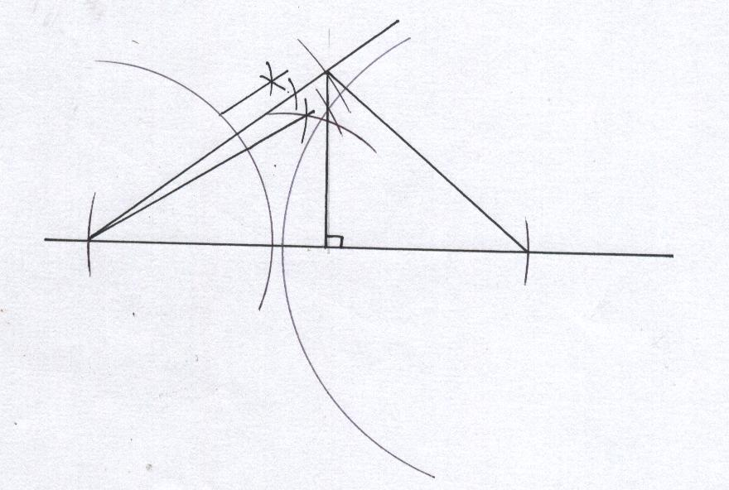  Area of  AE= | B₁  B₁  B₁  B₁  B₁  B₁  M₁  A₁  B₁  B₁ | conct 30⁰  conct 15⁰  AB 9cm  AC 6cm  ΔABC  CD  Loci of E  For AE

2 | 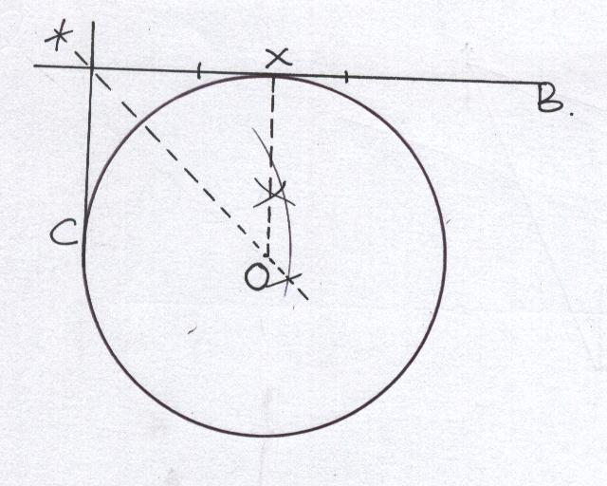 | B₁  B₁  B₁ | ✓construction of 90⁰at x  ✓bisection of line XC and location of centre O  ✓circle drawn
 |  | 3
3 | 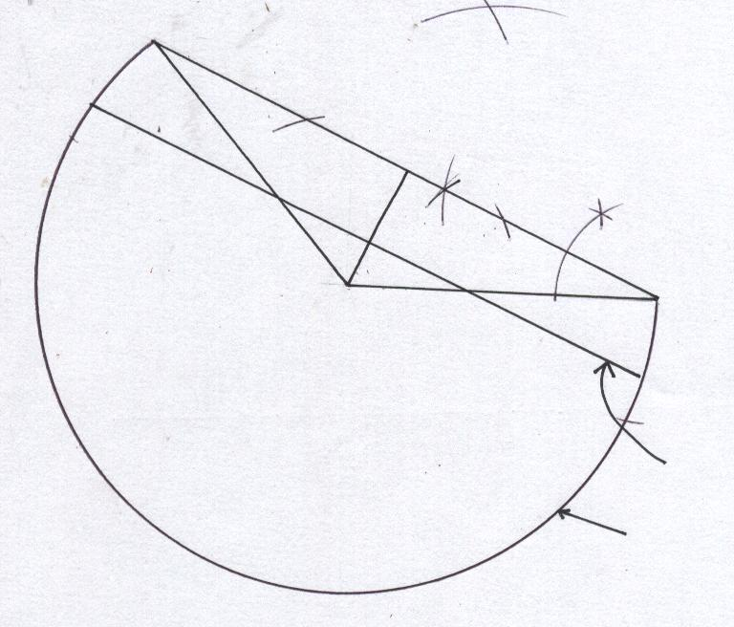  Locus of Q  Locus of P  BC = 9.4cm (  0.1)  AD = 2.7cm (  0.1) | B1  B1  B1  B1  B1  B1  B1  B1  B1  B1 | ✓length AB = 5.4cm  ✓construction of 300 at B  ✓location of C and ABC  ✓length of BC stated  ✓identification of A as centre  ✓Locus of P drawn. (Bo if circle completed)  ✓dropping of perpendicular  ✓length AD stated  ✓his height  ✓locus of Q drawn
 |  | 10
4. | 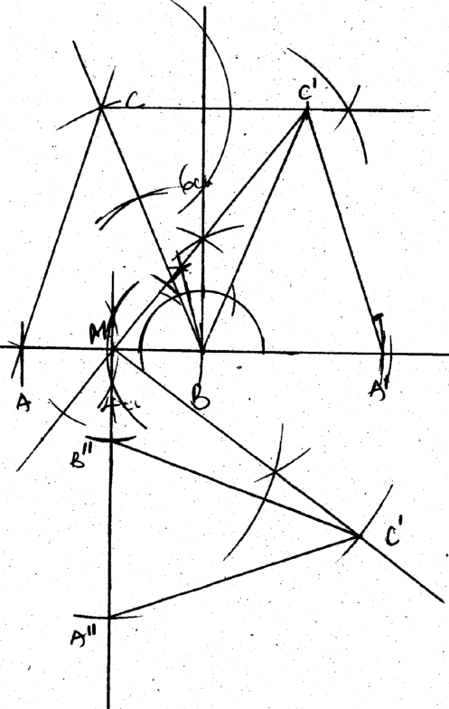 | B1  B1  B1  B1  B1  B1  B1  B1  B1  B1 | <67½0 constructed  ABC complete  AC = 5.7 ±0.1  C1Drawn  A1Drawn  A1BC1 completed  Locating M  (midpoint M of AB)  B11 and A11 rotated  C1 rotated  A11B11C11 completed
 |  | 10
6.
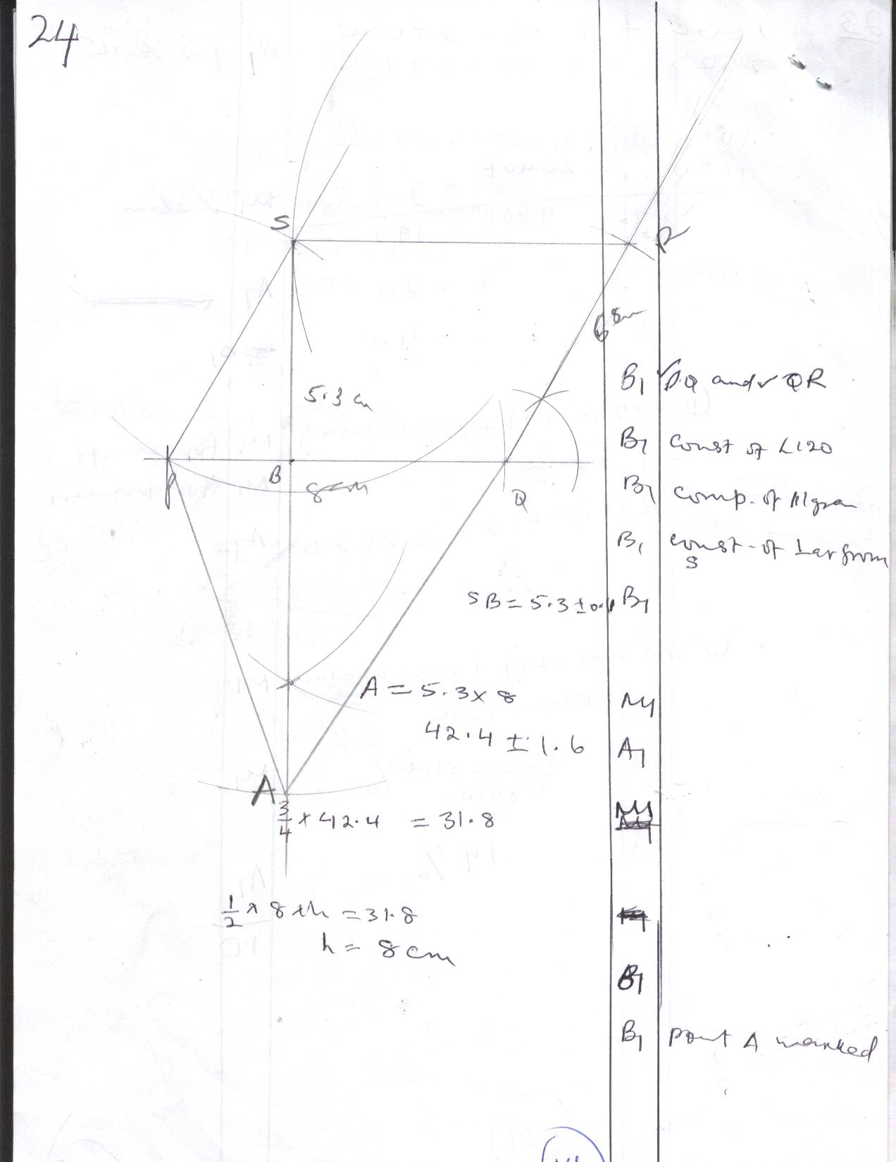

7. | 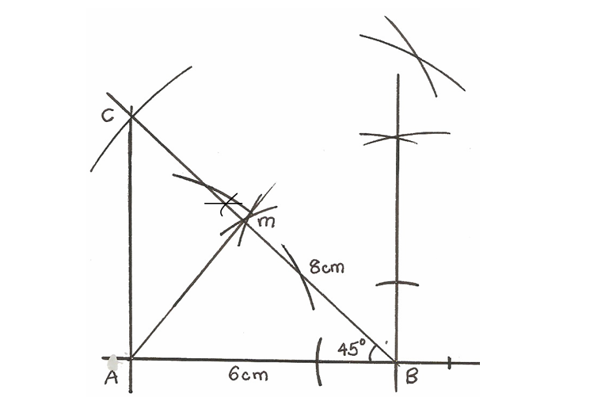  AM = 4.2cm, AC = 5.6cm (±0.1cm) | B1  B1  B1 | Construction of 45º  ΔABC  ⊥ dropped from A to BC
 |  | 04
9. (a) Tan 60⁰ = AC
5cm M1

AC = 8.6605CM A1

(b) A = ½ x 5 x 8.6605 M1
A = 21.65125 A1

- ⁶⁰/₃₆₀ x πr²

⁶⁰/₃₆₀ x 3.142 x 25 M1

= 13.091cm² A1
(d) Area of shaded part
Δ COA = Δ OBA, sector OCD = OCB
21.65 x 2 = 43.3025cm² M1
13.091 x 2 = 26.182cm² M1

∴ Area of shaded part
43.3025 – 26.182 M1
= 17.11225cm² A1

10
10. | 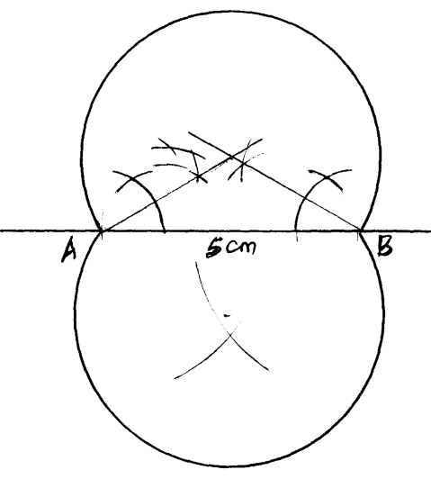  Constant angle locus | B1  B1  B1  B1 |  | Const of 30⁰ at A  Const. of 30⁰ at B  For one arc constructed  For lower arc constructed.
11. | 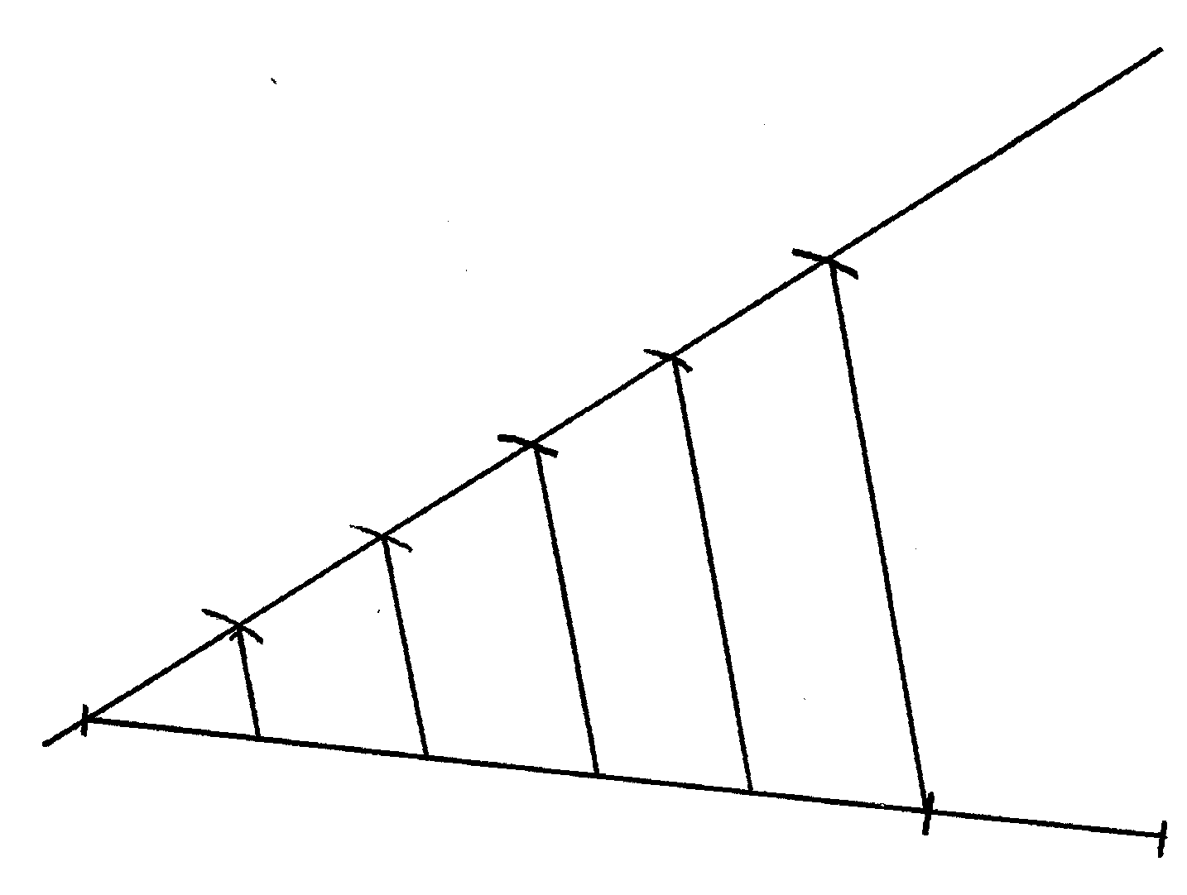 |  | B1  B1  B1 |  | A line drawn slunt to touch the given line at one end.  Subdivided to 5 equal  Sections  Parallel lines drawn from slunt line to touch the given line  .All complete
 |  |  | 03
12. | 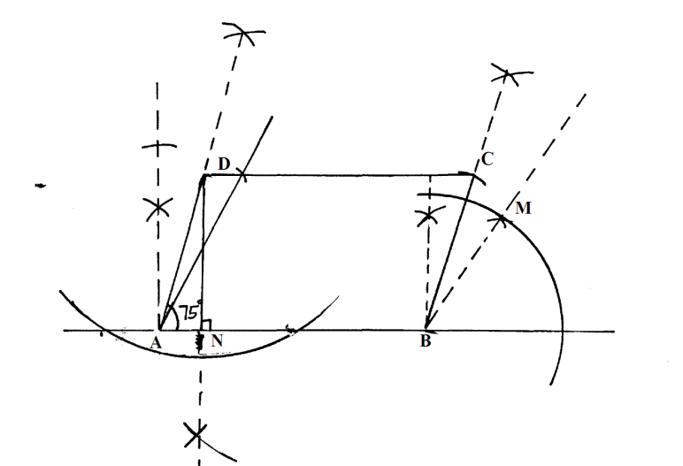  a) length of ON = 3.9cm  b) area = 6x3.9  = 23.4cm² |  | B1  B1  B1  B1  B1  B1  B1  B1  B1  A1 |  | Both 90⁰ & 60⁰at A  75⁰ at A  90⁰&60⁰ at B  75⁰ drawn at point B  Both AB=6cm and BC = 4cm  Parallelogram completed  ⊥ drawn
 |  |  | 10

13. A = 120000 ( 1 + ⁸/₁₀₀ x ¼ )³

120000 (1.02)³ = 127344.95

14.
60º
6cm
A
B
B
C

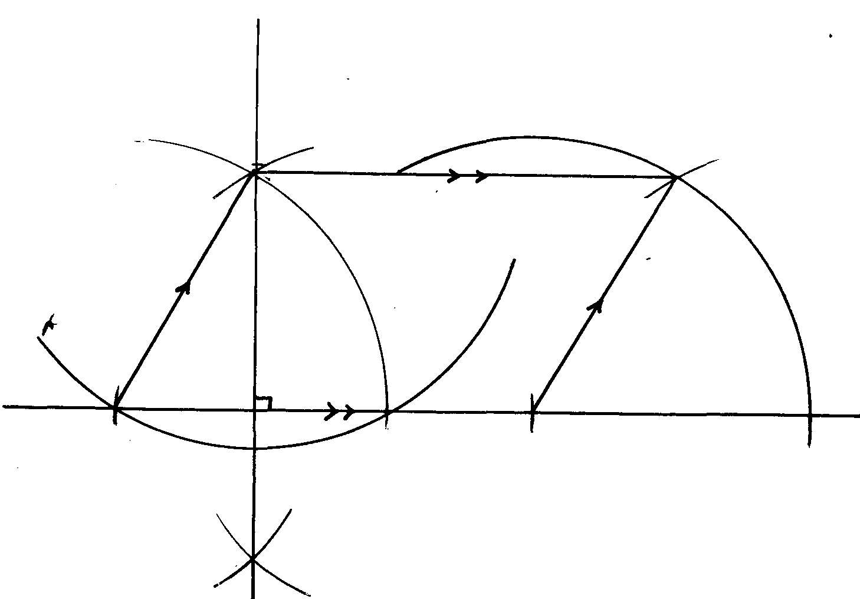
15. BC = 3.5 cm + 0.1 B₁
B1 construction of ∠CAB.
B1 completion of triangle.
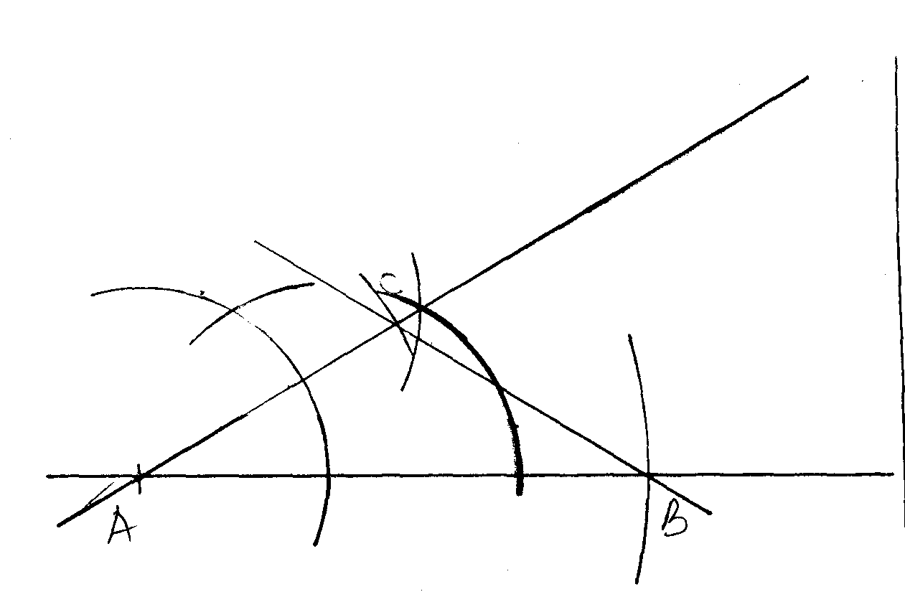
N/B/ Arcs should be seen in order to award the above marks.

16. Height = ± 8.7 1cm
( ½ x 7 x 8.7) 30.45cm²
2 ±1cm
17. Give 1m of correct and complete triangle
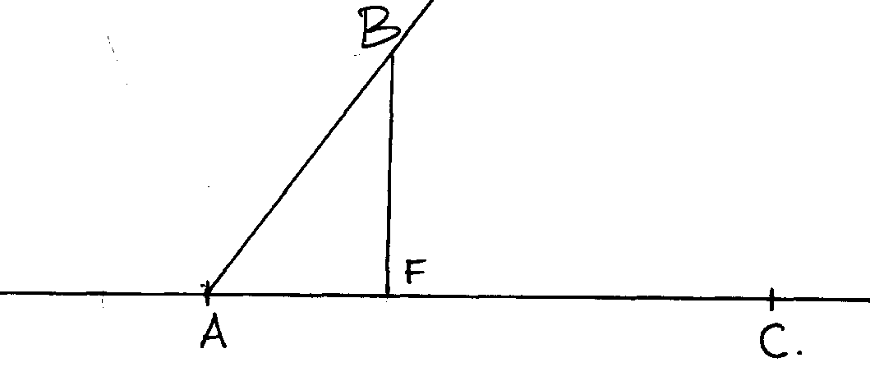
Correct angle
Correct construction of the height
18.

19. Marked price = 100 x 450 = shs.500
90
Cost = 100 x 450 = shs.360
25
Profit = 500 – 360
= shs. 140

