BUKAKA JOINT EVALUATION EXAM GEOGRAPHY 312/1
MARKING SCHEME
SECTION A
1. The diagram below shows some weather instruments.
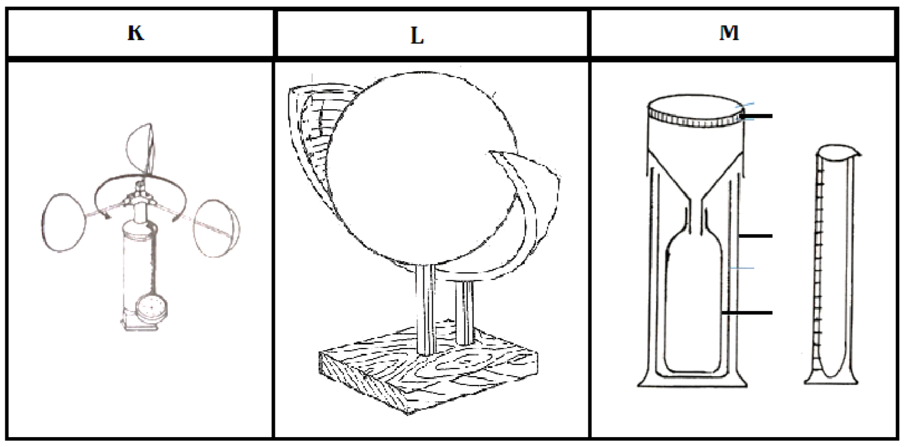

(a) Identify the instruments marked K, L and M. (3 marks)
- - Anemometer
-  Sunshine recorder
-  Rain gauge
(b) Give two modern methods of weather forecasting. (2 marks)
- Use of artificial satellites.
- Use of a radiosonde.
- Use of computers.
- Use of an aero sound.
- Use of weather radars.
2. (a) Give the two main movements of the earth. (2 marks)
- Rotation of the earth
- Revolution of the earth
(b) State three reasons why the interior of the earth is very hot. (3 marks)
- The original heat at formation is still being retained.
- Due to the weight of overlying materials.
- Due to the breakdown of radioactive elements.

3. The diagram below show the occurrence of an earthquake
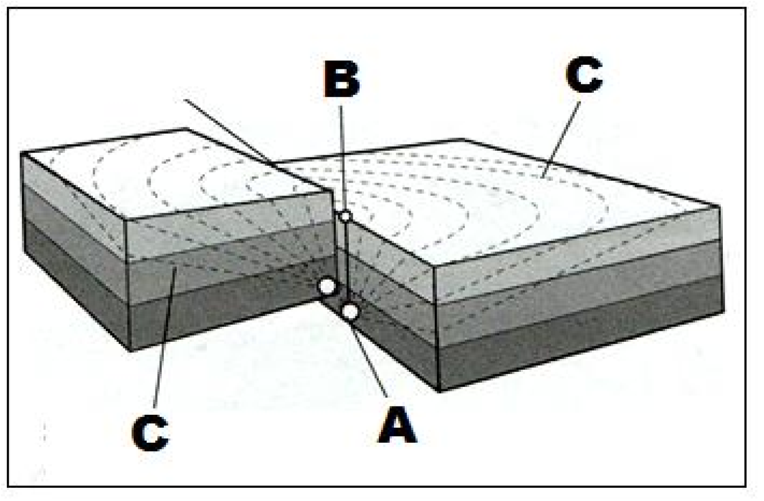
- Name the parts marked A, B and C (3marks)
  - Seismic focus
  -  Epicentre
  -  Shock waves
- List two scales used to measure the magnitude of an earthquake.(2 marks)
- Richter scale
- Moment magnitude scale
4. State five characteristics of coniferous forests. (5 marks)
- Tree species are softwoods
- Most tree species are evergreen.
- The trees have a big portion of stem compared to the leaves.
- Trees have a conical shape to allow snow to slide off easily.
- Trees have needle like leaves.
- Trees occur in big pure stands.
- Trees have a thick bark which is waxy to protect them from winter cold.
- The forest floor has very little or no undergrowth due to long winters.
- Trees have wide shallow roots to utilize moisture from the top soil.
- Trees are tall with flexible trunks to prevent breaking during strong winds.
5. (a) What is soil catena? (2 marks)
Soil catena refers to the sequence variation of soil derived from the same parent material down a slope from top to bottom.
(b) State three factors that influence soil colour. (3 marks)
- The chemical composition of the soil particles
- The amount of organic matter present in the soil.
- The type of parent material from which the soil has developed.
- The drainage of the area in which the soil is found.

SECTION B
6. a) Study the map of MUMIAS (1:50,000, sheet 101/2) provided and use it to answer the following questions.
i) What type of map is Mumias extract? (1 mark)
- Topographical map
ii) Give the magnetic declination of the map as at 1965. (2 marks)
- 2 ° 19
iii) Identify any two districts covered by the map. (2 marks)
- Busia
- Kakamega
- Bungoma
- Siaya

b) i) Name two human made features found in the grid square 6132. (2 marks)
- School
- Settlement
- Main tracks/motorable
- Other tracks and footpaths

ii) What is the bearing of Bumala Dam from the Trigonometrical station-Other, 101 T 6 found in the Northern part of the map? (2 marks)
- 250° ± 1° ( 249 - 251°)
iii) Measure the length of the Dry weather road found in the North Western part of the area covered by the map. (2 marks)
- 4.5 km ± 0.1 km (4.4  4.6 km)
c) i) Using a scale of 1cm to represent 20 m, draw a cross section from grid reference 610310 to 650350. (3 marks)
ii) On the cross-section mark and name:
- River Lusimu (1 mark)
- Woodland (1 mark)
- All weather road-Loose surface (1 mark)
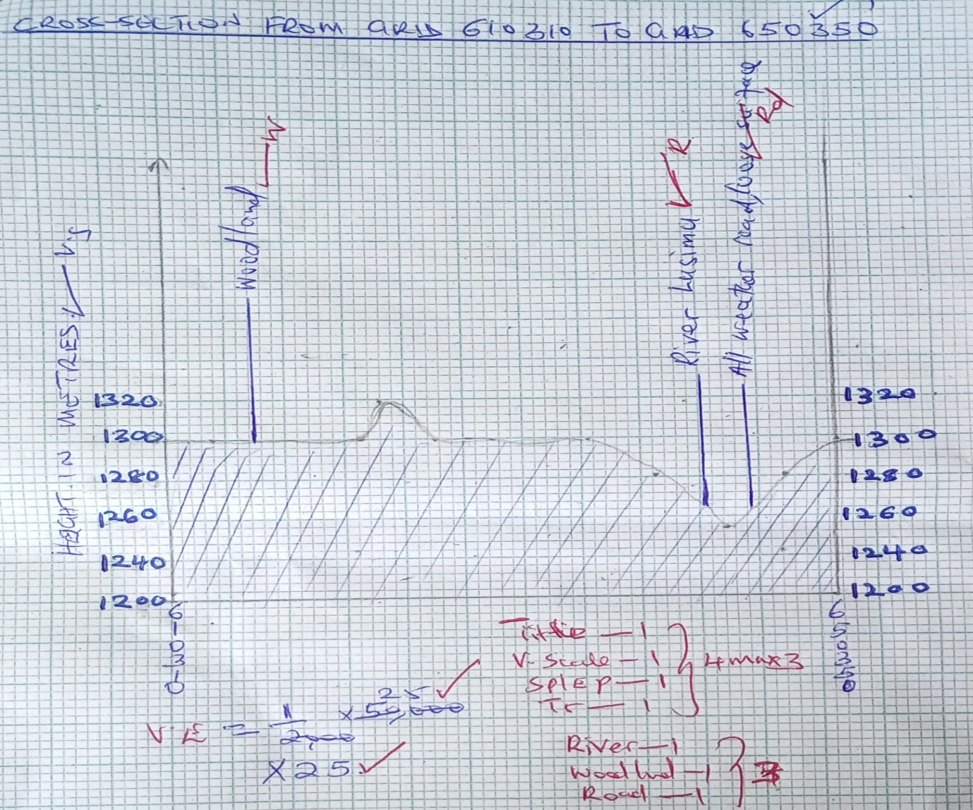
iii) Calculate the vertical exaggeration of the cross-section. (2 marks)
- VE=Vertical scale÷ Horizontal scale
VE= 1:2000÷1:50000
VE= ×25/ 25 times
d) i) Identify two social services offered in the area covered by the map. (2 marks)
- Education
- Health/ Medical services
- Religious
ii) Describe the drainage of the area covered by the map. (4 marks)
- There are many permanent rivers in the area.
- The main river is Nzoia.
- Rivers flow from NE to SW.
- There are disappearing rivers
- There are seasonal swamps.
- There are dams in the area.
- Rivers form dendritic drainage pattern

7. (a) (i) What is a mineral? (2 marks)
A mineral is a naturally occurring inorganic crystalline substance with a definite chemical composition and physical properties.
(ii) Give three ways used to classify rocks.(3 marks)
- According to their mode of formation.
- According to their chemical composition.
- According to their age.
(b) (i) Describe how igneous rocks are formed.(5 marks)
- High temperatures in the interior of the earth causes materials to be in molten form.(magma)
- High pressure underneath pushes the molten magma through lines of weakness such as faults and vents.
- If the pressure is low, magma fails to reach the earths surface. The magma cools and solidifies below the surface forming intrusive igneous rocks.
- If the pressure acting on magma is high, the magma reaches the surface as lava.
- The lava cools on the earths surface forming extrusive igneous rocks.
(ii) List three examples of mechanically formed sedimentary rocks. (3 marks)
Sand stone, Grit, Shale, Mudstone, Siltstone, Claystone,
Loess, Breccia, Conglomerate, Boulder clay
(c) Explain three types of rock metamorphism. (6 marks)
- During thermal/contact metamorphism, hot magma intrudes original crustal rocks during vulcanicity. The hot magma may melt and recrystallize some sections of the original rock thus altering them forming new minerals.
- During dynamic metamorphism, intense compressional pressure acting within a limited area thus alters the structure and texture of crustal rocks. Weight materials overlying some sedimentary rocks may alter the structure of bottom layers.
- Regional metamorphism occurs during fold mountain formation. Intense compressional force/pressure and heat act on sedimentary rocks over a wide area altering both the structure and chemical composition of the rocks.
(c) Suppose you were to carry out a field study on rocks in the area surrounding your school.
(i) State three characteristics that you would look for while identifying different rock types (3marks)
- The hardness of the rocks
- The density of the rocks
- Texture of the rocks
- Colour of different rocks
- Lustre of the minerals forming the rock
- Shape of the rock crystals
(ii) State three follow up activities for the field study. (3marks)
- Writing a report in essay form
- Displaying photographs on rocks taken from the field
- Displaying labelled samples
- Laboratory testing of the mineral composition of some rocks collected
- Discussing the findings in groups
- Giving a lecture to the students who never went.
8. (a) (i) Differentiate between faulting and folding. (2 marks)
Folding is the process through which young sedimentary rocks bend upwards or downwards due to compressional forces whereas faulting is the process through which crustal rocks fracture due to tectonic forces such as tension, compression or shear.
(ii) Name five features formed as a result of faulting. (5 marks)
- Rift valleys
- Fault blocks/Block mountains/Horsts
- Tilt blocks
- Escarpments/fault scarps
- Fault steps
(b) The world map below shows the location of some fold mountains. Use it to answer the questions that follow:
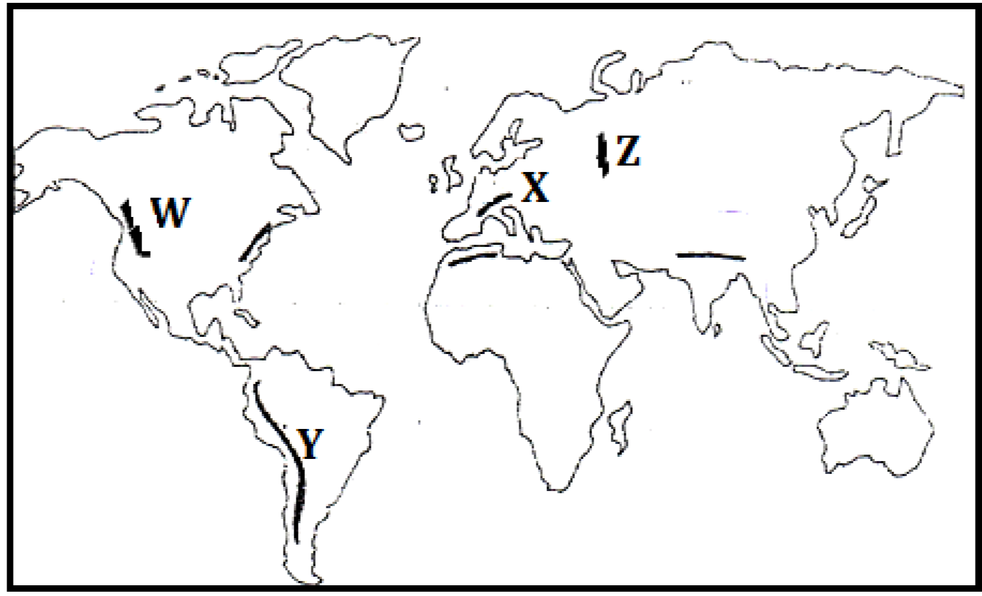
(i) Identify the fold mountains marked W, X, Y and Z (4 marks)
-  Rockies
-  Alps
-  Andes
Z  Ural
(ii) Citing relevant examples, explain how Fold Mountains were formed according to the plate tectonics theory.(6 marks)
- Fold Mountains are formed when two tectonic plates meet along compressional tectonic plate boundaries
- When an oceanic plate meets a continental plate the edges of the sediments and materials at the margins develops into fold mountains e.g. Andes and Rockies
- Fold Mountains are also formed when two continental plates meet squeezing the materials in between into Fold Mountains e.g. Himalayas, Atlas and Alps.

- Explain the effects of Fold Mountains on the following
- Transport.(2 marks)
Fold mountain scenery acts as a barrier to easy construction of roads, railways and pipelines thus making it difficult to access some regions due to ruggedness.
ii) Agriculture (2 marks)
Leeward slopes of some fold mountain ranges receive dry winds leading to arid conditions. This discourages crop farming but favours ranching and transhumance.
Windward slopes of some fold mountains receives high rainfall hence favouring crop farming.
Windward slopes of most fold mountains receive high orographic rainfall which supports crop farming
iii) Tourism. (2 marks)
Fold mountain scenery and snow-capped slopes are important tourist attractions with some slopes favouring winter sports such as skiing and ice skating, e.g. Swiss Alps
- Mining.(2 marks)
Along some slopes of some Fold Mountains, valuable minerals were exposed thus are exploited for various economic uses e.g. copper and tin along the Andes slopes in Bolivia and Chile.

9. (a) Give three examples of West coast deserts.(3 marks)
- Namib
- Atacama
- Californian
- The Great Sandy Desert of Australia
- i) Apart from rock pedestals, name four other features formed due to wind erosion in arid regions.(4marks)
- Zeugen
- Yardangs
- Mushroom block
- Deflation hollows
- Millet seed sand grains
- oases
- Ventifacts

(ii) With the aid of well labelled diagrams, describe how a rock pedestal is formed. (7 marks)
- Initially, there existed an outcrop rock mass with horizontal and alternating layers of hard and soft rocks.
- The heterogeneous rock lie on the path of prevailing wind on a desert.
- The rock was weakened by both weathering and wind abrasion.
- The soft layers are eroded faster thus forming hollows.
- The hard/resistant layers are worn out slowly hence bulge.
- Abrasion is greater at the lower part of the outcrop rock thus greater undercutting.
- With time, this resulted in an irregular rock pillar with a narrow base called a rock pedestal.

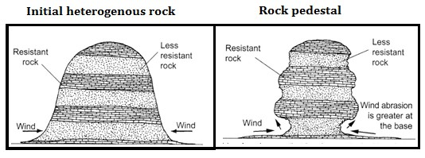
[Diagrams 2 marks]
[Description 5 marks]
(c) Explain four factors that influence the rate of wind transport. (8 marks)
- The strength and the speed of the wind. A strong wind transports heavier and more materials than a weak wind.
- Presence of obstacles such as outcrop rocks and vegetation reduce the wind speed hence reducing its capacity to transport materials.
- Nature of the materials transported. Light particles such as dust are transported to great distances while heavier sand and pebbles over short distances.
- Wind transport is effective during a hot and dry season. Weather changes such as torrential rain washes air borne particles to the ground.
(d) State three negative influence of desert features. (3 marks)
- Advancing sand dunes can be barriers across transport lines such as roads.
- Spreading sand dunes encroach onto productive land hence desertification.
- Flash floods from torrential rains in deserts deposit materials that block roads.
- Excess surface run off flowing in wadis may sweep away and drown people

10. (a) (i) What is a lake? (2marks)
A lake is a mass of water which occupies a depression/basin/hollow on the surface of the earth.
(ii) Give three processes that lead to formation of Lakes. (3marks)
- Through earth movements.
- Through vulcanicity.
- Through erosion.
- Through deposition.
- Through mass movement.
- Through weathering by solution.
- Through human activities.
(b) Describe how Lake Victoria was formed (6marks)
- Internal land forming processes caused vertical earth movements which resulted in down warping of a huge region.
- Down warping led to the formation of a huge depression/basin.
- Uplifting of landmasses around the depression during the formation of the Mau Ranges and the Ruwenzori altered the drainage of the area.
- Some rivers from Kenya which flowed westwards were cut off and diverted into the depression.
- Some rivers in Uganda such as Katonga, Kafu and Kagera were reversed to flow into the depression.
- Deposition of water into the depression caused further down warping.
- The mass of water which accumulated formed Lake Victoria.
- Explain three factors why some Lakes in the Rift Valley in Kenya are saline. (6marks)
Some rivers and surface runoff flowing over volcanic rocks empty salt solutions in some lakes thus increasing salinity.
Some lakes lack surface outlets in form of rivers which lead to accumulation of salts.
Some lake beds are made of rocks rich in soluble salts where the lake water directly dissolves some salts thus increasing salinity.
Some lakes are fed by springs rich in salty water which contributes to salinity.
Some lakes are located in high temperature regions with high evaporation rates thus accumulation of salts.
- Explain four ways in which lakes influence the climate of the surrounding areas.(8marks)
Large lakes contribute large quantities of moisture which aids in the formation of convectional rainfall.
Lakes increase the absolute humidity of the surrounding area by adding extra moisture through evaporation.
Lakes facilitate the development of land and lake breezes through creation of pressure differences between water surface and the land surface.
Air currents from lakes lower the temperature of the surrounding regions during the hot/summer season.
During winter, lake breezes may bring a warming effect to adjacent regions e.g. The Great lakes of North America.
Land and lake breezes may strengthen or reverse the pattern of prevailing winds over adjacent regions.

