**312/2**

**GEOGRAPHY**

**Paper 2**

**July, 2024**

**Time 2 hours 45 min.**

**MOKASA II JOINT EXAMINATION**

**Kenya Certificate of Secondary Education**

**312/2**

**Paper 2**

**GEOGRAPHY**

**INSTRUCTIONS TO STUDENTS**

* *This paper has* ***two*** *sections* ***A*** *and* ***B***
* *Answer* ***ALL*** *the questions in section* ***A****. In section* ***B*** *answer questions* ***6*** *and any other* ***TWO*** *questions.*

**SECTION A: 25 MARKS**

*Answer* ***ALL*** *questions in this section*

1. (a) Why is mining referred to as ‘a robber industry’? (2 marks)

(b) Name ***three*** underground methods of mining. (3 marks)

2. (a) What is tourism? (2 marks)

(b) Name ***three*** tourist attraction sites at the Kenyan coast. (3 marks)

3. (a) Differentiate between manufacturing and tertiary industries. (2 marks)

(b) Give ***three*** Agricultural non-food manufacturing industries in Kenya. (3 marks)

4. (a) What is energy crisis? (2 marks)

(b) State ***three*** problems that affect hydroelectric power production long river Tana. (3 marks)

5. (a) Give ***two*** methods used to rehabilitate land in Kenya. (2 marks)

(b) Stage ***three*** benefits that Kenya derives from Perkerra irrigation scheme. (3 marks)

**SECTION B**

*Answer question* ***6*** *and any other* ***TWO*** *questions from this section.*

6. The pyramid below represents population structure. Use it to answer the questions below.

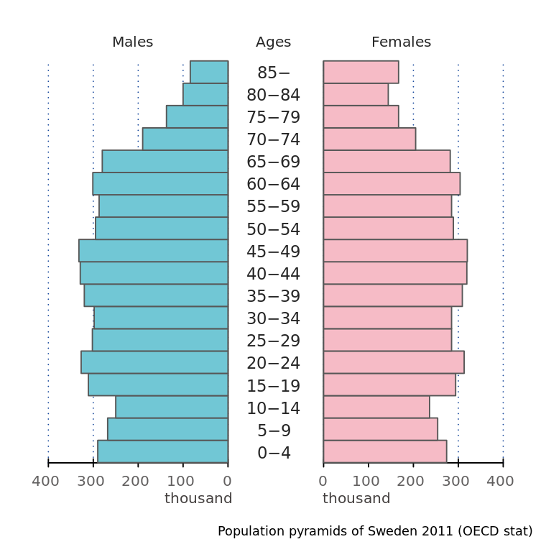

(a) Describe the ***five*** characteristics of the population structure represented by the pyramid above. (5 marks)

(b) The table below shows items exported from Kenya in the year 2023. Use it to answer the questions that follow.

**KENYA**

|  |  |
| --- | --- |
| **EXPORTS** | **WEIGHT IN TONNES** |
| Maize | 12,600 |
| Coffee | 9,990 |
| Oil cakes | 1,560 |
| Spices | 750 |
| **TOTAL** | **24,900** |

(i) Name the main exports in Kenya in the year 2023. (1 mark)

(ii) Calculate the percentage of the export item with the least tonnage in the year 2023. (2 marks)

(iii) Draw a divided rectangle 15cm long to represent the export items for Kenya. (5 marks)

(iv) Stage ***two*** disadvantages of using a divided rectangle as a method of presenting the data. (2 marks)

(c) (i) State ***four*** effects of high population in a country. (4 marks)

(ii) Explain how the following factors have influenced the high population density in the Kenyan Highlands.

* Rainfall (2 marks)
* Temperature (2 marks)
* Soils (2 marks)

7. (a) (i) Define the term forestry. (2 marks)

(ii) Give ***two*** examples of indigenous soft wood tree species. (2 marks)

(iii) State ***four*** factors favoring growth of forests on mount Kenya. (4 marks)

(b) The map below shows the distribution of forests in Kenya.

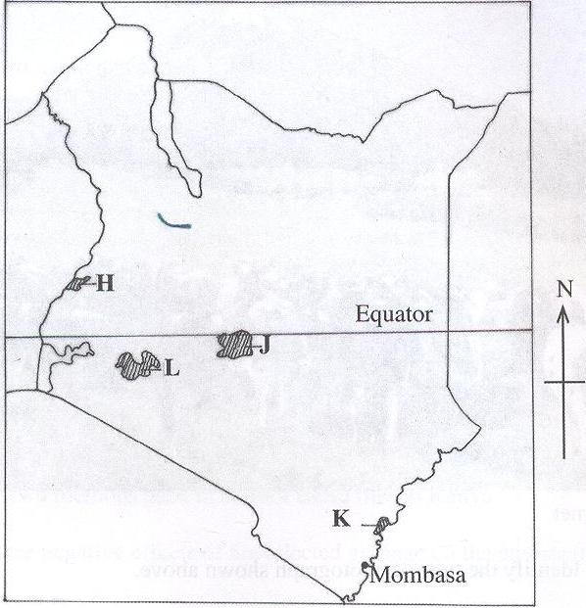

(i) Name the forests reserves marked **J** and **K**. (2 marks)

(ii) State ***three*** measures undertaken in Kenya in order to conserve forests. (3 marks)

(c) Explain ***three*** features of coniferous forests that favors their exploitation. (6 marks)

(d) Compare soft wood forests in Kenya and Canada under the following subheadings.

* Transportation (2 marks)
* Harvesting (2 marks)
* Distribution (2 marks)

8. (a) (i) Define Agriculture. (2 marks)

(ii) Give ***four*** characteristics of plantation farming. (4 marks)

(iii) State ***four*** social factors influencing agriculture. (4 marks)

(b) (i) Draw a sketch map of Nigeria and on it mark and name ***two*** main oil palm growing areas. (5 marks)

(ii) Give ***four*** physical conditions that favor oil palm growth. (4 marks)

(iii) Describe oil palm processing. (6 marks)

9. (a) (i) Distinguish between regional trade and international trade. (2 marks)

(ii) List ***four*** imports Kenya buys from Japan. (4 marks)

(b) (i) What is a trading bloc? (2 marks)

(ii) Describe ***three*** economic benefits of COMESA to member countries. (3 marks)

(iii) State ***six*** reasons why the government should get involved in trade. (6 marks)

(c) Explain ***four*** ways in which the Kenyan government promotes internal trade.

(8 marks)

10. (a) Define the term environment. (2 marks)

(b) (i) Name ***two*** flood prone counties in Kenya. (2 marks)

(ii) State ***four*** causes of floods in Kenya. (4 marks)

(iii) Explain ***three*** measures undertaken to control floods in Kenya. (6 marks)

(c) State ***four*** significance of conserving the environment. (4 marks)

(d) Form four students of Mokasa high school conducted a field study on pollution in a nearby trading center.

(i) Identify ***two*** forms of pollution they identified during the study. (2 marks)

(ii) State ***two*** methods of data collection the used during the study. (2 marks)

(ii) Give ***three*** importance of the information obtained during the study to the local authority. (3 marks)