**312/2**

**GEOGRAPHY**

**Paper 2**

**July, 2024**

**MOKASA II JOINT EXAMINATION**

**Kenya Certificate of Secondary Education**

**312/2**

**Paper 2**

**GEOGRAPHY**

**MARKING SCHEME**

**SECTION A: 25 MARKS**

*Answer* ***ALL*** *questions in this section*

1. (a) Why is mining referred to as ‘robber industry’? (2 marks)

*- It is because through exploitation the minerals get exhausted and they cannot be renewed.*

(b) Name ***three*** underground methods of mining. (3 marks)

*- Deep shaft mining method*

*- Adit/drift mining method*

*- Solution mining method*

*- Drilling mining method*

2. (a) What is tourism? (2 marks)

*- It is the act of traveling to places of interest for recreational purposes*

(b) Name ***three*** tourist attraction sites at the Kenyan coast. (3 marks)

*- Sandy beaches*

*- Coral reefs*

*- Historical sites such as fort Jesus*

*- Traditional culture*

*- Marine Part at Watamu*

*- Mangrove swamps*

*- Water sporting like surfing and fishing*

*- Natural trails e.g. at Bamburi for crocodiles and snakes.*

3. (a) Differentiate between manufacturing and tertiary industries. (2 marks)

*- Manufacturing industries are those that rely on processing goods to make final products or which make final products directly from raw materials while tertiary industries are those which are involved in providing services.*

(b) Give ***three*** Agricultural non-food manufacturing industries in Kenya. (3 marks)

*- Tobacco processing - Foots ware industries*

*- Pyrethrum processing - Glue making*

*- Textiles - Rubber based industries*

*- Saw milling - Plant fiber processing*

*- Leather tanning*

4. (a) What is energy crisis? (2 marks)

- *It is a situation where the prices of fossil fuel rise uncontrollably as a result of short supply and high demand.*

(b) State ***three*** problems that affect hydroelectric power production are long river Tana. (3 marks)

*- Fluctuation of water levels of the river seasonally with lowest water levels recorded during the dry season causing low power production.*

*- Inadequate capital for maintenance of machinery and dredging of the reservoirs.*

*- Siltation of the reservoirs which makes them shallow thus expensive to dredge.*

*- Use of old turbines that break down often and it’s expensive to buy their spare parts.*

5. (a) Give ***two*** methods used to rehabilitate land in Kenya. (2 marks)

*- Re-afforestation - Planting leguminous crops*

*- Control of soil erosion - Adding manure*

*- Bush fallowing*

*- Constructing bunds and gabions*

(b) Stage ***three*** benefits that Kenya derives from Perkera irrigation farming. (3 marks)

*- It provides farmers with steady income improving their living standards.*

*- It creates employment opportunities which arms income to any people thus raising their living standards.*

*- It has facilitated development of infrastructure and social amenities for better services.*

*- It has led to increased food production making the country self-reliant in foods which saves the country foreign exchange.*

*- Some crops grown under irrigation are exported which arms foreign exchange for the country.*

*- It helps to reclaim some marginal lands by increasing their agricultural productivity thus promoting settlements.*

*- Some crops grown provide raw materials for agro-based industries promoting industrialization.*

*- Irrigation schemes have promoted the development of urban centers thus opening up some remote areas*

**SECTION B**

*Answer question* ***6*** *and any other* ***TWO*** *questions from this section.*

6. The pyramid below represents population structure. Use it to answer the questions below.

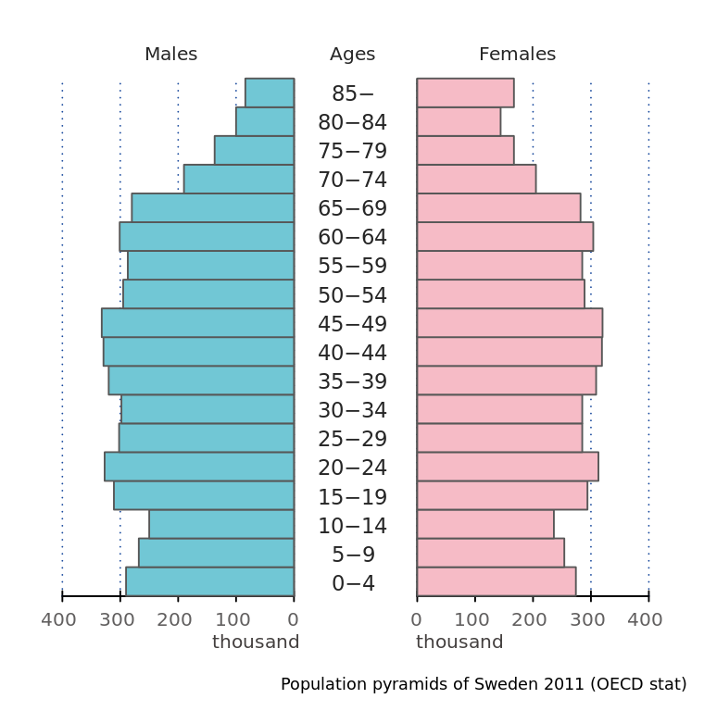

(a) (i) Identify the country whose population could be represented by the above pyramid.

*- Kenya/ a developing country*

(ii) Describe the ***five*** characteristics of the population structure represented by the pyramid above. (5 marks)

*- The number of males and females is almost equal in all ages.*

*- The dependency ratio is high.*

*- The number of infants from ages 0 - 4 is high.*

*- The working population is low.*

*- The number of youths between 15 - 19 years is high.*

*- The number of females in 74 -79 years ……… is higher than men*

(b) The table below shows items exported from Kenya in the year 2023. Use it to answer the questions that follow.

**KENYA**

|  |  |
| --- | --- |
| **EXPORTS** | **WEIGHT IN TONNES** |
| Maize | 12,600 |
| Coffee | 9,990 |
| Oil cakes | 1,560 |
| Spices | 750 |
| **TOTAL** | **24,900** |

(i) Name the main exports in Kenya in the year 2023. (1 mark)

*- Maize*

(ii) Calculate the percentage of the export item with the least tonnage in the year 2023. (2 marks)

$\frac{750}{24900} ×100=3\%$

(iii) Draw a divided rectangle 15cm loan to represent the export items for Kenya. (5 marks)

$\frac{12600}{24900} ×15=8cm$

$\frac{9990}{24900} ×15=6cm$

$\frac{1560}{24900} ×15=0.9cm$

$\frac{750}{24900} ×15=0.4cm$

**SPICES**

**COFFEE**

**MAIZE**

**OIL CAKES**

(iv) Stage ***two*** disadvantages of using a divided rectangle as a method of presenting the data. (2 marks)

*- One cannot locate value at a glance.*

*- Too many calculations making it tedious*

(c) (i) State ***five*** effects of high population in a country. (5 marks)

*- Leads to unemployment*

*- Strain to social amenities*

*- Leads to high dependency ratio*

*- Leads to food shortage*

*- Leads to land fragmentation*

*- Leads to increased crime*

(ii) Explain how the following factors have influenced the high population density in the Kenyan Highlands.

* Rainfall (2 marks)

*- High rainfall received in the Highlands promotes agricultural activities which attract large population in highlands*

* Temperature (2 marks)

*- Cool conditions experienced in the Kenyan Highlands attracts many people to settle in the highlands.*

* Soils (2 marks)

*- Fertile volcanic soils supports arable family which attracts large population in the Kenyan Highlands*

7. (a) (i) Define the term forestry. (2 marks)

*- Forestry is the science of developing and managing forests including cultivating them*

(ii) Give ***two*** examples of indigenous soft wood tree species. (2 marks)

*- Cedar*

*- Podo*

(iii) State ***four*** factors favouring growth of forests on mountain Kenya. (4 marks)

*- The area receives high rainfall 1000 - 2000mm throughout the year which encourages the growth of trees.*

*- The area has deep fertile volcanic soils that allow the roots to penetrate deep into the ground to support the trees*

*- The area has well drained soils thus there is no water logging which can choke the plant and interfere with their growth.*

*- The area has moderates cool conditions/climate which are ideal for the growth of a variety of trees.*

*- The steep slopes discourage human activities thus enabling forests to thrive well.*

(b) The map below shows the distribution of forests in Kenya.

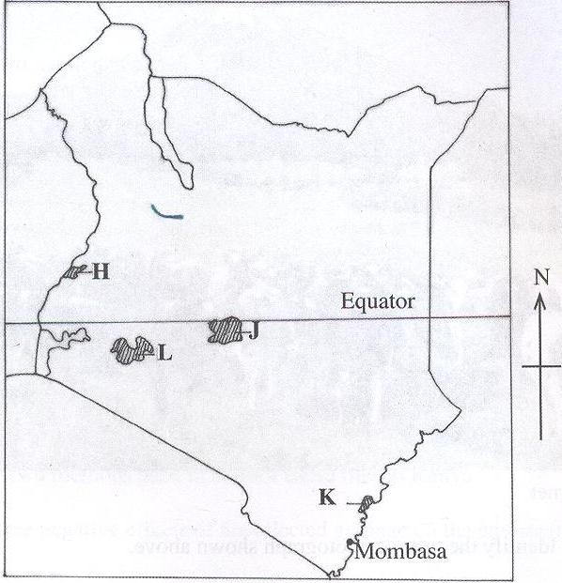

(i) Name the forests reserves marked **J** and **K**. (2 marks)

*J - Arabuko Sokoke*

*K - Mt. Kenya*

(ii) State ***three*** measures undertaken in Kenya in order to conserve forests. (3 marks)

*- Creation of forest reserves to protect indigenous forests from extinction.*

*- Setting of forest guard posts in the forests to protect forests against illegal logging.*

*- Setting Nyayo Tea Zones to act as protective belts to prevent people from trespassing into the forests.*

*- Conducting afforestation and reforestation programs in Kenya.*

(c) Explain ***three*** features of coniferous forests that favors their exploitation. (6 marks)

*- Most trees are softwoods and are light in weight hence easy to cut/fell*

*- Trees mature faster than hardwoods of tropical regions.*

*- Trees species occur in big pure stands hence easy to exploit.*

*- Very little undergrowth due to acidic humans from leaf fall.*

*- Trees have straight trunks*

(d) Compare soft wood forests in Kenya and Canada under the following subheadings.

* Transportation (2 marks)

*- In Kenya the trees are transported via road/trucks while in Canada the trees are transported by rivers or slid down the highlands over ice*

* Harvesting (2 marks)

*- In Kenya, harvesting is throughout the year while in Canada, harvesting is mainly during winter.*

* Distribution (2 marks)

*- In Kenya, most of the softwoods forests are mainly found in Highland areas while in Canada they are mainly found in the lowland areas*

8. (a) (i) Define Agriculture. (2 marks)

*- Agriculture is the practice of cultivating crops and rearing of livestock for subsistence and commercial purposes.*

(ii) Give ***four*** characteristics of plantation farming. (4 marks)

*- Farms are large in size.*

*- A lot of capital is invested.*

*- The farms are either owned by individuals, groups or companies.*

*- One type of crop is grown on a large area.*

*- Farming activities are highly mechanized.*

*- Some farms are labor intensive.*

*- There is high production per unit area.*

*- The produce is market oriented.*

*- There is heavy application of fertilizers for high yields.*

(iii) State ***four*** social factors influencing agriculture. (4 marks)

*- Traditional beliefs determines the type of crops grown and livestock kept in order to meet the dietary needs of a given community.*

*- Land ownership systems such as communal land ownership limits the community land use of the land available to a particular activity thus decreasing produce.*

*- Religious beliefs determines the type of livestock kept while discouraging raring of others.*

*- Gender roles influences productivity as the produce will depend on the effort of gender involved.*

*- Foreign influence through interaction with people from other cultures leads to adaption of new farming techniques and crops hence improved production.*

(b) (i) Draw a sketch map of Nigeria and on it mark and name ***two*** main oil palm growing areas. (5 marks)

(ii) Give ***four*** physical conditions that favor oil palm growth. (4 marks)

*- High temperature throughout the year.*

*- High rainfall that is well distributed throughout the year.*

*- Hi relative humidity.*

*- Plenty of sunshine during the ripening period.*

*- Deep, well drained nutrient rich soils.*

*- Slightly acidic soils.*

*- Gently sloping landscape that permits large scale farming.*

*- Low altitude*

*- Shelter from strong winds and direct sunshine.*

(iii) Describe oil palm processing. (6 marks)

*- At the factory the fruits are weighed*

*- The fruits are put into tube-like cages.*

*- The fruits are passed through hot steam to prevent acidic developments and to sterilize them.*

*- Fruits are stripped off the top cover and other unwanted materials.*

*- Fruits are put into a digester for more cooking which soften them into pulp.*

*- The pulp is separated from kernel inside the fruit.*

*- The pulp is then passed through oil extraction machines to make palm oil.*

*- Kernels are crushed to remove their shelves and extract kernel oil.*

9. (a) (i) Distinguish between regional trade and international trade. (2 marks)

*- Regional trade is between countries that are found in the same geographical region while international trade involves two or more countries.*

(ii) List ***four*** imports Kenya buys from Japan. (4 marks)

*- Electronics*

*- Pharmaceuticals*

*- Motor vehicles*

*- Watches*

*- Automobiles and spare parts*

*- Textiles*

*- Machinery*

*- Precision instruments*

(b) (i) What is a trading bloc? (2 marks)

*- This is an association formed by countries within a region with trade agreements to promote free trading activities.*

(ii) Describe ***three*** economic benefits of COMESA to member countries. (3 marks)

*- It has created a large market for goods produced by the member countries.*

*- Countries are able to buy what they don’t produce.*

*- Establishment of a common tariff making trading easy in the region.*

*- It has led to removal of visa requirement for travel in the region.*

*- It has enhanced the interaction of people in the region, promoting friendship.*

*- It has promoted industrial development in the region as the raw material available are used in member countries.*

(iii) State ***six*** reasons why the government should get involved in trade. (6 marks)

*- To protect local industries/traders.*

*- To encourage trade for employment/self-employment.*

*- To generate income/revenue through taxation.*

*- To prevent illegal trade.*

*- To check on the quality of goods for trade.*

*- To improve on the balance of trade.*

*- To improve infrastructure for easier transportation of goods and services for trade.*

10. (a) Define the term environment. (2 marks)

*- Environment refers all the external conditions which have influence over the behavior of an organism.*

(b) (i) Name ***two*** food prone counties in Kenya. (2 marks)

*- Kisumu*

*- Siaya*

*- Busia*

*- Tana river*

(ii) State ***four*** causes of floods in Kenya. (4 marks)

*- Most of the land is low lying which causes the rain water of spread over wide area.*

*- Torrential rainfall which releases large volumes of water resulting to rivers overflowing their banks.*

*- Silting of some rivers making them shallow thus spilling their water over banks.*

*- The rivers in the flood prone areas are at their old stage, thus they have wide flood plains which allows water to spread over large areas.*

*- Most areas have black cotton soil which is non-porous and when soaks up allow water to flow and spread on the surface.*

*- The high amount of rain water discharged into lakes like Victoria makes their levels to rise thus flooding the adjacent lowlands.*

*- A periodic rise in sea level along the Indian Ocean sometimes causes intrusion of sea water and flooding in some low-lying coastal plains.*

*- Poor environmental management cause blocked urban drainage through poor litter disposal is responsible for the floods experienced in major urban towns.*

*- Cultivation along river banks causing sedimentation in rivers that reduces their capacity to carry its load of water, thus spilling to the adjacent lowlands.*

(iii) Explain ***three*** measures undertaken to control floods in Kenya. (6 marks)

*- Dykes are constructed along river banks levee of rivers to increase their height in order to prevent water from over flowing.*

*- Dredging of Riva channels to deepen/widen them to make it possible for them to accommodate excess water.*

*- Dams are built across the rivers to control the amount of water discharges downstream/construction of earth dams to hold back water.*

*- Draining re-directing a river/straightening of a river to control its wild flow (draining means cut meander loops)*

*- Diversion channels have been constructed in the flood plain and water used for irrigation thus reducing the effect of the excess water.*

*- Afforestation/planting of vegetation/forest in the river catchments areas to reduce the surface run-off and increase seepage.*

(c) State ***four*** significance of conserving the environment. (4 marks)

*- To sustain human life because it depends on resources from the environment e.g. soil, water, air, forests, wildlife, etc.*

*- So as to protect endangered species of plants and animals from becoming extinct e.g. Meru Oak and the white rhino.*

*- Because a lot of natural resources in the environment are of economic value by being consumed directly or by giving us an income.*

*- Because the features in the environment e.g. plants and animals are of esthetic value i.e. they are beautiful to look at.*

*- Full posterity i.e. to ensure a better life for future generations.*

*- To curb global warming by reducing the greenhouse effect which is causing a lot of heat to be trapped in the Earth’s atmosphere.*

(d) Form four students of Highland’s high school conducted a field study on pollution in a nearby trading centre.

(i) Identify ***two*** forms of pollution they identified during the study. (2 marks)

*- Air pollution*

*- Sound/noise polloution*

(ii) State ***two*** methods of data collection the used during the study. (2 marks)

*- Observing*

*- Interviewing*

*- Administering questionnaire*

*- Photographing/video recording/filming*

*- Reading secondary sources/content analysis*

(ii) Give ***three*** importance of the information obtained during the study to the local authority. (3 marks)

*- Used to plan for precaution/safety*

*- Would be used in the conservation of the environment*

*- May be used as a basis for further research*

*- Used for future reference*