Gas laws
1. A sample of unknown compound gas X is shown by analysis to contain Sulphur and Oxygen. The
gas requires 28.3 seconds to diffuse through a small aperture into a vacuum. An identical number
of oxygen molecules pass through the same aperture in 20seconds. Determine the molecular mass
of gas X (O= 16, S= 32)

2. (a) State Graham’s Law of diffusion
(b) Gas V takes 10 seconds to diffuse through a distance of one fifth of a meter. Another
gas W takes the same time to diffuse through a distance of 10 cm. if the relative molecular
mass of gas V is 16.0; calculate the molecular mass of W
3. (a) State Charles’ Law
(b) The volume of a sample of nitrogen gas at a temperature of 291K and 1.0 x 10⁵ Pascals
was 3.5 x 10⁻²m³. Calculate the temperature at which the volume of the gas would be
2.8 x 10⁻²m³ at 1.0 x 10⁵pascals.

4. 60 cm³ of oxygen gas diffused through a porous partition in 50 seconds. How long would it take
60 cm³ of sulphur (IV) oxide gas to diffuse through the same partition under the sane conditions?
(S = 32.0, O = 16.0)
5. (a) State Graham’s law of diffusion
(b) 30cm³ of hydrogen chloride gas diffuses through a porous pot in 20seconds. How long
would it take 42cm³ of sulphur(IV) oxide gas to diffuse through the same pot under
the same conditions (H =1 Cl = 35.5 S = 32 O =16)
6. a) State Boyles law
b) Sketch a graph that represents Charles’ law
c) A gas occupied a volume of 250cm³ at -23ºC and 1 atmosphere. Determine its volume
at 127ºC when pressure is kept constant.
7. A factory produces Calcium Oxide from Calcium Carbonate as shown in the equation below:-
Heat
CaCO_{3 (s)} CaO _{(s)} + CO_{2 (g)}
(a) What volume of Carbon (IV) Oxide would be produced from 1000kg of Calcium
Carbonate at s.t.p (Ca = 40, C = 12, O = 16, Molar gas volume at s.t.p = 22.4dm³)
8. A fixed mass of gas occupies 200cm³ at a temperature of 23ºC and pressure of 740mmHg.
Calculate the volume of the gas at -25ºC and 780mmHg pressure
9. Gas K diffuses through a porous material at a rate of 12cm³ s⁻¹ where as S diffuses through
the same material at a rate of 7.5cm³s⁻¹. Given that the molar mass of K is 16, calculate the
molar mass of S
10. (a) State Gay Lussac’s law
. 11. (a) What is the relationship between the rate of diffusion of a gas and its molecular mass?
(b) A sample of Carbon (IV) Oxide takes 200 seconds to diffuse across a porous plug.
How long will it take the same amount of Carbon (II) Oxide to diffuse through the
same plug?(C=12, O=16)
12. Below are structures of particles. Use it to answer questions that follow. In each case only
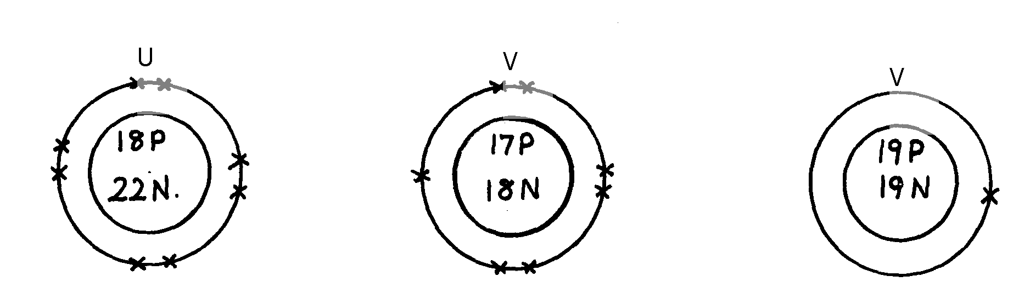
electrons in the outermost energy level are shown
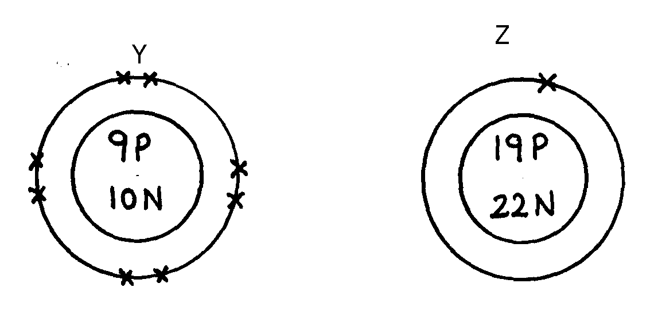
key
W
U
V
19P
20N
Z
Y
P = Proton
N = Neutron
X = Electron

(a) Identify the particle which is an anion
(b) Choose a pair of isotopes. Give a reason
13. The figure below shows two gases P and Q diffusing from two opposite ends 18 seconds after
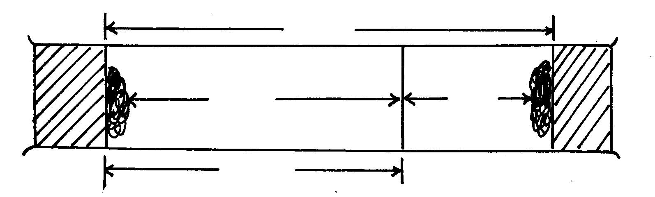
the experiment
72cm
P
Q
54cm

(a) Which of the gases has a lighter density?
(b) Given that the molecular mass of gas Q is 17, calculate the molecular mass of P

14. Identify the particles that facilitate the electric conductivity of the following substances
(i) Sodium metal
(ii) Sodium Chloride solution
(iii) Molten Lead Bromide
15. Gas B takes 110 seconds to diffuse through a porous pot, how long will it take for the
same amount of ammonia to diffuse under the same conditions of temperature and pressure?
(RMM of B = 34 RMM of ammonia = 17)
16. A gas occupies 5dm³ at a temperature of -27ºC and 1 atmosphere pressure. Calculate the
volume occupied by the gas at a pressure of 2 atmospheres and a temperature of 127ºC
17. A fixed mass of gas occupies 200 cm³ at a temperature of 23⁰c and a pressure of 740 mm Hg.
Calculate the volume of the gas at -25⁰c and 790 mm Hg pressure.

18. (a) State the Graham’s law
(b) 100cm³ of Carbon (IV) oxide gas diffused through a porous partition in 30seconds.
How long would it take 150cm³ of Nitrogen (IV) oxide to diffuse through the same
partition under the same conditions? (C = 12.0, N = 14.0, O = 16.0)

