**KENYA JUNIOR SCHOOL EDUCATION ASSESSMENT**

**KEJSEA 2025**

**GRADE 9**

**905/2- INTEGRATED SCIENCE (PRACTICAL)**

**Name: ______________________________________________________________________.**

**School: _____________________________________________________________________.**

**Signature: _______________________________ Date: _____________________________.**

**Duration:** 2 Hours  
**Total Marks:** 40

**FOR FACILITATORS USE ONLY**

|  |  |  |  |  |
| --- | --- | --- | --- | --- |
| SCORE RANGE | 30-40 | 20-29 | 11-19 | 0-10 |
| LEVEL | EXCEEDING EXPECTATION | MEETING EXPECTATION | APPROACHING EXPECTATION | BELOW EXPECTATION |
| LEARNER’S SCORE |  |  |  |  |
| TICK LEVEL |  |  |  |  |

**Instructions:**

1. Read all questions carefully before answering.
2. Write your answers in the spaces provided.
3. Use clear and neat handwriting.
4. You may use a calculator where necessary.
5. Answer all questions.

**General Tips**

* Always write your answers clearly. Even if you’re unsure, try to explain your thinking!
* Show your working for calculations—you can earn marks even if your final answer isn’t correct.
* Be creative and give examples where possible.

**TURN OVER**

**Questions**

1. **Experiment: Separating a Mixture of Sand and Salt** (20 Marks)  
   Describe the procedure you would follow to separate a mixture of sand and salt. Include materials and steps.

**_________________________________________________________________________________________________________________________________________________________________________________________________________________________________________________________________________________________________________________________________________________________________________________________________________________________________________________________________________________________________________________________________________________________________________**

1. The diagram below shows the water cycle representing various physical changes.

Label the following processes: (4 Marks)

* + Evaporation
  + Condensation
  + Precipitation
  + 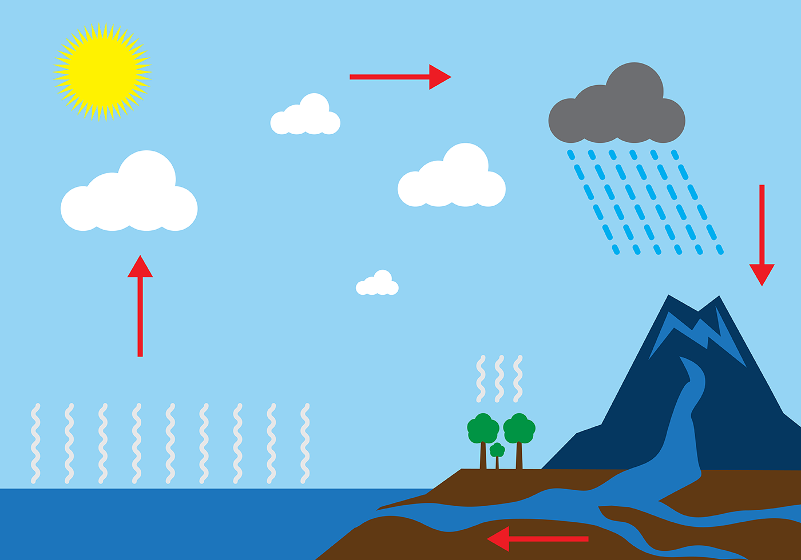Runoff

1. The teacher has provided you with a tomato plants that appears to have stunted growth and yellowing leaves. Using science knowledge:-  
   a) Identify two possible causes of the problem. (2 Marks)

______________________________________________________________________________________________________________________________________________________________  
b) Suggest two solutions to address the problem. (2 Marks)

______________________________________________________________________________________________________________________________________________________________

1. **Simple Machines** (10 Marks)  
   a) Draw and label a diagram of a lever. (5 Marks)

b) State two advantages of using simple machines in daily life. (2 Marks)

______________________________________________________________________________________________________________________________________________________________  
c) Give three example of a simple machine used at home. (3 Mark)

_______________________________________________________________________________ _____________________________________________________________________________________________________________________________________________________________

1. Test and classify the following specimens provided into acids, neutral or bases: (6 Marks)

|  |  |  |  |
| --- | --- | --- | --- |
| **Specimen** | **Base** | **Neutral** | **Acid** |
| **a) solution A** |  |  |  |
| **b) Solution B** |  |  |  |
| **c) Solution C** |  |  |  |

**THIS IS THE LAST PRINTED PAGE**

**Marking scheme Practical (40 Marks)**

**1. Experiment: Separating a Mixture of Sand and Salt (20 Marks)**

* **5 mark**: Materials required (e.g., beaker, water, filter paper, heating apparatus).
* **2 marks**: Add water to dissolve salt, leaving sand behind.
* **2 marks**: Filter the mixture to separate sand.
* **2 marks**: Collect filtrate (saltwater).
* **2 marks**: Evaporate water to retrieve salt.
* **2 marks**: Correct sequencing of steps.
* **5 marks**: if the learner has demonstrated using a drawing

**2. Physical changes (4 Marks)**

* **1 mark each**: Correct labeling of evaporation, condensation, precipitation, and runoff.

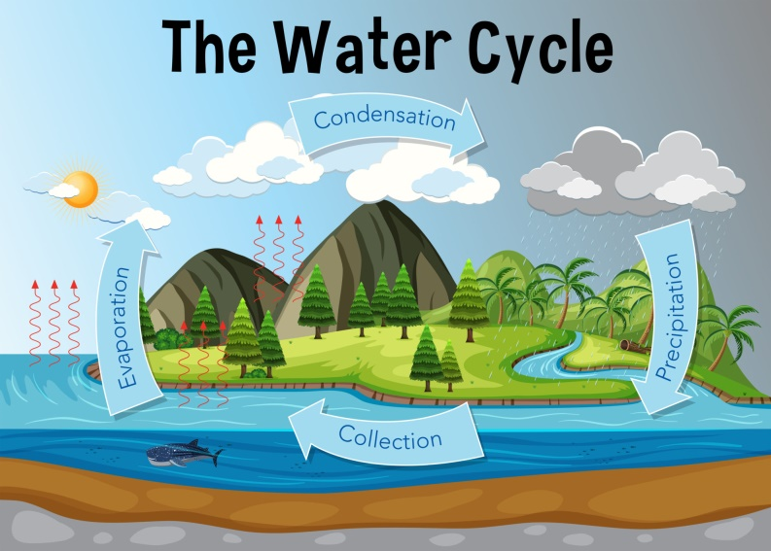

**3. a) Identify two possible causes of stunted growth and yellowing leaves in tomato plants. (2 Marks)**

* **1 mark each**: Examples include nitrogen deficiency, pest infestation.

b) Suggest two solutions to address the problem. (2 Marks)

* **1 mark each**: Applying fertilizers, using pesticides.

**4. Simple Machines (10 Marks)**

* a) Draw and label a diagram of a lever. (5 Marks)
  + **3 mark**: Correct diagram.

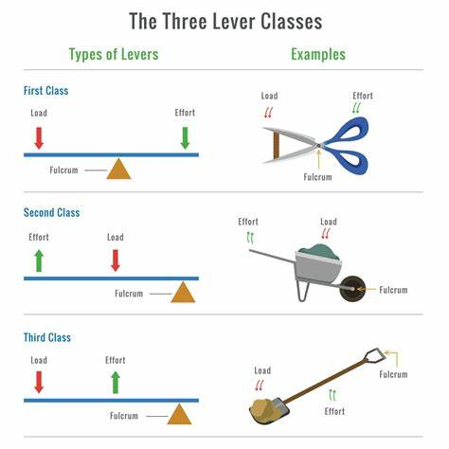

* + **2 marks**: Properly labeled fulcrum, load, and effort.
* b) State two advantages of using simple machines in daily life. (2 Marks)
  + **1 mark each**: Reduces effort, makes work easier.
* c) Give three example of a simple machine used at home. (3 Marks)
  + **3 marks**: Examples include scissors, wheelbarrow, pliers, spade, door hinge, secateurs, and stapler.etc

**5. ACID BASE AND NEUTRAL SUBSTANCES: (6 Marks)**

Provide the following in labeled beakers A,B, C(don’t write the name of the sample)

Provide litmus papers

A-Distilled Water-Neutral

B-Bleach Agent/Ammonia-Base

C-Lemon Juice/Vinegar-Acid

**INTEGRATED SCIENCE RUBRICS**

**Section A: Multiple Choice (20 Marks)**

* **1 mark**: Correct answer.
* **0 marks**: Incorrect or unanswered.

**Section B: Structured Questions (30 Marks)**

* Marks awarded based on clarity, accuracy, and relevance of the answers.

**Section C: Practical Application (30 Marks)**

* **6 marks**: For detailed, accurate procedures and explanations.
* **4 marks**: For diagrams and proper labeling.
* Emphasis on logical steps, critical thinking, and problem-solving.

| **Criteria** | **EXCEEDING EXPECTATION (4)** | **MEETING EXPECTATION**  **(3)** | **APPROACHING EXPECTATION (2)** | **BELOW EXPECTATION (1)** |
| --- | --- | --- | --- | --- |
| **Understanding of Concepts** | Demonstrates clear and thorough understanding of all concepts. | Good understanding, with minor inaccuracies. | Basic understanding with some key concepts missing. | Lacks understanding of key concepts or contains significant errors. |
| **Accuracy of Answers** | All answers are accurate and show clear reasoning. | Most answers are accurate with a few minor errors. | Several answers are inaccurate or lack necessary explanation. | Many answers are incorrect or incomplete. |
| **Application of Knowledge** | Effectively applies knowledge to solve problems and explain real-world examples. | Applies knowledge to solve problems with minor difficulty. | Struggles to apply knowledge to real-world scenarios or problems. | Does not apply knowledge effectively to problem-solving or examples. |
| **Clarity and Organization** | Answers are well-organized, clear, and easy to understand. | Answers are mostly clear and organized. | Answers are somewhat unclear or disorganized. | Answers are unclear or poorly organized. |
| **Creativity and Critical Thinking** | Shows original thinking and creativity in problem-solving. | Demonstrates critical thinking and some creativity. | Limited critical thinking or creativity. | Lacks critical thinking or creativity. |

**THEORY-60**

**PRACTICAL-40**

**Total: 100 Marks**

**THIS IS THE LAST PRINTED PAGE**