**COMPETENCE BASED CURRICULUM**

**SOCIAL STUDIES GRADE 4**

**ASSESSMENT ONE 2024**

**NAME: .**

**SCHOOL: .**

**GRADE 4: .**

**DATE: .**

**GENDER: BOY GIRL**

Answer **ALL** the questions in the spaces provided.

1. An instrument used to show direction is called

(2mrks)

1. The sun sets in the_

(1mk)

1. A high flat land is called a

(2mrks)

##### Study the diagram below and answer the questions (10marks)

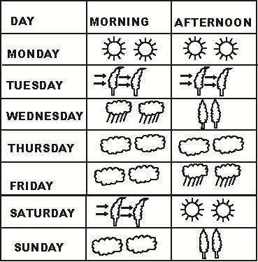

1. The above diagram is called a
2. Which day did the pupils wear gumboots in the morning?

6 The weather on Thursday was

1. Which day was sunny throughout?
2. The best day for winnowing was
3. A representation of a large area on a small flat surface is called

(1mark)

**10.** Name **two** social insects (4marks)

1. Identify and name any three physical features (6marks)
2. Your social studies teacher has asked you to draw a map. Name any three important elements that are supposed to be in your map (6marks)
3. Kenya is made up 47 counties. Name any 3 counties you know (6marks)
4. The head of a given country is called a

(1mk)

1. I live in county (1mk)
2. The green color found in the national flag represents (1mk)
3. People who kill our wild animals are called (1mk) 18.Draw a compass direction and show the 4 main cardinal points (8marks)

***RUBRICS (for official use)***

|  |  |  |  |  |
| --- | --- | --- | --- | --- |
| MARK SCORE RANGE | *Below 40* | *40-59* | *60-79* | *80-100* |
| PERFORMANCE LEVEL | *Below expectation* | *Approaching expectations* | *Meeting expectations* | *Exceeding expectations* |