**COMPETENCE BASED CURRICULUM**

**MATHEMATICS GRADE 4**

**ASSESSMENT ONE 2024**

**NAME: .**

**SCHOOL: .**

**GRADE 4: . DATE: . GENDER: BOY GIRL**

Work out **ALL** the questions in the spaces provided.

## Strand/ Sub-strand: Numbers, whole numbers, fractions, decimals

1. Calculate the total value of digit 4 in the abacus below.

## (1mark)

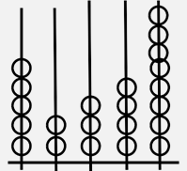

1. Write in symbols. **(1/2 mark)**

Two hundred and thirteen thousand four hundred and nine.

1. Find the next numbers in the sequence below. **(1/2mark)**

22, 29, 36, ,

1. Underline the correct pair of factors of 60. **(2marks)**

5 x 10 =60

6 x 10=60

12 x 5=60

4 x 15=60

1. Calculate the sum of the first 6 odd numbers.**(2marks)**
2. Find the difference and write your answer as a number.

## (1mark)

iv + vi =

1. Suleiman had sh.9480 in his wallet. He spent sh.4542 in buying food for family. How much money was he left with? **(1mark)**
2. Multiply 15 x 10 using repeated addition method. **(1mark**)
3. Zacheus was working out the table using his digital device. Circle the answers he got correct. **(2marks)**

|  |  |  |  |  |  |
| --- | --- | --- | --- | --- | --- |
| **X** | **10** | **20** | **30** | **40** | **50** |
| **11** | **100** | **210** | **330** | **410** | **150** |
| **12** | **130** | **240** | **320** | **280** | **500** |
| **13** | **103** | **263** | **190** | **470** | **650** |
| **14** | **144** | **240** | **320** | **560** | **400** |

1. Mwambi collected 93eggs. He shared these eggs equally among 5 children. **(2marks)**
   1. How many eggs did each child get?
   2. How many eggs remained?
2. A football team played t games. In each game played, it earned 3 points after winning. If it won all the t games and got 18 points, how many games did the team play? **(2marks)**
3. Fill in the box. **(1mark)**

÷ 7 = 3

1. Write the correct name of the parts of the fraction. **(1mark)**

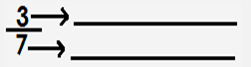

1. Convert 92/10 into an improper fraction. **(2marks)**
2. What fraction is un-shaded? **(2marks)**

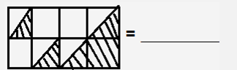

1. Shade ¼ of the balls. **(2marks)**



1. Work out the value of the space using repeated subtraction.

## (2marks)

x 8 = 72

1. Underline the correct answer which reduces by 10.

## (2marks)

**a.** 45, 40, 35, 30

**b.** 88, 78, 68, 58

**c.** 90, 70, 50, 30

**d.** 60, 50, 40, 30

1. A train took 4hour20minutes to travel from Nairobi to Makindu. It travelled again for 1hour 30minutes from Makindu to Voi. How long was the whole journey? **(1mark)**
2. Stella walk from home to school and back home from Monday to Friday. **(2marks)**

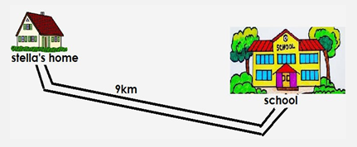

## Assessment Rubric

|  |  |  |  |
| --- | --- | --- | --- |
| **Exceeds**  **Expectαtion** | **Meets**  **Expectαtion** | **Αpproαching Expectαtion** | **Below**  **Expectαtion** |
| 27 - 30 | 21 - 26 | 15 - 20 | 0 - 14 |
|  |  |  |  |