**COMPETENCE BASED CURRICULUM**

**CREATIVE ARTS GRADE 4**

**ASSESSMENT ONE 2024**

**NAME: .**

**SCHOOL: .**

**GRADE 4: .**

**DATE: .**

**GENDER: BOY GIRL**

Answer **ALL** the questions in the spaces provided.

1. **Name the colors of the following things** (5 marks) Grass

Sky

Soil

Milk

Hair

1. Name three tools that you can use to draw (3marks)
2. Drawing an arrangement of non living things is called still life drawing. Give 4 examples of still life objects (4 marks)
3. Draw a human face from memory and smudge it neatly (3marks)
4. Name the first three colors of the national flag starting from the top (3marks)
5. Write down stanza 3 of the national anthem in English (2marks)
6. **Match the following musical instruments with their method of playing** (4 marks)

Guitar blowing

Drum shaking

Kayamba plucking

Whistle hitting

1. Name the following pictures (4 marks)

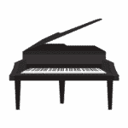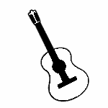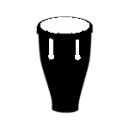

1. Name four ways you can play using a ball (4marks)
2. Name three play items used in your school (3marks)
3. You have been told by your P.E teacher to make a ball at home. Name three materials that you can use to make your own ball (3 marks)
4. Name two parts of your body that can be used to play a ball (2marks)

***RUBRICS (for official use)***

|  |  |  |  |  |
| --- | --- | --- | --- | --- |
| MARK SCORE RANGE | *Below 40* | *40-59* | *60-79* | *80-100* |
| PERFORMANCE LEVEL | *Below expectation* | *Approaching expectations* | *Meeting expectations* | *Exceeding expectations* |