COMPETENCE BASED CURRICULUM

AGRICULTURE GRADE 4

ASSESSMENT ONE 2024

NAME: . SCHOOL: .
GRADE 4: . DATE: . GENDER: BOY GIRL

Answer ALL the questions in the spaces provided.

Particles | Soil
Small particles
Medium particles
Large particles

Strand/ Substrand: Conserving our environment (soil) Task 1
- Grade 4 pupils collected different samples of soils. They used a sieve to investigate whether the soil samples pass the sieve equally. From their observation made complete the table below.

( /3marks)
- Look at the photographs below.
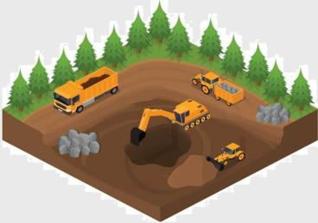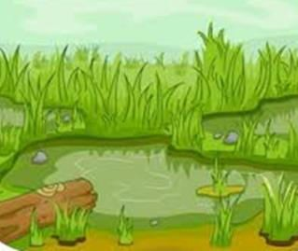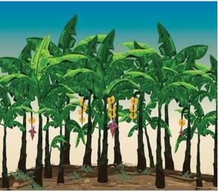

1 2 3
3. Which soil is likely to be found at photograph.
1
2
3

( /3marks)
- Mwangi set up the experiment below.
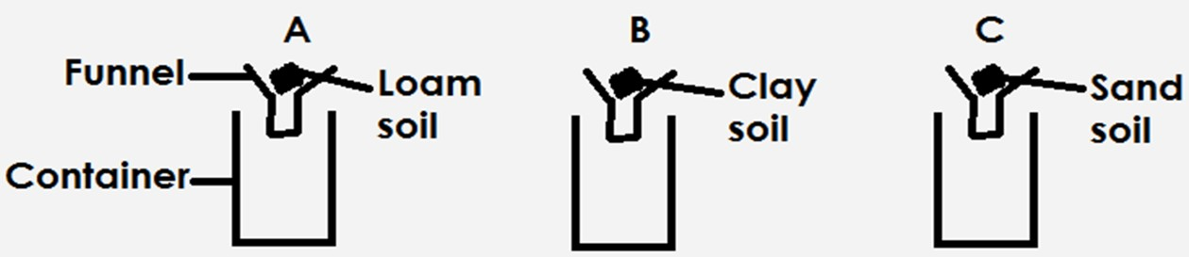

He poured a cupful of water into the containers.

From his findings.
- Which soil allowed most water to pass through
.
- Which soil retained most water? .

- Which soil allowed a little water to pass through it?
.
- What was he investigating? .

( /4marks)
Task 2
- Name two physical properties of soil.
    - .
    - .
- The roughness or smoothness of soil is called
.
- Which soil is best in rice farming? .
- Name four materials used to make compost manure by heap method.
    - .
    - .
    - .
    - .
- What is compost manure?

__________________________________________________________________________________________________________________ .
- ____________soil is the best for farming many types of crops.

( /10marks)

Task 3
- Draw and label a compost heap.

( /7marks)
- Write down the importance of compost manure in farming.
    - .
    - .
    - .

( /3marks)

Strand/Sub-strand: Healthy practices, Healthy living Task 1
- What do we need to grow healthy?
- .
- .
- .
- .
(__/2marks)

- Write down two qualities of a good play.
- .
- .
(__/2marks)
- You want to make a play item, list down materials needed and procedure on how to make the item.
Item to make (__/1mark)

Materials needed • .
• .
• .
• . (__/2marks)

- Write down four materials of cleaning the home.
1. . 2. . 3. . 4. .
(__/4marks)
- How do we clean earthen flour rooms.
Step i. . Step ii. . Step iii. .
(__/3marks)
- Grade four pupils of Kibiro Primary School were asked by their teacher to state ways of caring for materials for cleaning homes.
Write down what you think the pupils answers were.
  - .
  - .
  - .
(__/3marks)

 | 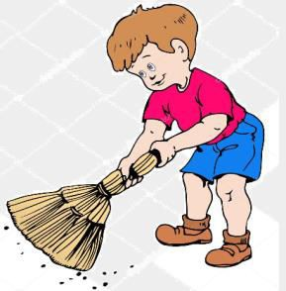 | 18. Which materials in our locality can we use to make cleaning materials?  a. b.  c. d.
(__/2marks)

Assessment Rubric

Exceeds  Expectαtion | Meets  Expectαtion | Αpproαching Expectαtion | Below  Expectαtion
45-50 | 35-44 | 21-34 | 1-20

