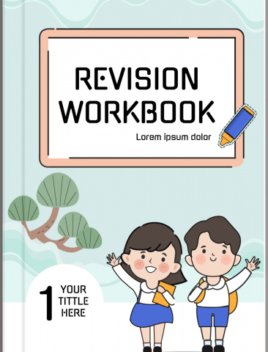
G3

CRE

Strand 1: CREATION

Answer all the questions

- List the good any bad feelings in the table below good feelings Bad feelings
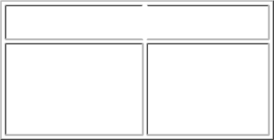

a)

b)

c)

a)

b)

c)

2. | We are created in the image anc likeness of ...............................................
3. | Every part of our ............................................... | was created by God.
4. | God created all human beings ............................................... | and female.
5. | We should have ............................................... | thoughts for others. (good, bad)
6. | We should ............................................... | God for being our Creator. (hate, thank)
7. | Stealing peoples things is a bad behavior | ...............................................(false, true)
8. | God wants us to make the ............................................... | choice. (wrong, right)
9. | Is helping our siblings a good choice?............................................... | (yes, no)
- Write two things that make God happy a. ...............................................

 | b. ...............................................
11. | Cousins, aunts and uncles are members of the ............................................... |  | family (single, extended)
12. | We should............................................... | members of our family. (love, hate)
13. | There should be............................................... | among siblings. (unity, dislike)
14. | We should visit our family in the rural area during the holidays............................................... |  | (correct,
 | incorrect)
15. | Look for members of the family in the word search below
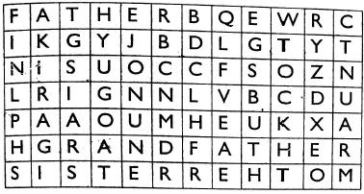

16. You call the sister of your father ...............................................

17. Name two members of the nuclear family

a. ...............................................

b. ...............................................

18. Look at the pictures below. Say whether they show sad or happy faces

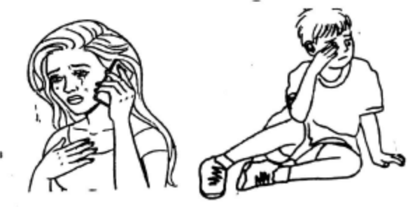

19. | God created the............................................... | on the second day.
20. | Our first parents were Adam and ...............................................
21. | Our first parents ............................................... | God when they ate the forbidden fruit (obeyed, disobeyed)
22. | Whenever we do not follow the instructions given by God we get ............................................... |  | (punished,
 | beaten)
23. | The first man to be created by God was ............................................... | (Noah, Adam)
24. | God created man from ............................................... | (bone, soil)
25. | In school we should obey our ...............................................
26. | Eve was created from the man's ............................................... | (flesh, rib)
- Adam and Eve lived in the garden of ...............................................

- Match the family relations in A with the ones in B
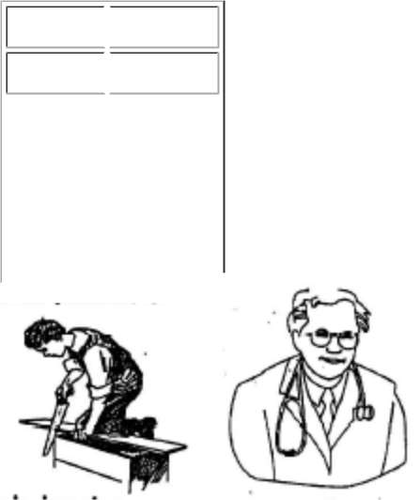

- B
Samuel Jesse

 |  | Isaac |  | Noah
 |  | David |  | Jacob
 |  | Rueben |  | Elikanah
 |  | Ham |  | Abraham
 |  |  |  |  |  |  | Coulor the correct picture.
29. Joseph the father of Jesus was a ................................................ |  |  |  |  |  |  | Coulor the correct picture.
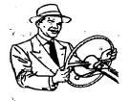

30. | Joseph had a ............................................... |  | of many colours (shirt, coat)
Strand 2: The Holy Bible
1. | Those who wrote the Bible were guided by |  | ............................................... | (a star, God)
2. | The first four books in the New Testament are called ............................................... |  |  | (Gospels, law books)
3. | The Old Testament has ............................................... |  |  | books (27, 39)
4. | The Bible is a book for all................................................ |  |  | (Christians, Hindus)
5. | The New Testament has............................................... |  |  | books (27, 30)
6. | The Bible should ............................................... |  | us through our lives (guide, misguide)
7. | The gospel books teach us about............................................... |  |  | (Jesus Christ, Luke)
8. | The Bible is divided into............................................... |  |  | parts. (2, 3)
9. | The second book of the Bible is............................................... |  |  | (Exodus, matthew)
10. | The last book of the Bible is............................................... |  |  | (Revelation, Genesis)
11. | Colour the picture below

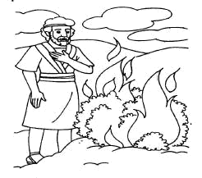

12. |  | Abraham, Isaac and Jacob were the............................................... |  |  |  | Israelites. (fathers, forefathers)
13. |  | Moses covered his............................................... |  | because he did not want to see God. (head, eyes)
14. |  | God told Moses he was standing on............................................... |  |  |  | ground.
15. |  | Moses saw the burning bush at Mount............................................... |  |  |  | (Kenya, Sinai)
16. |  | Draw and colour a big fish
17. | Jonah went to............................................... |  | instead of going to Nineveh (Joppa, Jerusalem)
18. | God is............................................... |  | with us when we disobey him. (happy, unhappy)
19. | The people of Nineve were............................................... |  | (evil, good)
20. | Jonah stayed inside the fish for............................................... |  | days. (4, 3)
21. | Naaman was a............................................... |  | soldier (Egyptian, Syrian)
22. | Naaman suffered from a............................................... |  | disease (skin, teeth)
23. | A little............................................... |  | girl said Naaman would be healed by a prophet. (Israelite, Phillistine)
24. | Naaman washed himself in R................................................ |  | (Tigris, Jordan)
25. | King ............................................... |  | ordered people to worship an idol (David, Nebuchadnezzar)
- Name the three man who refused to worship idols a. ...............................................

 | b. ...............................................
 | c. ...............................................
27. | Elisha was a............................................... |  | (king, prophet)
28. | Elisha cursed ............................................... |  | boys (45, 42)
29. | The fourth man in the fire where the three Hebrew boys were put looked like |  |  | ...............................................
 | (an angel, God)
30. | Who among the following people obeyed God? ............................................... |  |  | (Adam, Moses)
Stand 3: The Early life of Jesus Christ
1. | The wisemen were guided by the............................................... |  | (star, sun)
2. | ...............................................was the king when Jesus was born. (Solomon, Herod)
3. | After birth Jesus was laid in a............................................... |  | (bed, manger)
4. | The wisemen came from the............................................... |  | (east, west)
5. | Jesus was born in ............................................... |  | (Nazareth, Bethlehem)

6. | We read about the birth of Jesus in the | ............................................... | (New testament, Old testament)
7. | ............................................... and ............................................... |  | were the parents of Jesus
8. | Jesus and his parents lived in ............................................... |  | (Nazareth, Bethlehem)
9. | Jesus grew up and became ............................................... |  | (weak, strong)
10. | Jesus Christ was full of ............................................... |  | (wisdom, dishonesty)
11. | We should be ............................................... | of our home. (proud, sad)
12. | God's blessings were upon Jesus ............................................... |  | (true, false)
13. | The town of Nazareth was in ............................................... |  | (Galilee, Judea)
14. | The parents of Jesus ............................................... |  | the law of God (obeyed, disobeyed).
15. | The injured man was going to ............................................... |  | (Jerusalem, Jericho)
16. | The Good Samaritan took the injured man to a ............................................... |  | (hospital, hotel)
- Who did not behave like a neighbour to the injured man in the story of the Good Samaritan

............................................... (priest, Samaritan)

18. | We should be ............................................... |  |  | to the needy. (kind, unkind)
19. | Lake Galilee was also called Lake ............................................... |  |  | (Victoria, Tiberias)
20. | A large crowd followed Jesus because they saw him perform ............................................... |  |  |  | (magic,
 | miracles)
21. | Jesus asked ............................................... |  |  | where they would buy food to feed the people (Andrew, phillip)
22. | ............................................... |  | was the brother of Simon Peter. (Andrew, Phillip)
23. | Jesus fed ............................................... |  |  | people. (5000, 3000)
24. | After feeding the people they collected ............................................... |  |  |  | baskets of left overs (10, 12)
25. | We should keep the environment ............................................... |  |  | (dirty, clean)
26. | The little boy had ............................................... |  |  | loaves of bread and ............................................... | fish.
27. | ............................................... sank in water because of lack of faith. (Peter, John)
28. | Jesus went up a hill alone to ............................................... |  |  | (rest, Pray)
29. | Jesus Christ walked on ...............................................
30. | The disciples were afraid because they thought that Jesus was a ............................................... |  |  |  | (demon,
 | ghost)
Strand 4: Christian Values
1. | ............................................... is telling the truth (honesty, dishonesty)
2. | The story of Anannias teaches us to be ............................................... |  |  |  | (kind, truthful)
3. | Annanias lied to ............................................... |  |  | (Jesus, Holy Spirit)
4. | Annanias had a wife called ............................................... |  |  | (Saphira, Sarah)
5. | Annanias body was buried by same ............................................... |  |  | (young men, old men)
6. | ............................................... told Annanias that he had lied to God. (Peter, Paul)
7. | Annanias ............................................... |  | with his wife to hide some of the money. (disagreed, agreed)
8. | We thank God through ............................................... |  |  | (praising, playing)
9. | We should thank God because His love lasts ............................................... |  |  |  | (sometime, forever)
10. | We should thank God for creating our enemies ............................................... |  |  |  | (true, false)
11. | Jesus told Peter he should forgive ............................................... |  |  | times
12. | The King ............................................... |  | the servant who owed him a lot of money. (forgave, punished)
13. | The person who could not pay the servant was put in ............................................... |  |  |  | (a sack, jail)
14. | When we wrong others we should ask for |  |  | ...............................................
15. | You cannot ............................................... |  |  | a person who talks bad about others. (forgive, trust)
16. | When we talk about others God is happy |  |  | ............................................... | (true, false)
17. | We should always trust in ............................................... |  |  | (God, Satan)
18. | A stranger is someone we ...............................................
19. | To have a duty to do something is called |  |  | ............................................... | (irresponsibility, responsibility)
20. | We should clean every part of our body ............................................... |  |  |  | (true, false)

Read this story

Two pupils in grade 3 are unhappy with one another. Peter took Kamene's pen. Kamene refused to forgive him because he had not asked for it. Peter said he was sorry but Kamene refused to listen to him. They are no longer speaking to each other
21. Peter asked for ............................................... (forgiveness, wisdom)

- What did Kamene do to Peter? ...............................................

- This story teaches teaches us to ...............................................

- Name two Christian values

  - ...............................................

  - ...............................................

25. | We thank God through ............................................... | (fighting, praying)
26. | We should not forgive those who wrong us. ............................................... | (correct, incorrect)
- We should not expect P__YM_NT when we do work at home

- We should think about other people's INT_R_ST

29. | We should trust all the people with our secrets ............................................... | (yes, no)
30. | The King put the unforgiving servant in a cave until he paid his money ............................................... | (true,
 | false)

STRAND 5: THE CHURCH

This is the Lord's Prayer. Fill the gaps

Our Father in___1___ may Your ___2___name be honoured. May Your__3__come. May Your __4__ be done on __5__ as it is in heaven. Give us today our daily __6__ and forgive us our __7___ as we forgive those who lead us not int__9___but_ _10__ us from ___11___

12. | We should say the Lord's prayer ............................................... | (always, sometimes)
13. | Jesus Christ showed His ............................................... | how to pray. (disciples, parents)
14. | We should say the Lord's prayer ............................................... | (in the church, anywhere)
15. | The disciples were told not leave ............................................... | until they receive the Holy Spirit (Jerusalem,
 | Bethel)
16. | Jesus promised His disciples ............................................... | (a gift, The Holy Spirit)
17. | The disciples spoke in ............................................... | (Hebrew, other languages)
18. | The Holy Spirit came in form of a strong ............................................... | (force, wind)
- Write down three fruits of the Holy Spirit a. ...............................................

b. ...............................................

 | c. ...............................................
20. | When the Holy Spirit came the followers of Jesus saw tongues of ............................................... |  | (smoke, fire)
21. | The............................................... | of God is a light for my path. (word. angel)
22. | We should ............................................... | the Bible everyday so that it can guide us. (carry, read)
23. | Jesus raised the daughter of ............................................... | (Jairus, Martha)
24. | We should show ............................................... | to God during prayer (Disrespect, respect)
25. | Prayer is a way of ............................................... | with God (communicating, working)
26. | The prayer that Jesus taught His disciples is called the ............................................... |  | prayer (our Father,
 | Lord's)
27. | When praying we should ask God not to bring us to ............................................... |  | testing. (hard, big)
28. | We ask God to give us our daily ............................................... | (jobs, bread)
29. | The Holy Spirit is our............................................... | (helper, friend)
- Draw a tree on the following fruits of the Holy Spirit

Love Joy Peace Patience

QUESTIONS

Activities at home and at school

1. What are they doing?
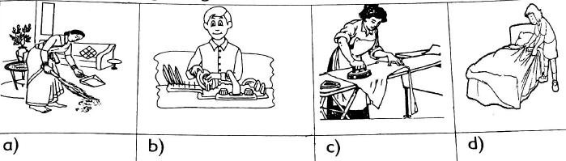

Use have or has to complete the sentences
2. | I ........................... | been a way from school.
3. | You ........................... | asked me this question many times.
4. | She ........................... | written a letter to me.
5. | They ........................... | lot of fun during music lessons.
6. | John ........................... | some boys to play with.
Write two words using these blends
7. | bl ........................... | ...........................
8. | sh ........................... | ...........................
9. | fl ........................... | ...........................
10. | gr ........................... | ...........................

Sharing duties and responsibilities
Use (nobody, anybody, somebody or everybody)
Zipa was lonely. ...........1................ | was at home. She had |  |  | .............. | 2............. | to talk to. Then .............. | 3.............
knocked on the door. She did not know who it was. It could be ........... |  |  |  |  | 4................ | She went to open the door. It was
her friend Sam. Zipa was happy. She had .............. |  |  | 5............. | to talk to.

Construct sentences using the following indefinite pronouns

- Anybody ...........................

- Everything ...........................

- Someone ...........................

- Nobody ...........................
Environment

Match the words with the pictures
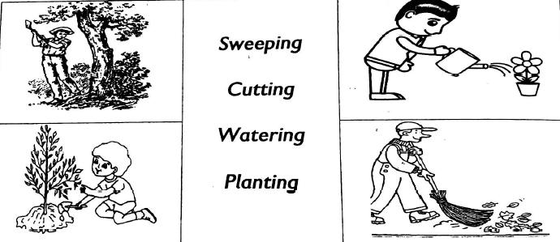

Punctuate these sentences correctly

- chacha, it is good you have learnt your lesson

- sifa will sweep the compound

- i will need somebody to help me

- will you help me, mercy

Complete using words in the bracket

5. | I saw two | ........................... | (mice, mouse) in our house yesterday.
6. | Many ........................... | (child, children) forget to brush their teeth.
7. | A ........................... | (geese, goose) has a beak.
8. | My ........................... | (tooth, teeth) are white in colour.
9. | I saw a woman carrying a ........................... |  | (children, child) on her back.
10. | The ........................... | (woman, women) are sweeping.
11. | His ........................... | (tooth, teeth) are paining.

Match the following children rights with the pictures
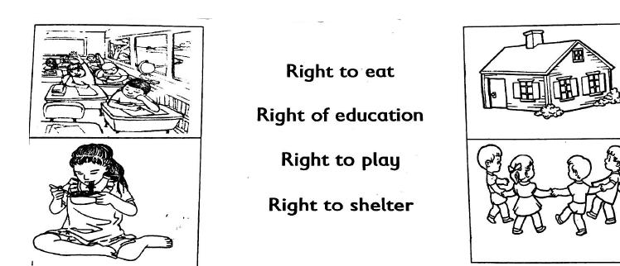
Read the passage below

Unhappy children

Martin and Monica are orphans. They live with their aunt. They don't go to school like other children. Every morning they wake up to go and look for work. Sometimes they pick coffee in a big plantation. They put small red coffee berries in two big baskets and take them to the factory. Other times, they pick green tea leaves and put them in a big white sack before taking them to the factory. Martin and Monica are always sad. They hope someone will help them one day.

Answer these questions

- Why don't Martin and Monica go to school?

- What work do Martin anad Monica do? ......................................................

3. Is it right for small children to work in plantations? ........................... Why? ...........................

- Where are Martin and Monica's parents? ...........................

- What would you do if you were Martin and Monica? ...........................
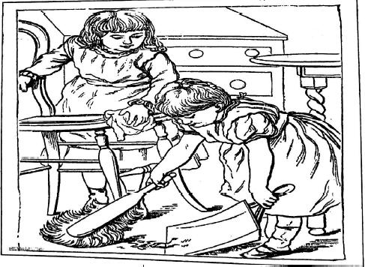

Look at the picture. Use the words in the box to complete the story.

Rescued, Needs, School, Parents, Labour

Amondi was an orphan. Her |  |  |  | ............6............... |  | died when she was a little girl. Her aunt took her to the city to work
as a house help. Amondi did not get her basic ........... |  |  |  |  |  | 7................ | She also did not go to ............. | 8.............. | One day
police officers came and |  |  | ...................................................... |  |  |  | her. The people who employed Amondi were arrested
for child .......... |  | 10.................
Occupation
Fill in the blanks with will or shall
1. | I ........................... |  | never go there again.
2. | We ........................... |  |  | come tomorrow for the party.
3. | ........................... |  | you send me the ball please?
4. | Tom ........................... |  |  | graduate next Saturday.
5. | I ........................... |  | become a doctor.
6. | They ........................... |  |  | have a good time together.
7. | ........................... |  | we go somewhere else?

Name the people in the pictures
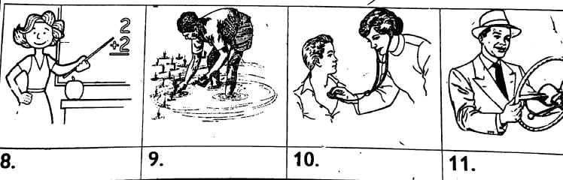

Match the person with the occupation

12. | A driver will | treat
13. | A pupil will | sell
14. | A shopkeeper will | drive
15. | A doctor | read

Technology

Write two words which begin with each sound

1. | Sh ........................... | ........................... ...........................
2. | Tw ........................... | ........................... ...........................
3. | Pl ........................... | ........................... ...........................

Match the parts of computer with its work
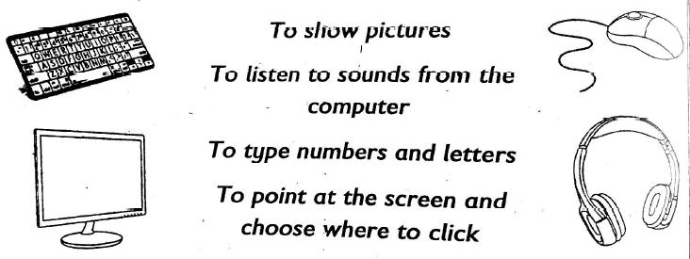

Make two sentences using shall

...................................................................................................................

...................................................................................................................

Make two sentences using will

...................................................................................................................

...................................................................................................................

Safety

Match the words with its opposite
1. | Top | thick
2. | Big | empty
3. | Full | bottom
4. | Long | small
5. | Thin | short
Use the opposites of the words in the boxes to fill in the blanks
6. | We must keep the floor ........................................... |  | to avoid accidents. (wet)
7. | ........................................... | tea can burn your mouth. (cold)
8. | You should be ........................................... |  | when crossing the road. (careless)
9. | ........................................... | hands help to prevent diseases. (dirty)
10. | We used the ........................................... |  | rope to skip. (short)
11. | The cup was ........................................... |  | table. (under)

Copy and read the sentences

- I must be careful when using the road ...........................................

- Always cross the road at the zebra crossing. ...........................................

- Do not play near the road. ...........................................

- Do not talk on the phone while crossing the road. ...........................................

Wild animals

Name these animals
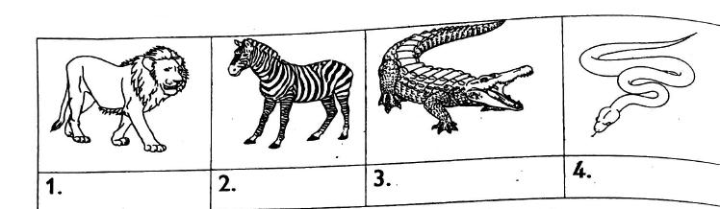

Rearrange the words to form correct sentences

- animals stop wild killing ...........................................

- wolf shephered a the saw ...........................................

- milk the shelf split on she ...........................................

- bush a jumped the over monkey ...........................................

Choose the correct word to fill in the blanks

9. | There is a frog ........................................... | the river (by, through)
10. | The hare jumped ........................................... | the bushed (at, over)
11. | A mouse ran ........................................... | the room (across, on)
12. | Jumba sat ........................................... | the guest (beside, on)
13. | He threw a ball ........................................... | me (across, at)
14. | The dog is ........................................... | the kennel (inside, over)

Saving

Use the words in the box to complete the questions

1. ........................................... | do you come home from school?
2. ........................................... | do you save water?
3. ........................................... | are you doing?

4. ........................................... | pencil is this?
5. ........................................... | is the baby crying?
6. ........................................... | left some food on the plate?
7. ........................................... | do you travel to school?

 | what | who | whose why when how
Match the words with the meaning
8. |  | waste | as much as you need
9. |  | Enough | use carelessly
10. |  | Save | what should be done
11. |  | Rules | use carefully

Underline the nouns in the following sentences

- The dirty man has a louse on his shirt.

- A goose is a bird.

- The woman is feeding an ox.

- He came to school on foot.

- That person ooks familiar.

Use the words in the box to fill in the blanks

17. | She wore a ........................................... |  | dress to the party.
18. | Kipoto has a ........................................... |  | sister.
19. | The sweater will .................. | d | ......................... if you hang it in the sunlight.
20. | The baby has ........................................... |  | skin.

 | soft | pink shrink twin
Festival
Fill in the gaps
1. |  | A banana is ........................................... |  |  |  | in colour.
2. |  | An exercise book is ........................................... |  |  |  | in shape.
3. |  | I have ........................................... |  |  |  | fingers.
4. |  | I have ........................................... |  |  |  | nose.
5. |  | Our school sweater is ........................................... |  |  |  | in colour.

Write the sentences correctly

- ten fingers i have ...........................................

- in the house mary was ...........................................

- food eating i was ...........................................

- doing mom what was ...........................................

Read the story and answer the questions

The hungry hyena ran very fast and caught a fat sheep. Mr. Musa was very unhappy. He shouted loudly but the hyena had gone into the forest.

- Who was hungry? ...........................................

- What is the opposite of the word fat? ...........................................

- Who shouted loudly? ...........................................

- Musa was very ...........................................

14. ........................................... had gone into the forest.

Playtime and sport

Use the correct form of the words in the boxes to complete the sentences
1. | The trophy is ........................................... |  |  | tan a whistle (heavy)
2. | Of the three teams, our team had the |  |  | ........................................... runner. (fast)
3. | February is the ........................................... |  |  | month of the year. (short)
4. | The ........................................... |  | animal we saw in the park was a giraffe. (tall)
5. | An ant is ........................................... |  |  | than a bee(small)
6. | A ruler is ........................................... |  |  | than a pencil (long)
Use "because", "and" or "but"
7. | Food makes our bodies strong |  | ........................................... | healthy.
8. | She opened the umbrella ........................................... |  |  | it was raining.
9. | The baby can crawl ........................................... |  |  | she cannot run.
10. | The weather was sunny ........................................... |  |  | windy.
11. | He is sad ........................................... |  |  | he has stomach pain.
12. | Sweets are bad for your teeth |  | ........................................... | milk is good.
13. | Her mother bought meat ........................................... |  |  | vegetables.
14. | He went to the dentist ........................................... |  |  | her tooth was paining.

Literacy

Match the words which have similar sounds

1. | Bin | gun
2. | Jug | sat
3. | Dog | pin
4. | Sun | dug
5. | Mat | log

Write the underlined words correctly to make sensible sentences

- My mother is a usenr ...........................................

- She is a atchere ...........................................

- We love sitorsvi ...........................................

- We bought a new stedur ...........................................

Write 5 sentences about my home

....................................................................................................................................................................................................

....................................................................................................................................................................................................

....................................................................................................................................................................................................

....................................................................................................................................................................................................

....................................................................................................................................................................................................

....................................................................................................................................................................................................

Read the passage and answer questions

Tina is in the toyshop. She wants a new toy. Her doll is old and broken. There are very many pretty dolls. Some are small and some are big. Tina wants a big doll. It is very expensive. Tina is sad. She cannot have her new doll.

Answer the following questions

- Who is in the toy shop? ...........................................

- What does she want to do in the shop? ...........................................

- How many dolls are in the shop? ...........................................

- Why is Tina sad? ...........................................
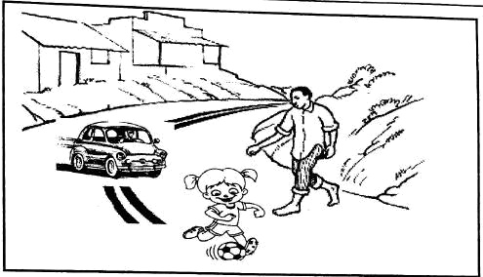

Write five sentences about the picture above

1. ...........................................

2. ...........................................

3. ...........................................

4. ...........................................

5. ...........................................

Name these pictures
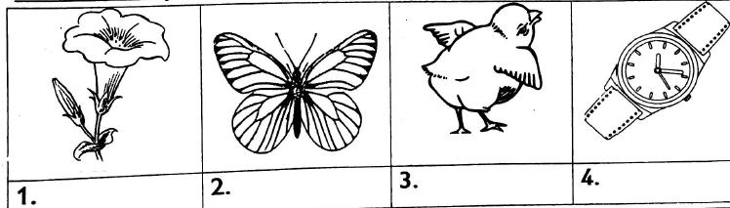

Circle the odd one out
1. | short | cards |  | blouse | dress | shirt
2. | forest | shrubs |  | river | trees | rubbish
3. | abuse | food |  | shelter | rest | education
4. | plaiting | milking |  | digging | farmer | sweeping
5. | tablet | computer |  | mobile phone | laptop | handbag

Look for seven words with the sounds below in the puzzle.

Circle them then write them down.
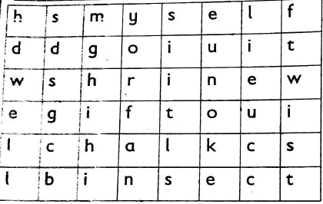

- tw ...........................................

- dw ...........................................

- ft ...........................................

- lf ...........................................

- shr ...........................................

- ct ...........................................

- lk ...........................................

Rearrange the words to make correct sentences

- Zack a card sent me to ...........................................

- Tank stored a in water we ...........................................

- Library to the read i went to a book ...........................................

- The made of house is bricks ...........................................

- Broke the who jar? ...........................................

- She school to went yesterday ...........................................

Use and or as to complete these sentences

- I have three green books. I have two red books.

- The teacher sat at the table. The teacher marked our books.

- We played football. They played netball

Rearrange the sentences to make a story

- Later in the afternoon, she walked to the beach with her cousins

- In the morning, they went to the stadium

- For lunch. Stella celebrated the Jamhuri holiday with her family

- Stella like the Jamhuri celebrations and the speeches.

- They had gone to Mombasa for the December holiday

....................................................................................................................................................................................................

....................................................................................................................................................................................................

....................................................................................................................................................................................................

....................................................................................................................................................................................................

....................................................................................................................................................................................................

....................................................................................................................................................................................................

....................................................................................................................................................................................................
....................................................................................................................................................................................................

....................................................................................................................................................................................................

....................................................................................................................................................................................................

....................................................................................................................................................................................................

....................................................................................................................................................................................................

Punctuate these sentences

- my name is caleb

...........................................................................................................................................

- yesterday i bought oranges bananas and mangoes

...........................................................................................................................................

- which day comes after wednesday

...........................................................................................................................................

- i went to visit my aunt in mombasa

...........................................................................................................................................

- my school is in dundora estate

...........................................................................................................................................

Write the past tense of these words

- Swim

- Clap ...........................................

- Sing ...........................................

- Stop ...........................................

- Rub ...........................................

- Keep ...........................................

- Learn ...........................................

- Dive ...........................................

- Sleep ...........................................

- Walk ......................................................................................

Add-ing

- write ...........................................

- Sing ...........................................

- Drive ...........................................

- Jump ...........................................

- Swim ...........................................

- Sleep ...........................................

- Watch ...........................................

- Clap ...........................................

- Dire ...........................................

- Hide ...........................................

ENVIRONMENTAL

Strand 1 Healthy practice

Sub strand 1.1 Health habits

1. Name below healthy habits.
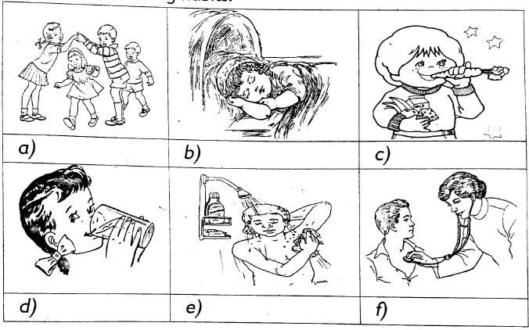

2. | Children your age should sleep for .............................................. | hours, (6,8)
3. | We should eat .............................................. | meals in a day, (2,3,1)
4. | Dirty feet can be c home for .............................................. | (lice, jiggers)
5. | Wearing clean clothes prevents us from .............................................. | (parasites, thirst)
6. | Health habits prevents our bodies from .............................................. | (growing, sickness)
7. | Which one of these foods should be washed thoroughly before eating .............................................. |  | (mango,
 | ugaii, chapatti)

Sub strand 11.2 Oral Hgqiene

- .............................................. foods are good for our teeth. (hard, soft weaith)

- Name two types of food that can make our teeth strong

  - ..............................................

  - ..............................................

3. | You should brush sour teeth .............................................. | in a day. (3,2,1)
4. | ..............................................are small holes found in teeth. (cavities, saves)
5. | We should not take too hot or too cold .............................................. | (food. drinks)

Write true or false
- Holes on our teeth are called cavities..............................................

- A Doctor who treats our teeth is called an optician ..............................................

- Babies are born with teeth. ..............................................

- Sugary foods are good for our teeth ..............................................

- Bad breath is as a result of not cleaning our teeth regularly ..............................................

- Name the tooth problem shown below
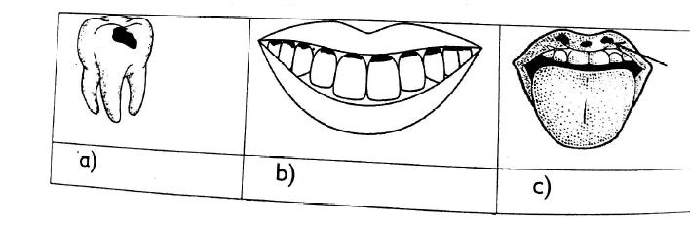

12. | Which one of these materials is not required when brushing teeth?
 | .............................................. |  | (toothpaste, toothbrush. soap)
13. | We should avoid .............................................. |  | foods because they spoil our teeth. (sugary, salty, soft)
14. | When brushng teeth, we can use a |  | .............................................. if we do not have a toothbrush. (spoon,
 | chewed stick, pencil)
Sub strand 1.3 Cleaning classroom
1. | Match the items with their uses
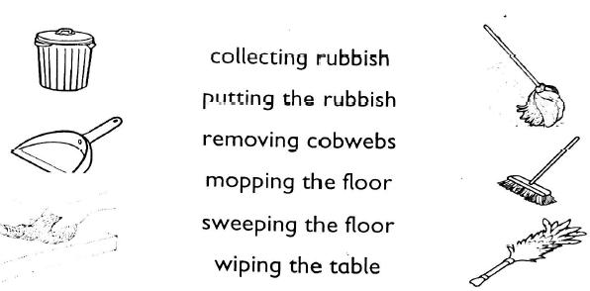

- Write two reasons for cleaning a classroom a. ..............................................
b. ..............................................

- We arrange our classroom to avoid ..............................................

4. | We can use small pieces of | .............................................. to scrub a Sufuria and make it clean. (papers,
 | charcoal, metal)
5. | We should sprinkle little .............................................. | on the floor before sweeping to make the dust settle.
 | (ash, water, salt)

Sub strand 1.4 Use of improvised materials

- Name three items we can use to clean utensils a. ..............................................
b. ..............................................

c. ..............................................

- The major types of dirt found on utensils are a. ..............................................

 | b. ..............................................
 | c. ..............................................
3. | Ash can be used to .............................................. | utensils (rinse, scrub)
4. | A piece of cloth can be used to .............................................. |  | utensils (wash, dry)
5. | Sisal Fibre can be used as .............................................. |  | (soap, sponge)
6. | Oily utensils should be washed in .............................................. |  | and .............................................. | water.
7. | Which one of the following materials can be used to clean greasy utensils? ..............................................
 | (wood ash, son, cow dung)
8. | Which one is not an improvised scrubbing .............................................. |  | (sand, charcoal, eggshells, sponge)
Sub strand 1.5 Proper use and storage of medicine
1. | Name three types of medicine
 | a. ..............................................
 | b. ..............................................
 | c. ..............................................
2. | The medicines applied on the skin are called ..............................................
3. | The instruction's given by a doctor on how to take medicine is called the ..............................................
 | (dosage, prescription)
4. | When we fall sick we go to ..............................................
5. | Name these types of medicine
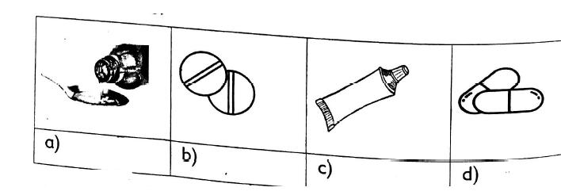

6. | Interpret the following instructions on dosage; 1 x 3, Before meals |  |  |  |  |  | ..............................................
7. | Medicine should be kept out of reach of .............................................. |  |  |  |  |  | (children, doctor)
8. | The types of medicine that are swallowed or drunk are called ..............................................
Sub strand 1.6 Making water safe for drinking
1. | Draw and colour three containers you use to store water at home

2. We fitter water to remove .............................................. and ..............................................

- Name three ways people make water dirty a. ..............................................
b. ..............................................

c. ..............................................

- Clean water is not safe for drinking It may contain

- We make water safe for drinking by ..............................................

- Why do we boil water ..............................................

- Is boiled water safe for someone to drink ..............................................

- Water that contain impurities is said to be ............................................................................................

Sub strand 1.7 Kitchen garden

- Nome four crops we can grow in the kitchen garden a. ..............................................
b. ..............................................

c. ..............................................

d. ..............................................

2. Kitchen garden helps us save .............................................. (money, vegetables)

- We can maintain the kitchen garden by doing the following. Fill in the blank spaces

  - Spraying with ..............................................

  - Removing unwanted plants. This is called ..............................................

c. Adding .............................................. to make Align ts healthy

d. Watering plaints regularly using a .............................................. can

- There are different forms of kitchen gardens Name any three a. ..............................................

b. ..............................................

c. ..............................................

d. ..............................................

- If you don't have a pot at home list two things you can use for kitchen garden a. ..............................................

b. ..............................................

Sub strand 1.8 Care of toilet,latrine and urinals.

1. | Urinals are used by .............................................. | (boys, girls)
2. | Clean toilets keep off .............................................. | (houseflies, butterflies)
3. | We should clean toilets everyday to prevent .............................................. |  | (germs. pain)
4. | We use a toilet brush,.............................................. and .............................................. |  | to clean a urinal.
5. | Name the following
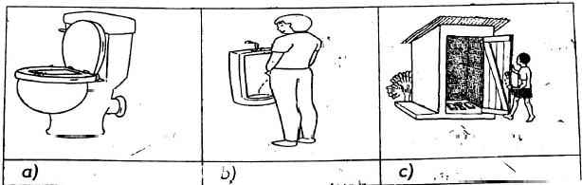

6. Name the following materials used to clean toilets, latrines and urinal.

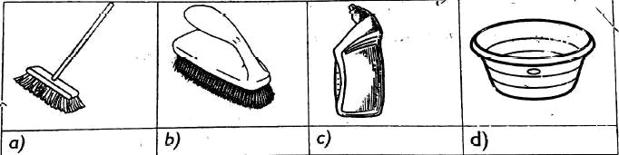

Sub strand 1.9 Bed Making

1. Name the bedding materials
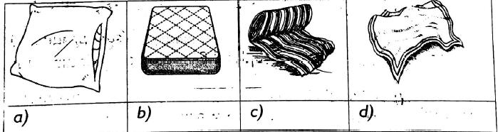

2. | Making our bed makes our room | .............................................. (neat, bad)
3. | We use a .............................................. | to keep off dust from the bed (bed covers, sheet)
4. | Bedding, materials keeps us .............................................. | and ............................................... | (warm, cold,
 | comfortable, sweat).
- .............................................. is used to raise me upright while in bed.

- .............................................. is a rectangular soft sponge found on a bed.

STRAND 2;0 PERSONAL HYGIENE

Sub strand 2.1 Prevention of parasite in and out of the body

1. | Hygiene means .............................................. | (cleanliness. bathing)
2. | A .............................................. | is an animal that lives in or on our bodies.
3. | A person who has been attacked by a parasite is called .............................................. |  | (host, human, sick)
4. | External parasite sucks ..............................................
5. | Parasites that are found inside our bodies are called .............................................. |  | parasites.
- List two examples of internal parasites

  - ..............................................

  - ..............................................

- List two examples of external parasites

  - ..............................................

  - ..............................................

8. | Lice are found on our .............................................. | (feet, hair)
9. | We can use a .............................................. | to cover our mattress and prevent urine from passing through
 | (pillow case, mackintosh)
10. | Name these parasites

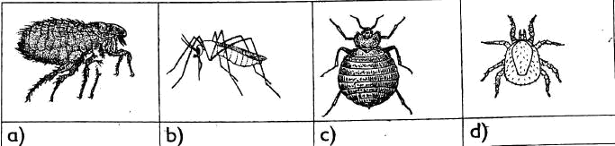

- ..............................................is when a person wets their bed during sleep

- Write down two things to do after wetting your bed

  - ..............................................

  - ..............................................

13. | Wetting the bed makes us feel | ..............................................(bad, good)
14. | We should .............................................. | the wet mattress and blankets to avoid bad smell. (wash, air)

STRAND 3:0 FOODS

1. | Some people do not eat some foods because of their .............................................. | (religion, taste, colour)
2. | Good behaviours during meals is called good .............................................. | manners
3. | A meal that has food from all the food groups is called a .............................................. | diet (balanced, full)
4. | Name these foodsfound in our communities
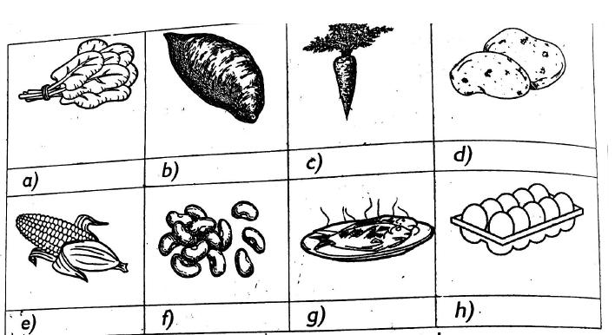

- Write two things we should not do during meals a. ..............................................
b. ..............................................

- Name two types of food in each category
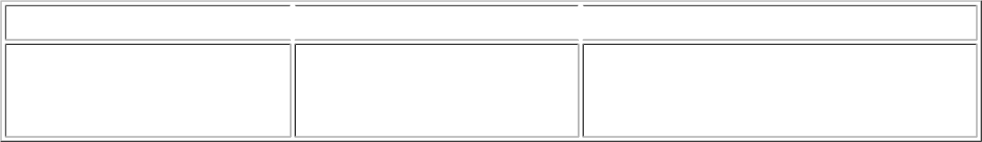

Food that gives us energyFood that builds our bodyFood that protects us from diseases

i).

ii).

iii).

i).

ii).

iii).

i).

ii).

iii).

- Name the parts of the plant we eat on the following

  - Sugarcane ..............................................

  - Beans ..............................................

  - Cassava ..............................................

  - Carrots ..............................................

  - Kales ..............................................

- Tick the correct column
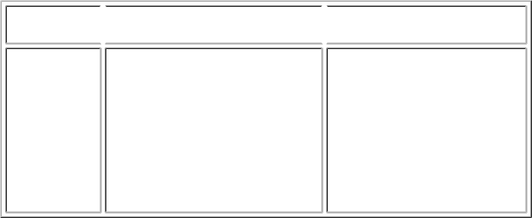

Foods from animals Foods from plants

- Bread

- Eggs

- Milk

- Beef

- Rice

9. | Food, rest and .............................................. | strong and healthy (exercise, running)
10. | People who are too fat may suffer from diseases like |  | .............................................. (cholera, heart attack)
11. | Same people eat too little food because they are .............................................. |  | (sick, healthy)
- Name three foods that can be eaten raw a. ..............................................

b. ..............................................

c. ..............................................

d. ..............................................

Write true or false

- Food should be stored in a clean and dry place ..............................................

- Cooked food should not be covered ..............................................

- Cooked food should not be mixed with uncooked food ..............................................

- Damp grains should be dried in the sun ..............................................

- Grains should be free from pests ..............................................

- Name the following food storage facilities
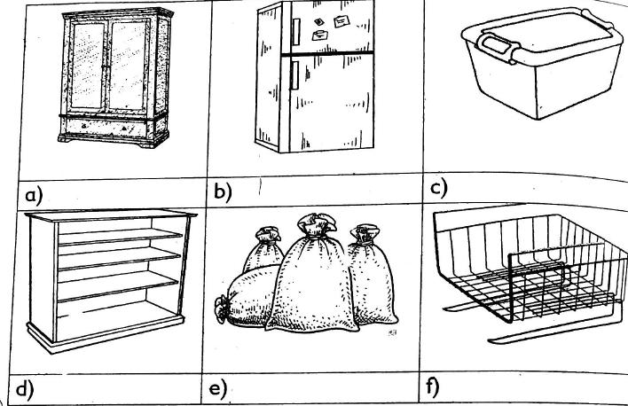

19. | Food should be stored proper to prevent .............................................. | (using, wastage)
20. | After harvesting, grains can be stored in ..............................................

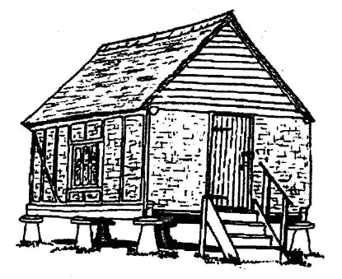

common accidents

1. Look at the pictures and say what has made the children to fall
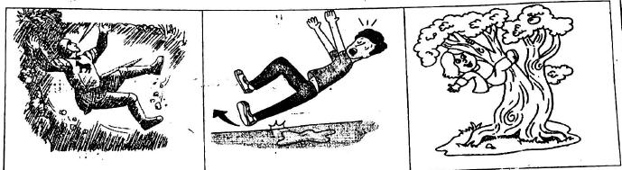

- Some of the things that can cut us are a. ..............................................
 | b. ..............................................
 | c. ..............................................
3. | When we fall on rough surfaces, our skin get .............................................. |  | (cuts, grazes)
4. | Razor blades can cause .............................................. | (falls, cuts)
5. | The first help we get after getting hurt is called .............................................. |  | (first help, first aid)
6. | When blood comes out of the nose, we say we are nose .............................................. |  | (bleeding, running)
7. | When a person faints we should .............................................. |  | their clothing. (tighten. loosen)
8. | We should .............................................. | the legs of someone who has fainted (raise, lower)
9. | We should be .............................................. | at school to avoid accidents (careless, careful)
10. | We should not throw .............................................. | objects like nails at others. (blunt, sharp)

Consumer Education

- Draw 3 types of containers where food is piackdd a. ..............................................
 |  | b. ..............................................
 |  | c. ..............................................
2. | Food that is put in a packet is called |  | .............................................. food (packet, packaged)
3. | The | .............................................. number tells us when the food was made among others. (expiry, batch)
4. | The date the food was made is the .............................................. |  | date (expiry, manufacturing)

Name these pictures where we buy food
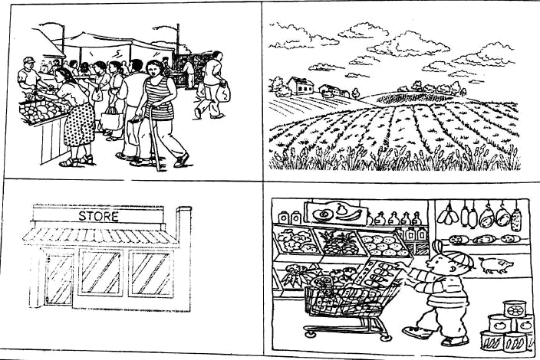

ENVIRONMENTAL PRACTICE 2

STRAND 1: ENVIRONMENT AND ITS RESOURCES

Answer all questions

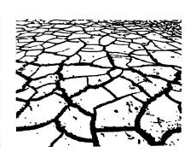
Look at the picture below

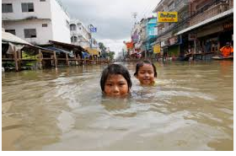

- Give two problems people living in the area shown above face a. ......................................................................
b. ......................................................................

2. Too much rain cause ..................................... (drought, floods)

- A lot of sunshine causes .....................................

- Arrange the letters below the show some things that cause unfavourable weather

  - airn .....................................

  - iwnds .....................................

- What happens when there are floods?

 | a. .....................................
 | b. .....................................
 | c. .....................................
6. | When there is a flood animals lack ..................................... | (grass, legs, houses, sunshine, water )
7. | Which one among the following cannot be affected by drought? ..................................... |  | (rocks, maize, dog)
- Look at the following. Which one cannot be affected by floods?

- The villagers of Budalangi were asked by the government to move to higher grounds. The weather condition was likely to be .....................................
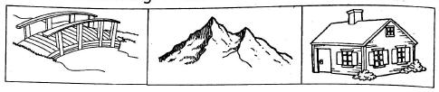
Write YES or NO

- We should cross flooded rivers .....................................

- Flood destroys schools. .....................................

- Which weather conditions are shown by the symbols below?
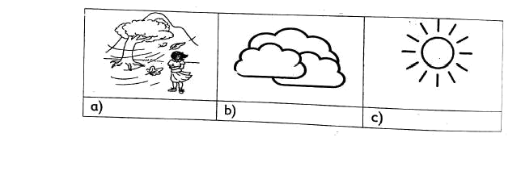

- Give two ways of keeping safe during cold conditions a. ..........................................................................
b. ..........................................................................

- Name three methods of making water clean for use at home

 | a. ..........................................................................
 | b. ..........................................................................
 | c. ..........................................................................
15. A | ..................................... can be used to filter dirty water (paper, piece of cloth).
- Match the soil characteristic with the soil type

Soil characteristics Soil type
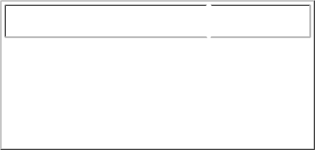
Course particles |  | clay
Fine when touched |  | loam
Had medium texture |  | sand

17. | The Best soil to plant a tree nursery is ................................................... | (clay, loam, sand)
18. | The soil that feels rough is ................................................... | (clay, sand, loam)
19. | ................................................... is the roughness or smoothness of soil.
20. | Say whether the plants below are edible or non-edible.
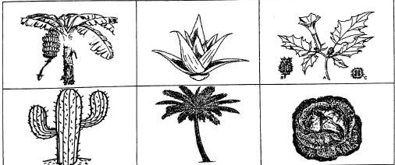

21. | ...................................................are non-thorny plants which are also eaten (potatoes, Aloe vera, sisal)
22. | Which of the following plants is edible? | ................................................... (cactus, pyrethrum, onions)
23. | Paw paws are examples of ................................................... | foods (edible, non-edible)
- Give three safe ways of handling thorny plants a. ...................................................

b. ...................................................

c. ...................................................

- Circle plants nan.es from the grid below
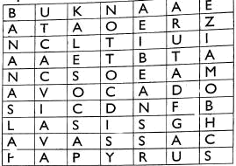

- Match the plants with where they grow papyrus In the garden
spinach Dry areas
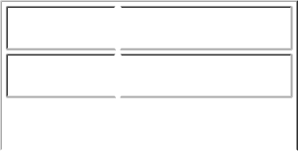

 |  | sisal |  |  |  | Wet areas
27. | ................................................... |  |  |  |  |  |  | is the largest source of water. (well, lake)
28. Fill the table
 |  | Animal |  | The food we get from it
 |  | bee
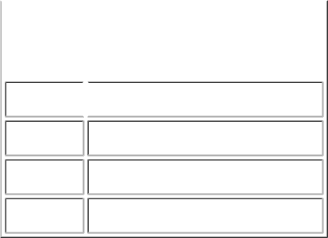
chicken

cow

pig

sheep

29. We take care of animals by ................................................... them (poaching, feeding)

- What is the animal doing?

- Give the uses of these animal
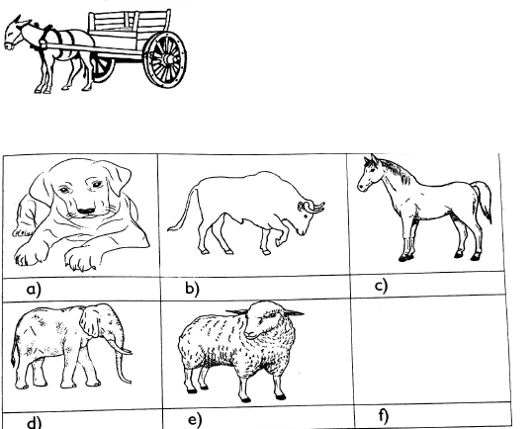

32. Look at the picture below

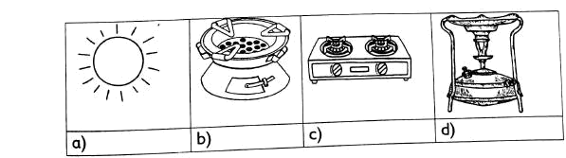

 | Name the sources of heat shown above
33. | Bull fighting is a ................................................... |  |  |  | involving animals (war, sport)
34. | Match the sources of heat with their uses
 | Electric cooker |  | Ironing clothes
 | Sun |  | Lighting at Night
 | Charcoal iron box |  | Drying clothes
 | Solar bulb |  | Cooking food
Say CORRECT or INCORRECT for number 35-37

- We should not insert metal objects in sockets ...................................................

- We can touch open electric cables with our bare hands ...................................................

- We sould switch off electric bulbs during the day ...................................................

- Write down two things that cun luuse fire ut home

 | a. ...................................................
 | b. ...................................................
39. | We take care of animals by ................................................... | them. (poaching, feeding)
40. | Bull fighting is a ................................................... | involving animals. (war, sport)

STRAND 2: SOCIAL ENVIRONMENT

- Write down three things that make the market dirty a. ...................................................
b. ...................................................

 | c. ...................................................
2. | Clean market keeps away bad sm .... |  |  | .... ....
3. | R....ts and fl .... | .... s like dirty places.
4. | We should throw li .... .... |  | er into the bin.
5. | If we do not clean our markets we will have fewer b....y....rs
- Give three ways of keeping the market clean a. ...................................................

b. ...................................................

c. ...................................................

- Write the name of safe areas that are free from danger in the circles
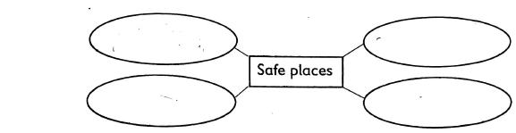

Say TRUE or FALSE

- We should not accept gifts from strangers. ...................................................

- it is safe to use an abandoned road when going home. ...................................................

- We should accept lifts from strangers. ...................................................
11. Give examples of dangerous places in the balloons above
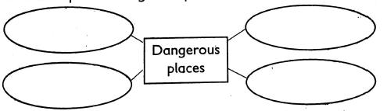

12. Always use the ................................................... crossing when crossing a busy road.

- People walking on foot are called ...................................................

- People driving vehicles are called ...................................................

- What do the road signs below show?.
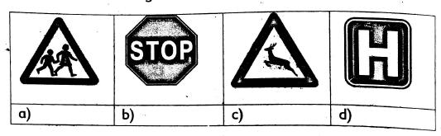

16. People cross the road when the traffic lights turn ................................................... in colour

- Which colour warns people not to cross the road? ...................................................

- Which colour alerts people and motorists to get ready? ...................................................

- Colour the traffic lights below using the right colour
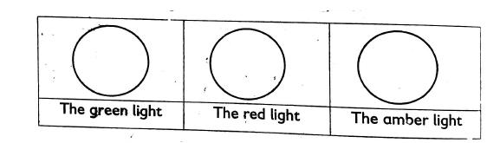

20. Dangerous places are ................................................... (safe, unsafe)

Underline the unsafe places

- Police station, forest

- Home, coffee plantation

- Vacated house, church

- Mosque. busy street

25. | ................................................... | keep away rats and snakes from our homes. (goats, sheep, cats)
26. | Animals kept at home are called | ................................................... (wild animals, domestic animals)
27. | Draw two things that you can use to clean a market


a)

b)

28. | ...................................................is the way of life of a particular community (culture, language)
29. | Name two cultural events
 | a. ...................................................
 | b. ...................................................
30. | We care for the environment through ................................................... | (fighting, planting trees, cutting trees)
31. | Which one of the following is not a sporting activity? ................................................... | (bullfighting, spear
 | throwing, harvesting)
32. | Name two harmful cultural practices
 | a. ...................................................
 | b. ...................................................
33. | An income generating activity helps us to make ................................................... | (money, noise)

Use these words to fill the gaps

(Reduce, reuse, sorting, collecting, recycling)

- Separating waste is called ...................................................

- Using materials again is called ...................................................

- Remaking new materials from waste is called ...................................................

37. | Fetching water, and sweeping the compound are ................................................... |  |  | of children.
 | (responsibilities, ceremonies)
38. | Poultry keeping project gives us ................................................... | and ...................................................
39. | Make a poster inviting your friends to an environmental day
- How can you reuse the following items?

  - Bottle tops ...................................................

  - Wires ...................................................

  - Old tyres ...................................................

STRAND 3: CARING FOR THE ENVIRONMENT
- Write down ways plants can be destroyed

  - ...................................................

  - ...................................................

  - ...................................................

  - ...................................................

- Watering plants during the dry season is referred to as ...................................................

- Removing unwanted branches is known as ...................................................

- ................................................... is removing plants not needed in the shamba.

- Putting dry leaves under the plants to protect them from heat is ...................................................

6. We tell people about plant protection to create ................................................... (awareness, fear)

- Why are plants important?

  - ...................................................

  - ...................................................

- Look at the picture below
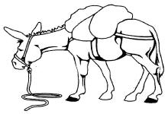

What is causing distress to the animal?

- ...................................................are harmful plants that grow with useful plants.

- Give three things we can do to protect plants.

  - ...................................................

  - ...................................................

  - ...................................................

- ...................................................destroys grass easily. (fire, water)

12. Doctors who treat animals are called ................................................... doctor

- List two signs of distress in animals

  - ...................................................

  - ...................................................

Write CORRECT or INCORRECT for No. 14-17

- A limping Carmel is in distress: ...................................................

- A cow with a dry nose is not in distress: ...................................................

- Cackling chicken are in distress: ...................................................

17. | A dog that keeps moving up and down its kennel: ................................................... |  | is in distress.
18. | Write each sentence about animals under the headings below
 | Cleaning their shelter | Painting them
 | Beating them | Treating them
 | Chasing them | Feeding them
 | Starving them

caring for animals

not caring for animals



- We get F_ _ d from plants.

- Plants make our environment beau ...................................................

- Animals in distress may lack appe_ _ _ _

- A cow produces m_ _ k

- Match the name of waste with its type

 | Waste |  | Type
 | a) Orange peelings |  | metal waste
 | b) dispose plastic bottles |  | animal waste
 | c) broken glass cups |  | plastic waste
 | d) empty fruit can |  | food waste
 | e) cow dung |  | glass waste
- How can a Grade 3 pudil dispose these wastes?

- Papers: .................................................

- Stones: .................................................

- Vegetables .................................................

- Leaves .................................................

- From the below circle types of waste
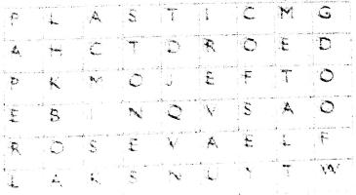

30. | Animais need ................................................. |  | (cow dung, food) and (oil, water)
31. | When animals are sick they should be |  | .......................................... (killed, treated)
32. | .......................................... | are special places where waste is thrown (Landfill, dust bin)
33. | .......................................... | makes plants to grow. (soil, people)
34. | The.......................................... | of trees hold the soil together. (branches, roots)
35. | Trees.......................................... | (speed, slow down) the speed of water as it flows over the land.
36. | The carrying away of soil by water or wind is called ..........................................
37. | Leaves and branches.......................................... |  | the force of rain (increase, reduce)
38. | Manure that can be made from grass and banana leaves is known as.......................................... |  |  | manure
- Give three examples of cover crops a. ..........................................

b. ..........................................
c. ..........................................

- Give 2 examples of different platforms that can be used to communicate messages on managing waste. a. ..........................................

b. ..........................................

QUESTIONS

QURAN
1. | Surah Lahab has ................................................. |  | verses. (4, 5, 3)
2. | Lahab means ................................................. |  | (fire, flames, rope)
3. | Abu Lahab was the ................................................. |  | of the prophet.
 | (Uncle, futher, grandfather)
- Surah Lahab is also called .................................................

(Kauthar, Masad, Flames)

- The wife of Abu Lahab was called .................................................

 | (Hawa, Halima, Ummujamil)
6. | Surah Nasr has ................................................. |  |  |  | verses. (3, 2, 5)
7. | The word 'Nasr' means ................................................. |  |  |  | (victory, help, success)
8. | Surah Nasr was revealed in ................................................. |  |  |  | (Makkah, Madina, Jerusalem)
9. | Surah kaafirun has ................................................. |  |  |  | verses. (6, 5, 4)
10. | Surah kaafirun was revealed in ................................................. |  |  |  | (Madina, Makka, Yathrib)
PILLARS OF IMAN
1. | Muslims believe in ................................................. |  |  |  | pillars of Iman. (6, 5,2)
2. | .................................................means coming back to life. (Assembly, resurrection, power of Allah)
3. | All things happen by the power of ................................................. |  |  |  | (Allah. Angels, prophets)
4. | Muslims believe in ................................................. |  |  |  | God. (one, three, two)
5. | Write three other names of the last day
5. | .................................................
6. | .................................................
7. | .................................................
8. | ................................................. |  | means the power of Allah. (Maashar, Qadar, Qirjamah)
9. | The fifth pillar of Iman is to believe in |  |  | ................................................. | (prophets, the last day, power of Allah)
10. | Angel ................................................. |  |  | will blow trumpet. (Izrail, Israfil, Mikail)
SURAH (LIFE OF THE PROPHET)
1. | .................................................was an orphan. (Muhammad, Is-haq, Issa)
2. | Abu Twalib was a ................................................. |  |  |  | man. (proud, rich, poor)
3. | Prophet Muhammad worked as a ................................................. |  |  |  | to help his uncle. (farmer, shepherd, trader)
4. | Who taught Muhammad trade? ................................................. |  |  |  | (Abdulmutwahib, Abu Twahib, Abu Lahab)
5. | Prophet Muhammad travelled with his uncle to Syria when he was ................................................. |  |  |  |  | years old.
 | (six, eight, twelve)
- ................................................. is the grandfather of Prophet Muahmmad. (Abu Twalib, Abdulmutwahib, Abu Lahab)

- The Christian monk that saw signs of prophethood in Muhammad was called

.................................................(Jaafar, Bahira, Answar)

Write down three qualities of the prophet (S.A.W)

8. .................................................

9. .................................................

10. .................................................
HADITH
1. | .................................................means worshipping Allah like you see him. (Iman, Ihsan, Islam)
2. | Allah created people to ................................................. |  |  |  |  | Him. (worship, praise, mock)
3. | Al- Basiir means that Allah is all S __ __ __ __ __ __
4. | Muslims should speak the truth even if it is ................................................. |  |  |  |  |  | (sweet, bitter, bad)
Write 5 ways on how you show respect to your parents and teacher
5. | .................................................
6. | .................................................
7. | .................................................
8. | .................................................
9. | .................................................
10. | A shepherd is responsible for his ................................................. |  |  |  |  | (flock, grass, enemies)
DEVOTIONAL ACTS
Write down the five pillars of Islam
1. .................................................
2. .................................................
3. .................................................
4. .................................................
5. .................................................
6. | Swalah gives me a chance to speak to .................................................
 | (Angels, Allah, Prophets)
7. | A good Muslim prays ................................................. |  |  |  |  | times in a day. (5, 6, 17)
8. | Maghrib prayer has ................................................. |  |  |  |  | rakaahs. (4, 2, 3)
9. | Between 3.45 pm and 5.00pm. I pray .................................................
 | (Fajr, Asr, Maghrib)
10. | Dressing properly is ................................................. |  |  |  |  | Ibaadah, good, bad)
MORAL TEACHINGS
1. | .................................................is the best place for prayers. (House, fleld, mosque)
2. | I enter the mosque with my ................................................. |  |  |  |  | feet first (right, left, both)
3. | When I sneeze I say ................................................. |  |  |  |  | (Bismillah, Alhamdulillah, Insha Allah)
- When I praise and glorify Allah, I say. .................................................

(Insha Allah, Hasbunallah wa Ni'mal Wakil. Yarhamukalian)

5. | The visit to the sick should be |  | ................................................. | (short, long)
6. | What do we do when we visit the sick? ................................................. |  |  |  | (Say dua, cry, bring flowers)
7. | Write 3 ways for caring the environment
7. | .................................................
8. | .................................................
9. | .................................................
ISLAMIC FESTIVALS
Complete with the correct words
1. | Eid-ul ................................................. |  | comes after fasting and Eid-ul |  | ................................................. in the
 | month of Dhul-Hajj
2. | We put on ................................................. |  | clothes for Eid
3. | We thank ................................................. |  | during Eid prayers
4. | We perform ................................................. |  | before prayers
5. | Eid prayer is a ................................................. |  |  | prayer. (Fardh Sunnah)
6. | After prayers ................................................. |  | is said. (ghusul, Khutbah, best, Hajj, Fitr, Allah)
7. | What do we recite dying Eid ................................................. |  |  | (Takbina, Songs, Poems)
8. | We eat something ................................................. |  |  | Eid-Ul-Fitr prayer | (after, before)

9. | Nabii ................................................. | obeyed the command of Allah (SWT) (Ibrahim, Musa)
10. | After Eid-ul-Adha prayer we slaughter ................................................. |  | which share with relatives the poor and
 | needy.

KISWAHILI

Kusikiliza na kuzungumza

A. Imla

Mwanafunzi asomewe maneno kisha ayaandike kwenye mapengo.

Maneno ya Imla

- Bwana

- fyonza

- mwanafunzi

- kwama

- fyatuka

- Nyundo

- mwewe

- kimbilia

- ndimu

- ukabila

- chinja

- pwaguzi

- vyombo

- kuteketea

- vifaa

B Soma maneno haya kwa sauti alikwea |  |  | afya
bweni | alikwea | fyeka | afya
mbegu | aliomba | vunjika | njama
mzalendo | kwekwe | pwaya | daktari
shuka | mchoro | hamali

C. Soma sentensi hizi kwa sauti

  - Kwa nini njiwa wamelala?

  - Wewe hukuimba wimbo wa taifa.

  - Nyinyi mlisafisha mazingira.

  - Walimu walitufunza tabia nzuri.

  - Usikae na mtu usiyemjua.

  - Salama alizaliwa mwezi wa Machi.

D. UFAHAMU

Mzazi au mlezi amsomee mwanafunzi taarifa hii kwa sauti mara mbili kisha amwulize maswali.

Shule zilipofungwa kwa likizo ya Aprill sikukaa tena mjini. Nilifunga safari yangu hadi mashambani kwa shangazi yangu. Shangazi yangu ni mkulima maarufu katika kijiji cha kwao. Nilifika kwa shangazi alasiri. Shangazi na watoto wake walikuwa shambani wakilima. Nilienda hadi shambani na nikaanza kulima. Hata sikubadilisha nguo.

Jioni tulienda nyumbani. Shangazi alipika kilalio. Baada ya kula, sisi sote tulienda kulala. Mimi nililala katika kitanda kimoja na mkoi wangu. Niliomba Mungu sana usiku huo nisikojoe kitandani; sikutaka kuchekwa na wakoi wangu.

Maswali

1. Shule zilipofungwa mwandishi aliondoka wapi? ...............................................
- Shangazi na watoto wake walikuwa wapi?

- Ni nani aliyepika kilalio?...............................................

- Mbona mwandishi aliomba Mungu sana?...............................................

- Chakula cha asubuhi huitwa ..............................................................................................

E.

Je, ni vifaa vipi hutumika shambani
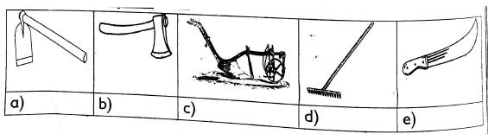

F.
1. |  | Mwaka una miezi mingapi? ..............................................
2. |  | Je, ulizaliwa mwezi gani? ..............................................
3. |  | Kwa kawaida shule hufungwa miezi gani?
 |  | a. ..............................................
 |  | b. ..............................................
 |  | c. ..............................................
4. |  | Sherehe ya Jamhuri husherehekewa mwezi gani? ..............................................
5. |  | Mwezi wa tano ni ..............................................

G.

Tazama picha hizi. Ni kazi zipi unazozijua
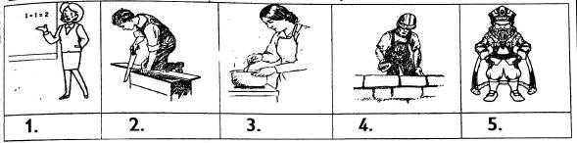

Wewe ungetaka kufanya kazi gani baada ya masomo?

Kwa nini mtu hafai kufanya mambo haya?

- Kwenda msituni peke yako! ..............................................

- Kuzungumza na watu usiowajua ..............................................

- Kucheza karibu na shimo? ..............................................

- Kunywa chochote kilicho kwenye chupa ..............................................

H.

Mazingira ni vitu vinavyotuzunguka kama vile:
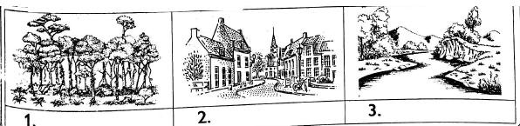

4. Mazingira machafu huleta wadudu na wanyama kama vile

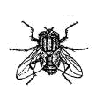
a.

..............................................
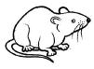

b.

..............................................

5. Ni muhimu kufungua madirisha wakati wa mchana ili ..............................................

6. Vitendo viwili vya kusafisha mazingira

a. ..............................................

b. ..............................................

I.

Taja majina ya bidhaa hizi;
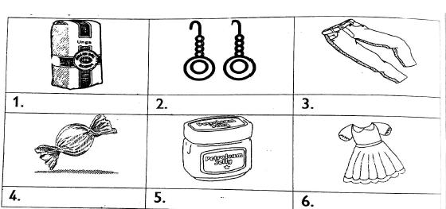

- Mtu anayeuza dukani huitwa ..............................................

- Pesa za karatasi zinaitwa..............................................

- Mtu akikopesha bidhaa bila kulipa huwa amefanya nini? ..............................................

- Uzito wa sukari hupimwa kwa kutumia ..............................................

J.

1. Chora ndege umpendaye?


- Kwa nini unampenda ndege huyo! a. ..............................................
b. ..............................................

c. ..............................................

- Unamtunzaje ndege unayempenda? a. ..............................................

b. ..............................................

c. ..............................................

- Hawa ni ndege gani?
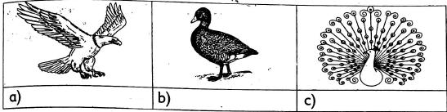

  - Nyumba ya ndege wa porini ni

A. KUANDIKA

Jaza mapengo kwa maneno yanayofaa zaidi

Juu ya mti _ 1__ (hiyo, hizo, huo) palikuwa na _2__ (kizimba, kiota, kikombe) cha ndege. Ndani palikuwa na mayai _ 3__ (mbili, mawili,pili) ya ndege. Mayai hayo__4_ (ilikuwa, yalikuwa, zilikuwa) ya ndege. Mimi __5__ (hakuyachukua, sikuyachukua,hachukui) mayai yale. Niliyaacha hapo nikaondoka. Nilirudi hapo __6__ (kabla ya, baada ya, badala ya) wiki_._7__ (tatu, mitatu, watatu). Niliwapata _8_ (vifaranga, viyoyo, makinda) kiotani. Nilikimbia hadi nutimbani. Nilimkuta baba ___9____ (zake, yangu, 'langu). Aliniambia hao ni watoto wa ndege. Alisema niachane na ndege __10__ (wandogo, wadogo, ndogo).

B. Andika maneno yanayoanza kwa herufi hizi kwa hati hadhifu

1. dh .............................................. ..............................................

2. th .............................................. ..............................................

3. ny .............................................. ..............................................

4. ng .............................................. ..............................................

5. sh .............................................. ..............................................

C.Kuandika kuhusu soko

Soko letu linaitwa Marikiti. Watu wengi hupenda kununua __1__ (bidhaa, bidha) huko. Kuna vitu ainati ambavyo __2__ (hupandwa, huuzwa) kwa ___3___ (noti, bei) nafuu sana.__4__ (Wauzaji, Wanunuzi) hutumia __5__ (pesa, vyakula) kununua wanachohitaji. Kuna wale ambao huwaomba wauzaji __6__ (wawaongezee, wawapunguzie) bei. Muuzaji akiuza yeye hupata__7____ (hasara, faida). Ukinunua kitu mara nyingi huwa unapewa -__8_(risiti, karatasi).
Mchele au unge hupimwa kwa __9__ (kipino, ratili), lakini maziwa hupimwa kwa ___10___ (pakiti, mafungu)

D. Kuandika kuhusu usalama

Tulikuwa tumesimama ___1__ (katikati ya , ndani ya) kaka na dada. Mzee ___2____ (moja, mmoja) alikuja

akatusalimia. Alituomba tumwonyeshe njia um kwenda sokoni. ___3___ (kabla ya, baada ya) kumwonyesha, alitushukuru na ___4___ (aliondoka, ataondoka). "Kwa nini mzee huyo ana macho (mekundu, nyekundu)? kaka akauliza “Labda ni mgonjwa,” nilijibu. Matatu iliwasili. Tuliingia na kuelekea sokoni. Tulifika sokoni haraka. __6__ (Tutanunua, Tulinunua) vitu tulivyotaka. Nilimwona mzee ___7___ (yule, ule) mwenye macho mekundu. Alikuwa ameshikwa na askari. Alishikwa ____8___ (lakini, kwa sababu) aliwauzia watoto bangi. Alikuwa mzee mbaya. Alitaka kuharibu maisha ya ___ 9___ (wazee, watoto). Tulichukua mizigo, tukaenda kwetu nyumbani.

SARUFI

A. Tumia maneno yaliyo kwenye kisanduku kujaza mapengo

Ndani ya Chini ya, Nje ya, kando ya, Juu ya
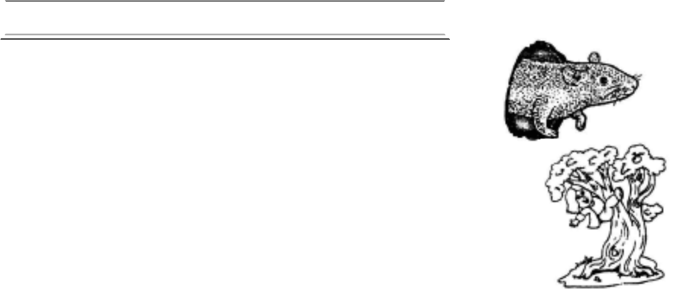

1. Panya yuko ..............................................shimo.

2. Mtoto mepanda..............................................ya mti.
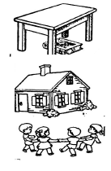

3. Kitabu kimeanguka..............................................ya meza

4. | Watoto wanacheza | ..............................................ya nyumba.
5. | Gari limeegeshwa.............................................. | ya barabara
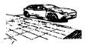

B. Tumia alama ya kuuliza swali (?)

- Wewe unaenda wapi .............................................

- Kwa nini unacheka.............................................

- Unapenda somo gani.............................................

- Jani lilianguka lini.............................................

- Kinyonga anatembea polepole kwa nini.............................................

C.Tumia "polepole" au "haraka"
1. | Mnyama huyu huwa anaenda .............................................
2. | Ni vizuri kufagia sakafu ............................................. |  | ili iwe safi
3. | Kimani alishinda mbio kwa sababu alikimbia.............................................
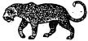
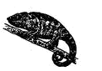
4. | Mnyama huyu huwa anaenda .............................................
5. | Kukiwa na baridi nguo hukauka .............................................
6. | Dereva aliendesha gari ............................................. | likaanguka

D. Andika Kinyume

  - Lala .............................................

  - Keti .............................................

  - Cheka .............................................

  - Tabasamu .............................................

  - Nenda .............................................

  - Penda .............................................

- Andika wingi wa sentensi hizi

  - Mimi niliandika vizuri. .............................................

  - Wewe nenda sokoni. .............................................

  - Yeye atasoma kitabu. .............................................

  - Choo kitasafishwa. .............................................

  - Mdudu anauma. .............................................

- Kanusha sentensi hizi

  - Mimi ninasoma vibaya .............................................

  - Nyinyi mlifanya makosa .............................................

  - Yeye atachora nyumba .............................................

  - Sisi tulipita mtihani .............................................

  - Msichana anaenda ziara .............................................

- Sahihisha sentensi hizi

  - sarah anapenda samaki .............................................

  - dada alizaliwa juni .............................................

  - sherehe ya leba ni mei .............................................

  - tutaenda Nakuru agosti .............................................

  - huu ni mwaka wa tatu .............................................

- Andika umoja wa sentensi hizi

  - Vitabu vyao vimepotea .............................................

  - Watoto wao wanalia .............................................

  - Hii ni mikoba yao .............................................

  - Kalamu hizi ni zao .............................................

  - Madawati yao yamenunuliwa .............................................

- Tumia "-ake" au "-ao"

1. | Yai ............................................. | limevunjika.
2. | Maembe............................................. | yameiva yote.
3. | Duka............................................. | limefungwa.
4. | Sahani ............................................ | zimepangwa kabatini.
5. | Vyoo ............................................ | vimeoshwa.

MSAMIATI

Mimea hii, hutupatia mazao gani?
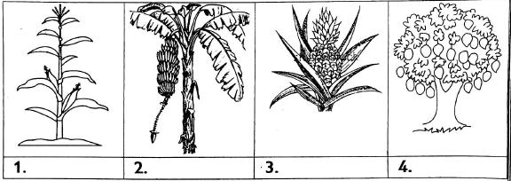

5. | Mtu anayeipenda nchi yake ni ............................................. | (Mwananchi, mzalendo)
6. | Mtu anayeijali nchi yake hupenda............................................. | (vita, amani)
7. | Sheria za nchi ya Kenya zimeandikwa kwenye ............................................. | (Kitabu, katiba)
8. | Bendera yetu ina rangi ............................................. | (tatu, nne)
9. | Wakazi wa nchi ni ............................................. | (ruiya, raia)
10. | Andika majina ya miezi ambayo ina siku thelathini na moja
10. | .............................................
11. | .............................................
12. | .............................................
13. | .............................................
14. | Andika.............................................majinayamieziambayo ina siku thelathini (30)
15. .............................................
16. | .............................................
17. | .............................................
18. | .............................................
19. | Ni mwezi upi umbo huwa na siku ishirini na nane (28) au ishirini na tisa (29)?.............................................

Tambua kazi ya watu hawa
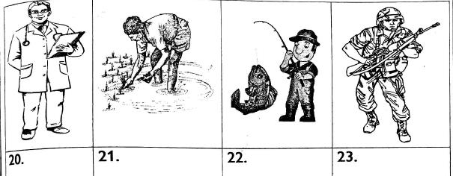

Andika vitendo vitatu ambavyo vinaweza kusababisha fujo au ghasia K.m kuchoma mali ya watu

24. ..........................................................................................

25. ..........................................................................................

26. ..........................................................................................

Kwa nini ni muhimu kufanya mambo haya?

- Kufyeka nyasi zilizoko karibu na nyumba zetu?

- Kuchoma takataka ....................................................................................................................................................................................
- Kusafisha vyoo shuleni ..........................................................................................

- Chora vifaa viwili ambavyo hutumiwa kusafisha

mazingira..........................................................................................


- Mtu anayenunua bidhaa dukani huitwa ..........................................................................................

- Pesa anazorudisha mnunuzi baada ya kununua zinaitwa .............................................

- Kuuza bidhaa kidogo kidogo ni kuuza kwa .............................................

- Kuuza bidhaa kwa wingi ni kuuza kwa .............................................

35. | Pesa ambazo si za karatasi huitwa | .............................................(Baki, Sarafu, Rejareja, Muujazi, Jumla)
36. | ............................................. ni ndege wa nyumbani (bata, kanga)
37. | ............................................. ni ndege mwenye macho makubwa (bundi, punda)
38. | Mtoto wa kuku ni ............................................. | (kiyoyo, kifaranga)
39. | Mdomo wa ndege huitwa............................................. | (meno, kidona)
40. | Njiwa ni ndege............................................. | (mkali, mpole)
41. | Bidha kama mboga na matunda hupimwa kwa............................................. |  | (mafungu, pakiti)
MATHEMATICS

NUMBERS 1.1

Ordinal numbers Exercise

1. | ............................................is the sixth day of the week.
2. | August is the............................................ | month of the year
3. | The fifth month of the year is ............................................
4. | Uhuru Kenyatta is the ............................................ | president of Kenya
- The last day of the week is ............................................

- The fastest animal on earth is ............................................

7. The deputy head teacher is the............................................senior staff in a school

- Which number comes after seventeen ............................................

- The biggest number in a phone key board is ............................................

10. November is the............................................ month of the year.

1.2 Whole numbers

Exercise 2

Counting forward and backward

Write six more and six less

1.

50 56 62
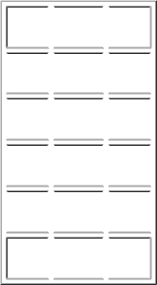

605

563

821

78

943

Fill in the following digits in their correct place value

2. 5619=

............................................thousands

............................................hundreds

............................................tens

............................................ones

3. 3427 =

............................................thousands

............................................hundreds

............................................tens

............................................ones

- What is the place value of digit 4 in the figures

  - 6435

  - 7642

  - 4001

Writing these numbers in words

- 67 ............................................

- 234 ............................................

- 781 ............................................

- 985 ............................................

Read and write the following numbers in symbols

- Thirty eight ............................................

- Eight hundred and six ............................................

- Six hundred and fifty eight ............................................

- Two hundred and four ............................................

Number pattern

- 50, 60, 70, 80, ............................................

- 7, 14, 21, 28, ............................................

- 100, 95. 90, 85, ............................................

- 700, 650, 600, 550, ............................................

Write the missing numbers in the patterns

- 34, 35, 36, 37, 38, 39 ............................................

- 205, 210, 215, 225, ............................................

- 80, 70, 50, 40, ............................................

- 444, 134, 424, 414, 404, ............................................

1.3 Fractions

Exercise 3

Write ¹/₂, ¹/₄ or ¹/₈ in the following.
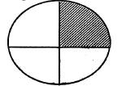

1.

............................................
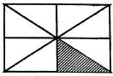

2.

............................................
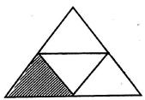

3.

............................................
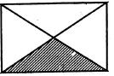

4.

............................................
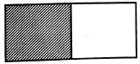
5.

Shade the shapes below

- ¹/₈

- ¹/₂

- ¹/₄
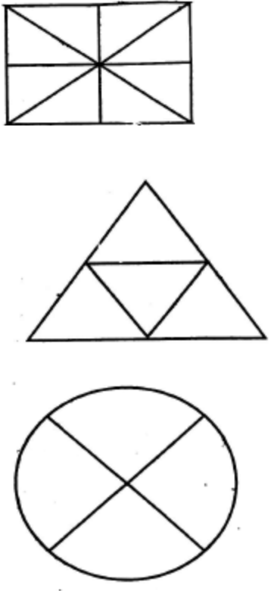

9. Below is half an orange. If cut through the line you will get?
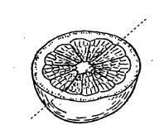

1.4 Addition

Exercise 4

Work out the following

- 326 + 451 = ...................................

- 672 + 205 = ...................................

- 648 + 238 = ...................................

- 342 + 464 = ...................................

- 812 + 178 = ...................................

- 456 + 278 = ...................................

- 367 + 228 = ...................................

- 763 + 409 = ...................................

- Kiraitu had 673 goats he bought 238 more. How manu goats does he have altogether?

......................................................................
- The cost of a bag is Shs.345. If the price rises with 39 shilling, what is the new cost?

......................................................................

- A village has 432 men and 558 women. What is the total number of people in the village?

......................................................................

- In a show 279 boys and 432 girls attended. How many were there all?

......................................................................

Exercise 5

- 6 + 4 + 5 = ..................................

- 9 + 2 + 9 = ..................................

- 15 +10 + 23 = ..................................

- 40 + 17 + 24 = ..................................

- 45 + 22 + 38 = ..................................

- 67 + 34 + 30 = ..................................

- Three strings of 15m, 13metre and 26metres were joined together. What is the new size?

......................................................................................................

- There were 45 pupils in grade one 34 pupils in grade two and 36 pupils in grade three. How many pupils were in total?

......................................................................................................

- In a library there were 45 story books, 60maths books and 8 cartoon books. How many books were they altogether?

......................................................................................................

- In a town there 22 green cars, 13 yellow pick-ups and 56 Blue Lorries. How many vehicles were there in that town?

....................................................................

- A farmer had 88 cows, 12 goats and 6 sheep in his farm. What is the total number of the animals in the farm?

......................................................................................................

- Lucy has 426 mangoes and 138 oranges. How many fruits does she have altogether?

......................................................................................................

Exercise 6

Complete the pattern

- 2, 4, 6, 8,..................................

- 6, 12, 18, 24, 30 ..................................

- 45, 50, 55, 60,..................................

- 11, 22, 33, 44, 55 ..................................

5. | 20,30 ............. | 50,...............70
Fill in the missing number
6. | 234 + | ........... = 424
7. | 142 + ........... | = 608
8. | 545 + ........... | = 875
9. | ........... | + 403 = 600
10. | ........... | + 330 = 780
11. | There were 120 litres of water in a tank. How many litres are needed to fill it, if it can hold 200litres?
 | .............................................................................
12. | A train carries 800 people. If 456 passengers bourded, how many are left?
 | .............................................................................
13. | Kiin had 450 Shillings in his pocket. If he wanted to save 990 Shillings, how much is left?
 | .............................................................................

1.5 Subtraction

Exercise 7

Work out the following
- 728 - 136 = .................

- 842 - 131 = .................

- 547 - 106 = .................

- Subtract 344 from 549 = .................

- Timo had 251 oranges. He gave away 39 oranges. How many oranges was he left with?

....................................................................

- Mr. Allan had 567 cows. He sold 218 cows. How many cows was he left with?

...................................................

- Chebet bought 789 pieces of sugarcane. She gave out 496 pieces to some children. How many pieces of sugarcane was she left with?

....................................................................

- There were 835 books in a library, 129 books were collected. How many were left?

.....................................................................................

- Lucy had 770 Shillings in her pockets. She bought a dre33 of 490 shillings. How much was she left with?

....................................................................

Work out the missing numbers

11. | 564 - | ........... = 300
12. | 456 - | ........... = 302
13. | 829 - | ........... = 123
14. | ........... | -59 =320
15. | ........... | - 208 = 450

1.6 Multiplication

Work out

Exercise 8

1. | 7+7+7 | + 7
 | ........... x ........... | = ...........
2. | 3+3+3 | +3+3
 | ........... x ........... | = ...........
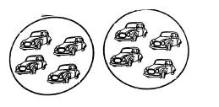

3.

........... x ........... = ...........
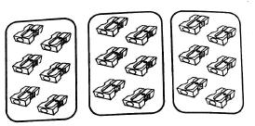

4.
 | ........... x ........... | = ...........
5. | 4 x 3 = ...........
6. | 6 x 2 = ...........
7. | 8 x 4 = ...........
8. | 5 x 5 = ...........
9. | 9 x 4 = ...........
10. | 7 x 6 = ...........

- In a class there were 6 rows of desks. Each row had 4 desks. How many desks are there in that class?

.............................................................

- A packet contains 6 pencils. How many pencils will be contained in 5 such packets?

.............................................................

- A dog has 7 puppies. How many puppies do 3 such dogs have?

.............................................................

- A pencil costs Shs.8, what is the cost of 5 pencils?

.............................................................

- A truck has 6 wheels. How many wheels do seven trucks have?

.............................................................

1.7 Division

Exercise 9

Use the numbers in the triangle to write a division and multiplication sum
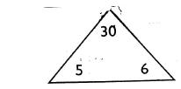

30÷5=6

30÷6=5

5 x 6 = 30
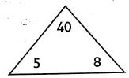

1.

........... ÷ ........... | = ...........
........... ÷ ........... | = ...........
........... x ........... | = ...........
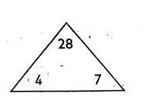

2.
 | ........... ÷ ........... | = ...........
 | ........... ÷ ........... | = ...........
 | ........... x ........... | = ...........
3. | 20 ÷ 4 = ...........
4. | 24 ÷ 6 = ...........
5. | 36 ÷ 9 = ...........
6. | 32 ÷ 4 = ...........
7. | 48 ÷ 8 = ...........
8. | Share 12 oranges among 4 boys ...........
9. | A rope is 20 metres long it was cut into 5 pieces. How long was one piece? ...........
10. | A packet has 24 crayons. If it was shared by 4 girls, how many will each get? ...........

2.0 MEASUREMENT
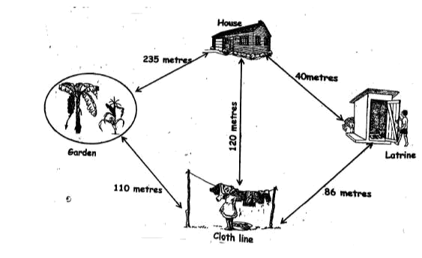

Exercise 10

Answer the questions using the map above

1. | What is the distance from house to the garden? ............................
2. | How far is house from latrine ............................
3. | How far is latrine from cloth line ............................
4. | Tony walked from the garden to the latrine through the cloth line. He covered ............................ | metres.
5. | Which distance is shorter, from house to the cloth line or from house to the garden? ............................
6. | How far is the cloth line to the house through the latrine ............................
7. | What is 424 m + 45m = ............................
8. | What is 564 m + 270m = ............................
9. | 360m + 126 m = ............................
10. | 420 m + 321 m = ............................
11. | 672m - 156m = ............................
12. | 420 m - 321 m = ............................
13. | What is the approximate length of the classroom?
 | ........................................................
14. | What is the approximate height of your teacher?
 | ........................................................
15. | What is the approximate height of a flag post?
 | ........................................................

2.2 Mass

Exercise 11

- Add 9kg + 14kg = ............................

- 340kg + 140kg = ............................

- 694kg - 234kg = ............................

- Subtract 32kg from 124kg = ............................

- 432Kg + 209 kg = ............................

- 552Kg - 346Kg = ............................

- 801 kg + 459 Kg = ............................

- 420 m - 321 m = ............................
- A pickup was carrying 345 kg of Unga; 205Kg of Rice was added. What is the new weight?

....................................................................................

- In a store there were 450K of maize. 238Kg were sold. How many Kg was left?

....................................................................................

2.4 Time

Exercise 12

Tell time on clock face below Using past or to
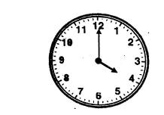

1.

........................................................
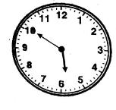

2.

........................................................
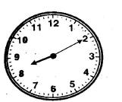

3.

........................................................

- How many days are there in 3 weeks?

........................................................

- How many minutes are there in one hour?

........................................................

- How many weeks are there in 42 days?

........................................................

- Hour min

    - 20

  - 1 15

- Hour min 6 35
  - 2 20

- Hour min

6 45

  - 2 23

- Hour min 7 53

+1 26

- Two lessons took 1hour 20minutes and 1hour 12 minutes. How long did both take?

........................................................

2.5 Money

Exercise 12

- How many 10 shilling coins make 50Shilling?

........................................................

- Atieno had two twenty shillings coin and one ten shillings coin. How much does she have in total? Use the price list below Items

........................................................

- What is the cost of Unga and salt?

........................................................

- If John bought Sugar with 200Shillings note,. how much was he given as change?

........................................................

- What is the cost of tea leave and sugar?

........................................................

- Shs cts

    - 50

  - 65 20

- Shs cts 340 80

- 120 60

- How many fifty shilling notes make 500 shillings?

........................................................

- If the cost of a pencil is 40 shillings, how many pencils would a 100 shilling buy?

........................................................

- Terry was given Shs.600 by her aunt. She spent Shs.450 and saved the rest. How much did she save?

