

**GRADE 3 ASSESSMENTS TERM ONE 2024**

**NUMBER WORK**

**NAME :……………………………………..**

1. **Add and carry;**

2 4 7 1 5 3

+ 3 6 + 3 6

1. **Complete the sentences;**

There are ____ or _____ days in the month of February.

One year has __________ months?

1. **Subtract and by borrowing;**

2 6 3 5 6

- 1 3 6 - 3 9

Subtract 60 from 100 = ________________

1. **Use the price list below to answer questions;**

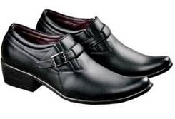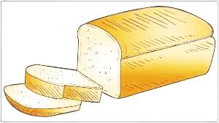

Shs. 35 Shs. 15 Shs. 60

Shs. 120 Shs. 10

Shs. 25

How much will I pay for three loaves of bread ____________?

Toto bought two rubbers and a soda. How much did he pay? _______________

If gave out Shs. 200 to the shopkeeper for the shoes. How much will he give me back? _____________

What is the cost of two chocolates? ______________

Mbura took bread and soda for lunch. How much dis she pay for the two items? _______________

**Αssessment Rubric:**

|  |  |  |  |
| --- | --- | --- | --- |
| Exceeds Expectαtion | Meets Expectαtion | Αpproαching Expectαtion | Below Expectαtion |
| 98-100 | 80-97 | 50-79 | 0-49 |
|  |  |  |  |