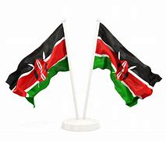

**GREDI YA 3 MUHULA 1 2024**

**KISWAHILI**

**NAME :……………………………………..**

**KISWAHILI**

1. **Jaza pengo zilizoachwa;**

Mw ___ naf ___ nz ___

S _____ remal _____

Ch ___ nd ____r ___a

Ch ___reh ____ni

Mw ___ vul _____

1. **Andika maeno yaliyo katika mabano kwa wingi**

______________ wote wamechelewa shuleni. [**mwanafunzi**]

Ni nani amevichukua _____________ vyetu? [**kikapu**]

_________ ile inapendeza sana. [ **mlima** ]

Kaka amenunua ___________ mengi. [ **gari** ]

Mwalimu atazichonga ___________ hizi. [ **penseli** ]

1. **Andika tarakimu hizi kwa maneno;**

16 = ______________________________________________________

45 = ______________________________________________________

100 = ______________________________________________________

1. 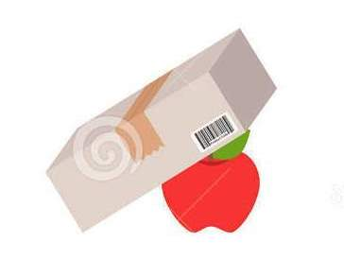Tumia- **juu ya, chini ya** , **kati kati ya** au **mbele ya** katika sentensi hizi

Tunda liko _______________ kasha

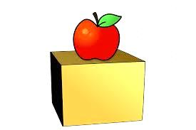

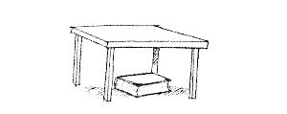Tunda liko __________________ kasha.

Kitabu kiko __________________ meza



Tunda liko _________________ kasha



Tunda liko ___________________ makasha mawili.

1. 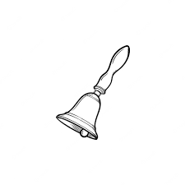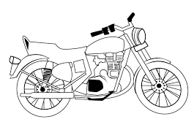**Andika majina ya picha hizi**

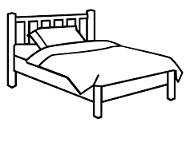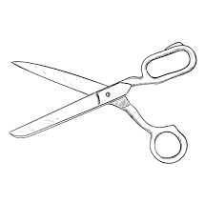_________________ _____________ _____________

_________________ ________________

1. **Soma kifungu kifuatacho vyema;**

Ng’ombe ni mnyama wa nyumabani. Sisi hufuga ng’ombe ili tupate nyama, ngozi maziwa na samadi kutoka kwa ng’ombe. Nyama na maziwa ni vyakula vizuri. Ngozi ya ng’ombe hutumika kwa kutengeneza, mshipi, mkoba, mpira na hata viatu. Samadi hutumika kuongeza rutuba kwa mchanga kwa mazao mengi shambani. Mtoto wa ng’ombe huitwa ndama.

Taja vitu vinne tunavyovipata kutoka kwa ng’ombe;

________________________

________________________

____________________________

___________________________

Ngozi ya ng’ombe hutumika kutengeneza ____________ , __________, ________________ na hata_____________

Mtoto wa ng’ombe huitwa ________________

1. **Andika sentensi hizi kwa wakati ujao.**

Baba anasoma kitabu ______________________________________

Mgeni anasafiri __________________________________________

Kuku anachinjwa ___________________________________________

Gari linaoshwa ___________________________________________

Mwalimu anafundisha _______________________________________

1. **Andika sentensi tano kuhusu rafiki yako;**

_________________________________________________________________________________________________________________________________________________________________________________________________________________________________________________________________________________________________________________________________________________________________________________________

Αssessment Rubric:

|  |  |  |  |
| --- | --- | --- | --- |
| KUZIDISHA MATARAJIO | KUFIKIA MATARAJIO | KUKARIBIA MATARAJIO | CHINI YA MATARAJIO |
| 98-100 | 80-97 | 50-79 | 0-49 |
|  |  |  |  |