**COMPETENCE BASED CURRICULUM**

**ΑSSESSMENT ONE 2024**



CBC



01

**CREATIVE ARTS GRΑDE TWO**

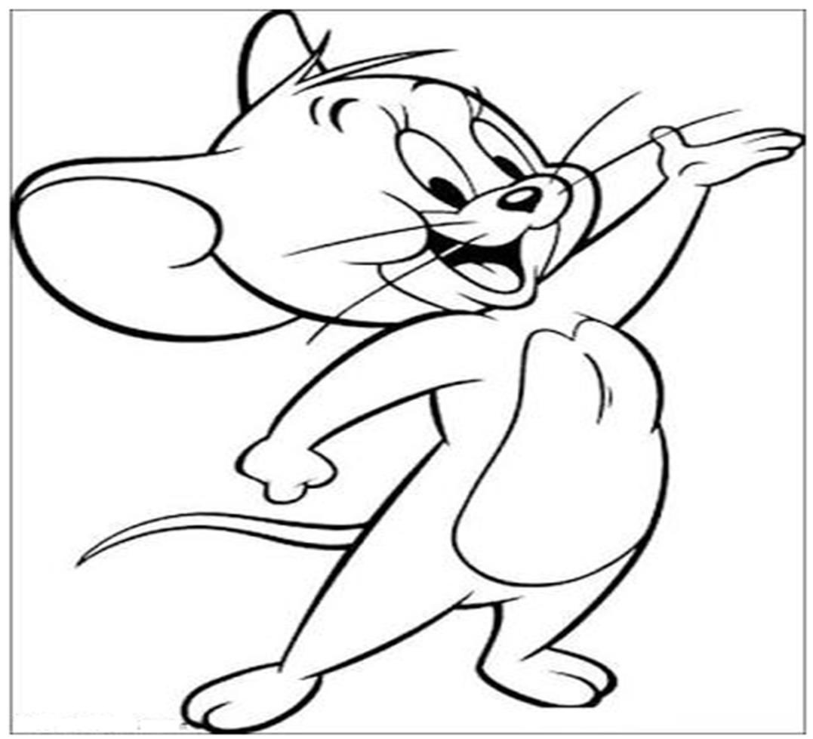

Name:

School:

Grade:

Date: .

**ART AND CRAFT ACTIVITIES**

1. We can feel texture by_______________________________ **(___/1mk)**  
   (Touching, tasting, seeing)
2. Write two things we use when colouring pictures.
   1. _______________________________
   2. ______________________________ **(___/2mks)**
3. Circle the word that does not describe texture____________________________  
   (Rough, far, smooth) **(___/1mk)**
4. ______________________________is used for cutting papers.   
   (Scissors, pencils, rubber)
5. We decorate fabrics to make them_______________________________  
   (clean, dull, beautiful) **(___/1mk)**
6. 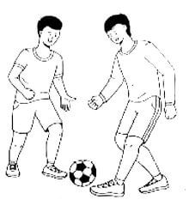Colour the picture below.   
   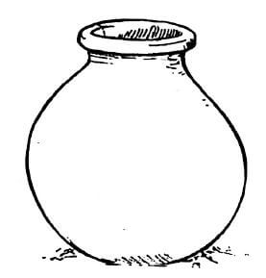**(___/5mks)**
7. Observe
8. Which game are the boys playing?____________________________________ **(___/1mk)**
9. Which play item are the boys above using?____________________________ (net, ball, food) **(___/1mk)**
10. Which other game can you play by catching?__________________________ **(___/1mk)**
11. Bending and curling help us to. _________________________________(Balance, fall, jump) **(___/1mk)**
12. Colour the picture below.  
    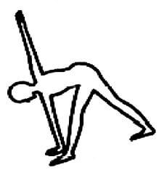**(___/3mks)**
13. **Practical activity**  
    With the help of your teacher, perform the activity in number 5 above

**(___/3mks)**

1. Name two places where the National Anthem is sung.
   1. _________________________________
   2. _________________________________ **(___/2mk)**
2. Draw an instrument played by hitting.

**(___/4mks)**

1. We play______________________________in a singing game. **(___/1mk)**  
   (Cartoons, games, station)
2. We show that we can_______________________________when we improvise rhythms.  
   (dance, sing, cry) **(___/1mk)**
3. Colour the picture below.  
   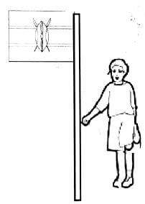**(___/2mks)**

Assessment Rubric:

|  |  |  |  |
| --- | --- | --- | --- |
| Exceeds Expectation | Meets Expectation | Approaching Expectation | Below Expectation |
| 50 - 48 | 40-47 | 30-39 | 0-29 |
|  |  |  |  |