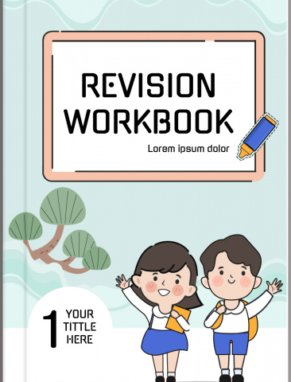
G1
CRE
CREATION

- God created man using ________________(sand, soil)

- I am ________________ before God (useless, important)

- God knows me by my ________________

- A nuclear family has father, mother and ________________

- Children are a ________________ in the family (gift, curse)

- Go ________________ us.(hates, loves)

- ________________ is talking to God.

- ________________ is a female parent.

- ________________ is a male parent.

- Father and mother are my ________________

- Some of the things we do together as a family are;-

________________________________

________________________________

- When do we pray as a family?

________________________________

________________________________

________________________________

- Things we don't share are called ________________

- Plants were created on ________________ day.(3rd 4th 5th)

- Name three plants that God created

________________________________

________________________________

________________________________

- We should care for the animals by

________________________________

________________________________

- Animals were created on _______________ day (5th, 6th, 7th)

- Which animals did God love most _______________

(wild, domestic, all)

- Wild animals live in the _____________________________

- Domestic animals are found in our ______________________________

THE HOLY BIBLE

- The Bible has _______________ divisions

- The New Testament has _______________ books (Gospel, English)

- The first two Gospel books are _______________ and _______________

- The holy book of God is called ____________________________

- How many books does the Holy Bible have? _______________

- I should read my Bible _______________ (everyday, sometimes)

- The _______________ is the holy book of God

Bible Stories David and Goliath
- David trusted in ______________________

- Like David we should always _______________ in God

- David killed Goliath using _______________ and _______________

- A _______________ is a person who looks after sheep.

- _______________ was a giant
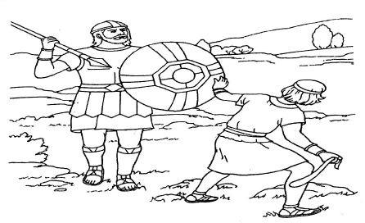

- David had _______________ in God (Fear, faith)

- _______________ was a young boy who liked to sing and was a shepherd. Joseph and his coat of many colours
- Joseph had _______________ brothers

- Joseph brothers were _______________ of him (loving, jealous)

- Joseph had _______________ dreams

- Joseph's brother pushed him into a _______________ before choosing to sell him as a _______________ in Egypt

- Did Joseph's brother love him or hate him? _______________

- Joseph had _______________ dreams (1,2)

Elijah and the chariot of fire

Use the words to fill in the blank spaces
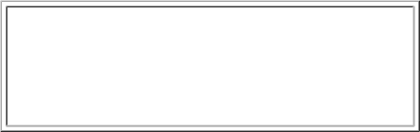

Food mountain Fire water

king Quick sad prophet

- Elijah was a _______________

- Elijah was hiding from an evil _______________

- An raven brought Elijah _______________ and _______________

- God spoke to Elijah on_______________ a called Horeb.

- On the mountain, God spoke in a_______________ voice.

- Elisha was _______________ when Elijah left in the chariot of _______________

- Elijah was a man of God. He was a _______________

- God loves _______________ children. (lazy, obedient)

- _______________ went up in a chariot of fire.
THE EARLY LIFE OF JESUS CHRIST

The birth of Jesus Christ

- Jesus was born in the town of _______________ (Bethlehem, Nandi)

- Joseph was his earthly _______________ (son, father)

- The mother of Jesus was _______________ ( Hannah, Mary)
- Bethlehem is a city in _______________(Judea, Egypt)

- Angel _______________ told the shepherds baby Jesus was born (Mary, Gabriel)

- The _______________ were the first people to see Jesus.

- A _______________ led the wisemen to where Jesus was.

- Jesus was laid in a _______________

- King _______________ was jea lous of Jesus

- Jesus grew up in the city of ___________________

Jesus Christ in a temple

Use the words below to fill in the blanks

When Jesus was |  |  | 11 |  | years old, he went with His | 12 | to Jerusalem for the |  | 13
 | of the | 14 |  | . After the feast was over they were returning home when His parents realized that |  |  |  |  | 15

was not with them. They returned to Jerusalem to took for Him. After searching for 16 , thye found Him in

the | 18

 | Parents | Teachers Jesus Passover
 | three | temple Feast twelve

Baptism of Jesus Christ

- Why should we be baptized? ______________________

- Who baptized Jesus? ______________________

- John and Jesus were ______________________ (brothers, cousins)

- Jesus showed ______________________ when He accepted John to baptize Him. (pride, humility)

- Jesus was______________________ to God when he went to be baptized (rude, obedient)

- Jesus was baptized in River ______________________

Wedding at Cana of Galilee

- The first miracle of Jesus was changing ________________ into ________________ at the wedding at Cana.

- Cana was in ________________ (Nazareth, Galilee)

- Jesus attended a wedding at ________________ in ________________

- Jesus changed ________________ jars of water into wine. (5,6,12)

- A Ceremony where two people are being united in marriage is called ________________(funeral, wedding)

CHRISTIAN VALUES

Sharing

- When we share, we show others ________________(love, hate)

- The little boy had ________________ loaves of bread and ________________ fish. He shared with Jesus and the disciples to feed the crowd.

- When we share we feel ________________ (happy, sad)

- Jesus shared ________________ (wine, soda, tea) Obedience /honest
- Children should ______________ their parents

- Samuel was called by God and he ______________

(ignored, answered)

- You trust and ______________ God (obey, refuse)

- Doing what you have been asked to do is called ______________ (sharing obedience)

- Children ______________ your parents for it is the right thing to do.

- God loves children who are ______________ (obedient, rude)

- Telling the truth is ______________ (obedience, honesty)

The Church

- A place of worship is called ______________

- Write two things people do in church

____________________________

____________________________

- We go to church on ______________(Sunday, Monday)

- We respect the church by

____________________________

____________________________

____________________________

ENGLISH

Exercise 1

Fill in the missing letters

- M___rn___ng

- Af___ern___ ___n

- E__ e ___ing

- N___gh___

Match the pictures with words
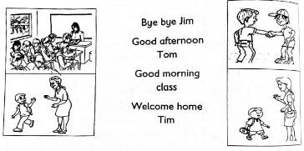

Fill the gaps with "am", "is" and "are"

- I _______ six years old

- This _______ a box

- These _______ my fingers

- The boys _______ playing with a ball

- That baby _______ eating

- the man _______ walking

- My mother _______ cooking

- We _______ playing with the baby

Write in small letters

- FATHER ____________________

- HOUSE ____________________

- CHAIR ____________________

- RULER ____________________

- TREE ____________________

- TEACHER ____________________

My School

Exercise 2

Name these pictures
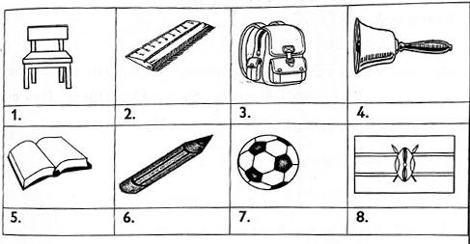

Write in plural

- boy ______________

- bed ______________

- deer ______________

- apple ______________

- duster ______________

- beak ______________

- dog ______________

- tree ______________

Write words that begin with these sounds

- th ______________

- b ______________

- cl ______________

- h ______________

- s ______________

My Family

Exercise 3

Read the story below

My nam is John. I am a boy. My parents are Mr and Mrs James. They are so loving. My grandparents are Mr and Mrs.

Oteino. they are old but look young. My brother is aAndrew. My sister is Linet.

- Mr James is John's F__th__r

- Mrs Otieno is John's g_________________

- Linet is John's _______________________

- Mrs James is John's m_________________

- Andrew is John's b____________________

- ____________________ are my brother

- ____________________ is my sister

- ____________________ will show me your father

- ____________________ are my family

- This is Ann. ____________________ is my sister

11. ____________________ are going to see my parents.

Home

Exercise 4

Name these things found at home.
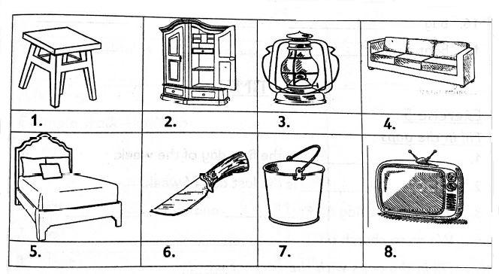

Draw the following

 | 9. Knife |  | 10. Spoon |  | 11. bucket |  | 12.Plate

Copy the words below three times

- brown ____________________ ____________________ ____________________

- book ____________________ ____________________ ____________________

- basin ____________________ ____________________ ____________________

- bag ____________________ ____________________ ____________________

- boat ____________________ ____________________ ____________________

Time

Exercise 5

Fill in the gaps

- ____________________ is the first day of the week

- ____________________ is the last day of week

- We raise the flag on F____________________ and on M____________________

- We go to church on ____________________

Fill in the gaps with the correct words

- My mother ____________________(go, goes) to the market

- I ____________________(brush, brushes) my shoes.

- Our teacher ____________________(marks, mark) the register.
- We ____________________(plays, play) at break time.

- The head teacher ____________________ (speaks, speak) at parade.

- Mike ____________________ to school at 7 O'clock (go, goes)

- We ____________________ story books in the library.(raed, reads)

- I ____________________ lunch at 1 O'clock (eats, eat)

Weather and Environment

Exercise 6
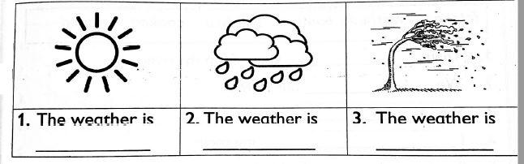

Add-ing

Example walk- walking

- eat ______________________

- sleep __________________

- cry __________________

- go __________________

- plant __________________

- play __________________

- cook __________________

- write __________________

- run __________________

- fly __________________

Add-ing to make correct sentences

- The boy is __________________ in his book (write)

- The baby is __________________(sleep)

- The teacher is __________________(teach) grade one

- We went __________________(swim) yesterday.

- My mother was __________________(sweep) when I got home.

Hygiene

Exercise 7

Use the correct word from the box to fill in the gaps

fetched washed combed brushed cooked jumped

- They __________________ water from the river

- We __________________ our clothes
- She __________________ our clothes

- I __________________ my teeth

- Susan __________________ the food

- He __________________ over the fence

- Find these words in the puzzle
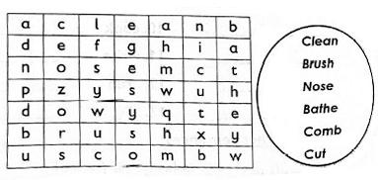

- He __________________(jump) over the rope yesterday

- They __________________(move) the car from here

- The doctor __________________(treat) her with medicine.

My Other Family

Exercise 8

Use the correct word to complete the sentences.

Mother nephew cousin uncle grandfather
- The brother of my mother is my __________________

- The son of my sister is my __________________

- The father of my mother is my __________________

- The female parent is my __________________

- The daughter of my uncle is my __________________

Safety

use in, on, and, under, between, to fill the gaps provided.

- This is cup is __________________ the chair.

- The dog is __________________ the table.

- The milk is __________________ the glass

- The boy is standing __________________ the tree.

- The girl is standing __________________ the boys.
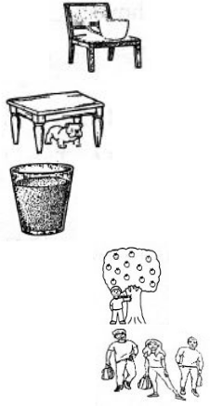

Community Leaders

Exercise 9

Fill in the gaps using "ee" and then read.

- F __ __ t

- Gr __ __ t

- M __ __ t

- Sl __ __p

- Gr __ __ n

use "a" "an" or "the"

- I have eaten ______________ apple

- Point at ____________moon

- She gave me ____________ doll.

- Colour ___________sky.

- We saw ______________elephant at the park.

- A cat eats _____________rat.

- Do you have _____________ umbrella?

- Did the hen lay _____________ egg?

- They live in _____________ big house.

- He draws with _____________ pencil.

Living Together.

Exercise 10

Fill in using its , mine my your, our, their, her, his Example: This is Jen. this is her book.

- This is Berry. This is _________ puppy.

- This is John and me. This is _____________ house.

- Thei is Peter and Wendy. This is _____________ flower.

- This is me. This is _____________ desk.

- This is you. This is _____________ cup.

- This is a kitten. This is _____________ toy.

Fill in the gaps

- I have _____________ fingers in _____________ hand.

- Our classroom has _____________ windows.

- My toy car is colour _____________.

- My sweater is _____________ in colour.

- A book looks like a _____________(circle, rectangle)

- A ball is _____________(square, round)

- A __ ___ eats grass.

- Keep your ___ ___ir clean.

Technology

Exercise 11

Fill in the blanks using where, who or what

- _____________ is your home?

- _____________ is your friend?

- _____________ are you doing?

- _____________ took my pen?

- _____________ lost his pen?

- _____________ does a doctor do?

- _____________ lost his sweater?

- _____________ did you keep the spoon?

- _____________ is the colour of your dress?

- _____________ do you go after school?

Count and write the numbers.
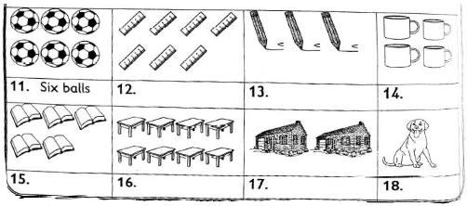

Literacy

Exercise 12

Name these pictures
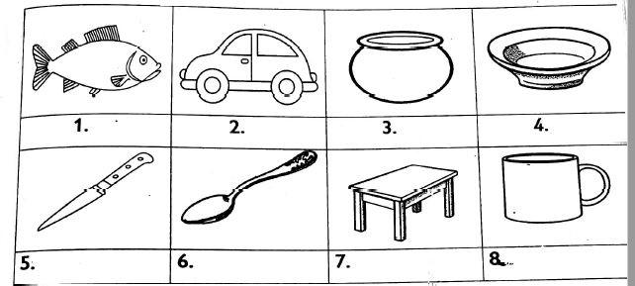

Match the greeting with the correct time.

9. | Good morning | midday
10. | Good evening | night
11. | Good afternoon | morning
12. | Good night | evening.

Exercise 13

Circle the correct answer

- She ate some __________________(rake, cake, make)

- The ________________ ate bananas (monkey, mocky, money)

- I ate cake in a ________________(mate, fate, plate)

- We can play a ________________(name, game, some)

- What is your ________________?(fame, tame, name)

- I am ________________ for the race(late, mate, gate)

- I see a fake ________________(make, take, snake)

- We saw inside a ________________(save, cave, gave)

Use the words in the box to complete sentences

is are am
- I ________________ a good boy.

- We ________________ are sitting down.

- We ________________ talking

- They ________________ going to the classroom.

- She ________________ driving a van.

- He ________________ kicking a ball.

- I ________________ riding a bike.

Exercise 14

Circle the odd one out.

 | 1 |  | mother |  | came |  | father |  | mat
 | 2 |  | cut |  | neck |  | visit |  | stand
 | 3 |  | want |  | window |  | winner |  | dot
 | 4 |  | meat |  | moon |  | mouth |  | share

1. Car 2.Book

Underline the doing words

- My mother told me to come.

- I like eating nuts.

- I can touch my neck

- The monkey climbs a tree.

- Linda can clean her nose.

- Tom knows hows to save money.

Write the sounds of the words below and say them

Example: Cat C a t

- Lorry __ __ __ __ __

- Red __ __ __

- Moon __ __ __

- Ball __ __ __ __

- Shoot __ __ __ __ __

- Bird __ __ __ __

Exercise 15

Draw the following

Fill in the blank

- My name is ________________

- I am in grade ________________

- I am ________________ years old.

- My grandfather's name is ________________

- My mother's name is ________________

- My brother's name is ________________

Write two words beginning with the following letter sounds

- s ________________ ________________

- m ________________ ________________

- n ________________ ________________

- b ________________ ________________

- t ________________ ________________

Exercise 16

Form other words from the word.

Potatoes

- Pot

- ________________

- ________________

- ________________

- ________________

- ________________

Say five words you can form from the sounds in the table below.
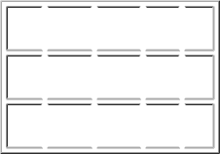

su ma u d le

ga fu wa ca tt

zi ra ki le li

Example

- Ugali

- ________________

- ________________

- ________________

- ________________

- ________________

Complete these sentences

- Mother is ________________ the baby (washing, feeding)

- Father is ________________ to Kanini. (talking, calling)

- Kakai is ________________ a book. (writing, reading)

- The dog is ________________ with a show. (playing, walking)

17. The boy is ________________ food.(cooking, eating)

Exercise 17

Read the story below

Peter's Family

Peter lives with both his father and mother in the city. Peter has one brother and two sisters. During the holidays, Peter visits his grandparents in the countryside. He helps them with chores. He also enjoys playing with his cousins.
- Where does Pter live? ________________

- How many brothers and sisters does Peter have? ________________

- When does Peter visit his grandparents? ________________

- How does Peter help his grandparents? ________________

- You are borrowing a sharpener from a friend. What would you say? ________________

- What would you say after receiving a gift? ________________

- What would you say when your mother welcomes you home after school? ________________

Write eight sentences about this picture

- ________________________________

- ________________________________

- ________________________________

- ________________________________

- ________________________________

- ________________________________

- ________________________________

- ________________________________

ENVIRONMENTAL
Health Practices

- Put a tick on healthy habits and an x on unhealthy habits

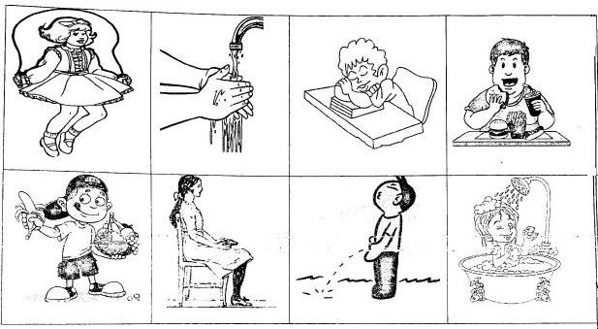

- Healthy habits are things we do to stay _______________( healthy, thin, fat)

- We should wash our hands ____________ visiting the toilet. (before, after, ever)

- We should _______________ the toilet after using it. (not flushing, flush, cover)

- You should wear__________clothes after taking a bath.(clean, dirty, torn)

- After working, our bodies need some________________(waste, rest)

- A clean body smells ____________(bad, good)

- We should eat healthy ___________(water, food)

- Good health habits prevent ____________(illness, welfare)

- Tick the healthy food.
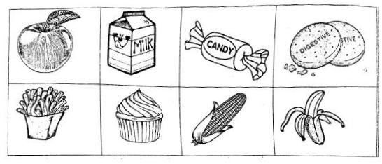

Care for The Teeth

- The first teeth to grow are called ____________teeth

- We should brush our teeth ___________times in a day.

- We use_____________ and _____________ to brush our teeth.

- The second set of teeth to grow is called _____________teeth.( milk, permanent)

- Fill in the missing gaps with the correct answer

How to remove teeth in a clean way

  - Wash your___________(hands, teeth)

  - Hold the tooth with a clean ______________(scissors, cloth)

  - Remove the _________________

  - Put the tooth in a _________________

  - Gurgle ____________ water

- teeth that we remove are _________________teeth. (milk, good)

- This is a ______________.

- A small baby has ____________ teeth (0,4,32)

- Join the dots and colour
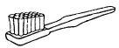
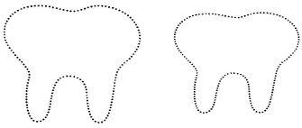

- Before removing our tooth we should ____________our hands(wash, bring)

- When we find a loose tooth we should tell an __________(adult, anybody)

- Drinking milk makes our teeth ____________(bad, strong)

Uses of Medicine

- Sick people take _____________ to feel better (medicine, milk)

- We should always keep machine in a __________ cupboard. (closed, open)

- Touching medicine with dirty hands is __________(good, bad)

- We should take medicine using ___________water(clean, sweet)

- Match the correct name of the medicine
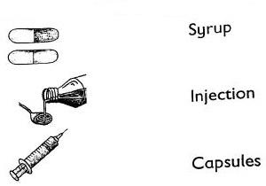

Personal hygiene

6. Name the body parts
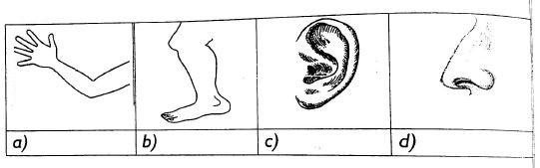

7. Name these items
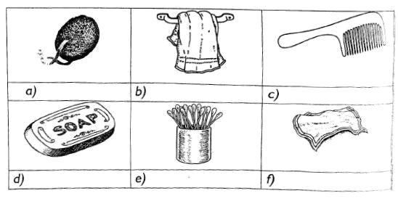

- We clean our nose using a ____________________

- We wash our bodies using _________and ______________

- We use this to make our hair neat________________

- Ear buds helps us to clean our ________________

- after bathing, we wipe our bodies using a ____________________

- Personal items should not be __________( shared, thrown away)
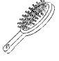

Use of Toilets and Latrine

1. Name the following
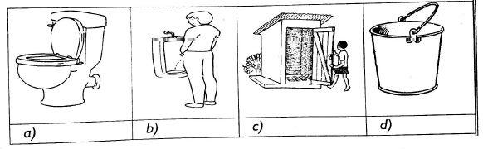

- Every home should have a _______________(television, knife, toilet)

- We should not pass faeces in _________________(toilet, urinal, latrine)

- We should wash our ___________after using the toilet.

- Clean toilets smeel ____________(good, bad)

- Good use of toilet and latrines prevents ________________(diseases, toilets , urinating)

- Latrines are built _____________ the house ( outside, inside)

- Fill the passage on how to use a toilet
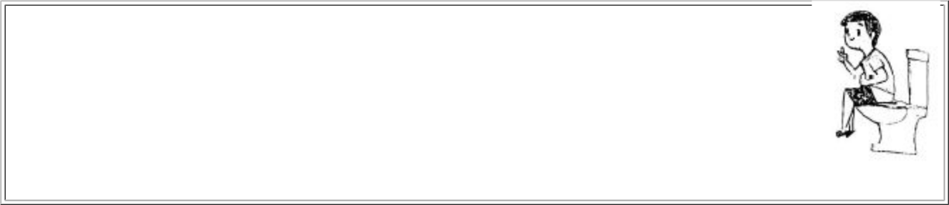

Sit on the __________,(toilet, hole) wipe yourself with a _________(rug, tissue paper) or clean yourself with__________. (soil, water)Throw the used toilet paper into the ___________(floor, toilet)after use.

Food
1. Colour these fruits to show they are ripe.
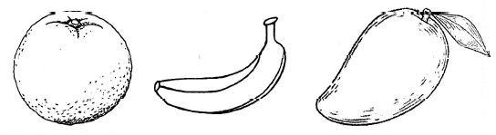

2. Name these foods that are green in colour
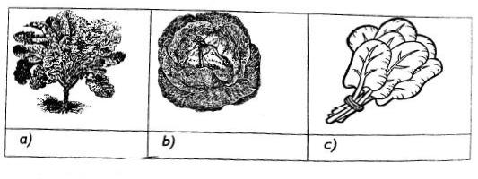

- Name two foods we buy from the market

  - ______________________

  - ______________________

- An ________________ is a fruit (beans, sukumawiki, orange)

- Name four fruits

  - ___________________________

  - ___________________________

  - ___________________________

  - ___________________________

- Milk is ______________________in colour (green, white, red)

- Circle the foods below that we get from plants

Guava | Apple | Bacons | Grapes | Chicken
Passion | Milk | Peas | Avocado | Sausages
Oranges | Meat | Sugarcane | Eggs | Bread
- We eat the stem of a ___________(sugarcane, cassava)

- We eat roots of

  - ________________

  - ________________

  - ________________

Eating Habits

- Which food do you like most

  - ________________

  - ________________

  - ________________

- I like eating ________________ and ________________ in the morning

- I do not like eating these foods. Tick them

FishCoconutChickenEggs

Pineapple Mala Kales Meat

Maize Water melon Potatoes Oranges

- Foos like ________________ and ________________ are not good for my teeth. (carrot, biscuits, milk, sweets)

- We can know food by its colour , taste, smell or ________________(touch, type)

- Foods that taste bitter are not good for our bodies (yes or no)________________

- Lemon tastes ________________(bitter, sour, sweet)

- We should eat ________________ fruits (fresh, rotten, dirty)

- Fruits should be ________________ before eating them.

- We eat everyday to get ________________(sick, energy , fat)

Good behaviour during meal time

- The time we eat is called _____________(meal time, lunch time)

- We should clear the table ________________ eating (before, after, when eating)

- You should chew food with mouth ________________(open, closed, laughing)

- Do not ________________ food(waste, eat)

- Which picture shows good behaviour when eating .
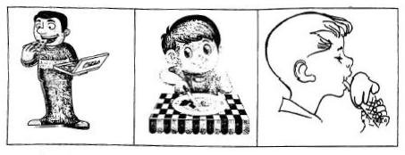

- Serve food that you can ________________(finish, waste, play with)

- a restaurant is a place where ________________ food is sold (raw, cooked, chips)

- Name two foods you buy from a super market

  - ________________

  - ________________

- Which food do we buy from the butchery ________________

- We buy fruits and vegetables from the ________________

Safety Education

- An ________________ is bad thing that happens to us. ( cut, accident, falling)

- ________________ can cause accidents in the kitchen. ( a knife, blanket)

- We can prevent falls by ________________( not playing with a knife, keeping the floor dry)

- Electricity can cause ________________ (electric shock, drowning)

- Look at the pictures and say what has happened to the children.
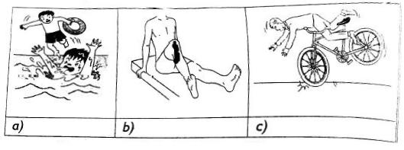

- Name 3 accidents that can happen at home.

  - ________________

  - ________________

  - ________________

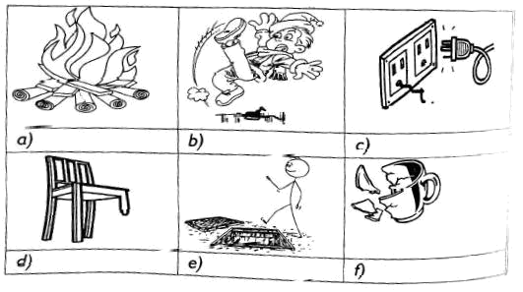
- Name these items that can cause accidents at home.

- we should put all wastes in the ________________

- Name two dangerous chemicals found at home

  - ________________

  - ________________

- Dangerous chemicals at home should be kept ________________ ( near food, away from food)

- ________________ is the first help given to a hurt person.

- We keep first aid things in a ________________(first aid kit, box, kitchen)

- Name four things that can cause accidents in our classroom

  - ________________

  - ________________

  - ________________

  - ________________

- Name these items found in a first aid box
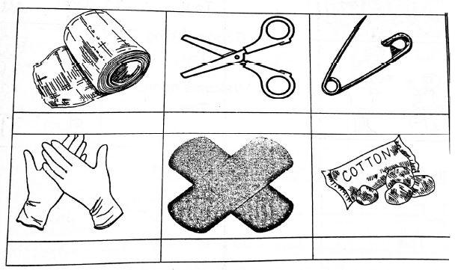

15. We do first aid on a cut to ________________ ( stop crying, stop bleeding)

The Sky

- What is the colour of the sky ________________

- How many suns are found in the sky ________________

- Name two things we see in the sky during the day

  - ________________

  - ________________

- Name two things we see in the sky at the night

  - ________________

  - ________________

- Sun rises up in the ________________(morning, evening) Write true or false
- We can see the sun during the ________________

- There are two moons in the sky ________________

- Stars are seen during the night ________________

- Sun keeps on moving during the night ________________

- Moon appears in different shapes ________________

- Draw the following
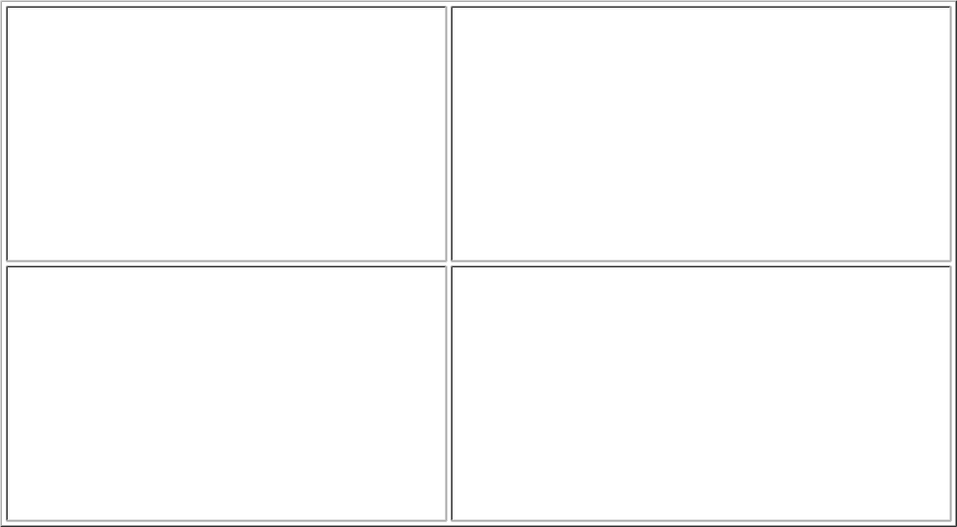

Sun

Cloud

Star

Moon

Exploring weather conditions

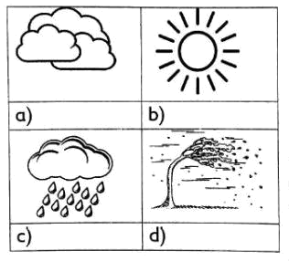
Name the weather symbol

Write true or false

- Weather changes ________________

- It can rain during the day or night ________________

- It can be hot during the night.

- Clouds are dark when it is raining ________________(true, false) Write what we do during the following weather
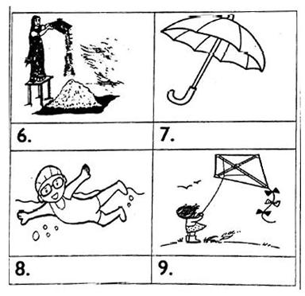

- On rainy day we near ________________(gumboots, slippers)

- When trees are standing still the weather is ________________(calm, windy)

Sources of Water

1. Find out the sources of water and write.
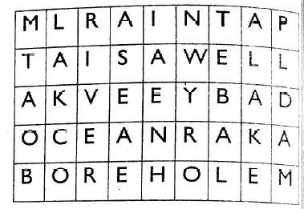

  - ________________________________

  - ________________________________

  - ________________________________

  - ________________________________

  - ________________________________

- ________________ is the main source of water.

- Name the sources of water

Use of water

- Write down three uses of water at home.

________________

________________

________________

- Name the uses of water shown in the picture
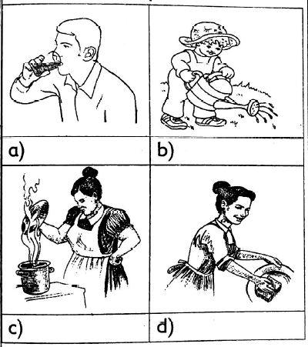

Soil

- Write three uses of soil

________________

________________

________________

- We do modelling using ________________ soil

- Write two things we can make using soil ________________

- Which type of soil is used for making stone houses________________

- Roots of plants are found in the ________________

- Name two types of soil

________________

________________

- After using soil we should wash our ________________

- When water is mixed with soil we get ________________

Plants

Write true or false

- Plants give us food ________________

- Plants make our environment ugly ________________

- Most plants are green in colur ________________

- Plants are home for wild animals ________________

- All plants look the same ________________

- Some plants are thorny ________________

- Plants give us

  - f __ __ d

  - m __ d __ c __ ne

  - pr __ t __ ct __ on

Name the plants below
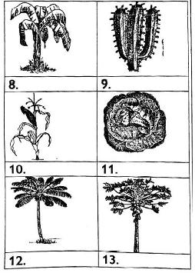

Animals

- Animals that live in our homes are called ________________

- Animals that live in the forest are called ________________

- Write four small animals

  - ________________

  - ________________

  - ________________

  - ________________

- Write why we keep these animals

  - Dogs ________________

  - Bee ________________

  - Cow ________________

  - Donkey ________________

- Name the following animals
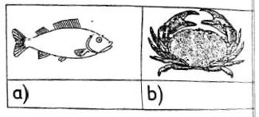

- Where do the animals above live ________________

- Draw two big animals
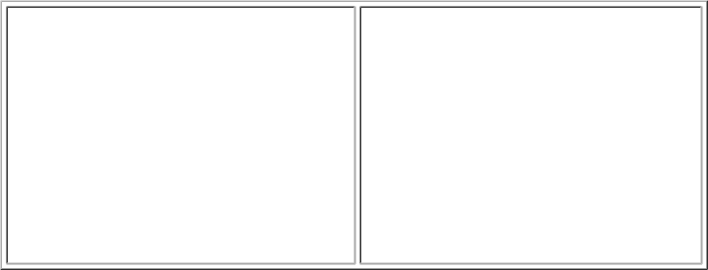

8. Name the following animals
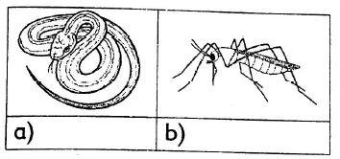

- The above animals are ________________(friend, dangerous)

- These are the homes of?
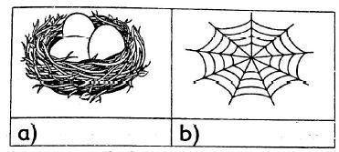

Energy:Sound

- Name three animals that make sounds

  - ________________

  - ________________

  - ________________

- Choose sound made by the following from the box

  - Dog ________________

  - Bell ________________

  - Cat ________________

  - Ambulance ________________

  - Car ________________

Hooting, ringing, siren, meow, barking

- Match the sound alert with the correct danger

 | Sound alert |  | Meaning
 | Ambulance |  | A burning house
 | Police siren |  | Thieves
 | Fire engine siren |  | Sick person
 | Screaming |  | Danger
4. Fill the answers using words in the box

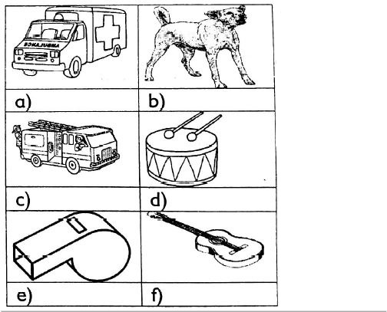

fire engine, guitar, drum, ambulance, dog, whistle
- Loud sound is ________________ with our ears

- We should avoid ________________ sounds.

Social Environment

Home environment

- Things found in the kitchen are called ________________

- Furniture are things made of ________________

- Name three utensils found at home

  - ________________

  - ________________

  - ________________

- Most of the things found in the stores are ________________

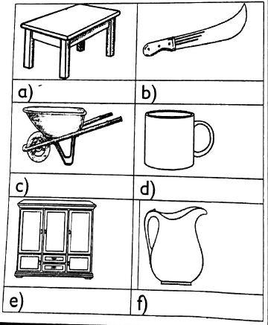
- From the picture write "furniture""tool" or "utensils"

6. Circle things found in the store
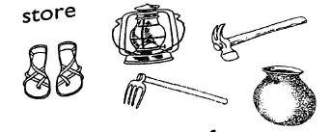

7. Write the uses of:

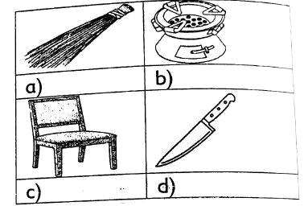

Keeping the home environment clean

- ________________ causes diseases.(dirt, cleanliness)

- Fill the gaps with way of cleaning

  - W __ p __ ng

  - Sw __ ep __ ng

  - Sl __ sh __ng

  - M__ pp __ng

- Write the three things that make our compound dirty.

________________

________________

________________

- We cut grass in the compound using ________________.

- What are they doing?
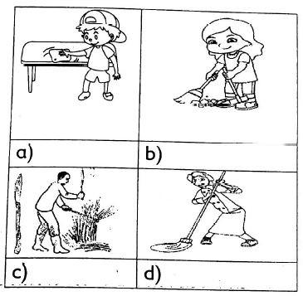

- We can keep our home environment clean by:

  - ________________ the compound using broom

  - ________________ long compound using slasher or panga

  - ________________ rubbish

  - ________________ the fence

( trimming, throwing, collecting, cutting, sweeping)

Keeping safe and secure at home

- Leaving tall grass in your home will welcome ________________ that cause bite ( snakes, grasshopper)

- Not draining water in our compound brings ________________ thta cause malaria. ( Flies, mosquitoes)

- If I play ith fire, I'll get ________________ ( warm, burnt)

- An untidy class looks ________________(good, bad)

- We should not ________________ with a shyarp knife. (play, eat)

- I should use a ________________ to dry the floors (rug, shirt)

- I should throw fruit peels in the ________________ (dust bin, floor)

- Touching sockets with wet hands can cause ________________(shock, happiness)

- Waht danger can be caused by? Pick answer from the box
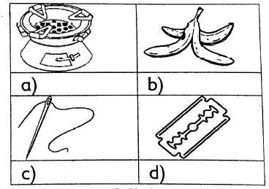

cut, prick, fall, burn

Child rights and responsibilities

- Write yes or no, if it is a child right

  - A right to a name ________________

  - A right to employment ________________

  - A right to good food and clean water ________________

  - A right to work hard in school ________________

- Match the rights with the pictures.
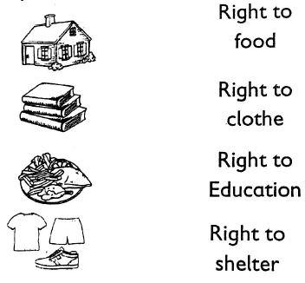

- Write three responsibilities you do to help your parents at home.

________________

________________

________________

Meeting family needs

- Things we must have to live are called ________________

- If I am thirsty, I should ________________ (eat food, drink water)

- We should drink clean and ________________ water.

- The other name for home is ________________ (latrine, shelter, hole)

- Street families don't have shelter ________________ (true, false)

- We cannot live without ________________ (cars, shelter, church)

- Every home must have a ________________ (television, toilet)

- A person who makes furniture is called a (farmer , carpenter)

- A person who plants crops is called a ________________ (doctor, farmer)

- Where do we get food from ________________ (farm, hospital)

Enterprise project

1. Draw two things a family buys using money


Choose the correct word from the box

( fish, driver, teaching , clothes, cattle)

2. My uncle makes money by selling ________________
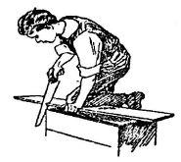

3. My father works as a ________________ to make money
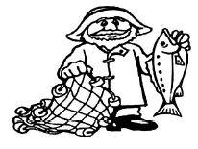

Write true or false

- We should steal things and sell them ________________

- We should sell things at the right price ________________

- We should sell things that are good ________________

- We don't have to work for money ________________

We should sell the right amount of things to people

- ________________

Care for the environment

Care for plants

- Name two ways you would care for plants

________________

________________

- Name two ways you would care for animals at home

________________

________________

- How many times do you water flowerbed ________________

( once, twice)

- We water plants in the ________________ and ________________

- Name three things you can use to water seedbed

________________

________________

________________

- Write true or false

  - We should give plants plenty of water ________________

  - We should water the soil and not the leaves ________________

  - We water plants in the morning ________________

Care for Animals

- A cat drinks ________________

- Cows like to eat ________________

- Hens and ducks eat ________________

- Dogs eat ________________

- Goats and sheep eat ________________

Caring for water

- After bathing or washing opur hands we need to ________________ the tap to save water.

- If a tap is leaking I can put ________________ to stop water going to waste.

- We can use water that has been used to rinse clothes to ________________________________________________

- Mention two ways you can re-use water

________________

________________

- What else can you use to water flowerbeds if you don't have watering can ________________.

Managing waster responsibility

- Name three wastes founds in your home

________________

________________

________________

- Name three wastes found in the classroom

________________

________________

________________

- We wear ________________ to stop dust freom getting into our nose(dust mask, glove)

- Hold waste ________________ your body. ( near, away from)

- Wear ________________ to protect your hands ( gloves , dust mask)

- Wear ________________ to protect your feet. (gloves , gumboots) Write true or false
- Waste is not harmful ________________

- Waste should be put in the right places ________________

- A dust mask helps us when sweeping dusty places ________________

Caring for water

Match the sentence with where is belong
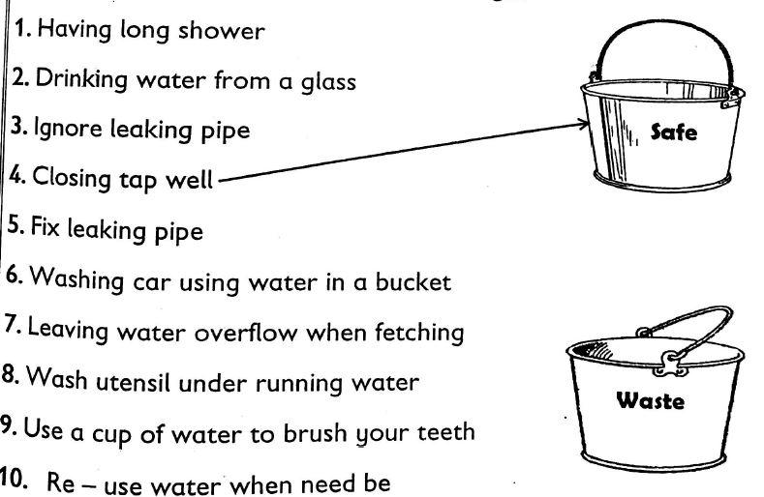

Conserving light energy

1. Draw and colour what gives you light at home.


2. Write the names of these source of light.
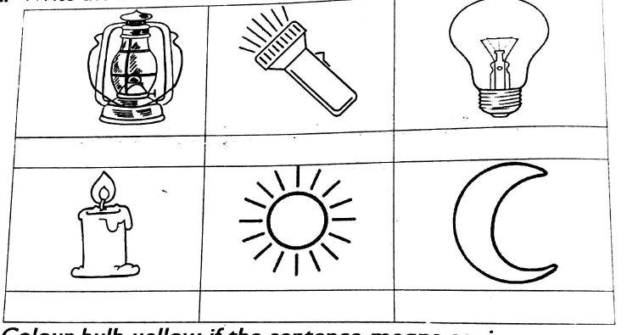

- Colour bulb yellow if the4 sentence means saving energy.

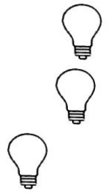
  - Turn off lights when you leave a room

  - I use light from the sun during the day

  - I sleep with my bedroom light on

  - I turn off the light when we leave the classroom


  - I light the torch during the day.
  - 

IRE

QURAN

- Write the missing letter

- Write the Arabic alphabet
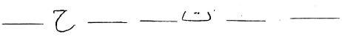

Ha Jim Tha

_____ _____ _____ _____

Ta

_____

Ba

_____

Alif

- Arrange these letters
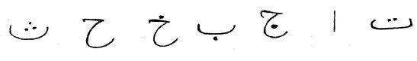

__________________________________________________________________________

- Copy these letters
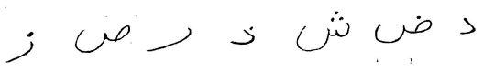

_________________________________________________________________________

- Write the Arabic letters with Fatiha

 | ______ | ________ ________ |  |  | ________ | _______
 | Fa | Gha |  | Swa | Sha |  | Za
6. | Write the Alphabet with Kasma
 | ______ | _______ | ______ | _______ _______
 | Hi | Ji | Thi |  | Ti | bi
7. | Write the alphabet with dhumma
 | _____ | _____ | ______ | ______ | ______
 | Su | Zu | Ru |  | Dhu | du
- Complete the order of the sounds
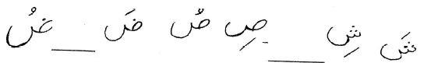

- Surah faatiha has _______________ aya (6, 7, 8)

- We read Surah Nas before ________________________

(drinking, eating, sleeping)

PILLARS OF IMAN

- My name is _____________________________

- I am a Muslim _____________________________

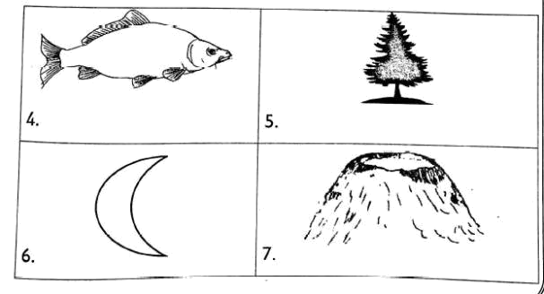
- I worship one God called _____________________________(Allah, word)

- Name these creations of Allah

(moon, tree, fish, mountain)

Write three Angels of Allah

- ________________________________

- ________________________________

- ________________________________

SIRAH ( LIFE OF PROPHETS)

Fill in missing letters

- My prophet is M __ha __ ___ d

- My prophet was born in M __kk ___h

- My prophet was born on a M __ nd __y

- The father of Prophet (S.A.W) was ____________________

(Abu twalib, Abdullahi, Abdu Lahab)

- The mother of prophet (S.A.W) was ____________________

(Aisha, Amina, Sofia)

- The grandfather of the prophet (S.A.W) was ____________________

(Abdulmutwalib, Abu Twalib)

- Amina died when Muhammad was ____________________ years old (eight, two, six)

- Draw the Kaaba

- ____________________wanted to destroy the Kaaba. (Abu Lahab, Abraha)
- I face ____________________ white praying. ( Mosque, Imam, Qibia)
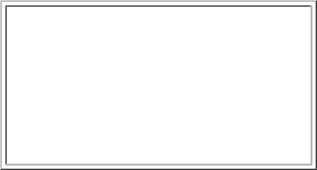

HADITH

- ____________________ is cleanliness. (Swalah, Saum, Islam)

- Allah loves people who are ____________________ (Dirty, lazy, Clean)

- ____________________ is part of Iman.(cleanliness, sleeping, eating) Choose the correct answer
- I brush my ____________________ everyday

- I wash my ____________________ everyday

- I put on clean ____________________ after bathing.

- I cut my____________________ short.
- I clean my ____________________ always. (Nose, body, nails, teeth, clothes)
- I man means ____________________ (Hope, trust, faith)

- Allah ____________________ those who help their parents. (hate, love, dislike)

DEVOTIONAL ACTS

Fill in the missing letters

- Sha ______________ adat

- Swa______________ lah

- Za ______________ at

- Sa ___________ m

- H ________ jj

Write three daily prayers. Fill in the correct names e.g • Fajir

- _______________________________

- _______________________________

- _______________________________

9. ____________________ is another name for Kalima

(Shahada, Akbar, Millah)

- Muslim fast during the month of _______________________________

(December, Ramadhan, Shabaan)

MORAL TEACHINGS

- The Islamic way of greeting is _______________________________

(As salaam Alaykum, Bisimillahi)

- We say _______________________________ before doing something good. (Bismillahu, Ma sha Allah)

- After eating we say _______________________________

(Insha Allah, Alhamdulullah) Fill in the missing letters
- J__Z___K___LL__HKH___YR

- M ___ SH ___ ____ LLAH

- IN ___ HAA ___ ___ AH

Draw things Allah (SWT) has given you
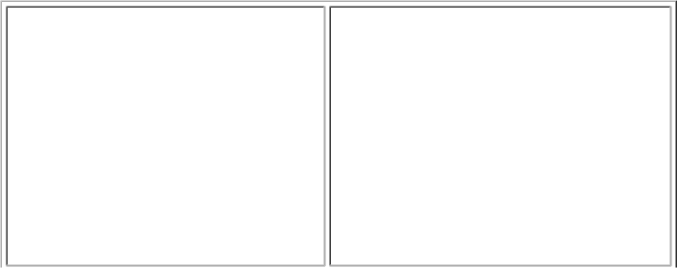

7.

8.

ISLAMIC FESTIVALS

- ____________________ is the best day of the week (Monday, Thursday, Friday)

Write three Sunnah acts done on Friday e.g taking a bath

- ______________________________

- ______________________________

- ______________________________

- Sumah is an ____________ day. (Fasting, Eid)

- I pray Jumu'ah at ____________ (mosque, church, home)

- Jum'ah prayer has ____________ rakaa. (4, 2, 3)

- We listen to ____________ on Jum'ah (Hadith, Strong, Khutbah)

- ____________ leads the Jum'ah prayer. (maamuma, Imam)

KISWAHILI
Kusikiliza na kuzungumza

Jibu maswali haya kwa kuzungumza,Mwalimu, mgzazi, akuulize maswali haya

- Je, unaitwa nani? ________________

- Wewe nu familia yako mnaishi wapi? ________________

- Baba yako anaitwaje? ________________

- Baba yako anafanya kazi gani? ________________

- Mama yako anaitwaje? ________________

- Mama anafanya kazi gani? ________________

- Je, una ndugu wadogo? ________________

- Je una ndugu wakubwa? ________________

- Nyanya na babu wanaishi wapi? ________________

- Nyanya na babu wanafuga wanyama gani? ________________

Mwambie mzazi au mlezi wako akusomee taarifa hii kish akuulize maswali. Jibu kwa sauti kubwa.

Zainabu alipoanza kufanya kazi yoke ya wakili alinunua shamba. Alitaka kuwa mkulima wa michungwa. Aliwapa watu kazi wakamlimia shamba lake na kupanda michungwa mingi. Michungwa ilianza kuwa mikubwa na shamba lake likapendeza. Baadaye michungwa yalikomaa akaanza kuwauzia watu. Siku hizi shamba hill linajulikana sana.

Maswali

- Zainabu alikuwa akifanya kazi gani?

- Zainabu alinunua nini?

- Zainabu alikuwa mkulima wa

- Shamba la Za inabu sasa lira

- Michungwa huzaa matunda yanayoitwa

Kusoma maneno

Soma kwa sauti

maziwa kiatu shingo wema

mafuta kuku kiuno safisha

mwa mkebe utosi viazi

uyoga ndizi bizari nyumbani

sufuria mihogo asali taulo

Soma sentensi hizi

- Hill ni dawati.

- Mwalimu anaandika ubaoni.

- Wao wanatumia tabieti.

- Huyu ni rafiki yangu.

- Mimi ni mfupi.

- Ndege wako angani.

- Jumatatu tunaenda shuleni.

- Kaka amebeba ua.

- Alimtembelea hospitalini.

- Ninaokota taka.

Msomee mzazi au mlezi wako hadithi hii kwa sauti. Tamka maneno vizuri

Hadithi ya kwanza

Mimi ninaitwa Mwakasi. Nyumbani ninafuga bata. Bata huyu nilipewa na babu. Nilienda kumtembelea mashambani. Babu aliserna nikimpa bata chakula atakuwa mkubwa. Akiwa mkubwa atanipa nyama na mayai. Niliendelea kumpa chakula na maji. Akawa mkubwa. Akapata watoto. Wanaitwa Viyoyo.

Hadithi ya Pili

Jina Iangu ni Asha. Ninasomea katika shule ya Tuko Mbele. Ni shule kubwa. Kuna wavulana na wasichana. Wasichana ni wengi kuliko wavulana. Mimi ni mwanafunzi wa gredi ya kwanza. Mwalimu mkuu anaitvva Bi. Chaurembo. Yeye ni mrembo. Anawapenda watoto wote shuleni. Wakati mwingine yeye hutuletea wageni. Wageni hawa hutupatia zawadi. Mara nyingi hutuambia tusome kwa bidii. Mimi ningependa kuwa mwalimu. Kwa hivyo nitafanya bidii shuleni. Je, wewe ungependa kufanya kazi gani?

- Jaza mapengo kwa jibu sahihi

  - __________ kwa kupoteza katamu (Pole, Asante)

  - __________niruhusu nipite. (Tafadhali, Asante)

  - __________ sikusikia swati tako. (Samahani, Habari )

  - Mwalimu __________ nimechelewa kuingia darasani. (niwie radhi, naomba)

  - __________ tutaonana tena Jumapiti (Sijambo, Kwaheri)

- Jibu salamu hizi

  - Hujambo? __________

  - Hamjabo? __________

  - Habari yako?__________

  - Umeshindaje? __________

  - Je, umeamkaje? __________

- Je, wajua vitu unavyovitumia darasani? Michoro hii inaonyesha vitu hivyo. Hebu vitaje.
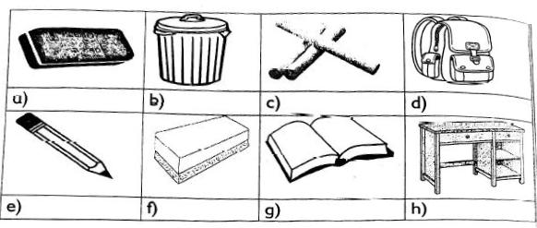

4. Tazama picha hii. Sema watoto wanacheza mchezo gani?

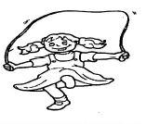

____________________

5. Je unaona wanyama gani kwenye picha hizi

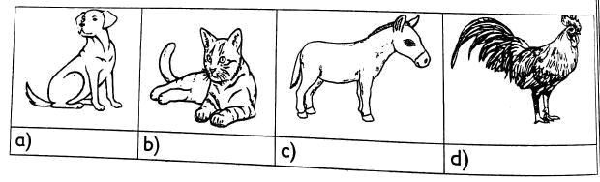

- Tambua sauti zinazounda maneno haya K.m Kiti = K + ti
  - boksi

  - kipepeo =

  - paka =

- Watoto hawa wamepewa maagizo ya kugusa sehemu gani za mwili?
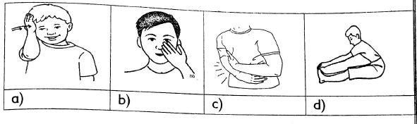

KUSOMA

Soma hadithi kisha ujibu maswali

Hadithi ya kwanza

Tunatumia mikono kulia chakula. Mono inaweza kumega ugali na kuchukua mboga kisha kuweka kinywani. .Tunatumia meno kutafuna chakula. Chakula huvunjwavunjwa no kuwa chepesi na rahisi. Mate nayo hukitayarisha chakula na kukipeteka tumboni Kupitia kooni. Mtu akishiba huwa haoni njaa.

Maswali

- _________________ hutafuna chakula.

- _________________ huzungusha chakula kinywani.

- Chakula hupitia _________________ iii kuweza kufika tumboni.

- Mtu hula kwa sababu anahisi _________________

- Tunatumia nini kuchukua mboga? _________________

Hadithi ya pili

Mazingira ni kitu chochote kinachotuzunguka. Tunafaa kutunza mazingira yetu. Tunaweza kuyatunza kwa kupanda miti. Miti ni mizuri. Miti ikiwa mikubwa hutupa mahati pazuri pa kukaa tunaposoma au kupumzika kwenye kivuli. Mahali penye miti mingi huitwa msitu. Miti pia huleta mvua. Wakulima hutumia mvua kukuza mimea shambani. Ningewaambia watu wapande miti mingi ili tupate kivuli na mvua.

Maswali

- Mid ina umuhimu gani ?

  - __________________

  - __________________

- Wewe unajua miti gani ambayo hutupatia matunda?

  - __________________

  - __________________

- __________________ ni chochote kinachotuzunguka

- Mahaii penye mid mingi huitwa __________________

- Wakulima hutumia __________________ kukuza mimea.

Hadithi ya tatu
Baba yangu ni fundi wa mbao. Pia anaweza kuitwa seremala. Yeye ni fundi wa kutengeneza vitu kwa mbao kama meza na viti. Watu wanapenda kutengenezewa fanicha na baba yangu. H ii ni kwa sababu anapenda kazi yake. Yeye hutengeneza meza, viti na kabati vizuri. Kazi hii ndiyo hutupa pesa za chakula. Pia humpatia pesa na kutuIipia shule na kutununulia nguo. Baba ameifanya kazi hii kwa miaka mingi. Anajulikana sana.

Maswali

- Baba hufanya kazi gani? __________________

- Fundi wa mbao huitwa _________________

- Baba hutengeneza __________________., __________________ na __________________

- Watu wanapenda baba awatengenezee __________________

- Baba amefanya kazi kwa miaka __________________

KUANDIKA

- Jaza mapengo kwa kutumia "a"

  - K __ l __mu (d)

  - M __ kosa (e)

  - Mez___

  - K_ b__ ti P___ zi___
- Andika maneno haya kwa herufi kubwa

  - ndovu:_________________

  - simba: _________________

  - kunguru: _________________

  - jogoo:_________________

  - ngamia: _________________

- Panga herufi ill kuunda neno

  - nija: _________________

  - tmake: _________________

  - mokon: _________________

  - ynuamb: _________________

  - usim: _________________

- Jaza mapengo kwa silabi zinazofaa

  - _____ che _____ _____ chu

  - _____ _____ _____ fo fu

  - Ha _____ _____ _____ _____

- Tenganisha silabi kutoka maneno haya

  - Kitabu __________________

  - Darasa __________________

  - Kalenda __________________

  - Chati __________________

  - Kabati __________________

- Andika majina ya picha hizi;
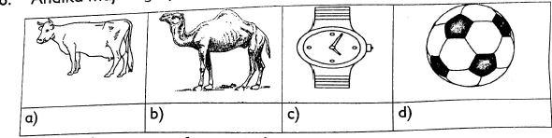

7. Watoto hawa wanafanya nini?

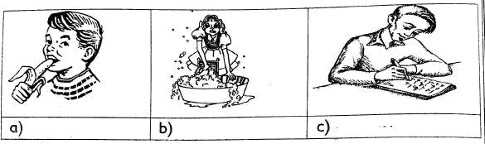

- Andika vifaa vya kusafisha nyumba unavyovijua

  - ____________________________

  - ____________________________

  - ____________________________

  - ____________________________

- Jaza mapengo

  - Baba ____________ kesho kutwa (anakuja, atakuja).

2. Mimi hupiga pasi ____________ kuvaa nguo.(kabla ya, baada ya)

- Ni ____________ kuwa na adabu. (vizuri, vibaya)

- Mtoto ____________ huwa na heshima. (mbaya, mzuri)

- Mimi ninapenda ____________ (usafi, uchafu)

SARUFI

- Andika wingi wa sentensi

  - Mimi ninaandika.____________________

  - Mimi ninasoma . ____________________

  - Mimi ninaimba. ____________________

  - Mimi nnakula. ____________________

  - Mimi ninasikia. ____________________

- Andika wingi wa maneno haya:

  - Jicho __________

  - Mguu __________

  - Mkono __________

  - Kidole __________

  - Kichwa __________

  - Goti __________

  - Sikio __________

  - Bega __________

  - Mdomo __________

  - Unywele __________

- Tumia "huyu" au "hawa"

  - __________ ananawa mikono.

  - Mvulana __________ anacheza.

  - Wanafunzi __________ wanasoma.

  - Mwalimu __________ anafundisha.

  - Watoto __________ wanacheza nje.

  - Wazazi __________ wanapika.

- Tumia maneno haya kujaza mapengo zangu , letu, vyetu, wangu, kwetu, yangu

  - Hili ni shamba ___________

  - Meza hizi ni ___________

  - Mtoto ___________ analia

  - Ninaenda nyumbani ___________
  - Vitabu ___________ vimeraruka

  - Sahani hii ni ___________

- Jaza mapengo

  - Mfuko ___________ una penseti (yangu, wangu)

  - ___________ si mbati na kanisa (kwangu, lao)

  - Shamba ___________ lina matunda (letu, kwetu)

  - Kitabu ___________ kimejaa uchafu (langu, change)

  - Nilipoteza rula za shule ___________

- Ambatanisha jina na picha
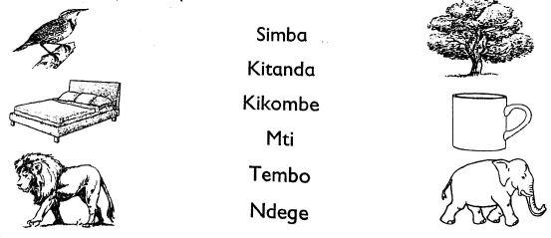

- Panga maneno hays iii kuunda sentensi

  - vizuri analima mkulima

  - kupigana si vizuri

  - asubuhi kilo ninaomba

  - ni unga huu

  - ni zuri letu pazia

- Jaza mianya kwa herufi ("i")

  - Sh ___ kamoo

  - Tafadhal___

  - Samahan__

  - Kar___ bu

  - N ___nashukuru

- Jaza mapengo

  - Mw__ lim___

  - Dere __ a

  - Diw ___ ___ ____

- Andika majina ya vitu hivi
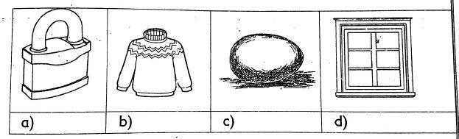

MSAMIATI

1. Paka rangi

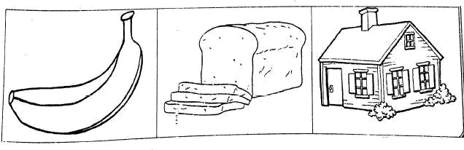

2. Andika majina ya sehemu za mwili katika nambari. Chagua kati ya yale yaliyo hapo chini.
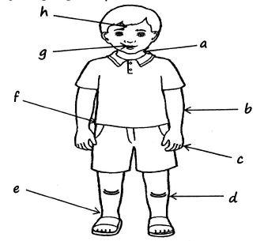

Shingo, utosi ,goti, mkono, Kiuno, vidale,mdomo kisigino

- Jaza mapengo kwa majibu sahihi

  - Wiki moja ina siku ngapi?

  - Katika wiki moja tunaenda shuleni mara ngapi?

  - Sehemu ya mwili inayotumiwa kuona ni

  - hutupa maziwa (kuku, ng'ombe)

  - Mbuzi ana miguu mingapi?

  - Suruali hufungiwa kwenye

  - Sisi hutembea kwa kutumia

  - Kisogo hupatikana

  - Kidole kikubwa cha mkono huitwa

  - Sisi hunusa kwa kutumia

  - Ndizi ikiiva ina rangi ya

- Chagua jibu sahihi.

  - Tunanunua bidhaa kama sukari na chumvi_______________(nyumbani, dukani)

  - Tunaenda ____________ kwa haja ndogo. (msituni, chooni)

  - Ukila ___________ utang'olewa jino. (pipi, bibi, baba)

  - Tunaweka __________ kwenye chakuta. (asali, chumvi)

  - Watu hulala juu ya ______________

- Tumia majina yanayofaa.

  - Dada wa mama anaitwa? __________________ (halati, babu)

  - Mama ya baba yangu ni __________________ (nyanya, babu)

  - Baba ya baba yangu ni __________________ (babu, bibi)

  - Anayewatibu watu ni __________________ (mwalimu, Daktari)

  - Samaki, mboga, viazi ni aina ya __________________ (matunda, vyakuta)

- Tazama vyakuta hivi. Mimi ninapenda kula

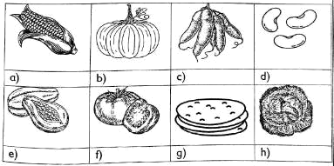

MATHEMATICS

NUMBERS

Exercise 1

Count then write the number
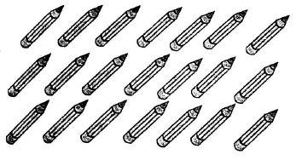

1.

2.
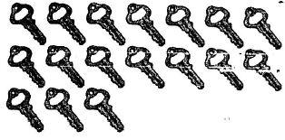

3.
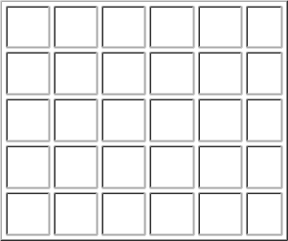

4.
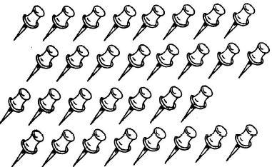

Write in figures

- Fifty nine ____

- sixty seven ____

- Forty four ____

- Eighty eight ____

- Thirty nine ____

Write in words

- 56 ___________________

- 92 ___________________

- 78 ___________________

- 17 ___________________

- 77 ___________________

- 87 ___________________

Exercise 2

Write the missing_number

- 45, 46, __ 48, ___

- 13, 12, ___,10,___

- ___, 56,___, 58, 60,___

- ___, 77, 79, 81, ___

- 25, 23, ___,___,___

Write number before and after

5.


66

6.

86

7.

41

Order from the lowest to the highest

8.


7 5 8

___,___,___

9.


17 19 12

___,____,___

10.
 |  |  | 6 |  | 14 |  | 13
 |  | ____,___,____
 |  | Count backward in twos
11. |  | 45,47, 49, ___, ___
12. |  | 22, 24, 26, ___, ___, 32
 |  | Count backward in twos
13. |  | 18, 16. 14 ___, ___
14. |  | 34,32, 30, ___, ___
 |  | Match to the correct one
 |  | Number |  |  |  |  |  |  |  | in words
15. |  | 45 |  |  |  |  |  |  |  | Eighty nine
16. |  | 17 |  |  |  |  |  |  |  | Seventeen
17. |  | 38 |  |  |  |  |  |  |  | Forty five
18. | 89 |  |  |  |  |  |  | Sixty
19. | 60 |  |  |  |  |  |  | Thirty eight

Circle the biggest number

- 56, 65, 43, 78, 54

- 97, 89. 86, 44, 65

Sub Strand 1.2

Exercise 3

Place value of tens and ones
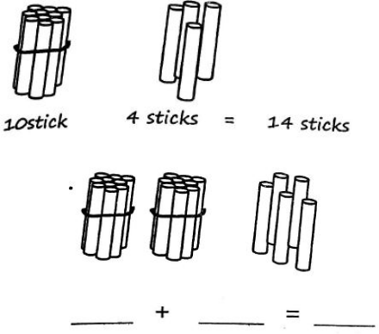

1.

2.
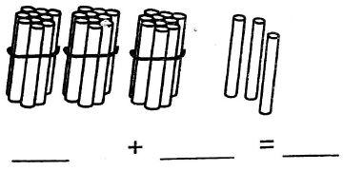

3.
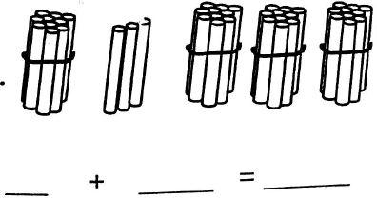

- 44 = ___ tens + ___ ones

- 87= ___ tens + ___ ones

- 45 = ___tens + ___ ones

- 90= ____tens + ____ones Fill the chart
- 23
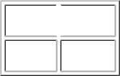

Tens Ones

9. 67

Tens Ones

10. 92

Tens Ones

11.
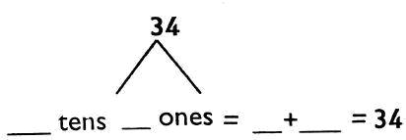
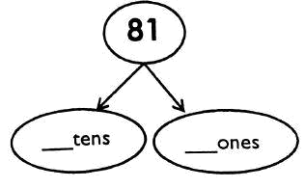

12.

- Which number is shown in the abacus?

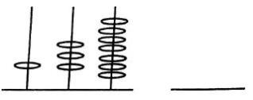
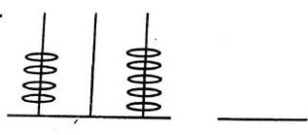

SUBS STRAND 1.3

ADDITIONS

Exercise 4

1. Write the signs between
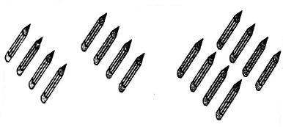

- Add using number line 2+3+5=

- 6+2+3=

- 6+2-3=
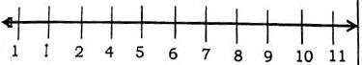

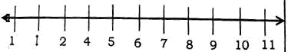
Match to the correct answer
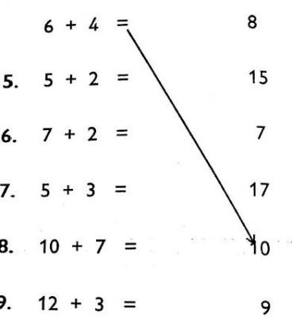

- Add 4 to get the next number

- Add 5 to get the next number
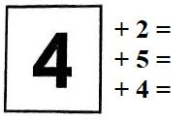
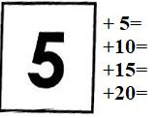

Exercise 5

1. Add four to get the answer
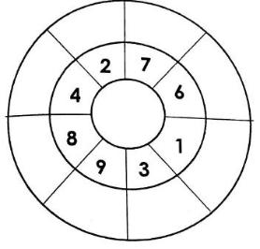

Make four different sums
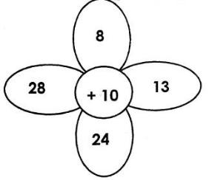

- _____ + __________= _______

- _____ + __________= _______

- _____ + __________= _______

- _____ + __________= _______

- 3+2+3=

- 6+4+5=

- 9+2+3=

- 5+5+5=

- 4+4+2=

Exercise 6
Fill in the missing numbers

- 8+ ___=10

- 7 + ____= 14

- 3+___=9

- ____+8=16

- ____+ 10 =30 Exercise 6
- Fifty plus twenty is equal to _____

- Eleven cups plus 12 cups is equal to ______

- Kamau had 10 cows. His father added him 5 more cows. How many cows had he altogether?

- There are 7 cats in the school. Six more were added. How many cats are there altogether?

- Peter sells eggs. He sold 14eggs and Eater

SUB STRAND 1.3

Subtraction

Exercise 7

- 5-2=

- 8-4=

- 9-5=

- 10-6=

- 20-8=

- 23-6=

- 18-10=

Subtract using number line E.g. 9 - 5 = 4

Fill number line and subtract

- 9-6=

- 14-4=

- 10-7=

- 17-9=
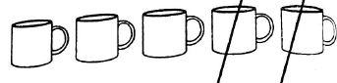
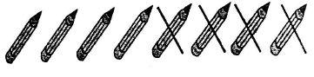
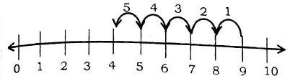
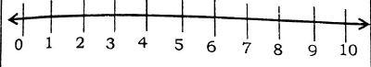
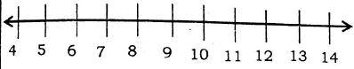
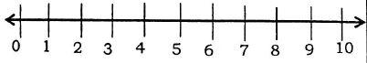

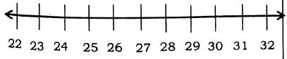
12. 32-10=

Exercise 8

1. Colour the correct answer
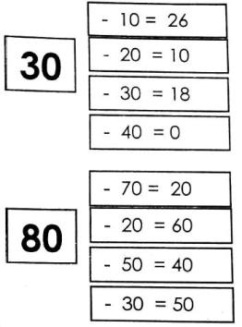

Subtract using place value chart

- 47

  - 13

_____

- 5 9

  - 3 5

______

- 38

-20

______

Fill in the missing number

- 24 - ____= 14

- 19 - ____=6

- 45 - ____= 24

- ____ - 7 =10

- Tim had 20 oranges. 6 oranges were stolen. How many oranges did he remain with?

- Lucu was given 13 balls by his uncle. He gave his friend 3 balls. How many balls was he left with?

- Subtract 18 from 20 ______________

- What is 40 minus 20 ______________

- Cain had 6 sheep. He sold all of them. How many sheep did he remain with? __________

STRAND 2.0

MEASUREMENTS

2.1 lengths

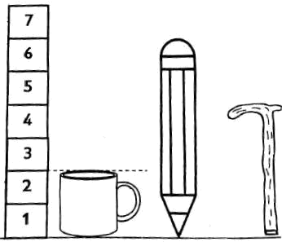
Draw a line across and write how many units

- How tall is the cup? _____________units.

- How tall is the pencil? _____________units.

- How tall is the walking stick? _____________units. Measure the length in units
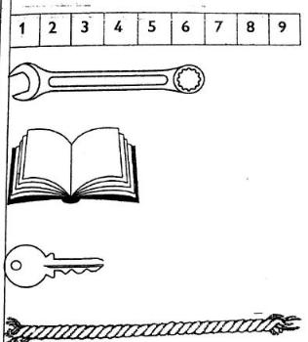

- What is the length of the spanner? _____________units.

- What is the length of the book? _____________units.

- What is the length of the key? _____________units.

- What is the length of the rope? _____________units.

Circle the shortest line

8.
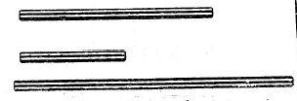

Circle the longest line

9.
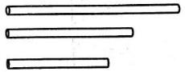

10. Circle lines of the same length
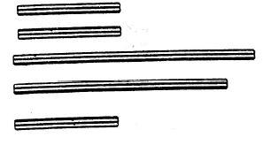

2.3 Capacity

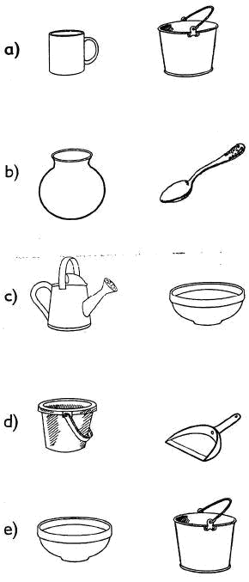
1. Circle the container which holds less

2.4 Time

- We go to school for ____ days in a week

- We raise the flag on _______________

- The fifth day of the week is _______________

- At what time do we take breakfast? _______________

- Which day of the week is between Thursday and Saturday? _______________

- I wash my face in the _______________

- We eat supper in the _______________

- Cock crows in the _______________

- Saturday comes before _______________

- _______________ is the first day of the week.

2.5 Money

Identify and write the value of following coins and notes

1.
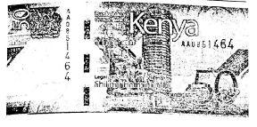

_____, which colour is this note _________________

2.
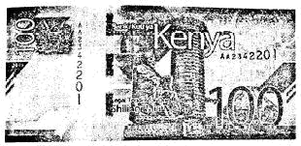

_____, which colour is this note __________________

3.
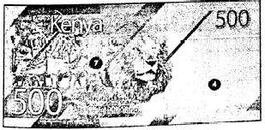

_______, which colour is this note _________________

2.5 Geometry

1. Name the following Shapes
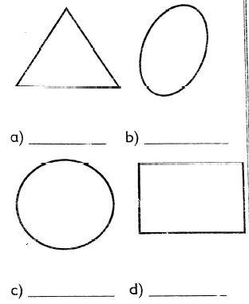

- The shape of an egg is ____________________

- The shape of a table top is _________________

- What is the shape of thetop of a Sufuria ________________

- What is the shape of your bedroom ___________________

- Name the following lines
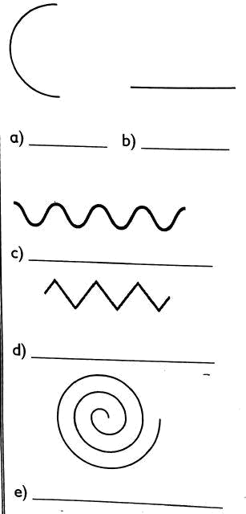

A shape with all equal sides is a ______________________

