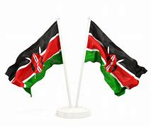

**GREDI YA 1 MUHULA 1 2024**

**KISWAHILI**

**NAME :……………………………………..**

1. **Tengeneza maneno kwa kuunganisha sauti;**

da de di do du

**mfano: da + da = dada**

da + ra + sa = _____________

de + re + va = _____________

da + ra + ja = _____________

du + ka = _____________

di + ri + sha = _____________

1. **Yaandike maneno haya kwa herufi kubwa**

darasa DARASA

dereva __________________

daraja __________________

duka __________________

dirisha __________________

1. **Andika majina ya maumbo**

**duara**

**mraba**

**pembe tatu**

________________ ____________ ______________

Αssessment Rubric:

|  |  |  |  |
| --- | --- | --- | --- |
| KUZIDISHA MATARAJIO | KUFIKIA MATARAJIO | KUKARIBIA MATARAJIO | CHINI YA MATARAJIO |
| 98-100 | 80-97 | 50-79 | 0-49 |
|  |  |  |  |