

**GRADE 1 ASSESSMENTS TERM ONE 2024**

**E**LITERACY

**NAME :……………………………………..**

**LANGUAGE ACTIVITIES**

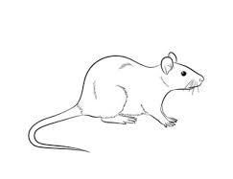Read the sentences aloud:

this is a rat

it is a small rat

that rat is bad

a cat kills a rat



**GRADE 1 ASSESSMENTS TERM ONE 2024**

**ENGLISH**

**NAME :……………………………………..**

**Read the sentences below and fill in the missing letters;**

|  |
| --- |
| This is a hut.  It is a big hut  It has a good door  It is my hut.  The hut is new |

This is a h ______ t

It is a b _____g hut

u. i. o. e, y

It has a g ____ ____d door

It is m ____ hut

The hut is n _____

**2. Complete the following;**

|  |
| --- |
| boy girl |

My name is ____________________________

I am a ____________________

I am in Grade ____________________

**3. Write in capital letters**

**A B C D E F**

**G H I J K L**

**M N O P Q R**

**S T U V W X**

**Y Z**

rat _______________

bad _______________

that _______________

small _______________

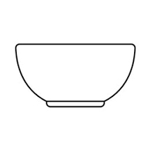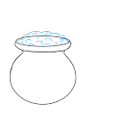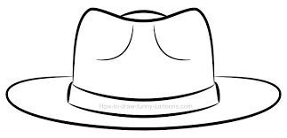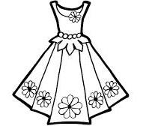4. Name the pictures below;

__________ ___________ _______ ________

**dish, dress, hat, pot**

**5. Re-write these words well**

Example: koob book

upc ____________

oyb ____________

epn ____________

tevs ____________

**6. Draw and colour;**

Flower

Αssessment Rubric:

|  |  |  |  |
| --- | --- | --- | --- |
| Exceeds Expectαtion | Meets Expectαtion | Αpproαching Expectαtion | Below Expectαtion |
| 98-100 | 80-97 | 50-79 | 0-49 |
|  |  |  |  |