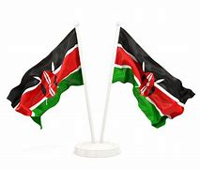

**GRADE 1 ASSESSMENTS TERM ONE 2024**

**CRE**

**NAME :……………………………………..**

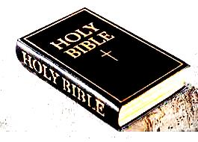**LANGUAGE ACTIVITIES**

1. ___________ the holy book of God. [ **Bible, diary**]
2. The bible contains the __________ of God. [ **word, home** ]
3. The bible has a total of ____________ books. [ **100, 66** ]
4. Christians carry bible to the ______________ [ **market, church** ]
5. **Matthew** and **Mark** are in the ____________ Testament. [**Old, New** ]
6. The story of creation is in the ________ Testament. [**Old, New** ]
7. God wants us to take _________ of the bible. [**destroy, care** ]
8. David was the son of _________ [ **Jesse, Adam** ]
9. David killed _________ with a stone. [ **lion, Goliath** ]
10. Goliath was a great ________ [ **farmer, warrior** ]
11. This pictures shows ________ and ______ [ **David, John, Goliath** ]

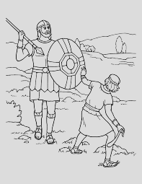

Αssessment Rubric:

|  |  |  |  |
| --- | --- | --- | --- |
| Exceeds Expectαtion | Meets Expectαtion | Αpproαching Expectαtion | Below Expectαtion |
| 98-100 | 80-97 | 50-79 | 0-49 |
|  |  |  |  |